**FAST2SMS**

|  |  |
| --- | --- |
| Date | 02 November 2022 |
| Team ID | PNT2022TMID19760 |
| Project Name | SmartFarmer – IoT ENABLED SMART FARMING APPLICATION |

**STEP 1:**

Type fast2sms in google and click on the first link

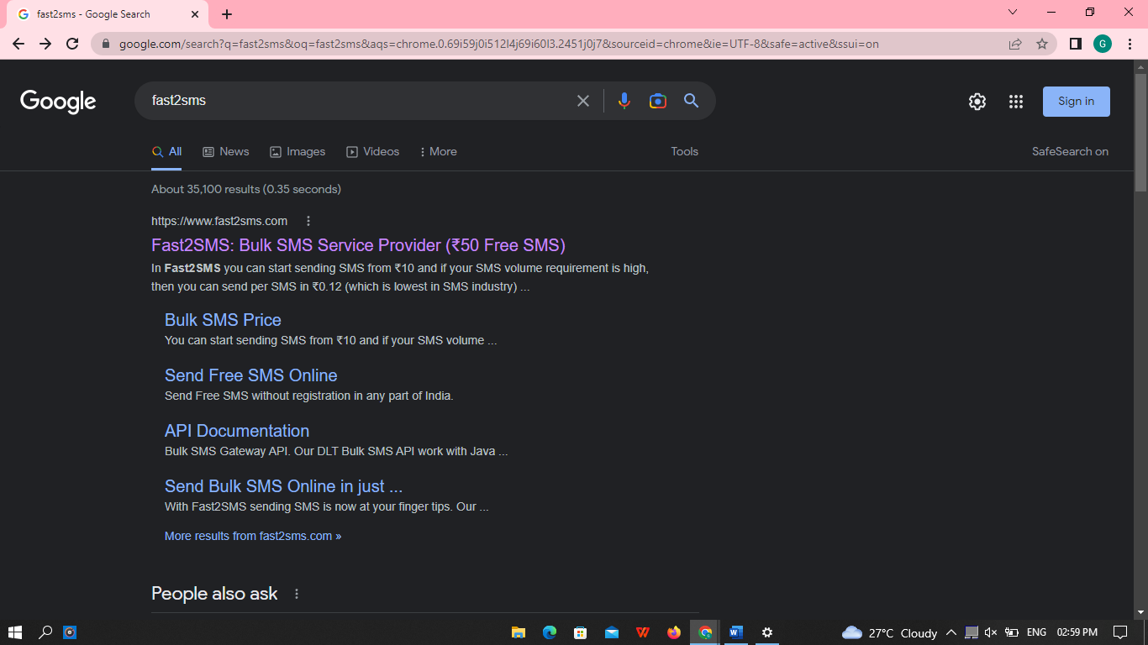

**STEP 2:**

Click on sign up now

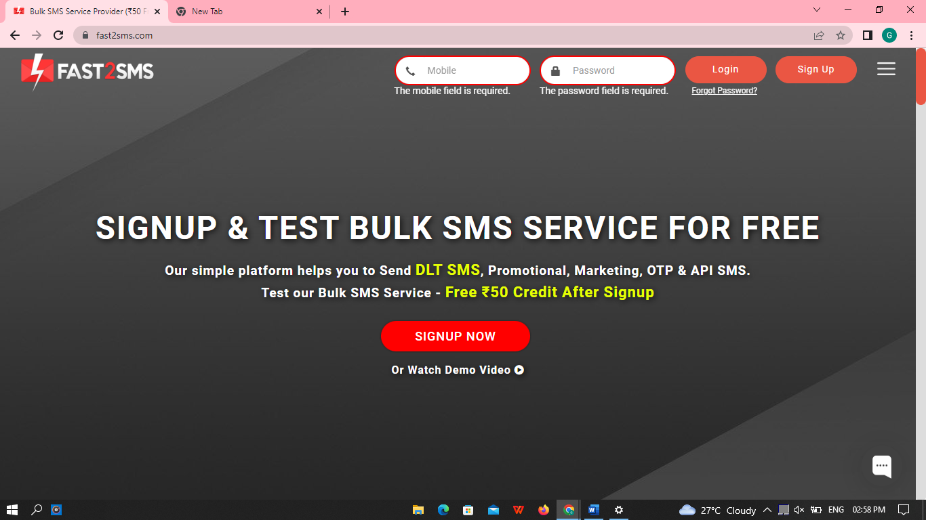

**STEP 3:**

Give your details and click on the check box, then click the submit button.

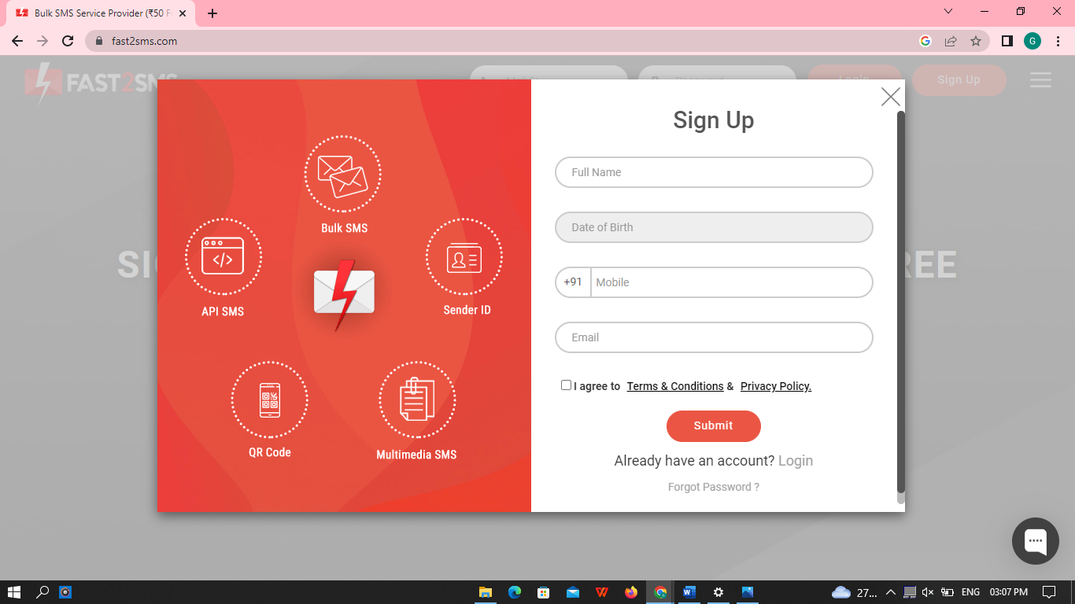

**STEP 5:**

You will get the SMS with your password. Type your mobile number and the password then click on the submit button.

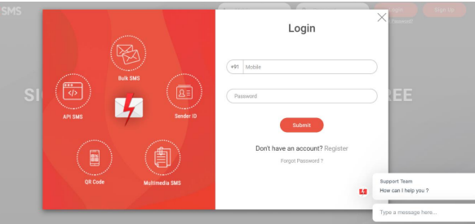

**STEP 5:**

Click on the Dev API

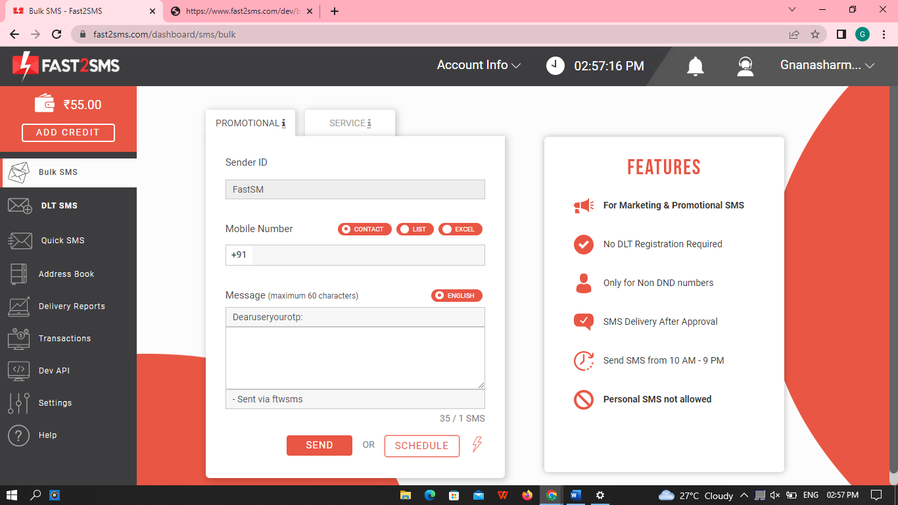

**STEP 6:**

Select the Route as Quick SMS and type the message in message box.

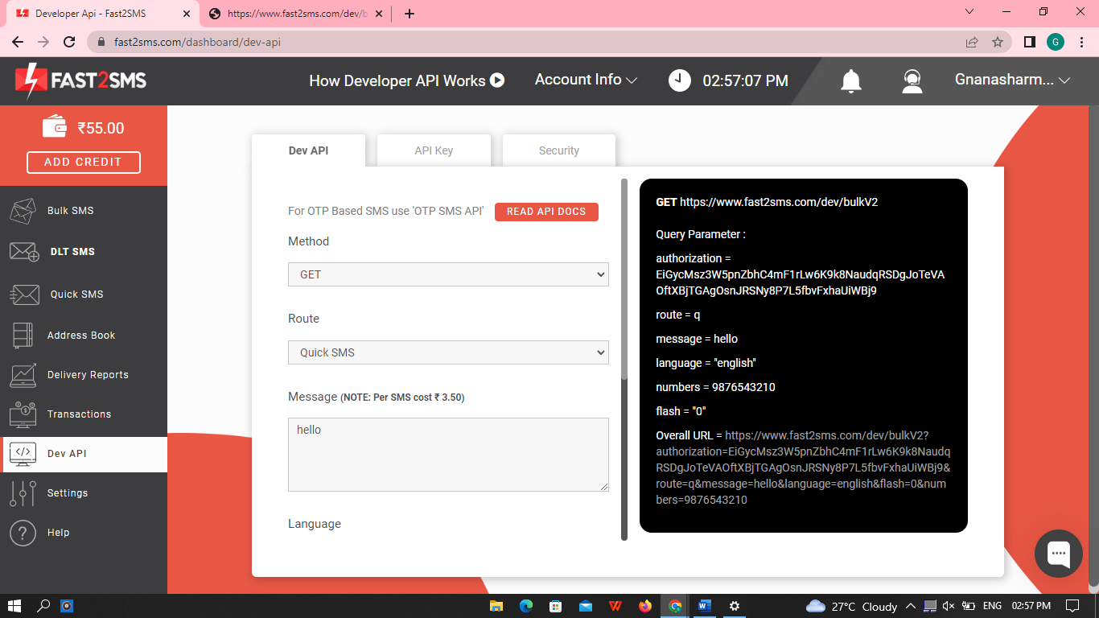

**STEP 7:**

Select your language and type your mobile number in contact



**STEP 8:**

Copy the URL and paste it in the new tab

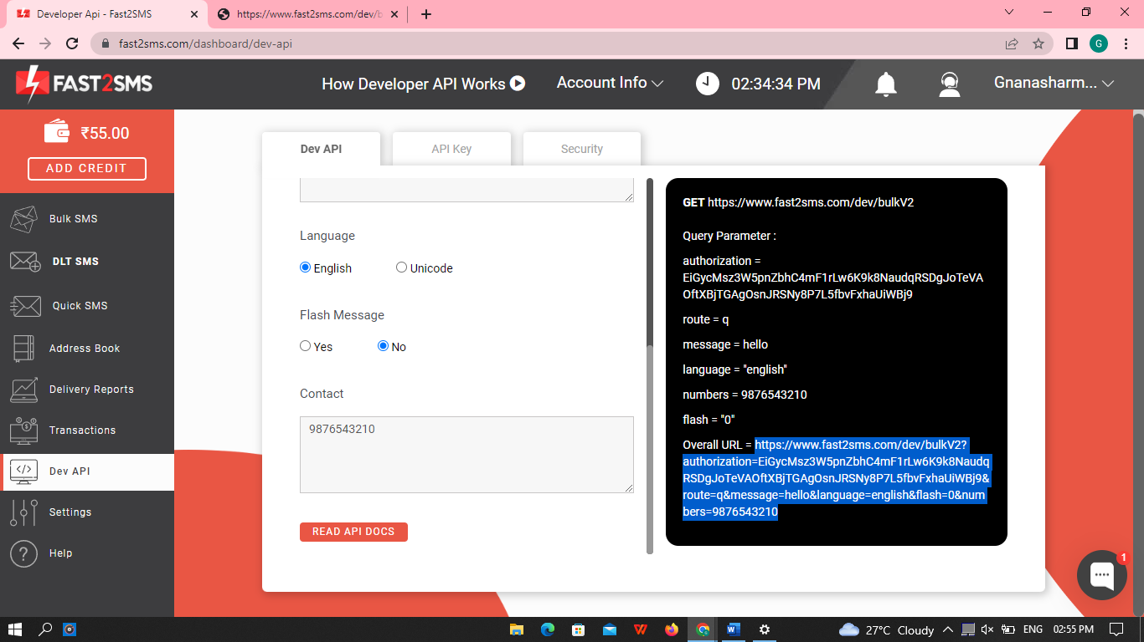

**STEP 9:**

Youwill getthe SMS in the new tab

