Assignment-3

IBM object storage & IBM Watson

|  |  |
| --- | --- |
| Date | 19 September 2022 |
| Team ID | PNT2022TMID32325 |
| Project Name | Smart Fashion Recommender Application |

Question:

1. Create a Bucket in IBM object storage.
2. Upload 5 images to ibm object storage and make it public. write html code to display all the 5 images. 3.Upload a css page to the object storage and use the same page in your HTML code.
3. Design a chatbot using IBM Watson assistant for hospitals. Ex: User comes with a query to know the branches for that hospital in your city. Submit the web URL of that chat bot as an assignment.
4. Create Watson assistant service with 10 steps and use 3 conditions in it. Load that script in the HTML page.

# Solutions:

**1.Create a Bucket in IBM object storage.**

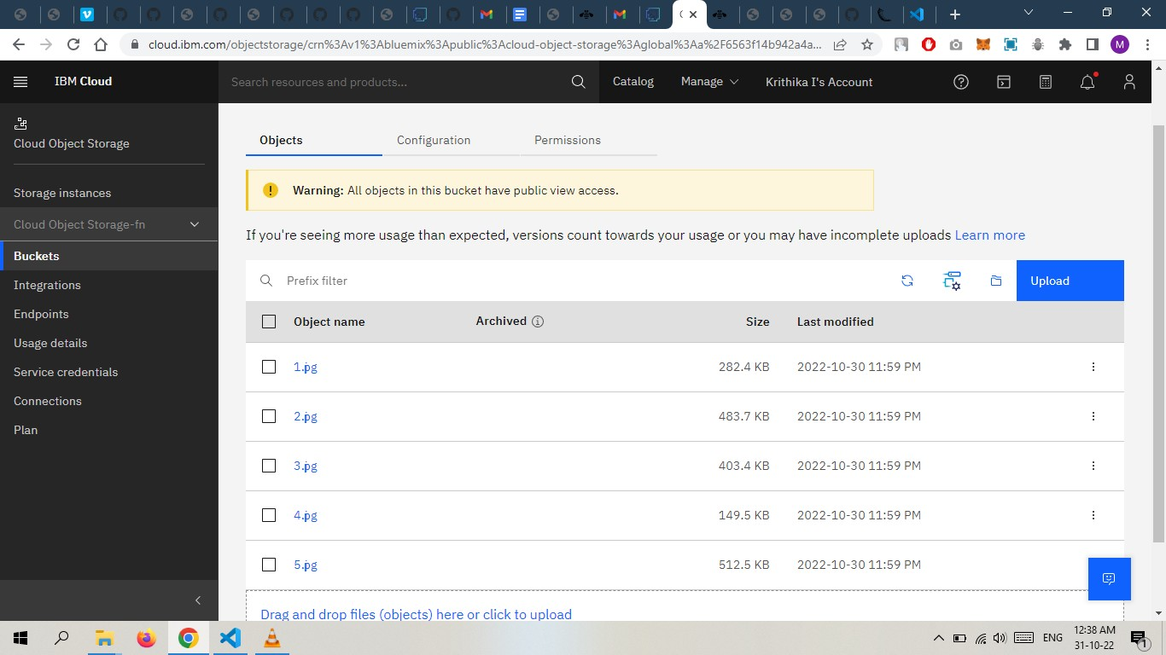

# Code:Home.html

**<!DOCTYPE html>**

**<html lang="en">**

**<head>**

**<meta charset="UTF-8">**

**<meta http-equiv="X-UA-Compatible" content="IE=edge">**

**<meta name="viewport" content="width=device-width, initial-scale=1.0">**

**<title>Smart Fashion shop </title>**

**<link rel="stylesheet"**

**href="https://teamys-assignment.s3.jp-tok.cloud-object-storage.appdomain.cloud/styl e.css">**

**</head>**

**<body>**

**<h1>Image Gallery</h1>**

**<div>**

**<img**

**src="https://teamys-assignment.s3.jp-tok.cloud-object-storage.appdomain.cloud/1.jpg " alt="one">**

**<img**

**src="https://teamys-assignment.s3.jp-tok.cloud-object-storage.appdomain.cloud/2.jpg " alt="two">**

**<img**

**src="https://teamys-assignment.s3.jp-tok.cloud-object-storage.appdomain.cloud/3.jpg " alt="two">**

**<img**

**src="https://teamys-assignment.s3.jp-tok.cloud-object-storage.appdomain.cloud/4.jpg " alt="two">**

**<img**

**src="https://teamys-assignment.s3.jp-tok.cloud-object-storage.appdomain.cloud/5.jpg " alt="two">**

**</div>**

**</body>**

**</html>**

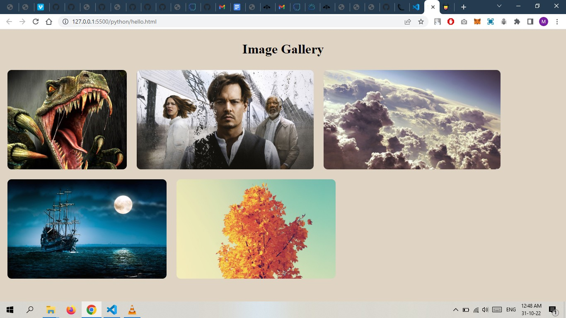

# Upload a css page to the object storage and use the same page in your HTML code.

* + <https://teamys-assignment.s3.jp-tok.cloud-object-storage.appdomain.cloud/style.css>
  + CSS Successfully Added from the object storage.

<link rel="stylesheet"

href="https://teamys-assignment.s3.jp-tok.cloud-object-storage.appdomain.cloud/styl e.css">



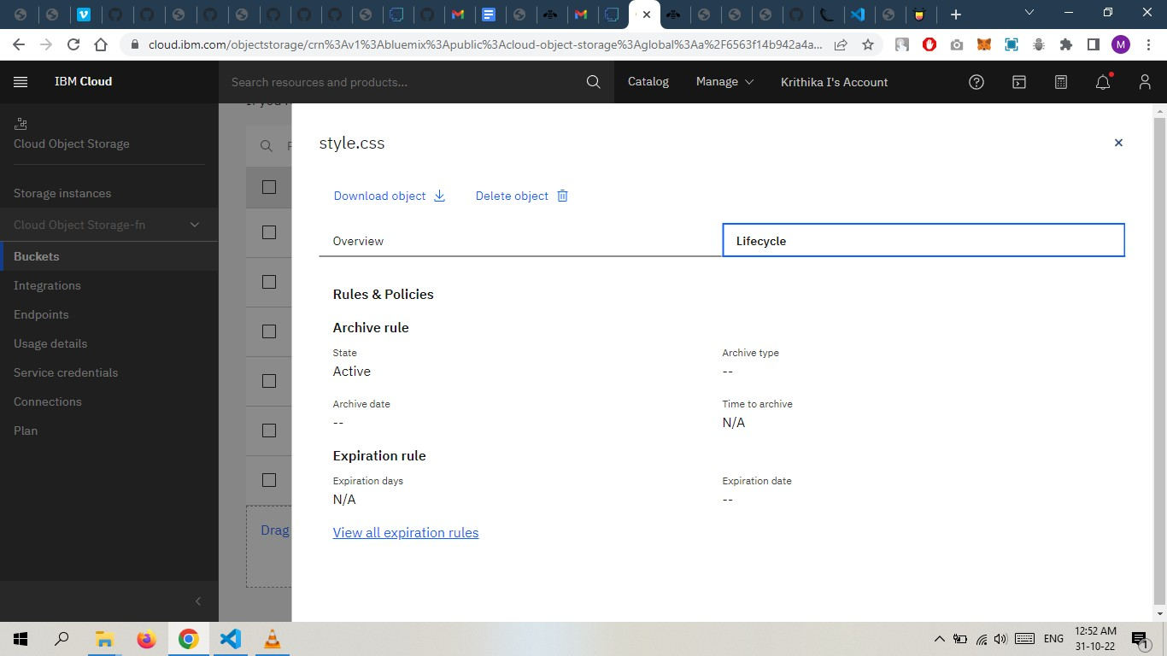

# Design a chatbot using IBM Watson assistant for hospitals. Ex: User comes with a query to know the branches for that hospital in your city. Submit the web URL of that chat bot as an assignment.

**Link:**

[**https://web-chat.global.assistant.watson.appdomain.cloud/preview.html?backgroundImageURL**](https://web-chat.global.assistant.watson.appdomain.cloud/preview.html?backgroundImageURL=https%3A%2F%2Fau-syd.assistant.watson.cloud.ibm.com%2Fpublic%2Fimages%2Fupx-fd1d391b-23ff-4912-a936-0cf5be1839b5%3A%3A62d069b3-c8ed-41d5-aab9-bbcb6624bd09&integrationID=5c9d3f18-3f55-421e-8f93-56b12ce97bd4&region=au-syd&serviceInstanceID=fd1d391b-23ff-4912-a936-0cf5be1839b5)

[**=https%3A%2F%2Fau-syd.assistant.watson.cloud.ibm.com%2Fpublic%2Fimages%2Fupx-fd1d391b**](https://web-chat.global.assistant.watson.appdomain.cloud/preview.html?backgroundImageURL=https%3A%2F%2Fau-syd.assistant.watson.cloud.ibm.com%2Fpublic%2Fimages%2Fupx-fd1d391b-23ff-4912-a936-0cf5be1839b5%3A%3A62d069b3-c8ed-41d5-aab9-bbcb6624bd09&integrationID=5c9d3f18-3f55-421e-8f93-56b12ce97bd4&region=au-syd&serviceInstanceID=fd1d391b-23ff-4912-a936-0cf5be1839b5)

# [-23ff-4912-a936-0cf5be1839b5%3A%3A62d069b3-c8ed-41d5-aab9-bbcb6624bd09&integrationID](https://web-chat.global.assistant.watson.appdomain.cloud/preview.html?backgroundImageURL=https%3A%2F%2Fau-syd.assistant.watson.cloud.ibm.com%2Fpublic%2Fimages%2Fupx-fd1d391b-23ff-4912-a936-0cf5be1839b5%3A%3A62d069b3-c8ed-41d5-aab9-bbcb6624bd09&integrationID=5c9d3f18-3f55-421e-8f93-56b12ce97bd4&region=au-syd&serviceInstanceID=fd1d391b-23ff-4912-a936-0cf5be1839b5)

[**=5c9d3f18-3f55-421e-8f93-56b12ce97bd4&region=au-syd&serviceInstanceID=fd1d391b-23ff-491**](https://web-chat.global.assistant.watson.appdomain.cloud/preview.html?backgroundImageURL=https%3A%2F%2Fau-syd.assistant.watson.cloud.ibm.com%2Fpublic%2Fimages%2Fupx-fd1d391b-23ff-4912-a936-0cf5be1839b5%3A%3A62d069b3-c8ed-41d5-aab9-bbcb6624bd09&integrationID=5c9d3f18-3f55-421e-8f93-56b12ce97bd4&region=au-syd&serviceInstanceID=fd1d391b-23ff-4912-a936-0cf5be1839b5)[**2-a936-0cf5be1839b5**](https://web-chat.global.assistant.watson.appdomain.cloud/preview.html?backgroundImageURL=https%3A%2F%2Fau-syd.assistant.watson.cloud.ibm.com%2Fpublic%2Fimages%2Fupx-fd1d391b-23ff-4912-a936-0cf5be1839b5%3A%3A62d069b3-c8ed-41d5-aab9-bbcb6624bd09&integrationID=5c9d3f18-3f55-421e-8f93-56b12ce97bd4&region=au-syd&serviceInstanceID=fd1d391b-23ff-4912-a936-0cf5be1839b5)

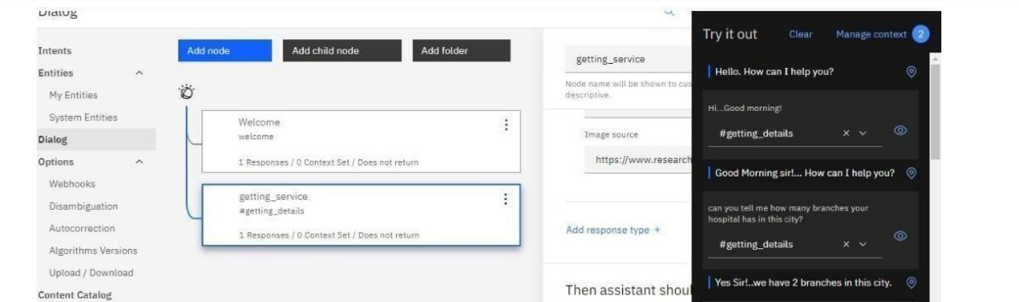

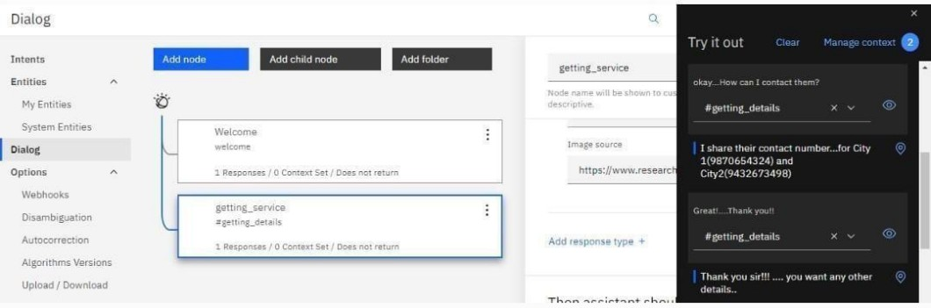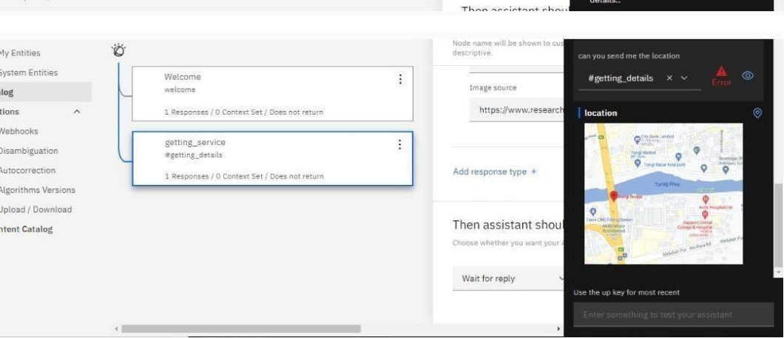

# Create Watson assistant service with 10 steps and use 3 conditions in it.

<script>

window.watsonAssistantChatOptions = {

integrationID: "5c9d3f18-3f55-421e-8f93-56b12ce97bd4", // The ID of this integration. region: "au-syd", // The region your integration is hosted in.

serviceInstanceID: "fd1d391b-23ff-4912-a936-0cf5be1839b5", // The ID of your service instance.

onLoad: function(instance) { instance.render(); }

};

setTimeout(function(){

const t=document.createElement('script');

t.src="https://web-chat.global.assistant.watson.appdomain.cloud/versions/" + (window.watsonAssistantChatOptions.clientVersion || 'latest') + "/WatsonAssistantChatEntry.js";

document.head.appendChild(t);

});

