Assignment-4

IBM object storage & IBM Watson

|  |  |
| --- | --- |
| Date | 19 September 2022 |
| Team ID | PNT2022TMID32326 |
| Project Name | News Tracker Application |
| Student Name | MUGILAN E |
| Student Roll No | 810019104043 |

|  |  |
| --- | --- |
| Date | 19 September 2022 |
| Team ID | PNT2022TMID32326 |
| Project Name | News Tracker Application |
| Student Name | MOHAMED AMEER ABBAS |
| Student Roll No | 810019104040 |

|  |  |
| --- | --- |
| Date | 19 September 2022 |
| Team ID | PNT2022TMID32326 |
| Project Name | News Tracker Application |
| Student Name | KIRUBALANI G |
| Student Roll No | 810019104034 |

|  |  |
| --- | --- |
| Date | 19 September 2022 |
| Team ID | PNT2022TMID32326 |
| Project Name | News Tracker Application |
| Student Name | KIRUBAKARAN P |
| Student Roll No | 810019104035 |

Assignment Kubernetes / Docker:

1. Pull an Image from docker hub and run it in docker playground.
2. Create a docker file for the job portal application and deploy it in Docker desktop application.
3. Create an IBM container registry and deploy a hello world app or job portal app.
4. Create a Kubernetes cluster in IBM cloud and deploy hello world image or job portal image and also expose the same app to run in node port.

# Pull an image from docker hub and run it in docker Playground

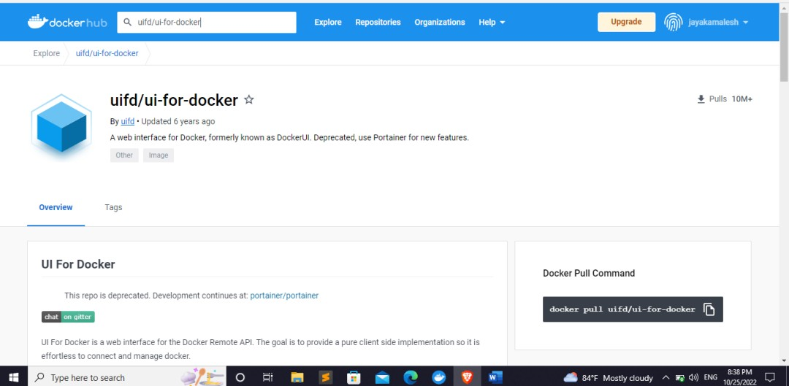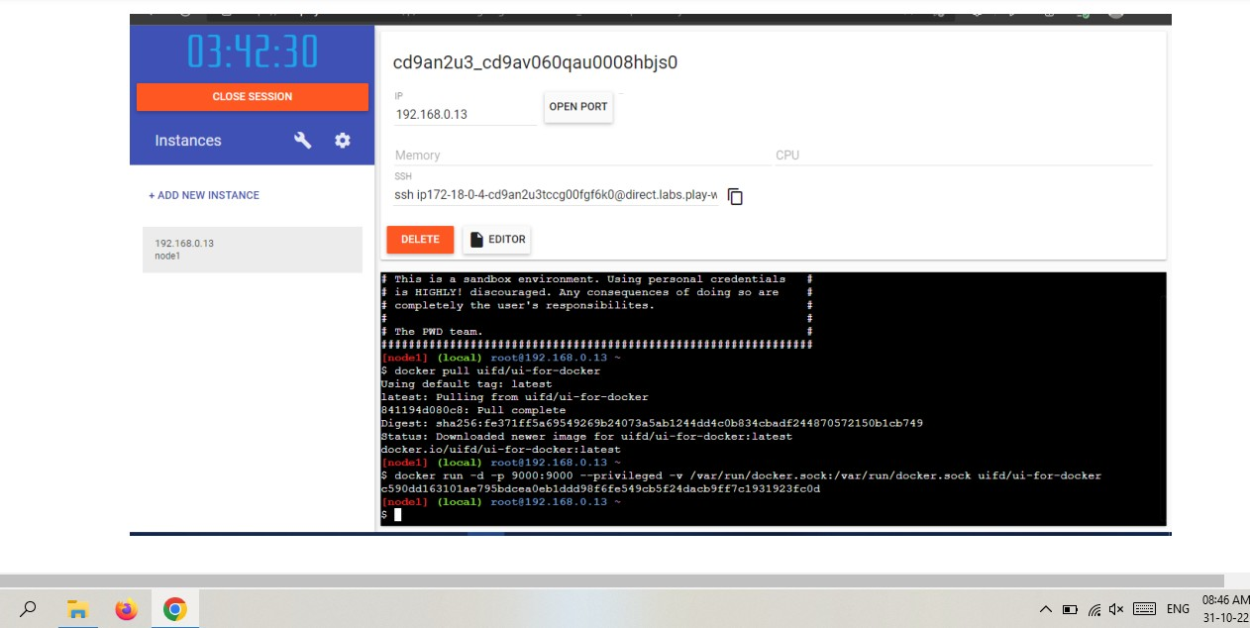

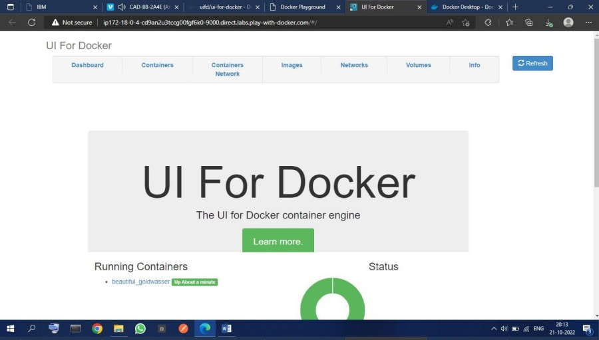

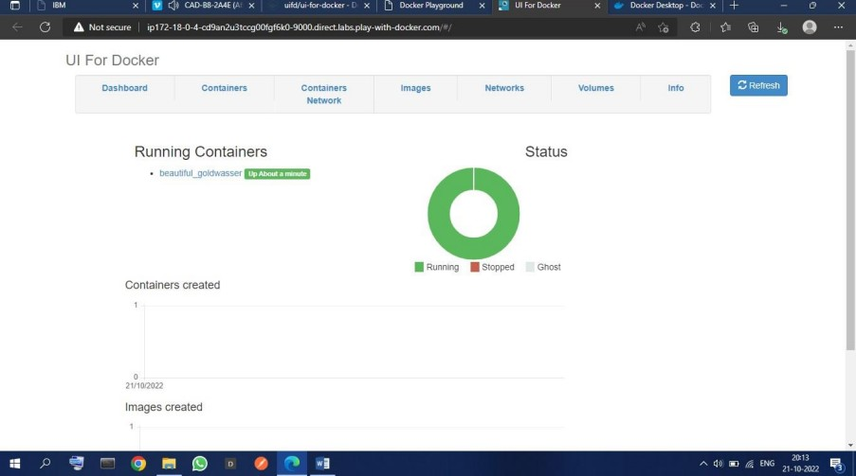

1. **Create a docker file for the job portal application and deploy it in Docker desktop application.**

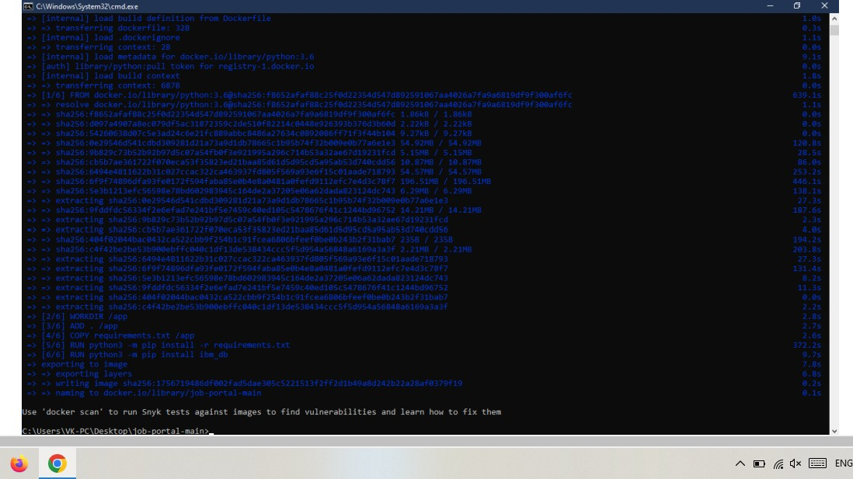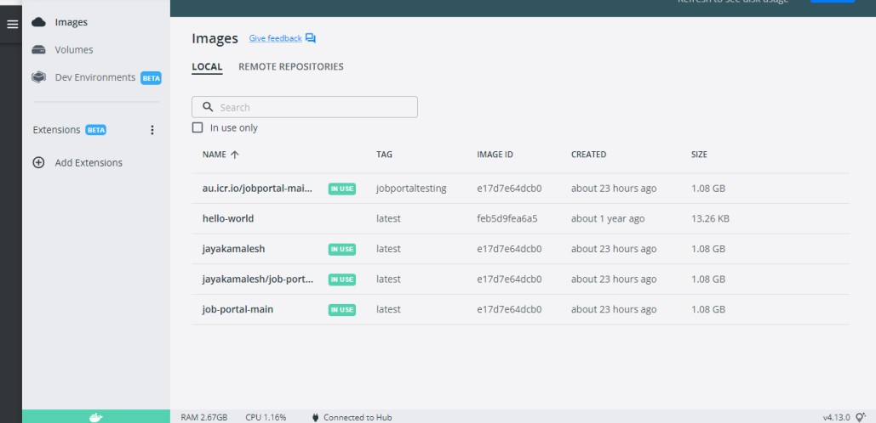

# Create an IBM container registry and deploy a hello world app

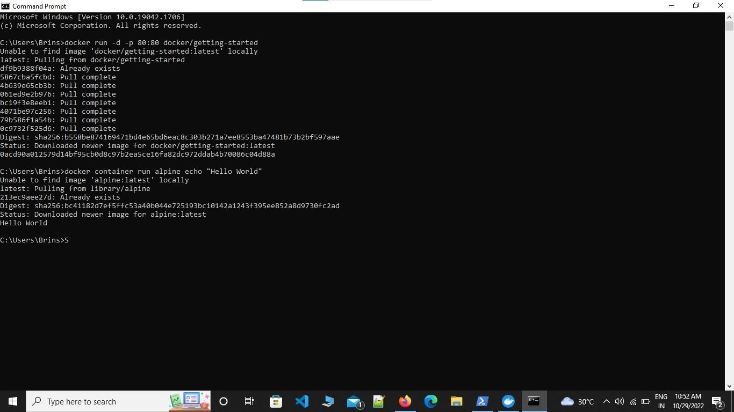

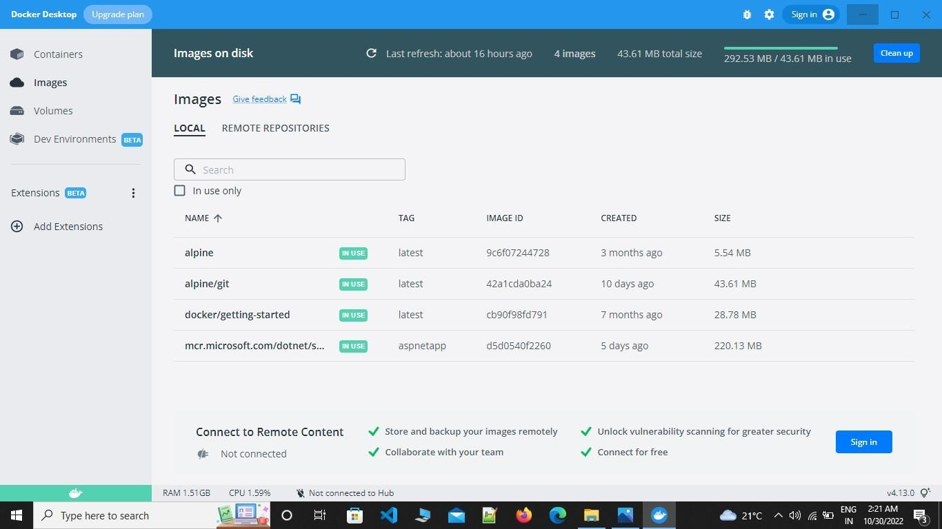

1. **Create a Kubernetes cluster in IBM cloud and deploy a job portal image and also expose the same app to run in node port.**

# Job Portal:

