PREREQUISITES

SOFTWARE (PYTHON 3.11.0)

|  |  |
| --- | --- |
| TEAM ID | PNT2022TMID05359 |
| PROJECT NAME | PROJECT-SMART WASTE MANAGEMENT SYSTEM |

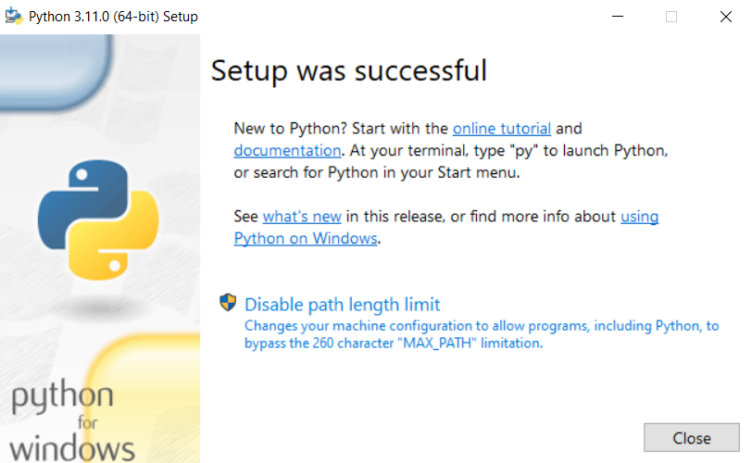

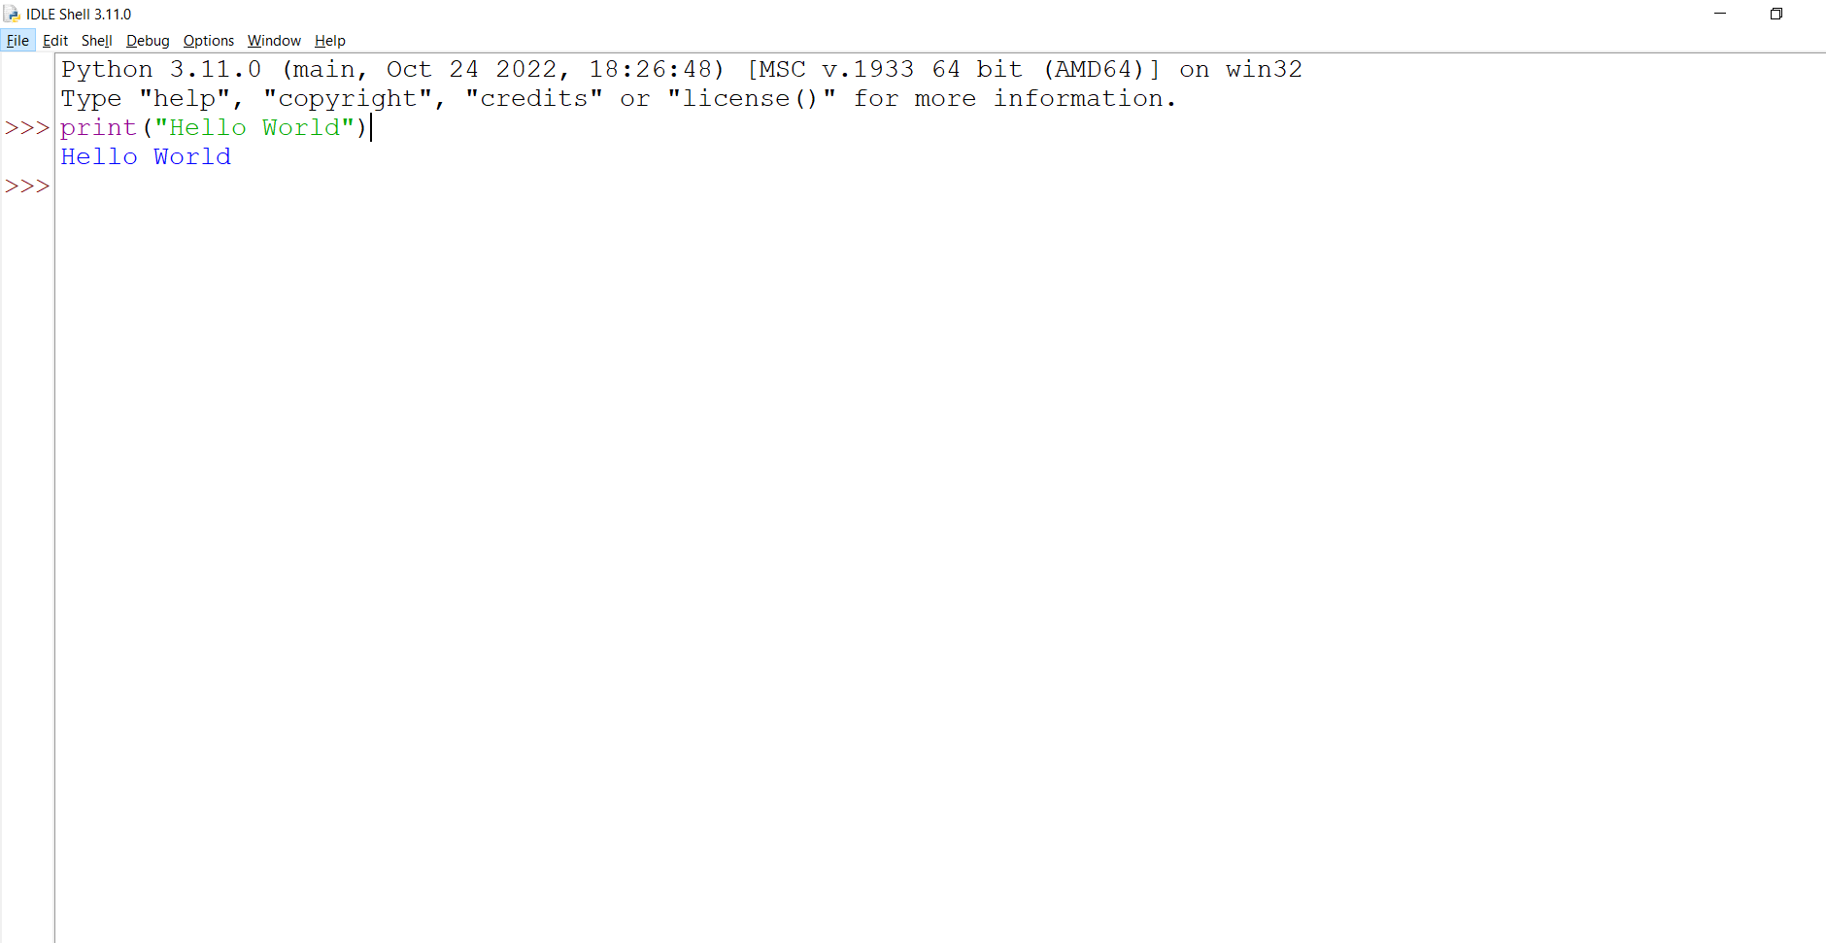

PROGRAM & OUTPUT IN PYTHON IDLE 3.11.0-64BIT

