 **ADHIYAMAAN COLLEGE OF ENGINEERING** 

DR. M.G.R NAGAR, HOSUR-635130

**TEAM ID : PNT2022TMID07957**

**A MINI PROJECT REPORT**

**ANALYTICS FOR HOSPITAL’S HEALTH-CARE DATA**

**Submitted by**

**JAYAKEERTHANA R (AC19UCS040)**

**DHANUSHYA M (AC19UCS024)**

**GAYATHRI S (AC19UCS030)**

**NAVEENKUMAR S (AC19UCS077)**

***In partial fulfilment for the award of the degree***

***of***

**BACHELOR OF ENGINEERING**

***In***

**COMPUTER SCIENCE AND ENGINEERING**

**ADHIYAMAAN COLLEGE OF ENGINEERING**

**(AUTONOMOUS)**

DR. M.G.R NAGAR, HOSUR-635130

**ANNA UNIVERSITY: CHENNAI 600025**

**NOVEMBER 2022**

## ANNA UNIVERSITY: CHENNAI 600 025

## BONAFIDE CERTIFICATE

Certified that this mini project report **“ANALYTICS FOR HOSPITALS’ HEALTH-CARE DATA”** is the bonafide work of **“”** who carried out the project under my supervision.

SIGNATURE SIGNATURE

Dr.G.FATHIMA, M.E.,ph.D. D.M.LILLY FLORENCE,M.Tech

HEAD OF THE DEPARTMENT .,ph.D.

PROFESSOR, PROFESSOR,

Department of CSE, Department of CSE,

Adhiyamaan College of Engineering Adhiyamaan College of Engineering

(Autonomous) (Autonomous)

Dr. M.G.R. Nagar, Dr. M.G.R. Nagar,

Hosur – 635 130. Hosur – 635 130.

Submitted for the Mini project VIVA-VOCE Examination held on at

**Adhiyamaan College of Engineering (Autonomous), Hosur-635 130.**

#### 

**INTERNAL EXAMINER EXTERNAL EXAMINER**

**TABLE OF CONTENT**

**CHAPTER NO.**

###### 1

**TITLE**

**INTRODUCTION**

1.1Project Overview

1.2Purpose

1. **LITERATURE SURVEY**
   1. Existing problem
   2. References
   3. Problem Statement Definition
2. **IDEATION & PROPOSED SOLUTION**
   1. Empathy Map Canvas
   2. Ideation & Brainstorming
   3. Proposed Solution
   4. Problem Solution fit
3. **REQUIREMENT ANALYSIS**
   1. Functional requirement
   2. Non-Functional requirements
4. **PROJECT DESIGN**
   1. Data Flow Diagrams
   2. Solution & Technical Architecture
   3. User Stories
5. **PROJECT PLANNING & SCHEDULING**
   1. Sprint Planning & Estimation
   2. Sprint Delivery Schedule
   3. Reports from JIRA
6. **CODING & SOLUTIONING**
   1. Feature 1
   2. Feature 2
7. **TESTING**
   1. Test Cases
   2. User Acceptance Testing
8. **RESULTS**
   1. Performance Metrics
9. **ADVANTAGES & DISADVANTAGES**
10. **CONCLUSION**
11. **FUTURE SCOPE**
12. **APPENDIX**

Source Code

GitHub & Project Demo Link

**CHAPTER 1**

**INTRODUCTION**

**1.1 PROJECT OVERVIEW**

Healthcare management has various use cases for using data science, patient length of stay is one critical parameter to observe and predict if one wants to improve the efficiency of the healthcare management in a hospital.

This parameter helps hospitals to identify patients of high LOS-risk (patients who will stay longer) at the time of admission. Once identified, patients with high LOS risk can have their treatment plan optimized to minimize LOS and lower the chance of staff/visitor infection. Also, prior knowledge of LOS can aid in logistics such as room and bed allocation planning.

Suppose you have been hired as Data Scientist of Health Man – a not for profit organization dedicated to manage the functioning of Hospitals in a professional and optimal manner

**1.2 PURPOSE**

The goal is to accurately predict the Length of Stay for each patient on case by case basis so that the Hospitals can use this information for optimal resource allocation and better functioning. The length of stay is divided into 11 different classes ranging from 0-10 days to more than 100 days.

a) Length of stay for each Case of Patients.

b) Stay by patient ID using Column Chart.

c) Severity of illness by Patient-ID using Tree Map.

d) Age, Department wise patient using Table.

e) Room availability by Pie Chart.

f) Dashboard Creation.

g) Department wise no. of Admissions by Waterfall Chart.

**CHAPTER 2**

**LITERATURE SURVEY**

**2.1 EXISTING SOLUTION**

A dashboard solution for a private practice enables private practitioners and clinicians to optimize resource allocation and improve the standards of the quality of care they deliver. Typically, it includes KPIs such as patient satisfaction and average time spent per consultation and aims to find ways to drive patient engagement and increase profitability.

**USES**

-Helps to view patient’s information within a fraction of seconds.

-Personal care.

**Advantage**: saves time, can minimize spreading of infections to others, personalized care.

**Disadvantage**: The main disadvantage is Heterogenous data**.**

**2.2 REFERENCES**

**1. Smart Healthcare System using big Data analytics(2022).**

In this paper,it gives a review on Big Data technologies,big data analytics, its implementation and challenges in making a smart healthcare system.

**Tools:**Apache Hadoop,Tableau.

**Technology:**Big Data analytics

**Advantages:**-Automation of hospital administrative process.

-Acurate calculation of health insurance rates.

**Disadvantages:**-Lots of big data is unstructured.

-High cost to store more data.

**2.Development of the health information analytics Dashboard using big data analytics(2020).**

In this paper,they have created a dashboard that contains health information of the patients.

**Technology**:Big Data analytics

**Advantage**:-Health information dashboard can improve the ability of health service facilities.

**3. Concurrence of big data analytics and healthcare(2018)**

The application of big data analytics in healthcare has immense potential for improving the quality of care,reducing waste and error and reducing the cost of care.

**Technology:**Big Data analytics

**Advantage**:-Big data analytics helps in understanding and targeting customers.

-It helps in optimizing business processes.

**Disadvantage**: -It needs to be analyzed for longer duration to leverage its benefits.

**4.Systematic perspective on the applications of big Data analytics in healthcare management(2018).**

The exponential growth in the data collected in the form of electronic healthrecords,wear able sensors has bought revolution. Software integration platform and messaging system.

**Technology:** Big Data analytics

**Advantage**:-Increase productivity.

-Reducing cost.

**Disadvantage**:-Speedy updates in big data can mismatch real figure.

**2.3 PROBLEM STATEMENT DEFINITION**

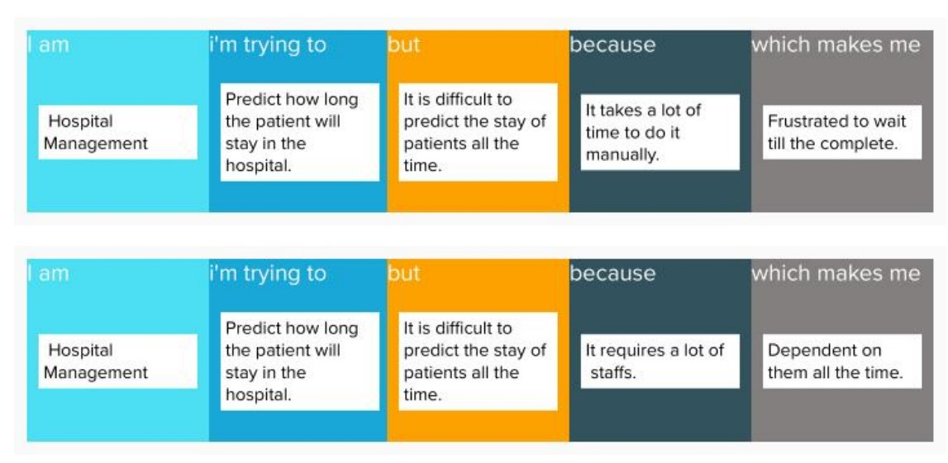

**Customer Problem Statement**

A well articulated customer problem statement allows us to find the ideal solution for the challenges our customers face. Throughout the process you will also be able to empathize with your customer which helps you understand how they perceive your service.

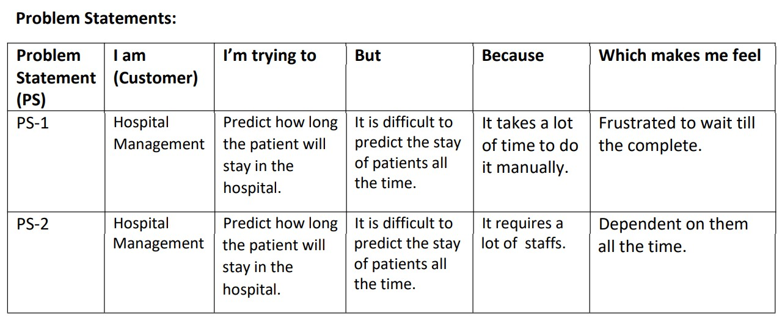

**CHAPTER 3**

**IDEATION & PROPOSED SOLUTION**

**3.1 EMPATHY MAP CANVAS**

**Empathy map canvas:**

An empathy map is a simple, easy-to-digest visual that captures knowledge about a user’s behaviours and attitudes.

It is a useful tool to helps teams better understand their users. Creating an effective solution requires understanding the true problem and the person who is experiencing it. The exercise of creating the map helps participants consider things from the user’s perspective along with his or her goals and challenges.

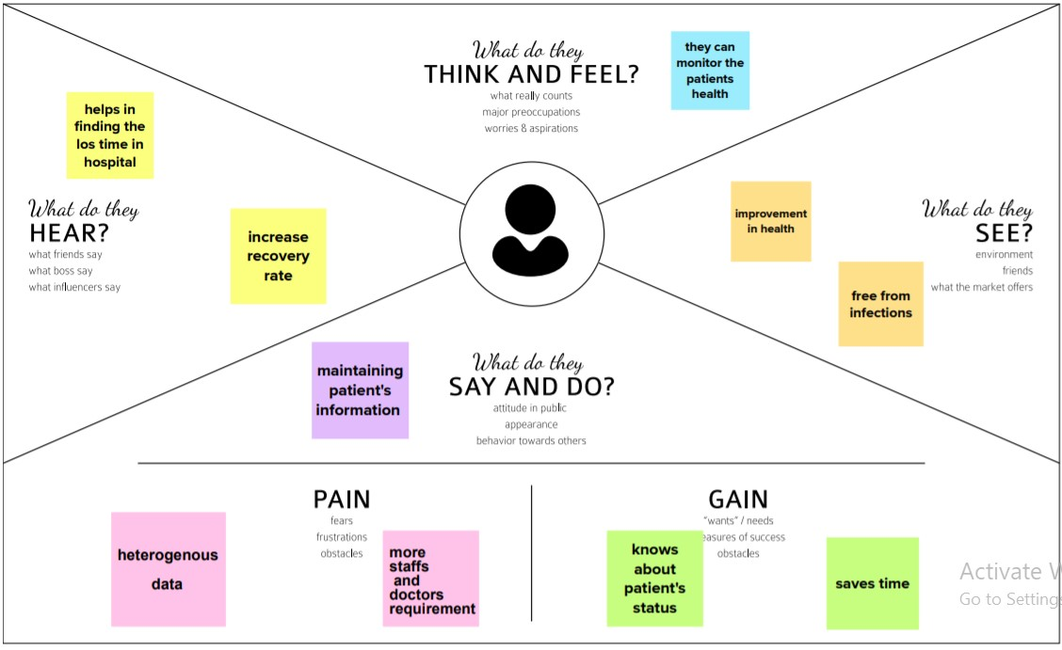

**3.2 Brainstorm & Idea Prioritization Template:**

Brainstorming provides a free and open environment that encourages everyone within a team to participate in the creative thinking process that leads to problem solving. Prioritizing volume over value, out-of-the-box ideas are welcome and built upon, and all participants are encouraged to collaborate, helping each other develop a rich amount of creative solutions. Use this template in your own brainstorming sessions so your team can unleash their imagination and start shaping concepts even if you're not sitting in the same room.

**Step-1: Team Gathering, Collaboration and Select the Problem Statement**

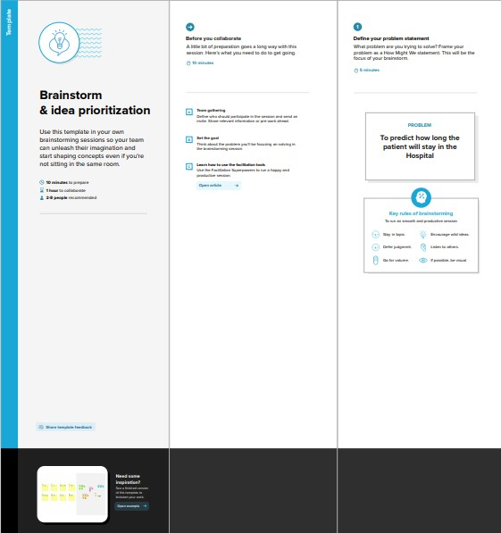

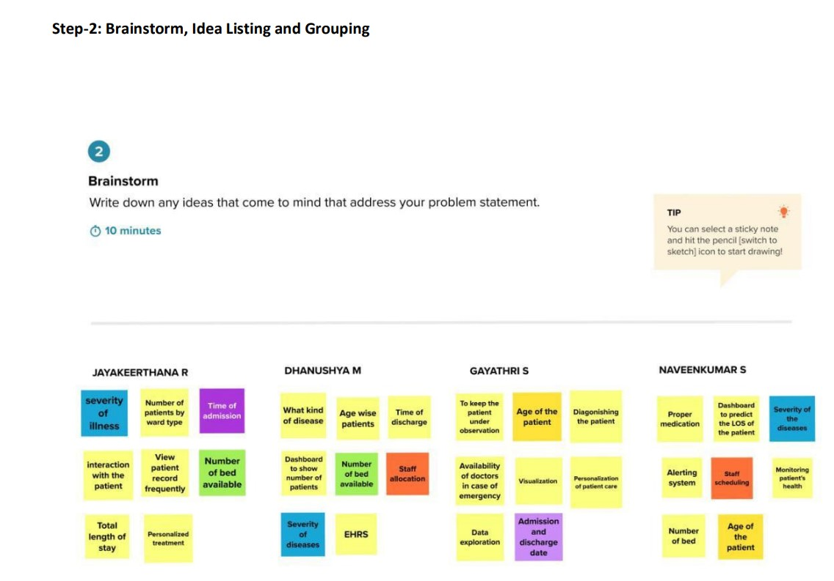

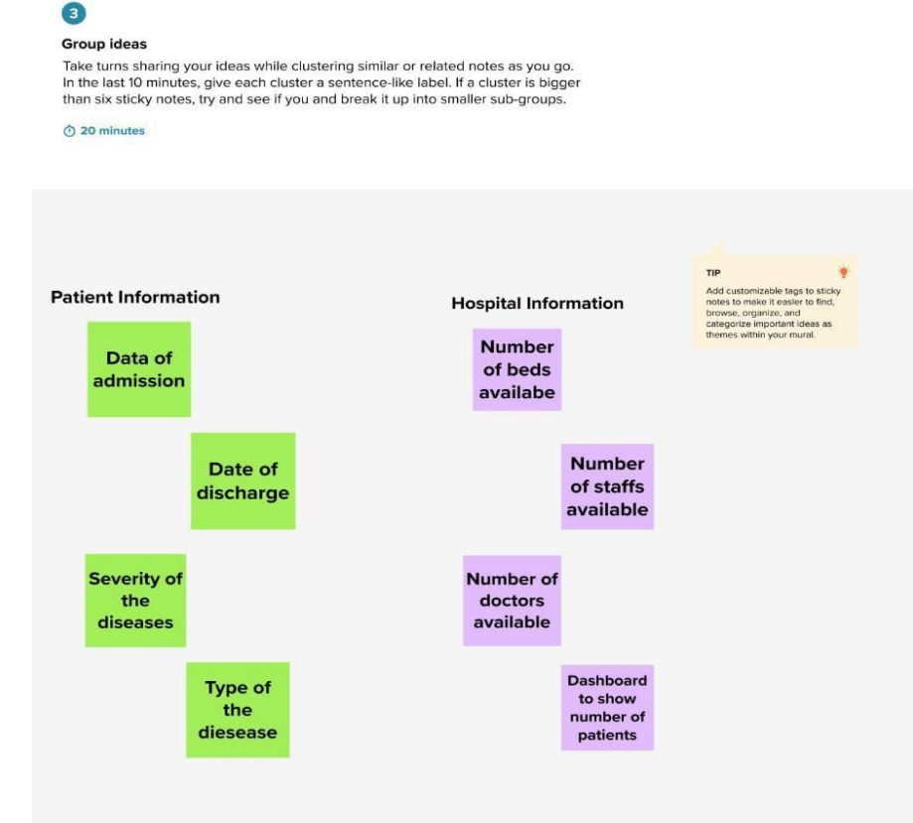

**Step 3: idea prioritization**

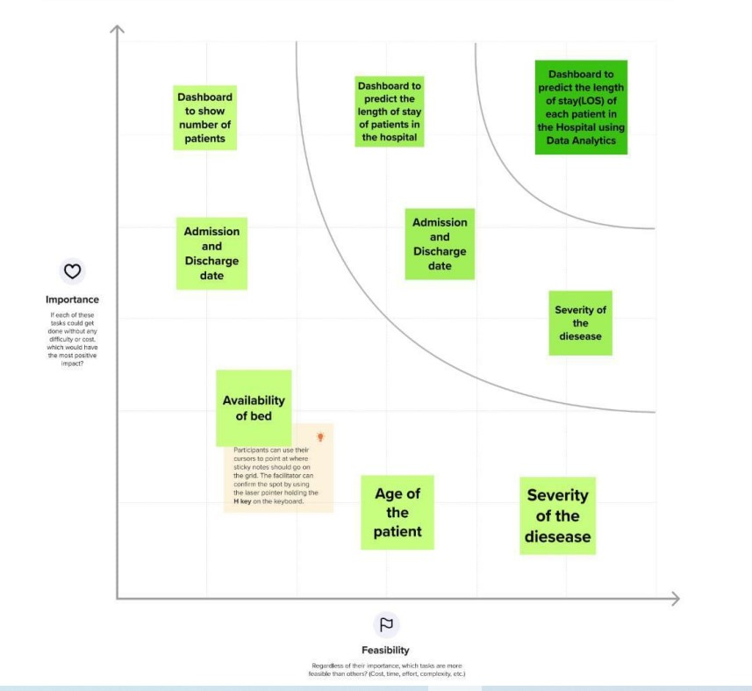

**3.3 PROPOSED SOLUTION**

|  |  |  |
| --- | --- | --- |
| **S.NO** | **Parameter** | **Description** |
| **1.** | Problem Statement (Problem to be solved) | To predict (LOS) how long the patient will stay in the Hospital. |
| **2.** | Idea / Solution description | • Healthcare management has various use cases for using data science, patient length of stay is one critical parameter to observe and predict if one wants to improve the efficiency of the healthcare management in a hospital. • This parameter helps hospitals to identify patients of high LOSrisk (patients who will stay longer) at the time of admission. Once identified, patients with high LOS risk can have their treatment plan optimized to minimize LOS and lower the chance of staff/visitor infection. |
| **3.** | Novelty / Uniqueness | In this project, we will create a dashboard that contain prediction about how long the patient will stay in the hospital. |
| **4.** | Social Impact / Customer Satisfaction | • Access to primary healthcare  • Less casualty. |
| **5.** | Business Model (Revenue Model) | • Pharmacy companies will sell their medical products to generate more revenue.  • Insurance companies will sell their health policies to needed people. |
| **6.** | Scalability of the Solution | Prior knowledge of LOS can aid in logistics such as room and bed allocation planning. |

**3.4 PROBLEM SOLUTION FIT**

The Problem-Solution Fit simply means that you have found a problem with your customer and thatthe solution you have realized for it actually solves the customer’s problem. It helps entrepreneurs, marketers and corporate innovators identify behavioral patterns and recognize what would work and why.

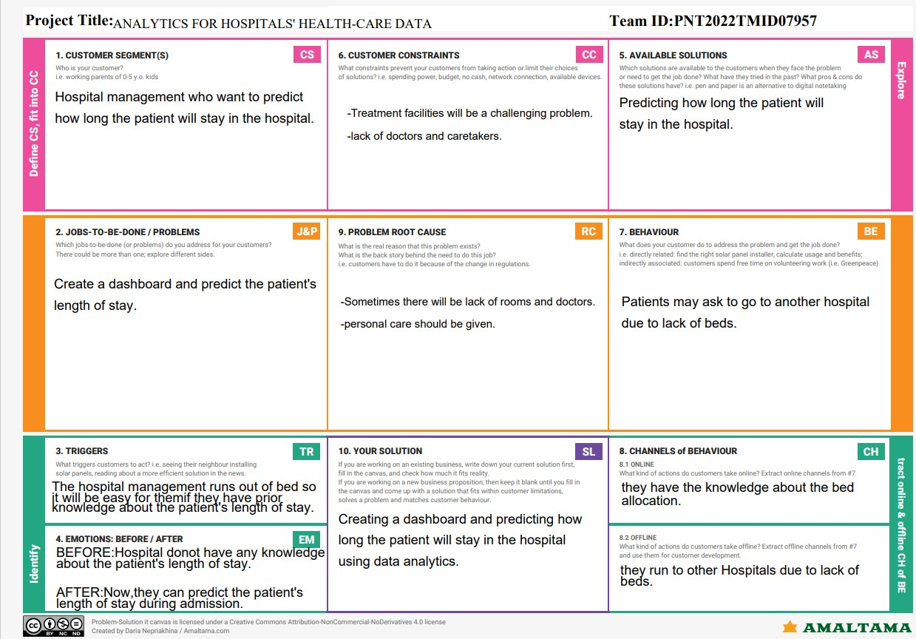

**PURPOSE OF SOLUTON FIT:**

• Solve complex problems in a way that fits the state of your customers.

• Succeed faster and increase your solution adoption by tapping into existing mediums andchannels of behavior.

• Sharpen your communication and marketing strategy with the right triggers and messaging.

• Increase touch-points with your company by finding the right problembehavior fit andbuilding trust by solving frequent annoyances, or urgent or costly problems.

• Understand the existing situation in order to improve it for your target group.

**CHAPTER 4**

**REQUIREMENT ANALYSIS**

**4.1 FUNCTIONAL REQUIREMENTS**

|  |  |  |
| --- | --- | --- |
| **FR no** | **Functional requirement (epic)** | **Sub Requirement (story/sub-task)** |
| **FR-1** | Registration process of SRS(Software Requirements Specification) | Adding Patients: The  Hospital Management  enables the staff at the front  desk to include new patients  in the system. |
| **FR-2** | Check Out of SRS: | Deleting Patient ID: The staff  in the administration section  of the ward can delete the  patient ID from the system  when the patient checkout  from the hospital. |
| **FR-3** | Report Generation of SRS: | Information of the Patient:  The Hospital Management  System generates a report  on every patient regarding  various information like  patients name, Phone  number, bed number, the  doctor's name whom its  assigns, ward name, and  more. |
| **FR-4** | Database of SRS: | Mandatory Patient  Information: Every patient  has some necessary data like  phone number, their first and  last name, personal health  number, postal code,  country, address, city,  'patient's ID number, etc. |

**4.2 NON-FUNCTIONAL REQUIREMENTS**

|  |  |  |
| --- | --- | --- |
| **NFR No** | **Non-Functional**  **Requirement** | **Description** |
| **NFR-1** | Security | ●Patient Identification: The system  needs the patient to recognize herself  or himself using the phone.  ● Logon ID: Any users who make use  of the system need to hold a Logon ID  and password.  ● Modifications: Any modifications like  insert, delete, update, etc. for the  database can be synchronized quickly  and executed only by the ward  administrator. |
| **NFR-2** | Performance | ●Response Time: The system provides  acknowledgment in just one second  once the 'patient's information is  checked. |
| **NFR-3** | Capacity | The system needs to  support at least 1000 people at once.  Maintainability  ● Back-Up: The system offers efficiency for data backup.  ● Errors: The system will track every  mistake as well as keep a log of it. |
| **NFR-4** | Errors | ● Availability: The system is available  all the time |

**CHAPTER 5**

**PROJECT DESIGN**

**5.1 DATA FLOW DIAGRAMS**

A Data Flow Diagram (DFD) is a traditional visual representation of the information flows within a system. A neat and clear DFD can depict the right amount of the system requirement graphically. It shows how data enters and leaves the system, what changes the information, and where data is stored.

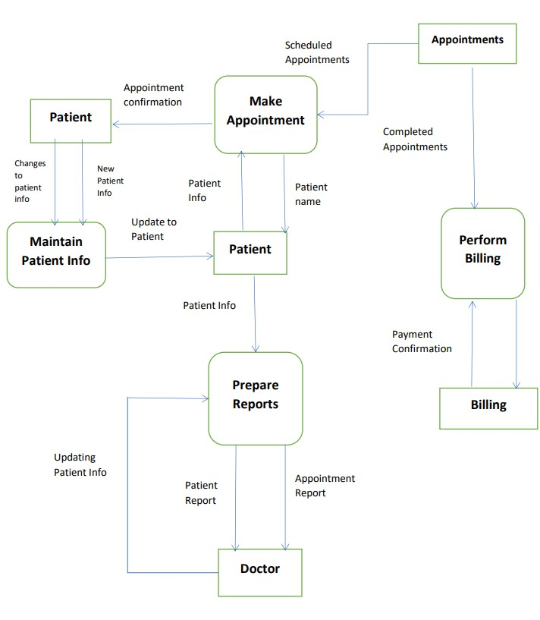

**5.2 SOLUTION & TECHNICAL ARCHITECTURE**

Solution architecture is a complex process – with many sub-processes – that bridges the gap between business problems and technology solutions.

Its goals are to:

• Find the best tech solution to solve existing business problems.

• Describe the structure, characteristics, behavior, and other aspects of the software to project stakeholders.

• Define features, development phases, and solution requirements.

• Provide specifications according to which the solution is defined, managed, and delivered.

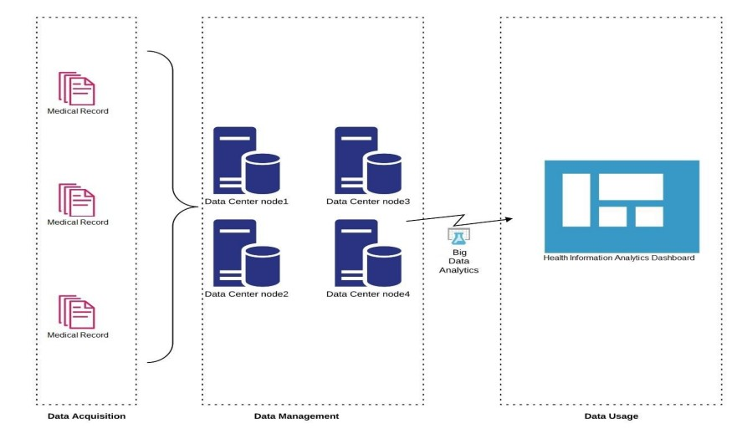

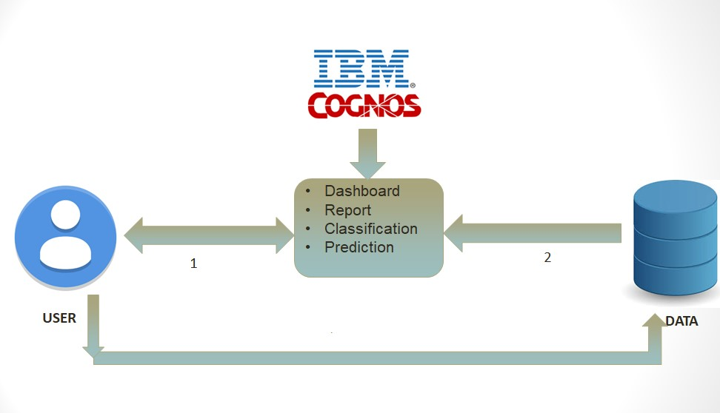

**5.3 USER STORIES**

Use the below template to list all the user stories for the product.

|  |  |  |  |  |  |  |
| --- | --- | --- | --- | --- | --- | --- |
| **User Type** | **Functional Requirement (Epic)** | **User Story Number** | **User Story / Task** | **Acceptance criteria** | **Priority** | **Release** |
| Patient | Patient_name | USN-1 | The preferred name of the patient | Name of the patient | High | Sprint-1 |
| Patient | Patient _id | USN-2 | Patient identification is the process of correctly matching a patient to appropriately intended interventions and communicating information about the patient | matching a patient identification | High | Sprint-1 |
| Patient | Patient_room | USN-3 | The space where patients receive care and treatment from medical staff | patient receive care and treatment | High | Sprint-1 |
| Patient | Appointment report | USN-4 | Including patient name,clinic location treatment appointment date and booking date | Appointment date and booking date | High | Sprint-1 |
| Patient | Bed allocated | USN-5 | Hospital and to efficiently which patient to where | Which patient to where | High | Sprint-2 |
| Patient | Maintain patient info | USN-6 | Patient demographics progress notes problem medications | problem medications | High | Sprint-2 |
| Patient | Updating patient info | USN-7 | Improving health care quality safety and patient | Health care quality | High | Sprint-3 |
| Patient | Changes to patient info | USN-8 | Change patient details | Patient details | High | Sprint-3 |
| Patient | payment confirmation | USN-9 | A transaction document that can be part of receipt | Payment | High | Sprint-3 |
| Patient | Perform billing | USN-10 | To bill the claims for in patient and out patient services provided by hospitals | patient services provided by hospitals | High | Sprint-4 |
| Patient | Patient info | USN-11 | Patient during consultations health disease | patient information | High | Sprint-4 |
| Patient | Health condition | USN-12 | Medical records | information that refers individual’s | High | Sprint-4 |

**CHAPTER 6**

**PROJECT PLANNING & SCHEDULING**

**6.1 SPRINT PLANNING AND ESTIMATION**

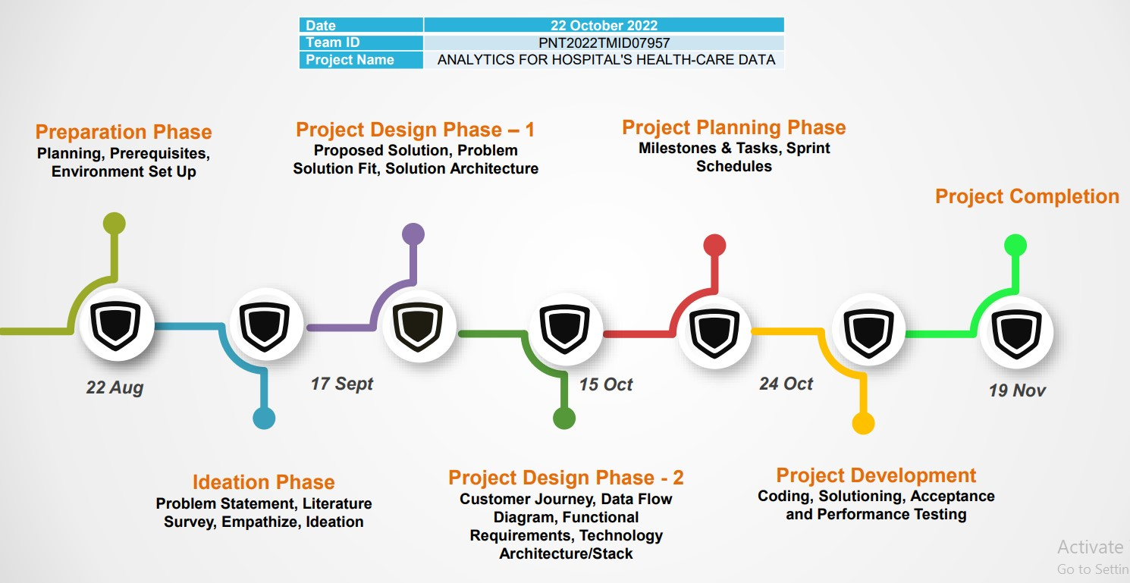

**6.2 SPRINT DELIVERY SCHEDULE**

|  |  |  |  |  |  |  |
| --- | --- | --- | --- | --- | --- | --- |
| **sprint** | **Functional Requirement (Epic)** | **User Story Number** | **User Story / Task** | **Story points** | **Priority** | **Team members** |
| Sprint1 | Patient_name | USN-1 | The preferred name of the patient | 2 | high | Jayakeerthana R |
| Patient _id | USN-2 | Patient identification | 1 | high | Dhanushya M |
| Patient_room | USN-3 | The space for patients | 1 | high | Gayathri S |
| Appointment report | USN-4 | name,clinic location treatment appointment | 2 | high | Naveenkumar S |

|  |  |  |  |  |  |  |
| --- | --- | --- | --- | --- | --- | --- |
| Sprint 2 | Bed allocated | USN-5 | Hospital and to efficiently which patient to where | 2 | high | Jayakeerthana R |
| Maintain patient info | USN-6 | Patient demographics progress notes problem medications | 2 | high | Dhanushya M |

|  |  |  |  |  |  |  |
| --- | --- | --- | --- | --- | --- | --- |
| Sprint 3 | Updating patient info | USN-7 | Improving health care quality safety and patient | 2 | high | Gayathri S |
| Changes to patient info | USN-8 | change patient details | 2 | high | Naveenkumar S |
| Payment confirmation | USN-9 | A transaction document that can be part of receipt | 2 | high | Jayakeerthana R |

|  |  |  |  |  |  |  |
| --- | --- | --- | --- | --- | --- | --- |
| Sprint 4 | Perform billing | USN-10 | To bill the claims for in patient and out patient services provided by hospitals | 2 | high | Dhanushya M |
| Patient info | USN-11 | Patient during consultations health disease | 2 | high | Gayathri S |
| Health condition | USN-12 | Medical records | 2 | high | Naveenkumar S |

**CHAPTER 7**

**CODING & SOLUTIONING**

**Index.html**

<!DOCTYPE html>

<html lang="en">

<head>

<meta charset="utf-8">

<meta content="width=device-width, initial-scale=1.0" name="viewport">

<title>IBM Nalaiyathiran Project</title>

<meta content="" name="description">

<meta content="" name="keywords">

<!-- Favicons -->

<link href="assets/img/anonymus.png" rel="anonymus">

<link href="assets/img/anonymus.png" rel="anonymus">

<!-- Google Fonts -->

<link href="https://fonts.googleapis.com/css?family=Open+Sans:300,300i,400,400i,600,600i,700,700i|Jost:300,300i,400,400i,500,500i,600,600i,700,700i|Poppins:300,300i,400,400i,500,500i,600,600i,700,700i" rel="stylesheet">

<!-- Vendor CSS Files -->

<link href="assets/vendor/aos/aos.css" rel="stylesheet">

<link href="assets/vendor/bootstrap/css/bootstrap.min.css" rel="stylesheet">

<link href="assets/vendor/bootstrap-icons/bootstrap-icons.css" rel="stylesheet">

<link href="assets/vendor/boxicons/css/boxicons.min.css" rel="stylesheet">

<link href="assets/vendor/glightbox/css/glightbox.min.css" rel="stylesheet">

<link href="assets/vendor/remixicon/remixicon.css" rel="stylesheet">

<link href="assets/vendor/swiper/swiper-bundle.min.css" rel="stylesheet">

<!-- Template Main CSS File -->

<link href="assets/css/style.css" rel="stylesheet">

</head>

<body>

<!-- ======= Header ======= -->

<header id="header" class="fixed-top ">

<div class="container d-flex align-items-center">

<h1 class="logo me-auto"><a href="index.html">IBM Project</a></h1>

<!-- Uncomment below if you prefer to use an image logo -->

<!-- <a href="index.html" class="logo me-auto"><img src="assets/img/logo.png" alt="" class="img-fluid"></a>-->

<nav id="navbar" class="navbar">

<ul>

<li><a class="nav-link scrollto active" href="#hero">Home</a></li>

<li><a class="nav-link scrollto" href="#Project">Project Idea</a></li>

<li><a class="nav-link scrollto" href="#Dashboard">Cognos Dashboard</a></li>

<li><a class="nav-link scrollto" href="#Report">Report</a></li>

<li><a class="nav-link scrollto" href="#Story">Story</a></li>

<li><a class="nav-link scrollto" href="#Prediction">Prediction</a></li>

<li><a class="nav-link scrollto" href="#team">Team</a></li>

<li><a class="nav-link scrollto" href="#Contact">Contact</a></li>

</ul>

<i class="bi bi-list mobile-nav-toggle"></i>

</nav><!-- .navbar -->

</div>

</header><!-- End Header -->

<!-- ======= Hero Section ======= -->

<section id="hero" class="d-flex align-items-center">

<div class="container">

<div class="row">

<div class="col-lg-6 d-flex flex-column justify-content-center pt-4 pt-lg-0 order-2 order-lg-1" data-aos="fade-up" data-aos-delay="200">

<h1>Analytics for Hospital's Health Care Data</h1>

<h2>Being a developing country, India has gone through many issues especially during the pandemic period. The most unforgettable era for India is the second wave of the covid-19 pandemic. Data analytics in health care sector can help us to face any situations in the future</h2>

<div class="d-flex justify-content-center justify-content-lg-start">

<a href="#Project" class="btn-get-started scrollto">Get Started</a>

</div>

</div>

<div class="col-lg-6 order-1 order-lg-2 cover-pic-medical-data-analytics" data-aos="zoom-in" data-aos-delay="200">

<img src="assets/img/cover-pic-medical-data-analytics.png" class="img-fluid animated" alt="">

</div>

</div>

</div>

</section><!-- End Hero -->

<main id="main">

<!-- ======= Clients Section ======= -->

<section id="clients" class="clients section-bg">

<div class="container">

<div class="row" data-aos="zoom-in">

<div class="col-lg-2 col-md-4 col-6 d-flex align-items-center justify-content-center">

<img src="assets/img/clients/sns.png" class="img-fluid" alt="">

</div>

<div class="col-lg-2 col-md-4 col-6 d-flex align-items-center justify-content-center">

<img src="assets/img/clients/DT.png" class="img-fluid" alt="">

</div>

<div class="col-lg-2 col-md-4 col-6 d-flex align-items-center justify-content-center">

<img src="assets/img/clients/doctor.png" class="img-fluid" alt="">

</div>

<div class="col-lg-2 col-md-4 col-6 d-flex align-items-center justify-content-center">

<img src="assets/img/clients/analytics.png" class="img-fluid" alt="">

</div>

<div class="col-lg-2 col-md-4 col-6 d-flex align-items-center justify-content-center">

<img src="assets/img/clients/naive.png" class="img-fluid" alt="">

</div>

<div class="col-lg-2 col-md-4 col-6 d-flex align-items-center justify-content-center">

<img src="assets/img/clients/Team.png" class="img-fluid" alt="">

</div>

</div>

</div>

</section><!-- End Cliens Section -->

<!-- ======= Project Idea Section ======= -->

<section id="Project" class="about">

<div class="container" data-aos="fade-up">

<div class="section-title">

<h2>Project Idea</h2>

</div>

<div class="row content">

<div class="col-lg-6">

<p>

Main Idea of this Project is:

</p>

<ul>

<li><i class="ri-check-double-line"></i>Data Collection</li>

<li><i class="ri-check-double-line"></i>Data Cleaning</li>

<li><i class="ri-check-double-line"></i>Data Exploration</li>

<li><i class="ri-check-double-line"></i>Visualization</li>

<li><i class="ri-check-double-line"></i> Story Creation</li>

<li><i class="ri-check-double-line"></i> Prediction</li>

<li><i class="ri-check-double-line"></i> Report Creation </li>

</ul>

</div>

<div class="col-lg-6 pt-4 pt-lg-0">

<div class="pic"><img src="assets/img/Data Analytics.png" class="img-fluid" alt=""></div>

</div>

</div>

</div>

</section><!-- End Project Idea Section -->

<!-- ======= Dashboard Section ======= -->

<section id="Dashboard" class="Dashboard section-bg">

<div class="container" data-aos="fade-up">

<div class="section-title">

<h2>Dashboard</h2>

<p>This Dashboard is created in Cognos Analytics</p>

</div>

<iframe src="https://us3.ca.analytics.ibm.com/bi/?perspective=dashboard&amp;pathRef=.my_folders%2FSprint%2B3%2BDashboard%2B2&amp;closeWindowOnLastView=true&amp;ui_appbar=false&amp;ui_navbar=false&amp;shareMode=embedded&amp;action=view&amp;mode=dashboard&amp;subView=model0000018488cd6a1f_00000002" width="1500" height="1000" frameborder="0" gesture="media" allow="encrypted-media" allowfullscreen=""></iframe>

</div>

</section><!-- End Dashboard Section -->

<!-- ======= Report Section ======= -->

<section id="Report" class="Report section-bg">

<div class="container" data-aos="fade-up">

<div class="section-title">

<h2>Report</h2>

<p>This Report is created in Cognos Analytics</p>

</div>

<iframe src="https://us3.ca.analytics.ibm.com/bi/?pathRef=.my_folders%2FSprint%2B4%2Breport%2B2&amp;closeWindowOnLastView=true&amp;ui_appbar=false&amp;ui_navbar=false&amp;shareMode=embedded&amp;action=run&amp;format=HTML&amp;prompt=false" width="1500" height="1000" frameborder="0" gesture="media" allow="encrypted-media" allowfullscreen=""></iframe>

</div>

</section>

<!-- ======= Report Section ======= -->

<!-- ======= Story Section ======= -->

<section id="Story" class="Story section-bg">

<div class="container" data-aos="fade-up">

<div class="section-title">

<h2>Story</h2>

<p>This Story is created in Cognos Analytics</p>

</div>

<iframe src="https://us3.ca.analytics.ibm.com/bi/?perspective=story&amp;pathRef=.my_folders%2FSprint%2B4%2BStory&amp;closeWindowOnLastView=true&amp;ui_appbar=false&amp;ui_navbar=false&amp;shareMode=embedded&amp;action=view&amp;sceneId=model00000184850abab4_00000002&amp;sceneTime=0" width="1500" height="1000" frameborder="0" gesture="media" allow="encrypted-media" allowfullscreen=""></iframe> </div>

</section>

<!-- ======= Story Section ======= -->

<!-- ======= Goal Section ======= -->

<section id="cta" class="cta">

<div class="container" data-aos="zoom-in">

<div class="row">

<div class="col-lg-9 text-center text-lg-start">

<h3>Goal</h3>

<p> The goal is to accurately predict the Length of Stay for each patient on case by case basis so that the Hospitals can use this information for optimal resource allocation and better functioning. The length of stay is divided into 11 different classes ranging from 0-10 days to more than 100 days.</p>

</div>

<div class="col-lg-3 cta-btn-container text-center">

<a class="cta-btn align-middle" href="#">Description</a>

</div>

</div>

</div>

</section><!-- End Goal Section -->

<!-- ======= Prediction Section ======= -->

<section id="Prediction" class="Prediction section-bg">

<div class="container" data-aos="fade-up">

<div class="section-title">

<h2>Prediction</h2>

<p>This Prediction was done in google colab by using Naive Bayes Algorithm</p>

</div>

<button class="btn text-light bg-dark button1">

<a class="" href="./Prediction.html">Predit the length of stay (LoS)</a>

</button>

</div>

</section>

<!-- ======= Report Section ======= -->

<!-- ======= Team Section ======= -->

<section id="team" class="team section-bg">

<div class="container" data-aos="fade-up">

<div class="section-title">

<h2>Team</h2>

<p>Team Work is so essential for this whole project without them this project will be just few lines of unexcecutable codes</p>

</div>

<div class="row">

<div class="col-lg-6">

<div class="member d-flex align-items-start" data-aos="zoom-in" data-aos-delay="100">

<div class="member-info">

<h4>JAYAKEERTHANA R</h4>

<span>Team Leader</span>

<p>Worked on Model Creation , Cognos Analytics , Colab</p>

</div>

</div>

</div>

<div class="col-lg-6 mt-4 mt-lg-0">

<div class="member d-flex align-items-start" data-aos="zoom-in" data-aos-delay="200">

<div class="member-info">

<h4>DHANUSHYA M</h4>

<span>Team Member 1</span>

<p>Worked on Idea Creation, Cognos Analytics , Documentation</p>

</div>

</div>

</div>

<div class="col-lg-6 mt-4">

<div class="member d-flex align-items-start" data-aos="zoom-in" data-aos-delay="300">

<div class="member-info">

<h4>GAYATHRI S</h4>

<span>Team member 2</span>

<p>Worked on Story Creation , Predictive Analysis , Colab , Cognos Analytics</p>

</div>

</div>

</div>

<div class="col-lg-6 mt-4">

<div class="member d-flex align-items-start" data-aos="zoom-in" data-aos-delay="400">

<div class="member-info">

<h4>NAVEENKUMAR S</h4>

<span>Team Member 3</span>

<p>Worked on Literature Survey , Delivery Plan , Technical Stack</p>

</div>

</div>

</div>

</div>

</div>

</section><!-- End Team Section -->

<!-- ======= Frequently Asked Questions Section ======= -->

<section id="faq" class="faq section-bg">

<div class="container" data-aos="fade-up">

<div class="section-title">

<h2>Frequently Asked Questions</h2>

<p>Data Analytics in Hospital Data is very challenging task since a minor error in data can risk people life so there are some of the questions listed below</p>

</div>

<div class="faq-list">

<ul>

<li data-aos="fade-up" data-aos-delay="100">

<i class="bx bx-help-circle icon-help"></i> <a data-bs-toggle="collapse" class="collapse" data-bs-target="#faq-list-1">How does Data analytics helps us in Hospital Data? <i class="bx bx-chevron-down icon-show"></i><i class="bx bx-chevron-up icon-close"></i></a>

<div id="faq-list-1" class="collapse show" data-bs-parent=".faq-list">

<p>

During Covid 19 we faced a lot of trouble because of wrong prediction analysis which was made manually , if Data Analytics was used then there will be pre prediction which can reduce the mortality rate and avoids last minute chaos

</p>

</div>

</li>

<li data-aos="fade-up" data-aos-delay="200">

<i class="bx bx-help-circle icon-help"></i> <a data-bs-toggle="collapse" data-bs-target="#faq-list-2" class="collapsed">Will it makes major error in prediction and Visualization <i class="bx bx-chevron-down icon-show"></i><i class="bx bx-chevron-up icon-close"></i></a>

<div id="faq-list-2" class="collapse" data-bs-parent=".faq-list">

<p>

IBM Cognos has low level of error in prediction and visualization this can help us to make accurate results

</p>

</div>

</li>

<li data-aos="fade-up" data-aos-delay="300">

<i class="bx bx-help-circle icon-help"></i> <a data-bs-toggle="collapse" data-bs-target="#faq-list-3" class="collapsed">How it will help people? <i class="bx bx-chevron-down icon-show"></i><i class="bx bx-chevron-up icon-close"></i></a>

<div id="faq-list-3" class="collapse" data-bs-parent=".faq-list">

<p>

This project can help people to make analysis so that resource allocation can be done easily and better than the manual method

</p>

</div>

</li>

<li data-aos="fade-up" data-aos-delay="400">

<i class="bx bx-help-circle icon-help"></i> <a data-bs-toggle="collapse" data-bs-target="#faq-list-4" class="collapsed">Why we use IBM cognos? <i class="bx bx-chevron-down icon-show"></i><i class="bx bx-chevron-up icon-close"></i></a>

<div id="faq-list-4" class="collapse" data-bs-parent=".faq-list">

<p>

IBM Cognos can help us to make visualization faster than we do in python IDE , also it has a AI feature to predict and produce insights from the visualizations made

</p>

</div>

</li>

</ul>

</div>

</div>

</section><!-- End Frequently Asked Questions Section -->

<!-- ======= Contact Section ======= -->

<section id="contact" class="contact">

<div class="container" data-aos="fade-up">

<div class="section-title">

<h2>Contact</h2>

</div>

<div class="row">

<div class="col-lg-5 d-flex align-items-stretch">

<div class="info">

<div class="address">

<i class="bi bi-geo-alt"></i>

<h4>Location:</h4>

<p>Computer Science and Engineering , Adhiyamaan College of Engineering, Hosur</p>

</div>

<div class="email">

<i class="bi bi-envelope"></i>

<h4>Email:</h4>

<p>jayakeerthana816@gmail.com</p>

</div>

</div>

<div class="col-lg-7 mt-5 mt-lg-0 d-flex align-items-stretch">

<form action="forms/contact.php" method="post" role="form" class="php-email-form">

<div class="row">

<div class="form-group col-md-6">

<label for="name">Your Name</label>

<input type="text" name="name" class="form-control" id="name" required>

</div>

<div class="form-group col-md-6">

<label for="name">Your Email</label>

<input type="email" class="form-control" name="email" id="email" required>

</div>

</div>

<div class="form-group">

<label for="name">Subject</label>

<input type="text" class="form-control" name="subject" id="subject" required>

</div>

<div class="form-group">

<label for="name">Message</label>

<textarea class="form-control" name="message" rows="10" required></textarea>

</div>

<div class="my-3">

<div class="loading">Loading</div>

<div class="error-message"></div>

<div class="sent-message">Your message has been sent. Thank you!</div>

</div>

<div class="text-center"><button type="submit">Send Message</button></div>

</form>

</div>

</div>

</div>

</section><!-- End Contact Section -->

</main><!-- End #main -->

<!-- ======= Footer ======= -->

<footer id="footer">

<div class="footer-newsletter">

<div class="container">

<div class="row justify-content-center">

<div class="col-lg-6">

<h4>Join Us</h4>

<p>Health is Wealth , Technology can change the World</p>

<form action="" method="post">

<input type="email" name="email"><input type="submit" value="Join Us ...">

</form>

</div>

</div>

</div>

</div>

<div class="footer-top">

<div class="container">

<div class="row">

<div class="col-lg-3 col-md-6 footer-contact">

<h3>JAYAKEERTHANA R</h3>

<p>Computer Science and Engineering , Adhiyamaan College of Engineering, Hosur<br><br>

<strong>Email:</strong>jayakeerthana816@gmail.com<br>

</p>

</div>

<div class="col-lg-3 col-md-6 footer-links">

<h4>Go to</h4>

<ul>

<li><i class="bx bx-chevron-right"></i> <a href="#">Home</a></li>

<li><i class="bx bx-chevron-right"></i> <a href="#">Project Idea</a></li>

<li><i class="bx bx-chevron-right"></i> <a href="#">Cognos Dashboard</a></li>

<li><i class="bx bx-chevron-right"></i> <a href="#">Report</a></li>

<li><i class="bx bx-chevron-right"></i> <a href="#">Story</a></li>

<li><i class="bx bx-chevron-right"></i> <a href="#">team</a></li>

</ul>

</div>

<div class="col-lg-3 col-md-6 footer-links">

<h4>Project Idea</h4>

<ul>

<li><i class="bx bx-chevron-right"></i> <a href="#">Data Collection</a></li>

<li><i class="bx bx-chevron-right"></i> <a href="#">Data Exploration</a></li>

<li><i class="bx bx-chevron-right"></i> <a href="#">Visualization</a></li>

<li><i class="bx bx-chevron-right"></i> <a href="#">Prediction</a></li>

<li><i class="bx bx-chevron-right"></i> <a href="#">Dashboard Creation</a></li>

<li><i class="bx bx-chevron-right"></i> <a href="#">Report Creation</a></li>

<li><i class="bx bx-chevron-right"></i> <a href="#">Story Creation</a></li>

</ul>

</div>

<div class="col-lg-3 col-md-6 footer-links">

<h4>Our Social Networks</h4>

<div class="social-links mt-3">

<a href="#" class="twitter"><i class="bx bxl-twitter"></i></a>

<a href="#" class="facebook"><i class="bx bxl-facebook"></i></a>

<a href="#" class="instagram"><i class="bx bxl-instagram"></i></a>

<a href="#" class="google-plus"><i class="bx bxl-skype"></i></a>

<a href="#" class="linkedin"><i class="bx bxl-linkedin"></i></a>

</div>

</div>

</div>

</div>

</div>

<div class="container footer-bottom clearfix">

<div class="copyright">

&copy; Belongs to <strong><span>Dharshan</span></strong>. Please Don't Copy

</div>

</div>

</div>

</footer><!-- End Footer -->

<div id="preloader"></div>

<a href="#" class="back-to-top d-flex align-items-center justify-content-center"><i class="bi bi-arrow-up-short"></i></a>

<!-- Vendor JS Files -->

<script src="assets/vendor/aos/aos.js"></script>

<script src="assets/vendor/bootstrap/js/bootstrap.bundle.min.js"></script>

<script src="assets/vendor/glightbox/js/glightbox.min.js"></script>

<script src="assets/vendor/isotope-layout/isotope.pkgd.min.js"></script>

<script src="assets/vendor/swiper/swiper-bundle.min.js"></script>

<script src="assets/vendor/waypoints/noframework.waypoints.js"></script>

<script src="assets/vendor/php-email-form/validate.js"></script>

<!-- Template Main JS File -->

<script src="assets/js/main.js"></script>

</body>

</html>

**LOS.pynb**

**import** numpy **as** np

**import** pandas **as** pd

**import** matplotlib.pyplot **as** plt

np**.**set_printoptions(suppress**=True**)

**import** warnings

warnings**.**filterwarnings('ignore')

**from** google.colab **import** drive

drive**.**mount('/content/drive')

*#load data*

d1 **=** pd**.**read_csv('/content/drive/My Drive/Healthcare_Data/sample_sub.csv')

d2 **=** pd**.**read_csv('/content/drive/My Drive/Healthcare_Data/train_data_dictionary.csv')

test **=** pd**.**read_csv('/content/drive/My Drive/Healthcare_Data/test_data.csv')

train **=** pd**.**read_csv('/content/drive/My Drive/Healthcare_Data/train_data.csv')

train**.**head()

train**.**info()

train**.**Stay**.**unique()

*# NA values in train dataset :*

train**.**isnull()**.**sum()**.**sort_values(ascending **=** **False**)

*# NA values in test dataset :*

test**.**isnull()**.**sum()**.**sort_values(ascending **=** **False**)

*# Dimension of train dataset*

train**.**shape

*# Dimension of test dataset*

test**.**shape

*# Number of distinct observations in test dataset*

**for** i **in** test**.**columns:

print(i, ':', test[i]**.**nunique())

*#Replacing NA values in Bed Grade Column for both Train and Test datssets*

train['Bed Grade']**.**fillna(train['Bed Grade']**.**mode()[0], inplace **=** **True**)

test['Bed Grade']**.**fillna(test['Bed Grade']**.**mode()[0], inplace **=** **True**)

*#Replacing NA values in Column for both Train and Test datssets*

train['City_Code_Patient']**.**fillna(train['City_Code_Patient']**.**mode()[0], inplace **=** **True**)

test['City_Code_Patient']**.**fillna(test['City_Code_Patient']**.**mode()[0], inplace **=** **True**)

*# Label Encoding Stay column in train dataset*

**from** sklearn.preprocessing **import** LabelEncoder

le **=** LabelEncoder()

train['Stay'] **=** le**.**fit_transform(train['Stay']**.**astype('str'))

train**.**head()

*#Imputing dummy Stay column in test datset to concatenate with train dataset*

test['Stay'] **=** **-**1

df **=** pd**.**concat([train, test])

df**.**shape

*#Label Encoding all the columns in Train and test datasets*

**for** i **in** ['Hospital_type_code', 'Hospital_region_code', 'Department',

'Ward_Type', 'Ward_Facility_Code', 'Type of Admission', 'Severity of Illness', 'Age']:

le **=** LabelEncoder()

df[i] **=** le**.**fit_transform(df[i]**.**astype(str))

*#Spearating Train and Test Datasets*

train **=** df[df['Stay']**!=-**1]

test **=** df[df['Stay']**==-**1]

**def** get_countid_enocde(train, test, cols, name):

temp **=** train**.**groupby(cols)['case_id']**.**count()**.**reset_index()**.**rename(columns **=** {'case_id': name})

temp2 **=** test**.**groupby(cols)['case_id']**.**count()**.**reset_index()**.**rename(columns **=** {'case_id': name})

train **=** pd**.**merge(train, temp, how**=**'left', on**=** cols)

test **=** pd**.**merge(test,temp2, how**=**'left', on**=** cols)

train[name] **=** train[name]**.**astype('float')

test[name] **=** test[name]**.**astype('float')

train[name]**.**fillna(np**.**median(temp[name]), inplace **=** **True**)

test[name]**.**fillna(np**.**median(temp2[name]), inplace **=** **True**)

**return** train, test

train, test **=** get_countid_enocde(train, test, ['patientid'], name **=** 'count_id_patient')

train, test **=** get_countid_enocde(train, test,

['patientid', 'Hospital_region_code'], name **=** 'count_id_patient_hospitalCode')

train, test **=** get_countid_enocde(train, test,

['patientid', 'Ward_Facility_Code'], name **=** 'count_id_patient_wardfacilityCode')

*# Droping duplicate columns*

test1 **=** test**.**drop(['Stay', 'patientid', 'Hospital_region_code', 'Ward_Facility_Code'], axis **=**1)

train1 **=** train**.**drop(['case_id', 'patientid', 'Hospital_region_code', 'Ward_Facility_Code'], axis **=**1)

I

*# Splitting train data for Naive Bayes and XGBoost*

X1 **=** train1**.**drop('Stay', axis **=**1)

y1 **=** train1['Stay']

**from** sklearn.model_selection **import** train_test_split

X_train, X_test, y_train, y_test **=** train_test_split(X1, y1, test_size **=**0.20, random_state **=**100)

**MODEL**

**from** sklearn.naive_bayes **import** GaussianNB

target **=** y_train**.**values

features **=** X_train**.**values

classifier_nb **=** GaussianNB()

model_nb **=** classifier_nb**.**fit(features, target)

I

prediction_nb **=** model_nb**.**predict(X_test)

**from** sklearn.metrics **import** accuracy_score

acc_score_nb **=** accuracy_score(prediction_nb,y_test)

print("Acurracy:", acc_score_nb**\***100)

*# Segregation of features and target variable*

X **=** train**.**drop('Stay', axis **=**1)

y **=** train['Stay']

print(X**.**columns)

z **=** test**.**drop('Stay', axis **=** 1)

print(z**.**columns)

*# Data Scaling*

**from** sklearn **import** preprocessing

X_scale **=** preprocessing**.**scale(X)

X_scale**.**shape

X_train, X_test, y_train, y_test **=** train_test_split(X_scale, y, test_size **=**0.20, random_state **=**100)

**import** keras

**from** keras.models **import** Sequential

**from** keras.layers **import** Dense

**import** tensorflow **as** tf

**from** keras.utils **import** to_categorical

*#Sparse Matrix*

a **=** to_categorical(y_train)

b **=** to_categorical(y_test)

model **=** Sequential()

model**.**add(Dense(64, activation**=**'relu', input_shape **=** (254750, 20)))

model**.**add(Dense(128, activation**=**'relu'))

model**.**add(Dense(256, activation**=**'relu'))

model**.**add(Dense(512, activation**=**'relu'))

model**.**add(Dense(512, activation**=**'relu'))

model**.**add(Dense(11, activation**=**'softmax'))

model**.**summary()

model**.**compile(optimizer**=** 'SGD',

loss**=**'categorical_crossentropy',

metrics**=**['accuracy'])

**PREDICTION**

pred_nb **=** classifier_nb**.**predict(test1**.**iloc[:,1:])

result_nb **=** pd**.**DataFrame(pred_nb, columns**=**['Stay'])

result_nb['case_id'] **=** test1['case_id']

result_nb **=** result_nb[['case_id', 'Stay']]

result_nb['Stay'] **=** result_nb['Stay']**.**replace({0:'0-10', 1: '11-20', 2: '21-30', 3:'31-40', 4: '41-50', 5: '51-60', 6: '61-70', 7: '71-80', 8: '81-90', 9: '91-100', 10: 'More than 100 Days'})

result_nb**.**head()

test_scale = preprocessing.scale(z)

test_scale.shape

print(result_nb.groupby('Stay')['case_id'].nunique())

**CHAPTER 8**

**TESTING**

**8.1 TEST CASE**

|  |  |  |  |  |
| --- | --- | --- | --- | --- |
| **SECTION** | **TOTAL CASES** | **NOT TESTED** | **FAIL** | **PASS** |
| Print Engine | 7 | 0 | 0 | 7 |
| Client Application | 51 | 0 | 0 | 51 |
| Security | 2 | 0 | 0 | 2 |
| Outsource Shipping | 3 | 0 | 0 | 3 |
| Excepting reporting | 9 | 0 | 0 |  |
| Final report out put | 4 | 0 | 0 | 4 |
| Version control | 2 | 0 | 0 | 2 |

**8.2 USER ACCEPTANCE TESTING**

|  |  |  |  |  |  |
| --- | --- | --- | --- | --- | --- |
| **Resolution** | **Severity 1** | **Severity 2** | **Severity 3** | **Severity 4** | **subtotal** |
| By Design | 5 | 5 | 4 | 0 | 14 |
| Duplicate | 0 | 0 | 0 | 0 | 0 |
| External | 7 | 8 | 6 | 0 | 21 |
| Fixed | 11 | 4 | 0 | 6 | 21 |
| Not reproduced | 1 | 3 | 0 | 0 | 4 |
| Skipped | 0 | 0 | 0 | 0 | 0 |
| Won’t fix | 0 | 0 | 0 | 0 | 0 |
| Total | 24 | 20 | 10 | 6 | 60 |

**CHAPTER 9**

**RESULTS**

**DASHBOARD**

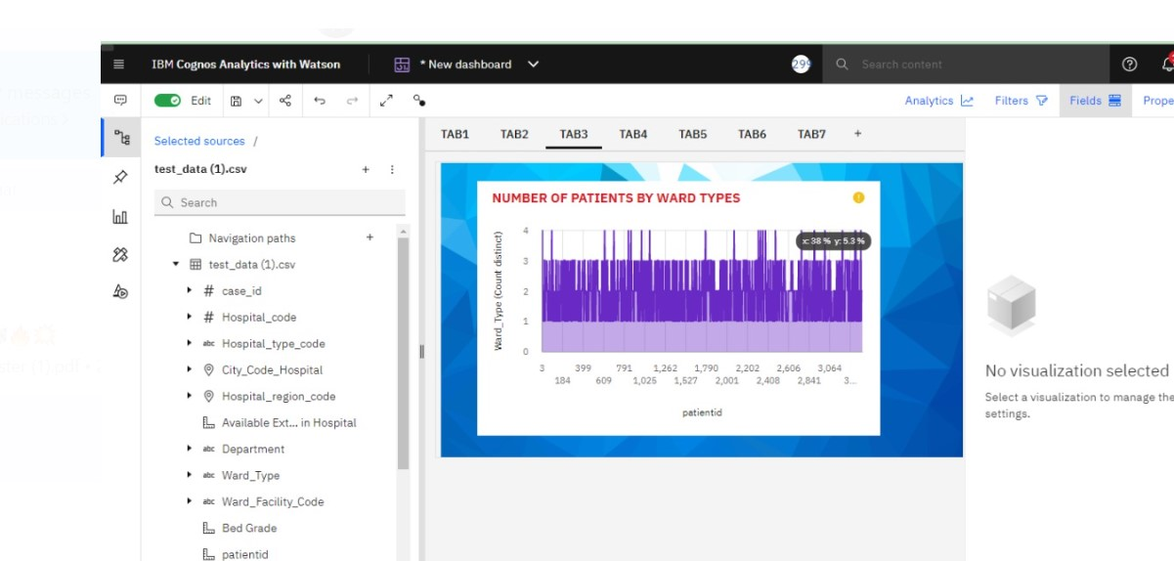

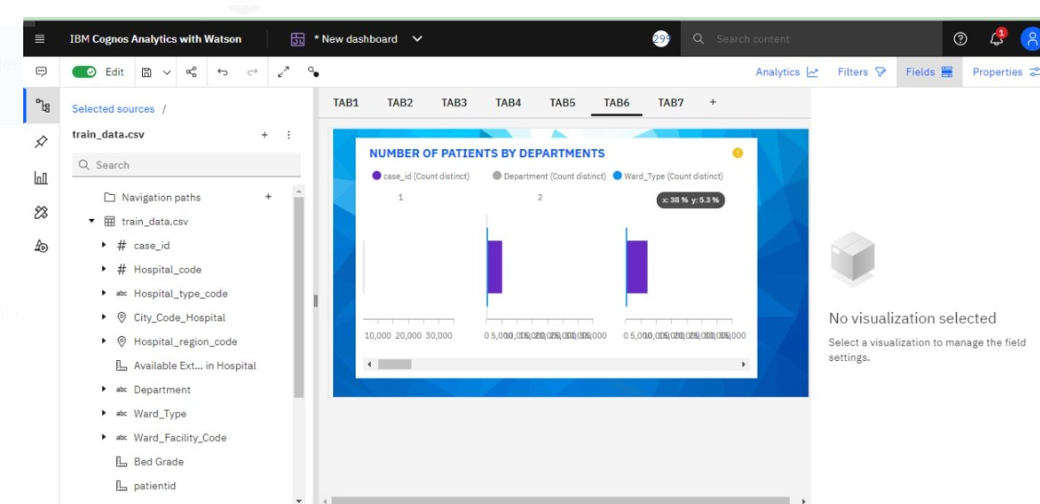

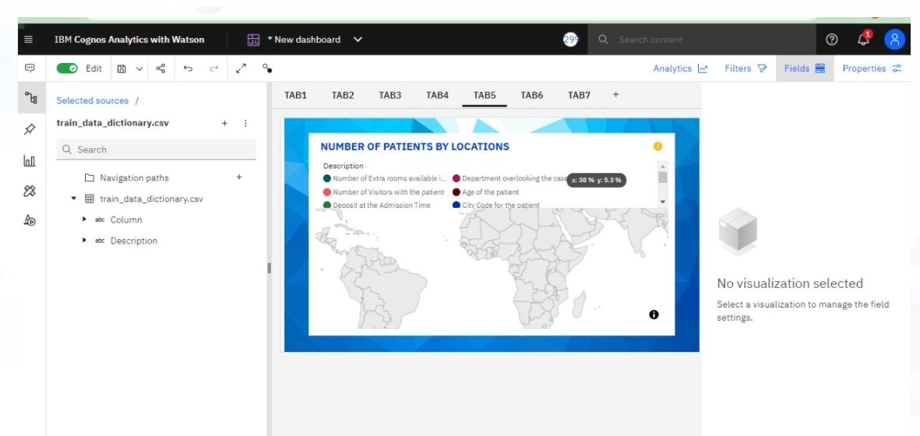

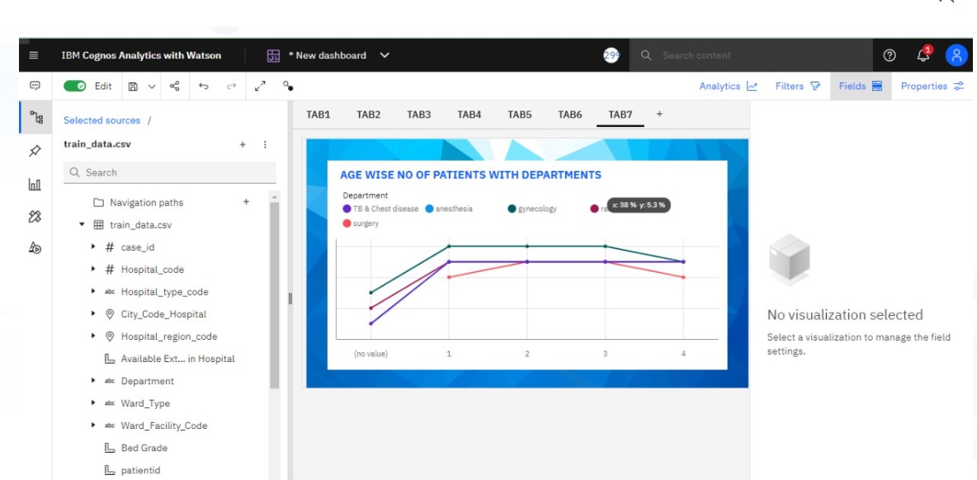

**REPORT**

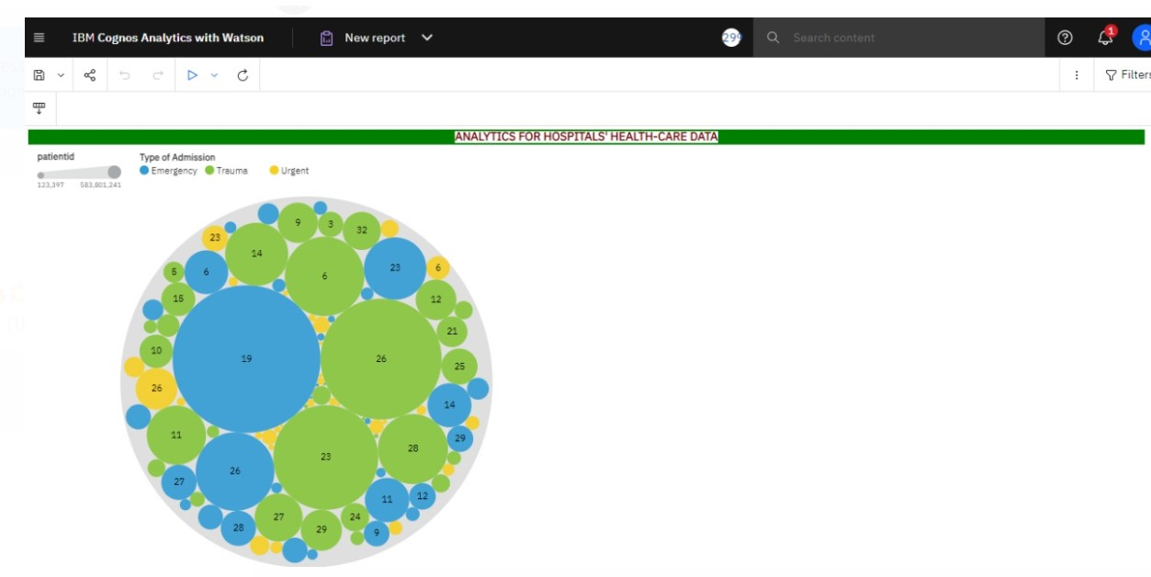

**WEBPAGE**

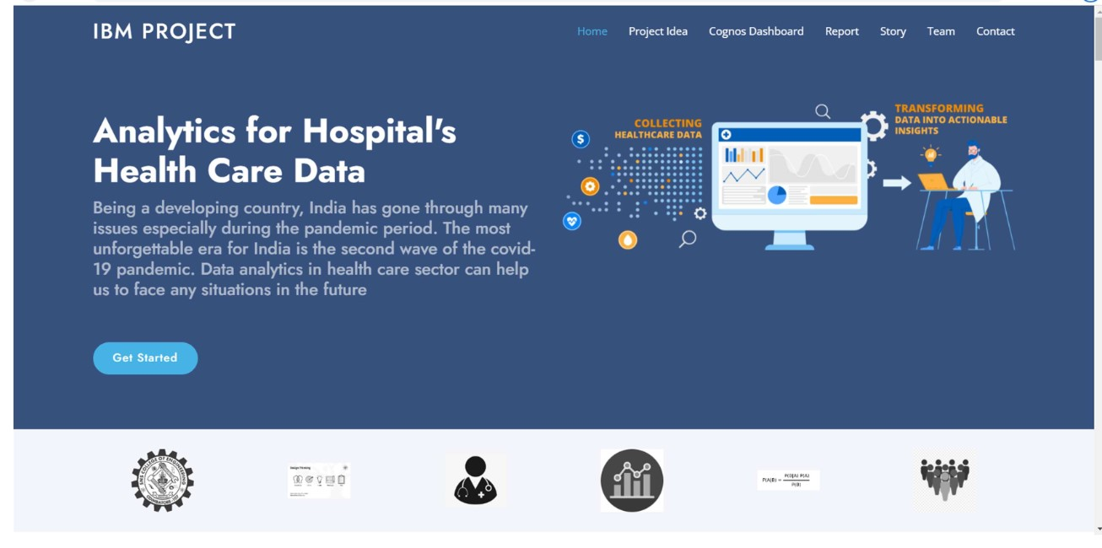

**FINAL OUTPUT**

**Stay**

**0-10 2598**

**11-20 26827**

**21-30 72206**

**31-40 15639**

**41-50 469**

**51-60 13651**

**61-70 92**

**71-80 955**

**81-90 296**

**91-100 2**

**More than 100 Days 4322**

**Name: case_id, dtype: int64**

**CHAPTER 10**

**ADVANTAGES & DISADVANTAGES**

**ADVANTAGES:**

• Helps an organization to make a better decision

• Increase the efficiency of the work

• The analytics keeps you updated of your customer behavioral changes.

• Personalization of hospital details.

• Improving quality of service and health care.

**DISADVANTAGES:**

• Lack of alignment within teams

• Lack of commitment and patience

• Low quality of data

• Privacy Concerns

• Complexity and Bias

**CHAPTER 11**

**CONCLUSION**

Data analytics in health care is vital. It helps health care organizations to evaluate and develop Number of patients by ward, Age wise patients with department details, Various types ofvisualizations to analyze the hospital's datasets and hence predict outbreaks in illness, Data analytics can also lower costs for health care organizations and boost business intelligence.

**CHAPTER 12**

**FUTURE SCOPE**

While every fact of the industry stands to be changed by data analytics in healthcare, data has significantly improved healthcare in three areas: conducting medical studies, understanding the cost of medical tests and health insurance, and making preventative recommendations to patients. Hospital Healthcare data analytics helps in analyzing the patient details via hospital that the availability of doctors and number of beds to the patients and hence, it reduce the man power and time of the respective Hospital.