**Assignment -1**

Python Programming

|  |  |
| --- | --- |
| Assignment Date | 19 September 2022 |
| Student Name | KRISHNAPRIYA D |
| Student Roll Number | 2019115048 |
| Maximum Marks | 1. Marks |

**Question-1:**

Splitting the string

Solution:

Str = input("Enter a string to split: ")

Str.split()

**Question-2:**

Use format() function to print the following string.

Output: The diameter of Earth is 12742 kilometers.

Solution:

planet = "Earth"

diameter = 12742

print("The diameter of {} is {} kilometers.".format(planet,diameter))

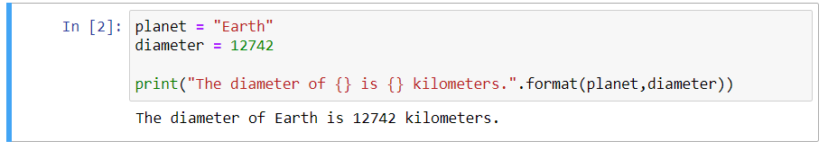

**Question-3:**

In this nest dictionary grab the word "hello".

Solution:

d = {'k1':[1,2,3,{'tricky':['oh','man','inception',{'target':[1,2,3,'hello']}]}]}

print(d['k1'][3]['tricky'][3]['target'][3])

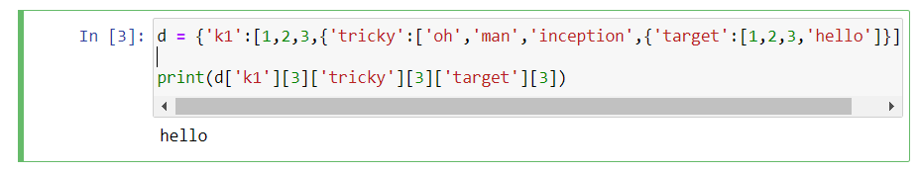

NUMPY

import numpy as np

**Question-4:**

Create an array of 10 zeros?

Solution:

np.zeros(10)

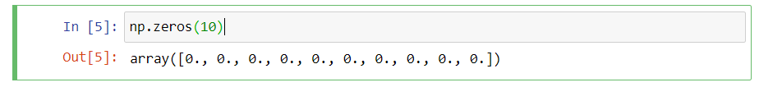

**Question-5:**

Create an array of 10 fives?

Solution:

np.ones(10) * 5

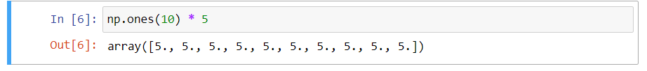

**Question-6:**

Create an array of all the even integers from 20 to 35.

Solution:

np.arange(20,35,2)

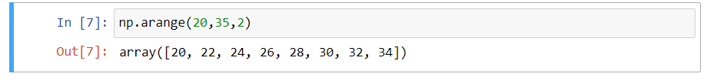

**Question-7:**

Create a 3x3 matrix with values ranging from 0 to 8.

Solution:

np.arange(0,9).reshape(3,3)

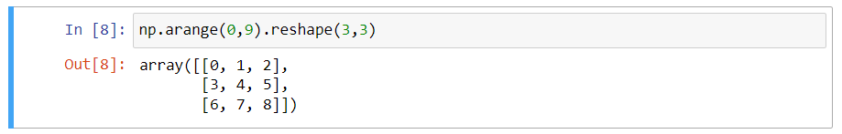

**Question-8:**

Concatinate a and b.

Solution:

a = np.array([1,2,3])

b = np.array([4,5,6])

c = np.concatenate((a,b),axis = 0)

print(c)

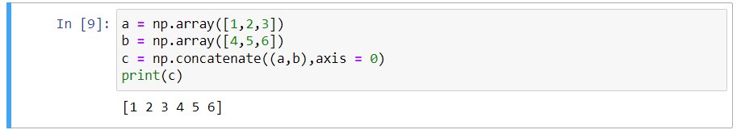

PANDAS

import pandas as pd

**Question-8:**

Create a dataframe with 3 rows and 2 columns.

Solution:

df = pd.DataFrame({"Name":['rocky','Raj','sam'],"Age":[25,24,28]})

print(df)

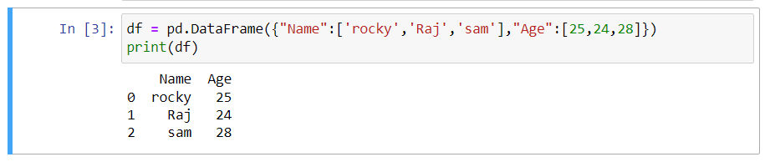

**Question-9:**

Generate the series of dates from 1st Jan, 2023 to 10th Feb, 2023.

Solution:

np.arange('2023-01-01','2023-02-10',dtype='datetime64[D]')

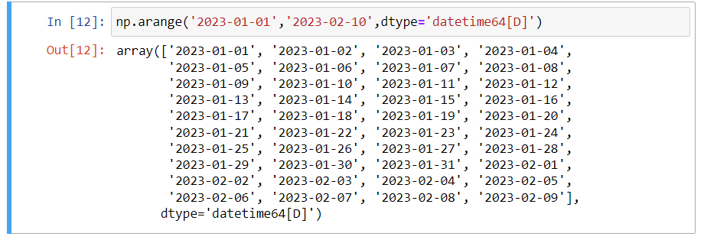

**Question-10:**

Create 2D list to DataFrame.

Solution:

lists = [[1, 'aaa', 22], [2, 'bbb', 25], [3, 'ccc', 24]]

df = pd.DataFrame(lists)

print(df)

