**Assignment -2**

Python Programming

|  |  |
| --- | --- |
| Assignment Date | 19 September 2022 |
| Student Name | KRISHNAPRIYA D |
| Student Roll Number | 2019115048 |
| Maximum Marks | 1. Marks |

## import required libraries

import pandas as pd

import numpy as np

import matplotlib.pyplot as plt

import seaborn as sns

from matplotlib import rcParams

## loading dataset

import pandas as pd

df=pd.read_csv('water.csv',encoding='latin-1')

df.head()

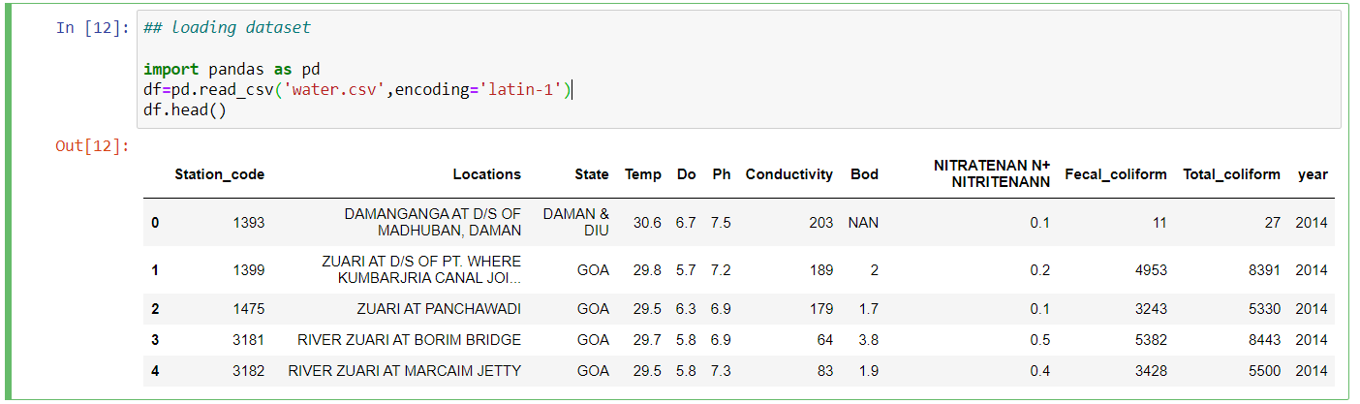

df.shape

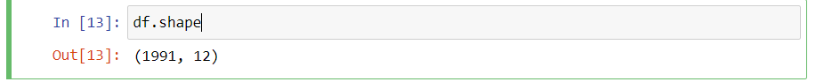

df.info()

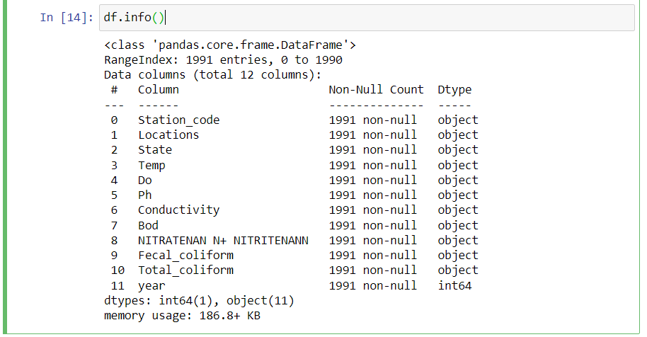

df.isnull().any()

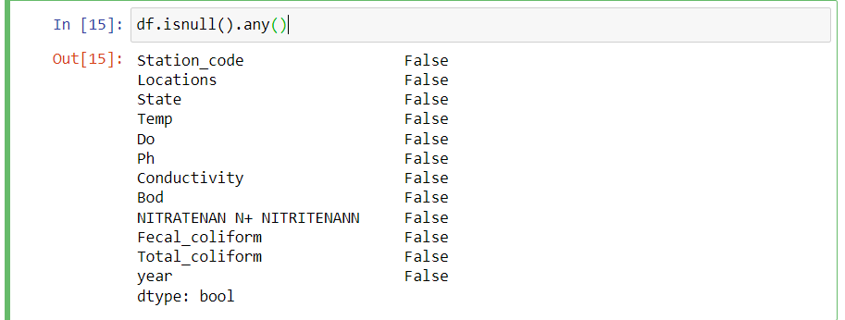

df.Temp.value_counts()

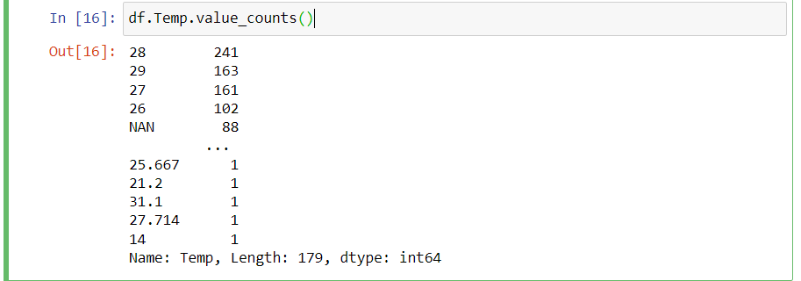

df.Ph.value_counts()

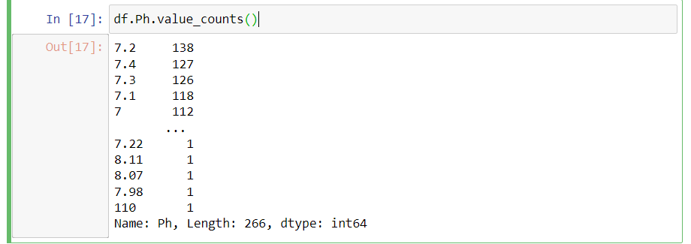

df.year.value_counts()

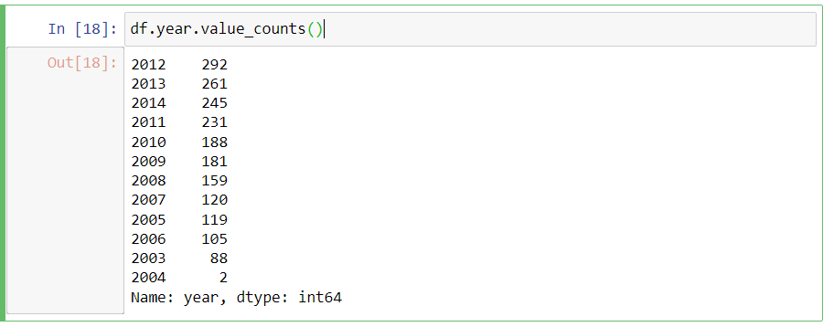

df.describe()

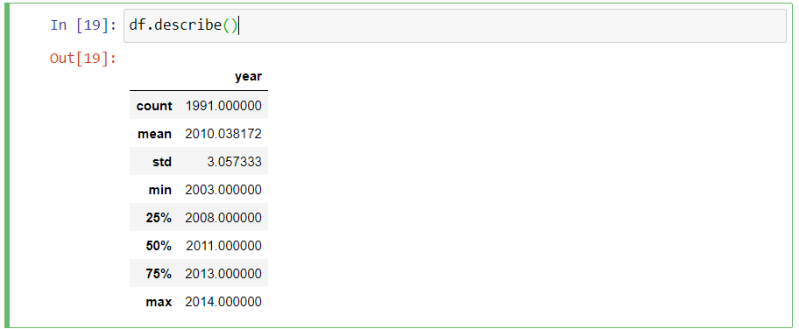

import seaborn as sns

sns.distplot(df.year) # univariate analysis

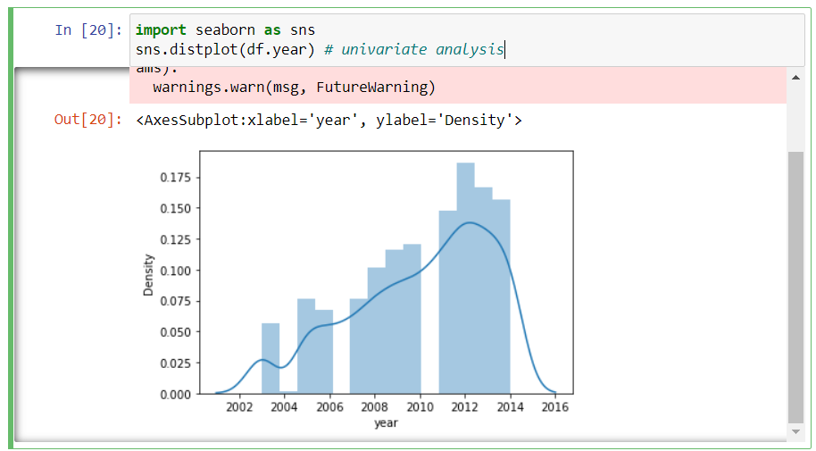

sns.lineplot(df.Bod,df.year) # bivariate analysis.

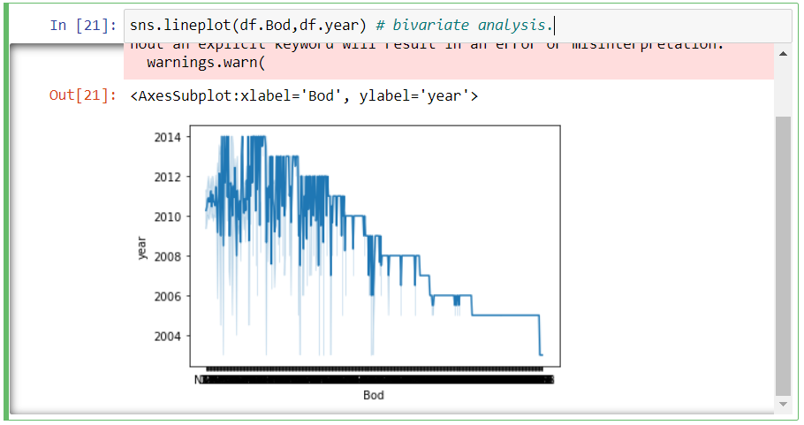

sns.barplot(df.Ph.value_counts().index, df.Ph.value_counts())

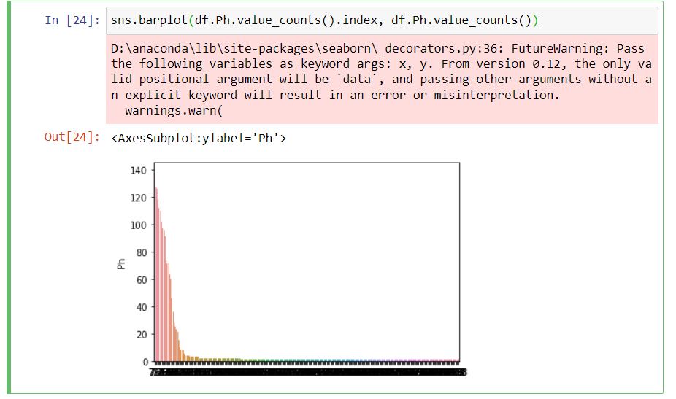

## countplot

import seaborn as sns

import matplotlib.pyplot as plt

def countplot_of_2(x,hue,title=None,figsize=(6,5)):

plt.figure(figsize=figsize)

sns.countplot(data=df[[x,hue]],x=x,hue=hue)

plt.title(title)

plt.show()

countplot_of_2('Ph','year','Ph/year')

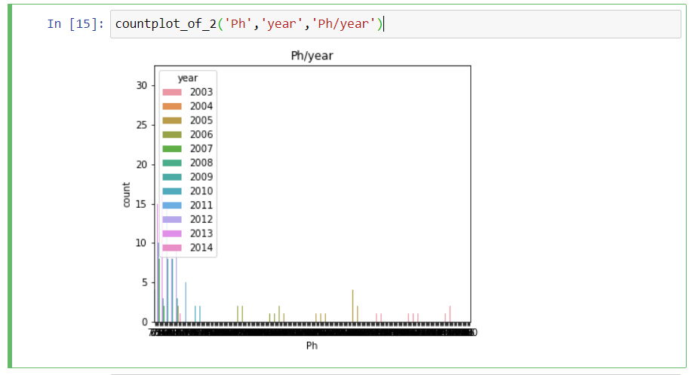

countplot_of_2('Bod','year','Bod/year')

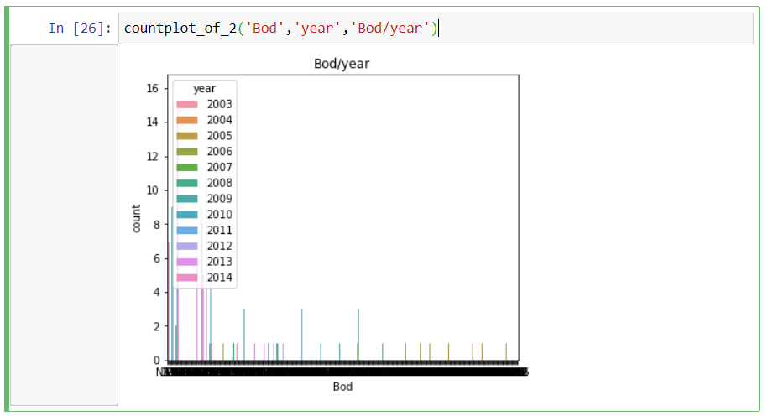

sns.pairplot(df)

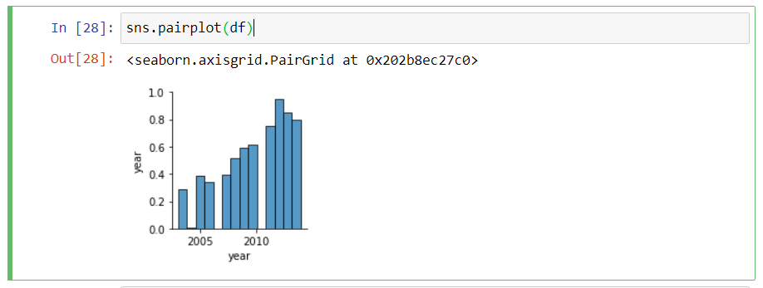

df.corr()

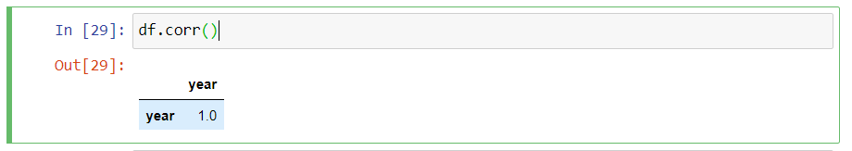

sns.heatmap(df.corr())

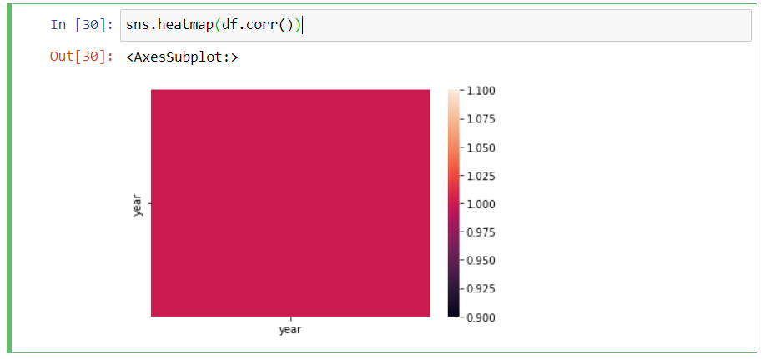

sns.heatmap(df.corr(),annot=True)

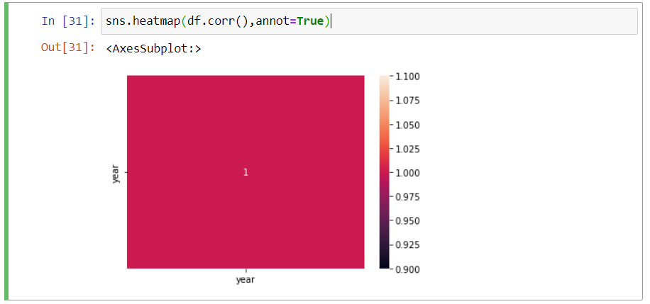

sns.boxplot(df.year)

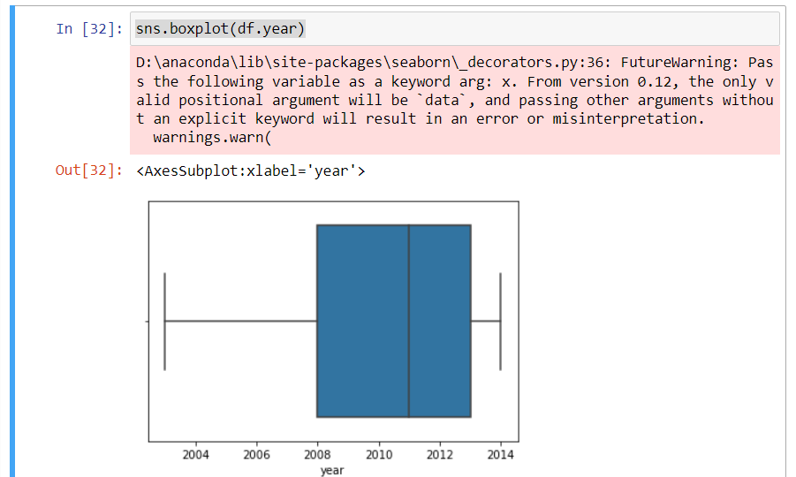

**outlier removal- IQR method**

Q1= df.year.quantile(0.25)

Q3=df.year.quantile(0.75)

IQR=Q3-Q1

upper_limit =Q3 + 1.5*IQR

lower_limit =Q1 - 1.5*IQR

upper_limit

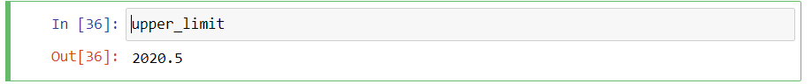

df=df[df.year<upper_limit]

sns.boxplot(df.year)

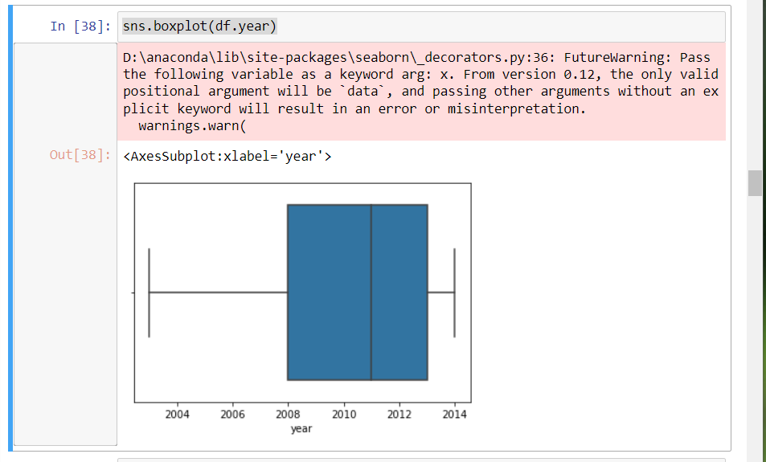

df.shape

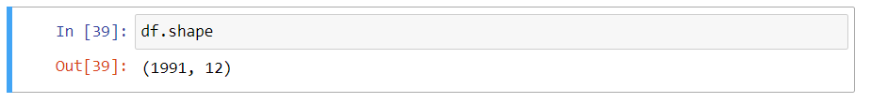

# Outlier replacement using median

sns.boxplot(df.year)

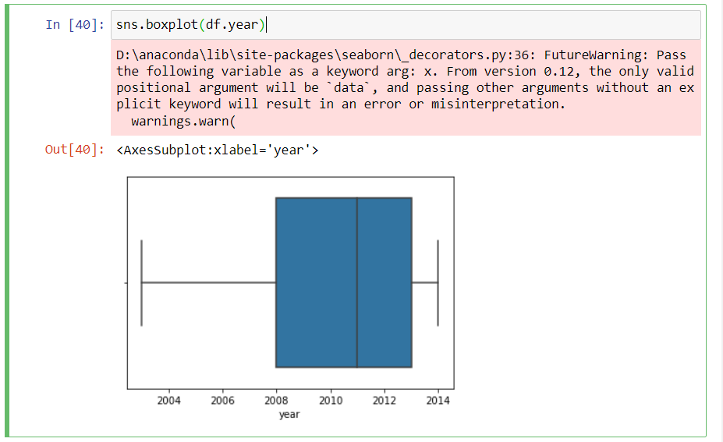

df.median()

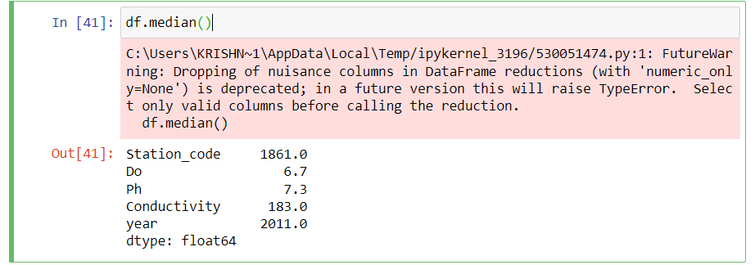

Q1= df.year.quantile(0.25)

Q3=df.year.quantile(0.75)

IQR=Q3-Q1

upper_limit =Q3 + 1.5*IQR

lower_limit =Q1 - 1.5*IQR

sns.boxplot(df.year)

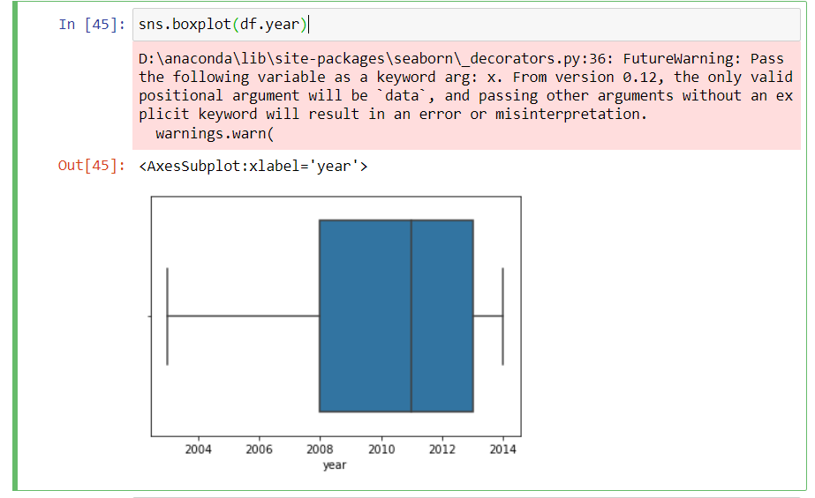

df.shape

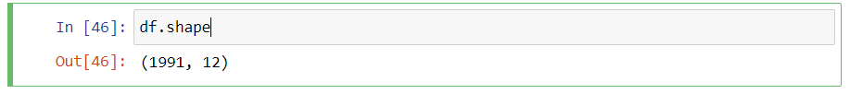

## outlier removal- Percentile method

sns.boxplot(df.year)

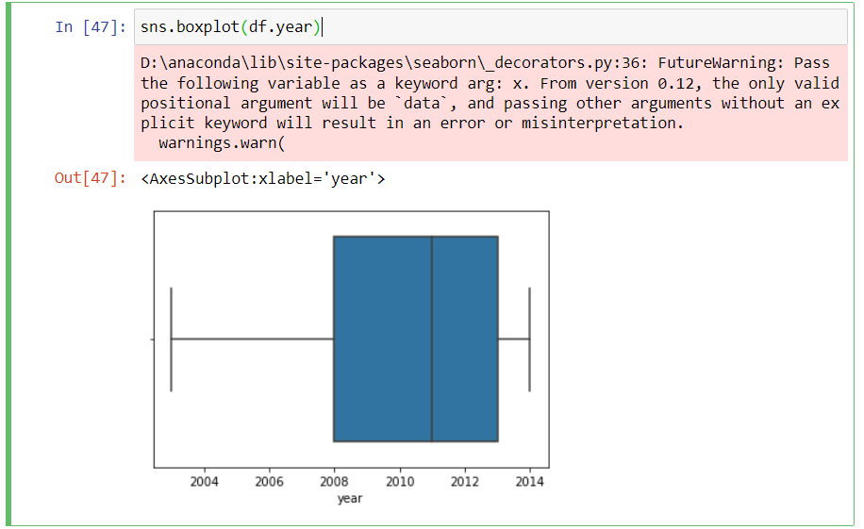

p99= df.year.quantile(0.99)

p99

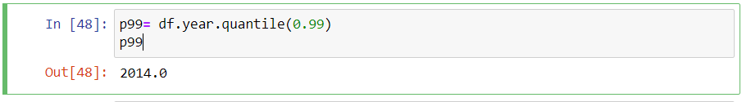

df = df[df.year<=p99]

sns.boxplot(df.year)

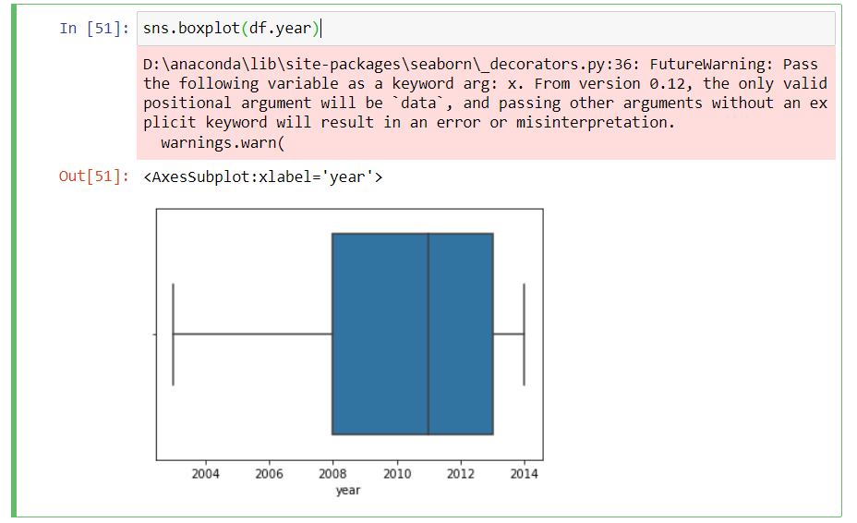

## outlier removal- z-score

sns.boxplot(df.year)

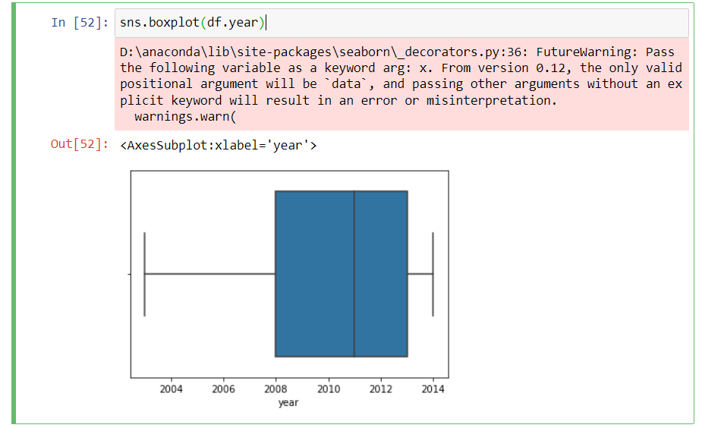

from scipy import stats

from scipy import stats

year_zscore = stats.zscore(df.year)

year_zscore

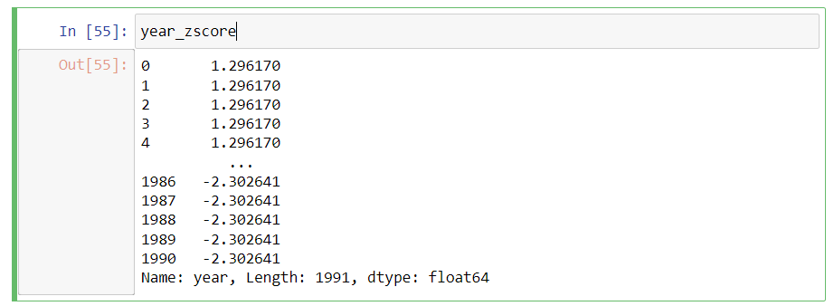

df_z = df[np.abs(year_zscore)<=3]

sns.boxplot(df_z.year)

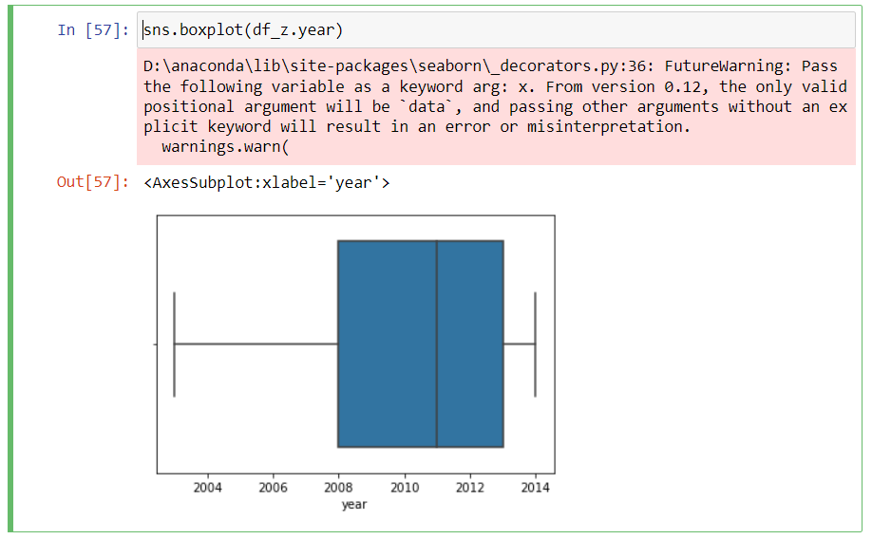

df.head()

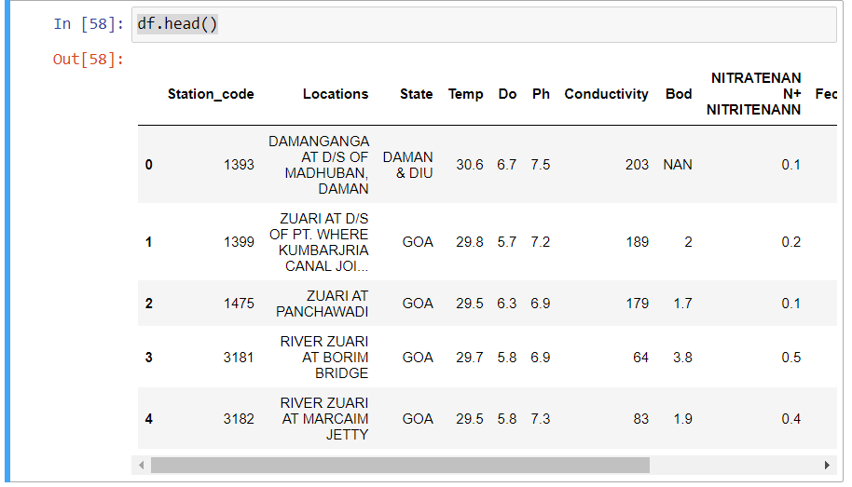

## Encoding Techniques

## 1.Label Encoding[¶](http://localhost:8888/notebooks/Documents/Data%20preprocessing.ipynb#1.Label-Encoding)

from sklearn.preprocessing import LabelEncoder

le=LabelEncoder()

df.head()

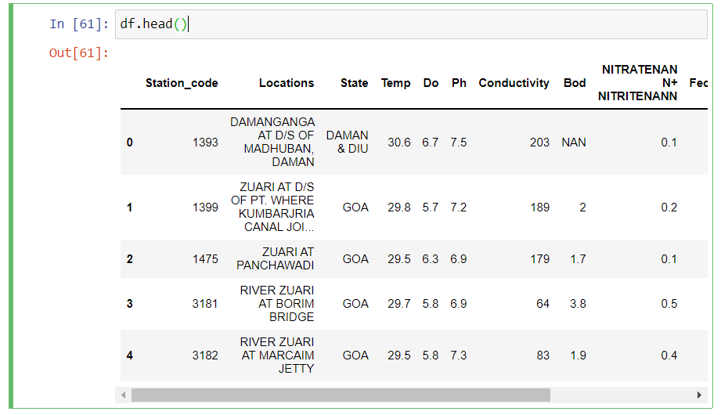

## 2.One hot Encoding[¶](http://localhost:8888/notebooks/Documents/Data%20preprocessing.ipynb#2.One-hot-Encoding)

df_main=pd.get_dummies(df,columns=['Station_code'])

df_main.head()

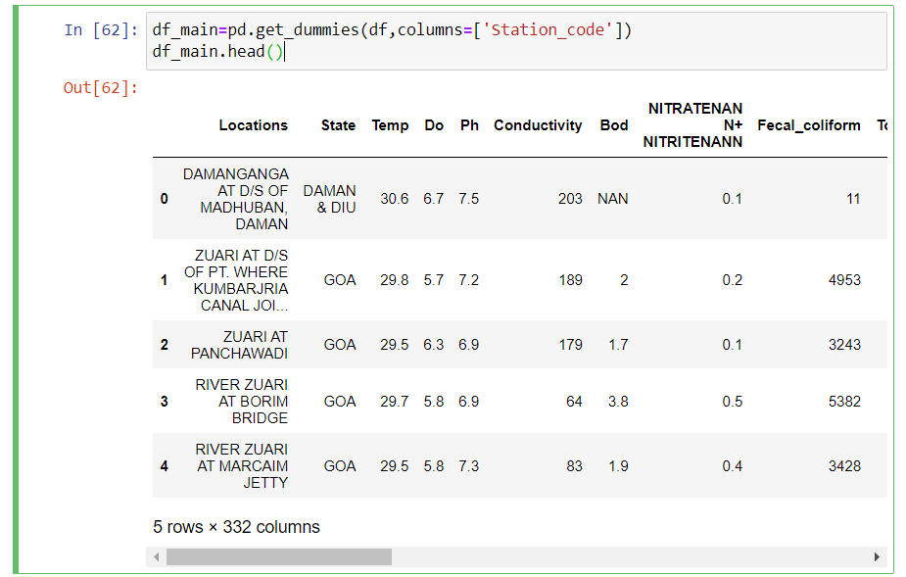

df_main.describe()

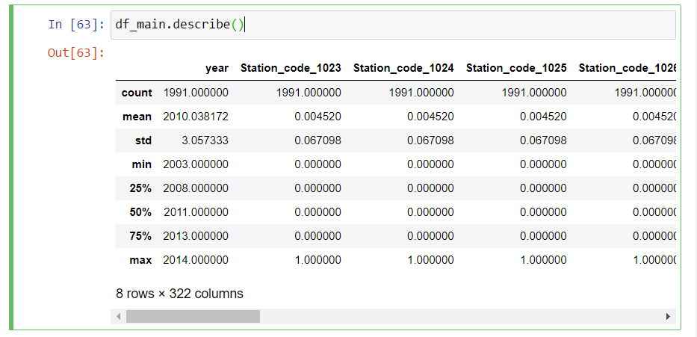

df_main.corr()

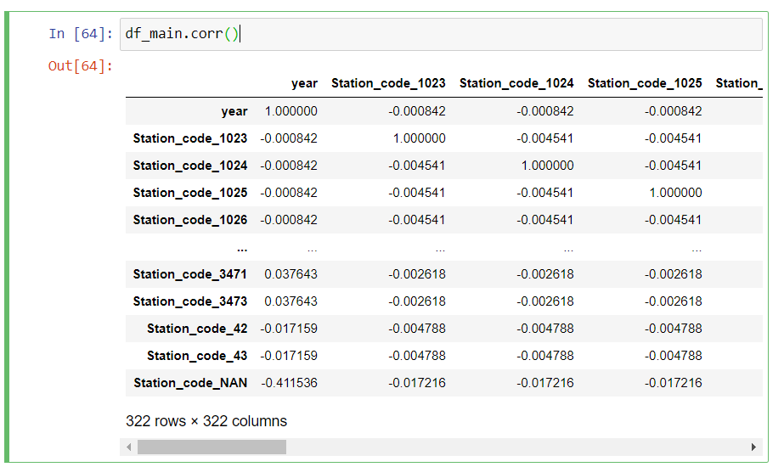

plt.figure(figsize=(10,8))

sns.heatmap(df_main.corr(),annot=True)

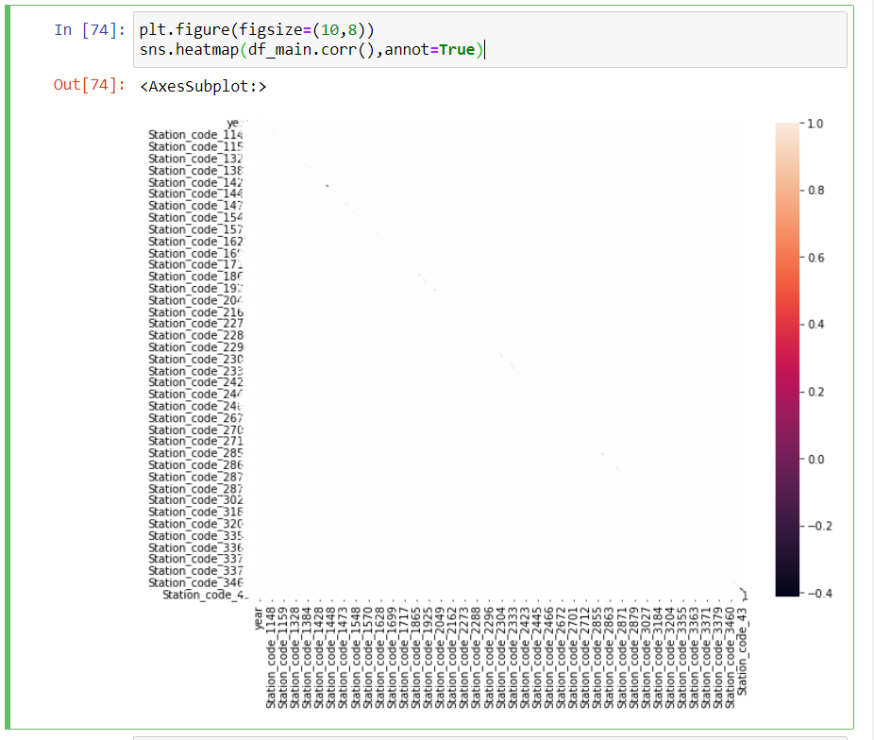

df_main.corr().year.sort_values(ascending=False)

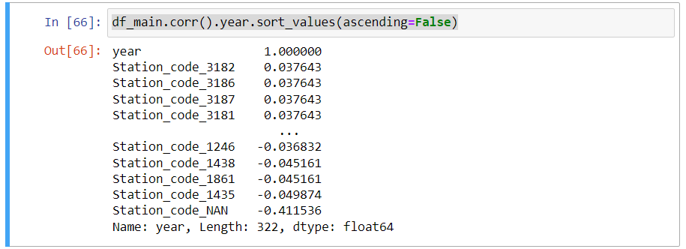

df_main.head()

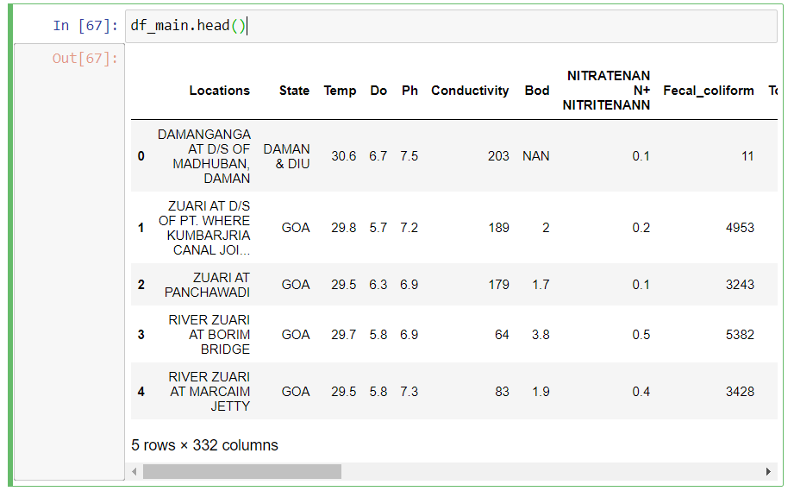

## X and y split

# independent varibles-X

X=df_main.drop(columns=['Bod'],axis=1)

X.head()

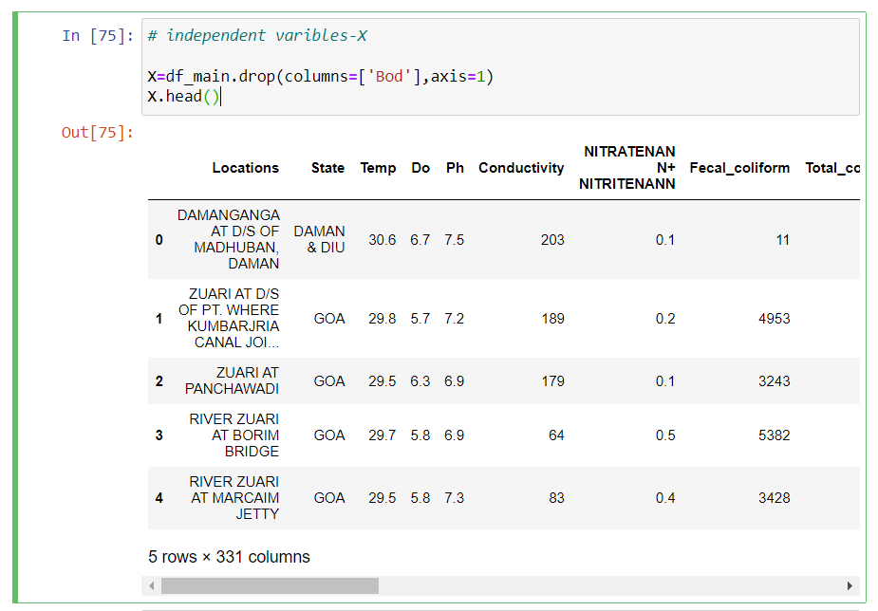

# y target-dependent variable

y=df_main.Bod

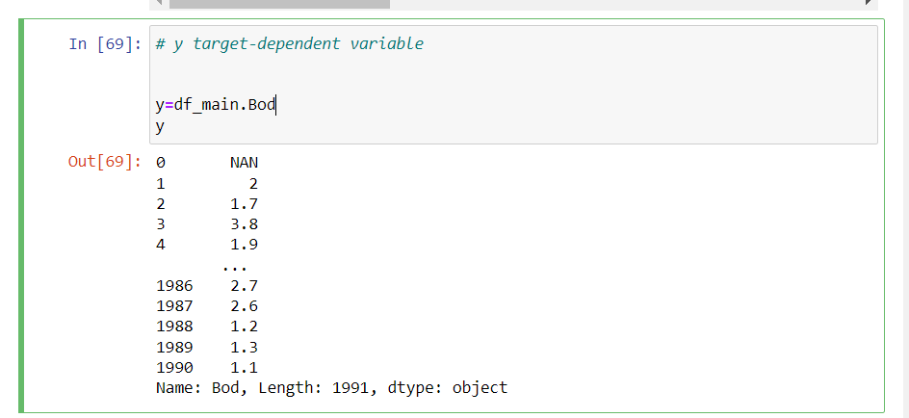

X.head()

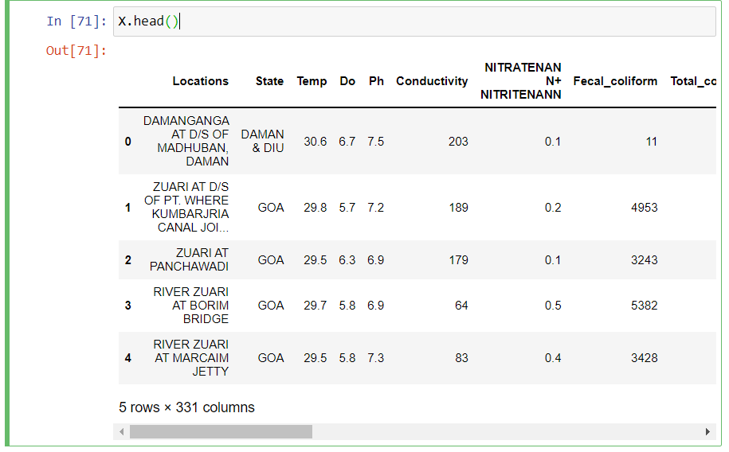

## scaling

from sklearn.preprocessing import scale

from sklearn.preprocessing import scale

X=pd.DataFrame(scale(X),columns=X.columns)

X.head()

## Train test split

from sklearn.preprocessing import scale

from sklearn.model_selection import train_test_split

X_train,X_test,y_train,y_test =train_test_split(X_scaled,y, test_size=0.3,random_state=0)

X_train

X_train.shape

y_train.shape

X_test

X_test.shape