# Project Design Phase-II

Data Flow Diagram & User Stories

|  |  |
| --- | --- |
| Date | 10 October 2022 |
| Team ID | PNT2022TMID31699 |
| Project Name | Project - Crude Oil Price Prediction |
| Maximum Marks | 4 Marks |

DATA FLOW DIAGRAM

The classic visual representation of how information moves through a system is a data flow diagram (DFD). A tidy and understandable DFD can graphically represent the appropriate quantity of the system demand. It demonstrates how information enters and exits the system, what modifies the data, and where information is kept.

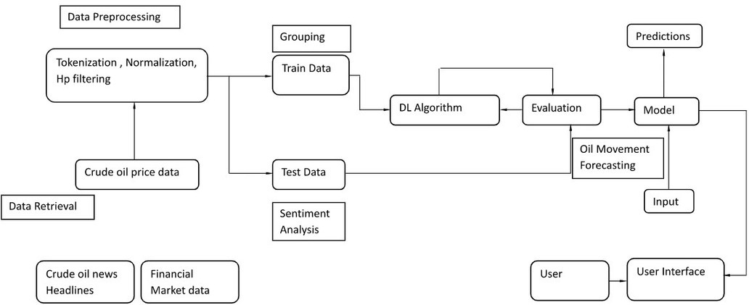

|  |  |  |  |  |  |  |
| --- | --- | --- | --- | --- | --- | --- |
| User Type | Functional Requirement (Epic) | User Story Number | User Story/ Task | Acceptance criteria | Priority | Release |
| Customer (Mobile User) | Registration | USN-1 | Asauser,Icanregisterfortheapplication byenteringmyemail,password,and confirming my password. | I can access my account/ Displays Line gragh /  Bar gragh. | High | Sprint-1 |
|  |  | USN-2 | As a user,I will receive confirmation email once I have registered for the application | I can receive  confirmation email & click confirm | High | Sprint-1 |
|  |  | USN-3 | As a user,I can register for the application through Facebook | I can register & accessthe my Account | Low | Sprint-2 |
|  |  | USN-4 | As a user,I can register for the  application through Gmail | I can register through  already  logged in gmail  account. | Medium | Sprint-1 |
|  | Login | USN-5 | As a user,I can log into the application by entering email & password | After registration,I can  log in by only email & password. | High | Sprint-1 |
|  | Line\Bar gragh |  | After entering the inputs,the model will display predictions in Line\Bar Gragh Format. | I can get the expected  prediction in various formats. | High | Sprint-3 |
| Customer (Web user) | Login | USN-1 | As the web user,I can login simply by using Gmail or Facebook account. | Already created gmail  can be used for Login. I can solve the | Medium | Sprint-2 |
| Customer  Care Executive | Support |  | The Customer care service will provide  solutions for any FAQ and also provide ChatBot. | problems arised by Support. | Low | Sprint-3 |

User Stories

Use the below template to list all the user stories for the product.

|  |  |  |  |  |  |  |
| --- | --- | --- | --- | --- | --- | --- |
| Administrator | News |  | Admin will give the recent news of Oil Prices. | Provide the recent oil prices. | High | Sprint-4 |
|  | Notification |  | Admin will notify when the oil prices changes. | Notification by Gmail. | High | Sprint-4 |
|  | Access Control |  | Admin can control the access of users. | Access permission for Users. | High | Sprint-4 |
|  | Database |  | Admin can store the details of users. | Stores User details. | High | Sprint-4 |