# Working with datasets

**TEAM MEMBERS**

* Lakshmanan A(TL)
* Idhayadasan S
* Karthickeyan K
* Kirubhaharan J

# Loading datasets

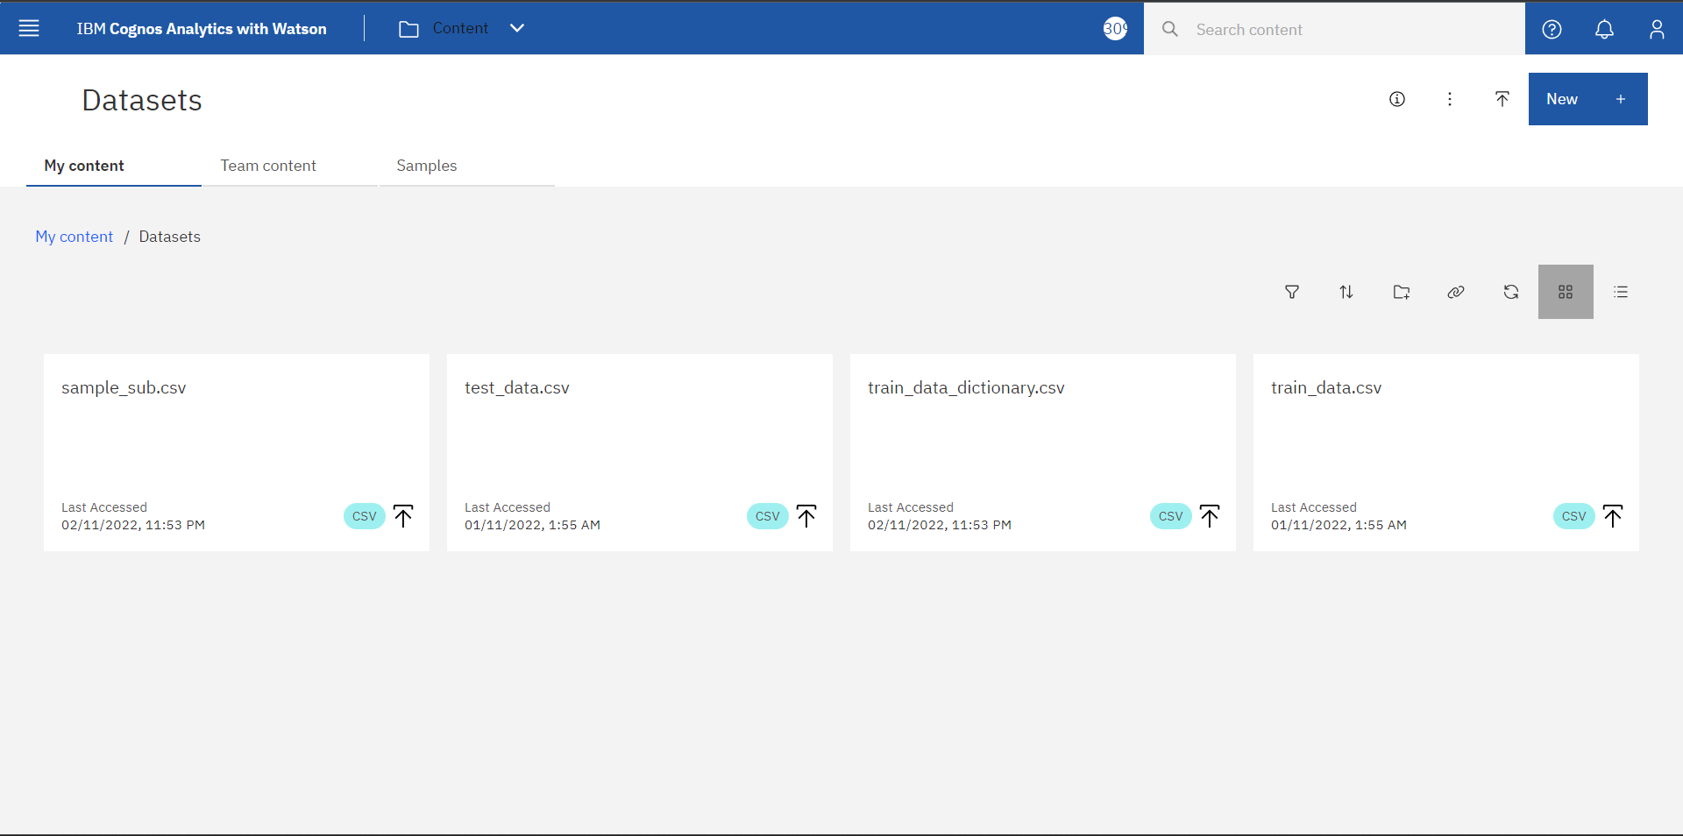

**Exploration of Data**

