**Ideation Phase**

**Define the Problem Statements**

|  |  |
| --- | --- |
| Date | 26 September 2022 |
| Team ID | PNT2022TMID35525 |
| Project Name | Project - AI based discourse for Banking Industry |
| Maximum Marks | 2 Marks |

**Customer Problem Statement Template:**

The main objective of our project is to create a chatbot that is smart and can answer any relevant question with respect to banking. Here the customer will find solutions to doubts regarding accessing the banking portal. The chatbot will guide the user through any banking procedure and thereby will provide a smooth and effective banking experience.

Our project also aims to mine valuable insights about the working of the bank based on customer queries. This will help improve the efficiency of the bank.

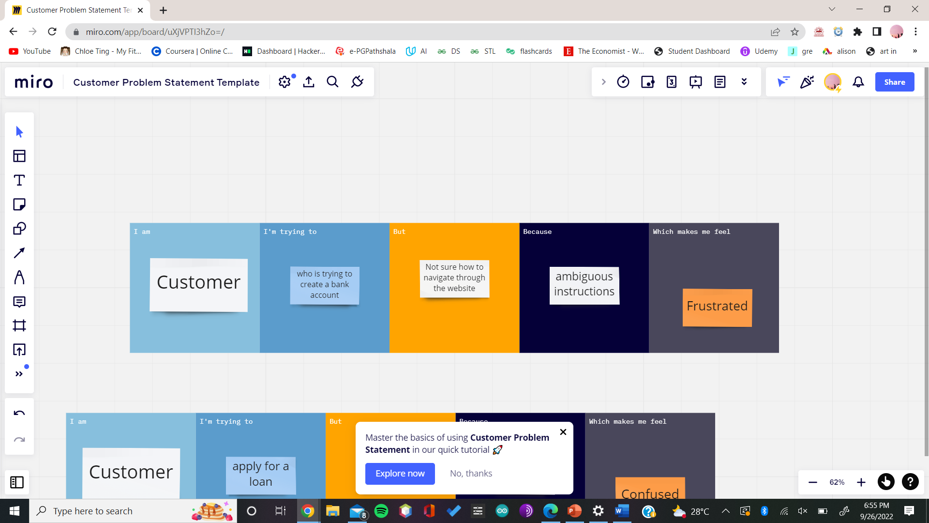

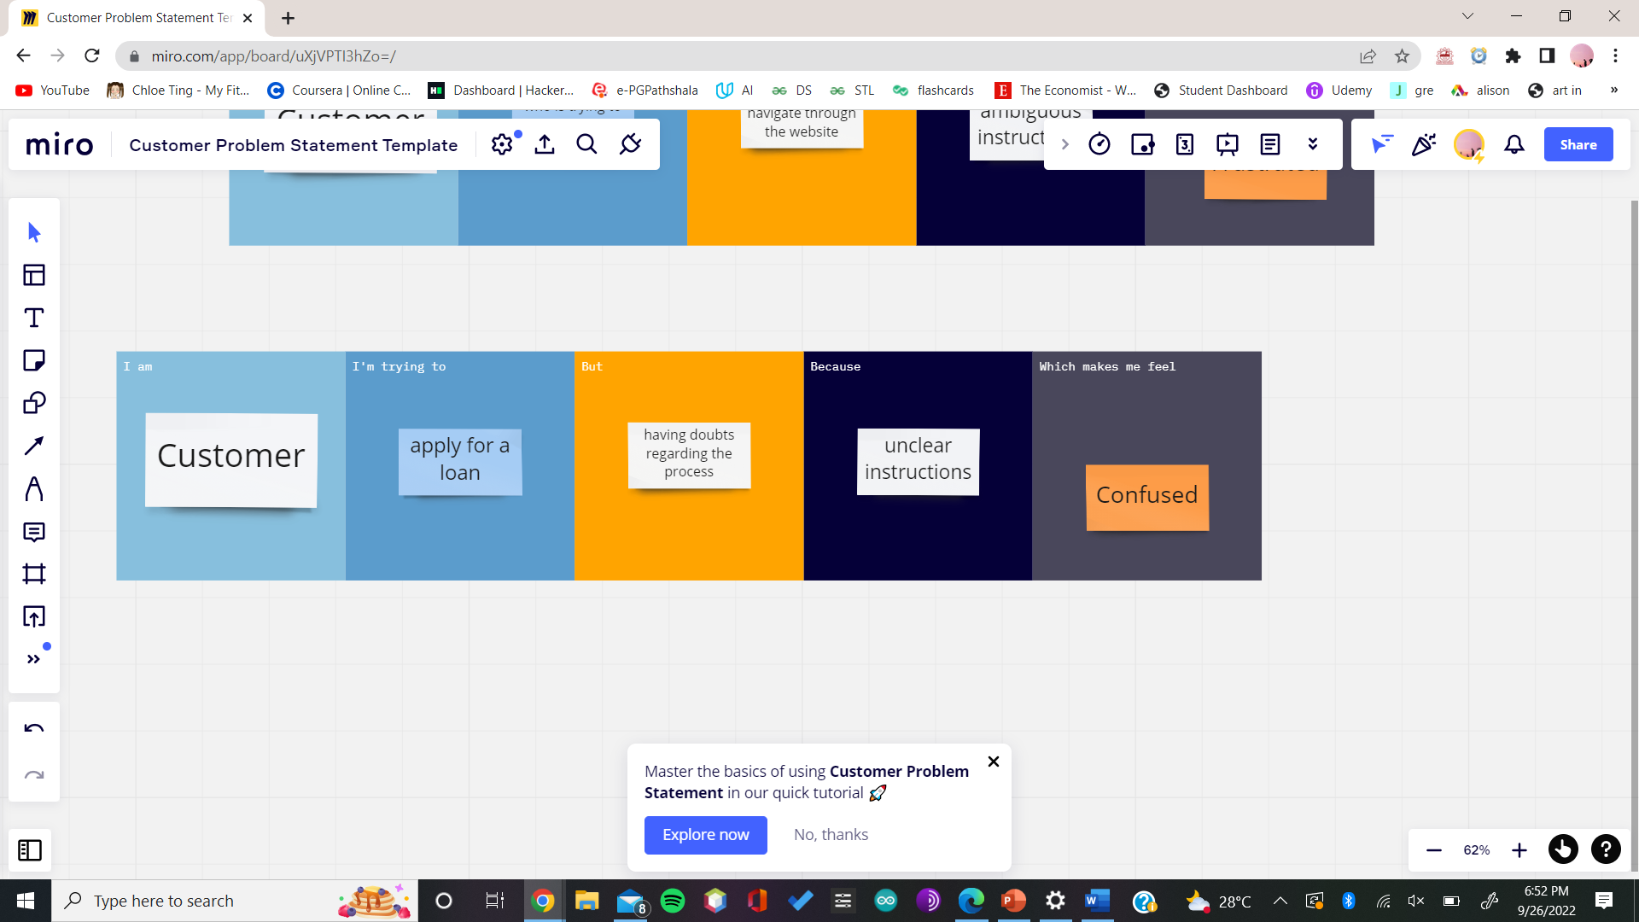

|  |  |  |  |  |  |
| --- | --- | --- | --- | --- | --- |
| **Problem Statement (PS)** | **I am (Customer)** | **I’m trying to** | **But** | **Because** | **Which makes me feel** |
| PS-1 | Customer | Create a bank account | Not sure how to navigate through the website | Ambiguous instructions | Frustrated |
| PS-2 | Customer | Apply for a loan | Having doubts regarding the process | Unclear instructions | Confused |