**B12-6A2E**

**TITLE: Personal Assistance for Seniors Who Are Self-Reliant**

**(Medicine Reminder)**

**Project Design Phase – I**

**Proposed Solution:**

In this modern society, many people will busy in their work schedule. Maintaining daily medication become very difficult for old people. In these days, vast number of technologies are emerging. In this project, we are using IOT and cloud technologies. IR sensor and Bluetooth module is used as a hardware which are used in medicinal box. Whenever we forget to take medicine on time and medicine shortage will be intimated to the respective person’s mobile phone through notification. Medicine timing with name is set to the mobile phone. If a person misses to open and take the medicine on time, notification will send to the person’s mobile phone. The medicinal box is always connected to the mobile phone through Bluetooth. If the person forgets the box, notification will automatically send. The non-availability of the medicines will be checked through mobile phones alarm time. If there is any shortage of medicines in the medicinal box, notification will send. We are sending the notifications using IBM cloud.

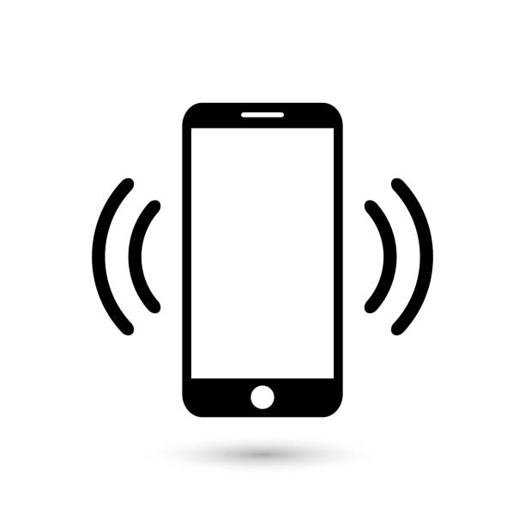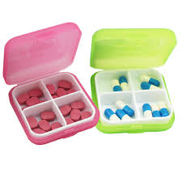

Forget to take medicine on time

z

Medicinal shortage

Forget to take medicinal box

Notification/Alarm