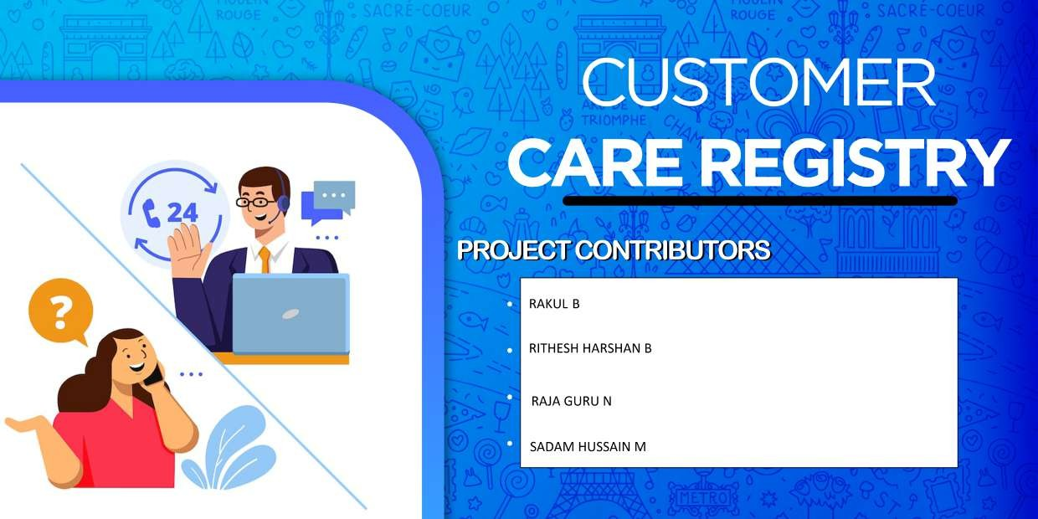

 

* SHAMIM AHAMED J
* SATHEESH PERIYANAN R
* RIYAAS MOHAMED N
* ROBIN SINGH D