**UAT**

**Acceptance Testing**

**UAT Execution & Report Submission**

|  |  |
| --- | --- |
| Date | 14 November 2022 |
| Team ID | PNT2022TMID52774 |
| Project Name | Project – IOT based smart crop protection using |
| Maximum Marks | 4 Marks |

# 1.    Purpose of Document

|  |
| --- |
|  |
|  |  |

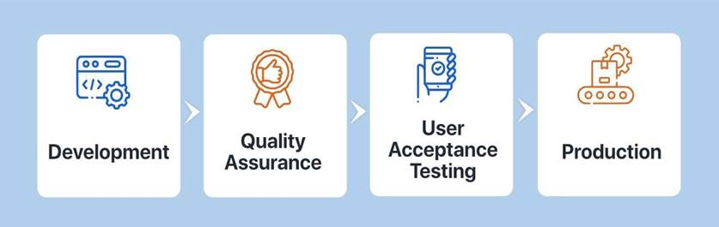

**Fig 11.1 UAT execution**

The main Purpose of UAT is to validate end-to-end business flow. It does not focus on cosmetic errors, spelling mistakes or system testing. User Acceptance Testing is carried out in a separate testing environment with production-like data setup. It is kind of black box testing where two or more end-users will be involved.

UAT is performed by :

1. Client
2. End users

 2.    Defect Analysis

This report shows the number of resolved or closed bugs at each severity level, and how they were resolved.

|  |  |  |  |  |  |
| --- | --- | --- | --- | --- | --- |
| **RESOLUTION** | **SEVERITY1** | **SEVERITY2** | **SEVERITY3** | **SEVERITY4** | **SUBTOTAL** |
| By Design | 3 | 2 | 1 | 0 | 9 |
| Duplicate | 2 | 1 | 2 | 0 | 5 |
| External | 4 | 1 | 1 | 1 | 7 |
| Fixed | 3 | 4 | 6 | 8 | 21 |
| Not Reproduced | 1 | 1 | 0 | 2 | 4 |
| Skipped | 1 | 0 | 1 | 1 | 3 |
| Won’t fix | 1 | 2 | 0 | 0 | 3 |
| Totals | 15 | 11 | 11 | 12 | 49 |

 3.    Test Case Analysis

This report shows the number of test cases that have passed, failed, and untested.

|  |  |  |  |  |
| --- | --- | --- | --- | --- |
| **SECTION** | **TOTALCASES** | **NOTTESTED** | **FAIL** | **PASS** |
| Web Page | 10 | 0 | 0 | 10 |
| Database | 40 | 0 | 0 | 40 |
| Twilio Dashboard | 15 | 0 | 0 | 15 |
| Sensor output value generation | 10 | 0 | 0 | 10 |