Netcool/OMNIbus & IBM Log Analysis – Insight Pack for SPSS Data Collection Interviewer

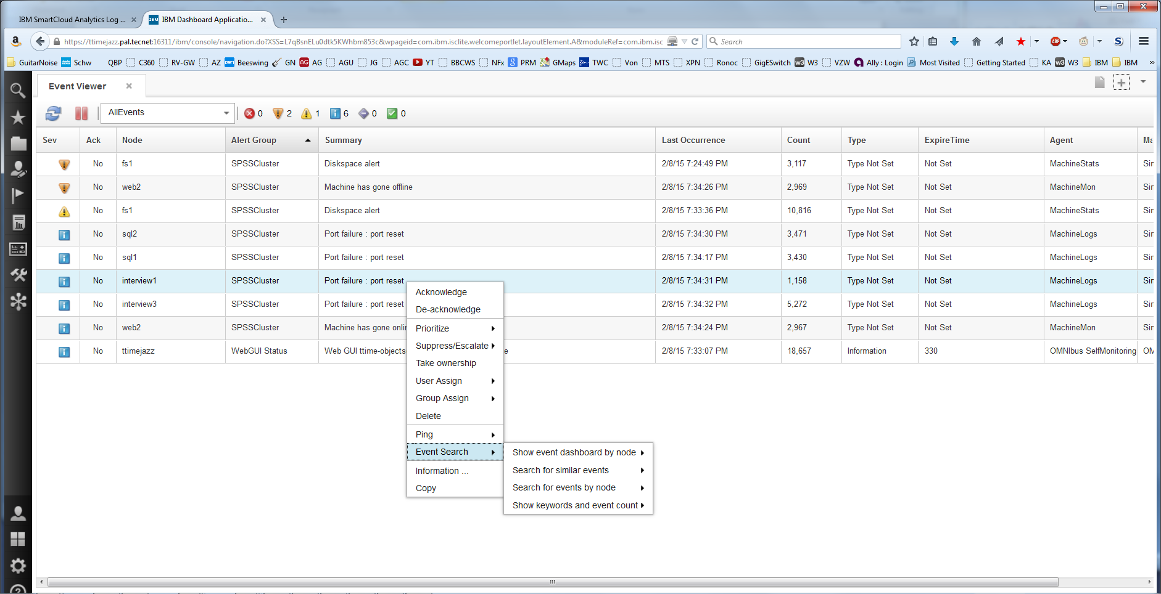
OMNIbus Events from SPSS Monitoring (simulated) – Launch into Log Analysis

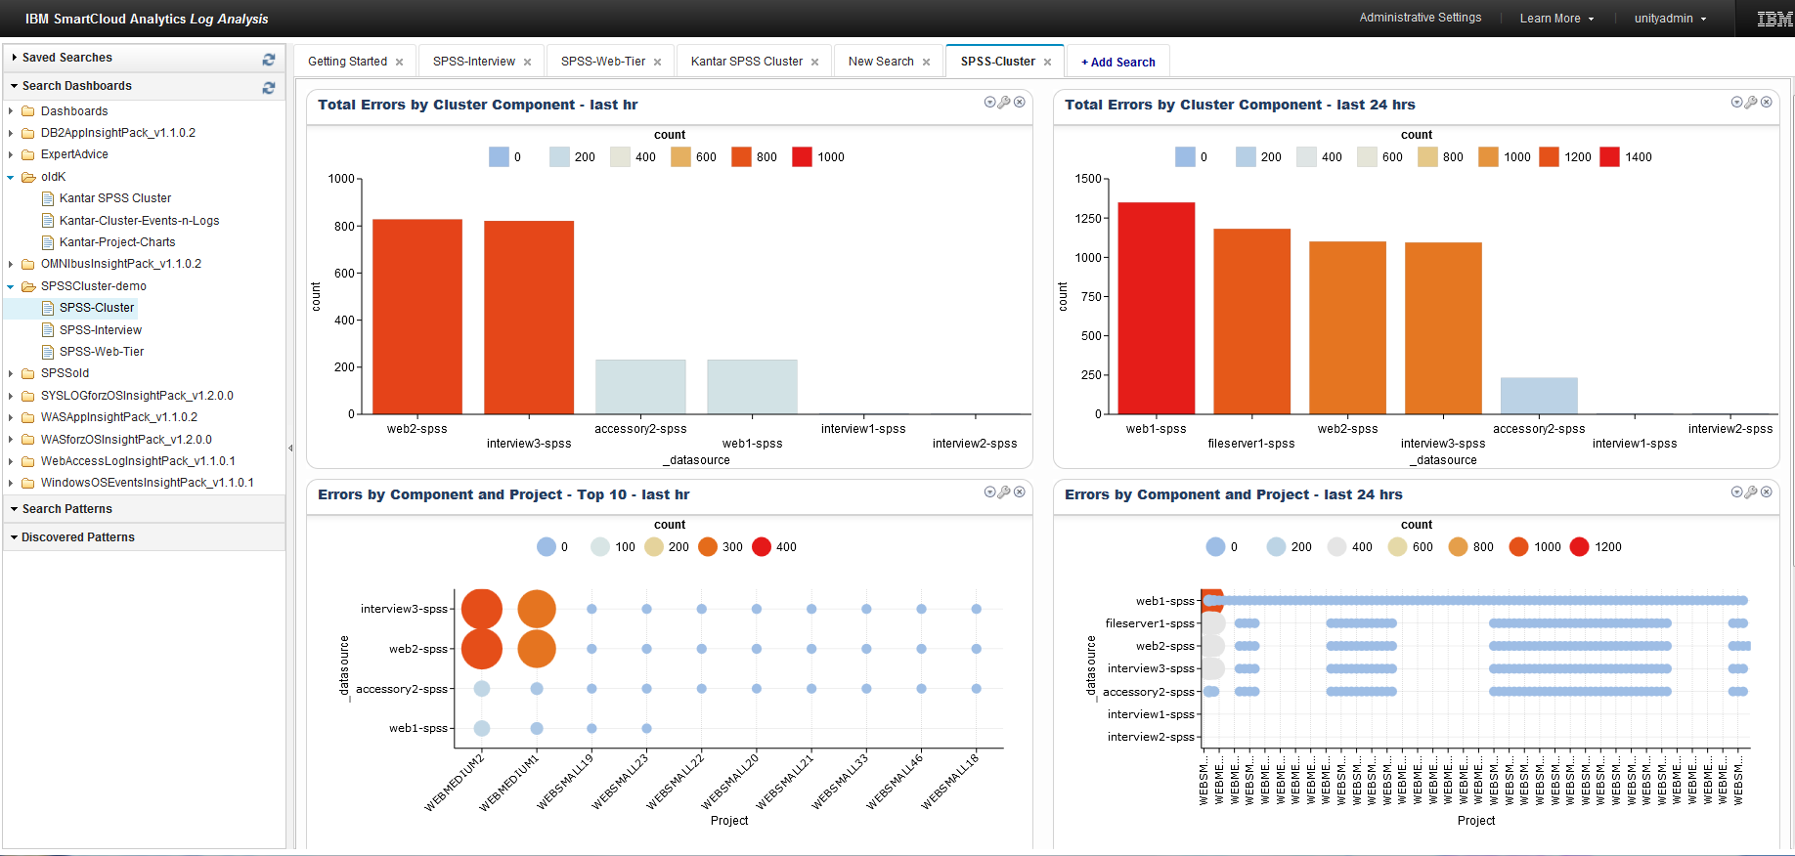
SPSS Cluster – 1st Four Charts – Errors by component / component & project
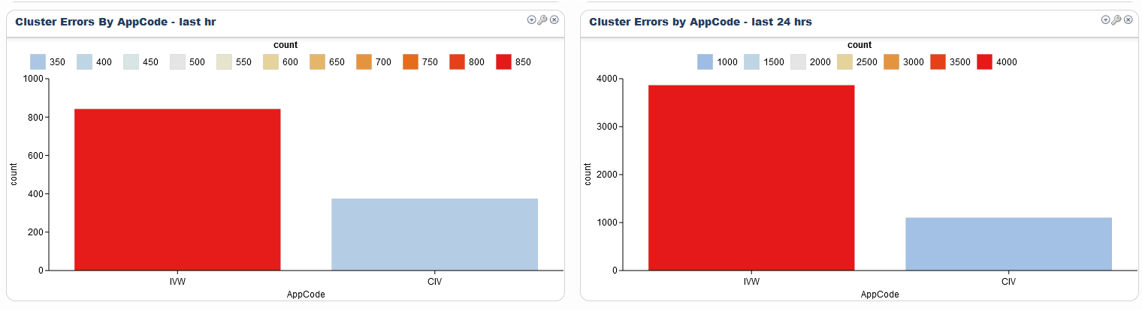
SPSS Cluster – last 2 charts – Errors by AppCode

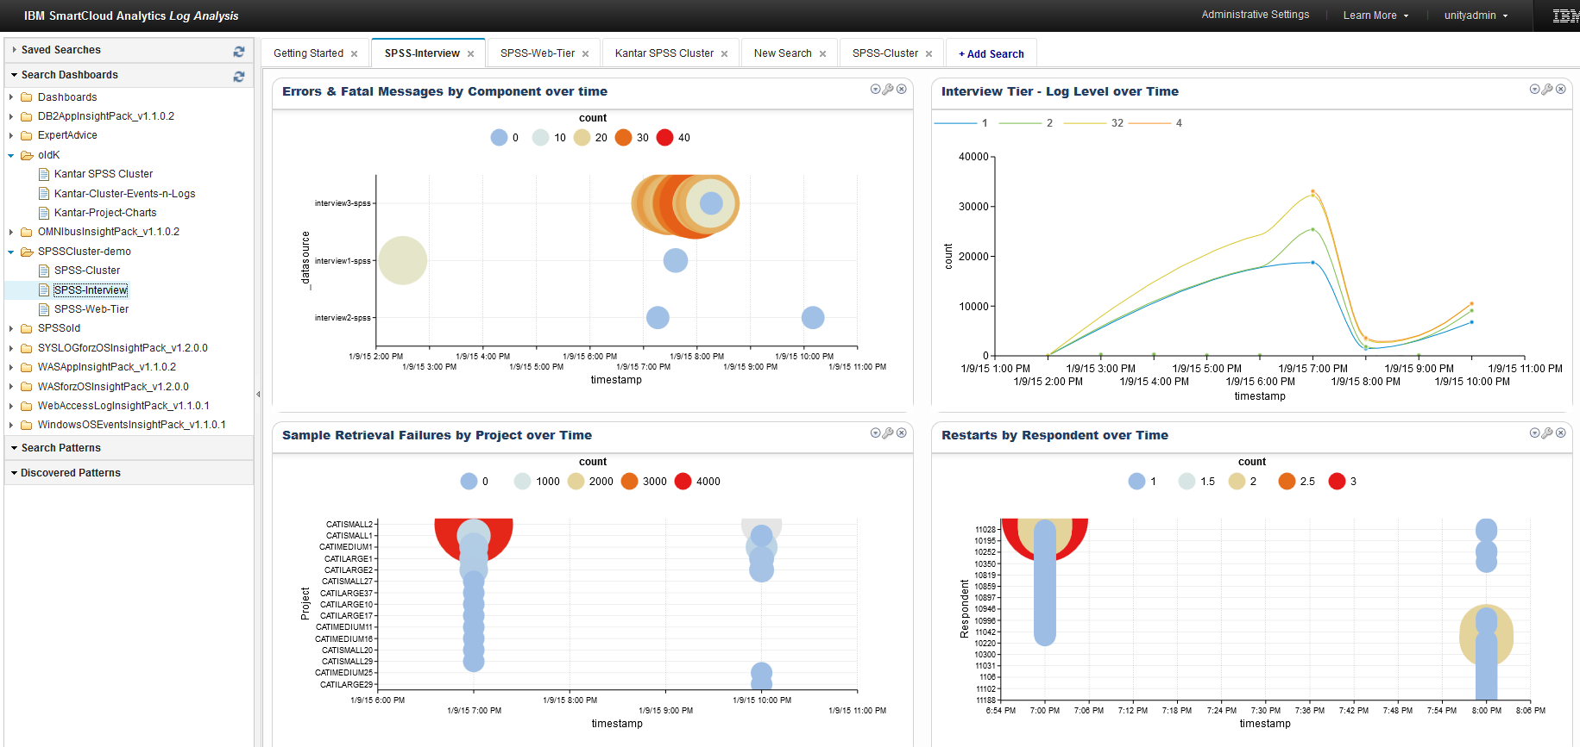
SPSS Cluster - Interview Tier Charts

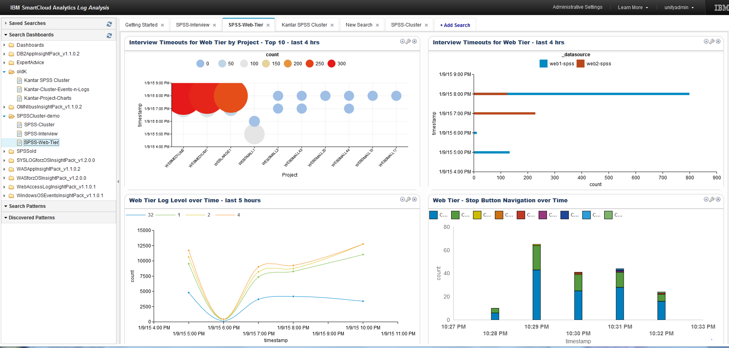
SPSS Cluster - Web Tier Charts

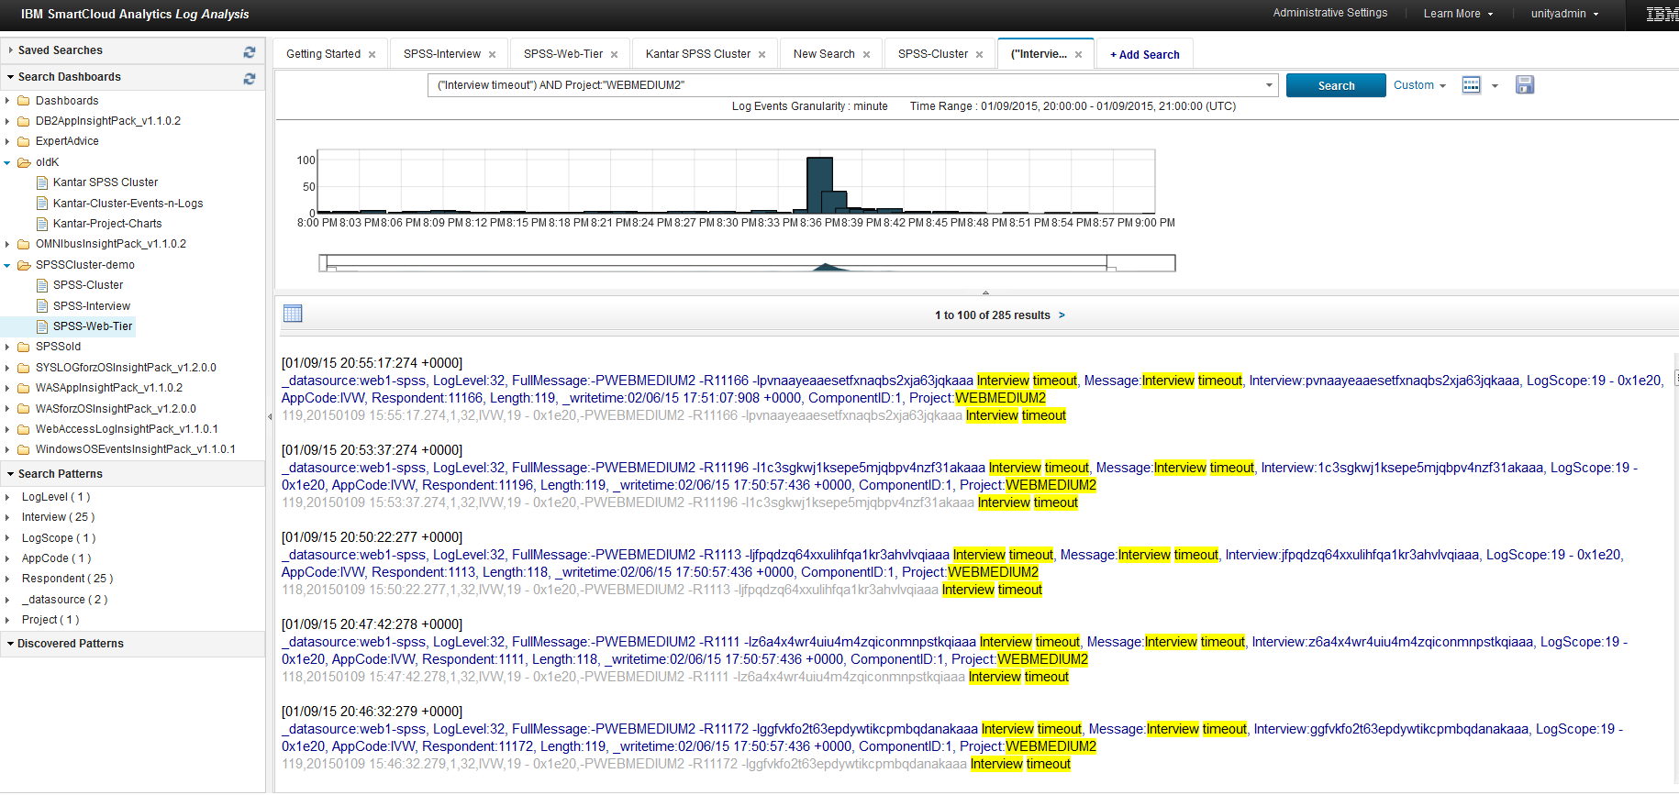
Drill Down into Interview Timeouts for WEBMEDIUM2 – “list view”

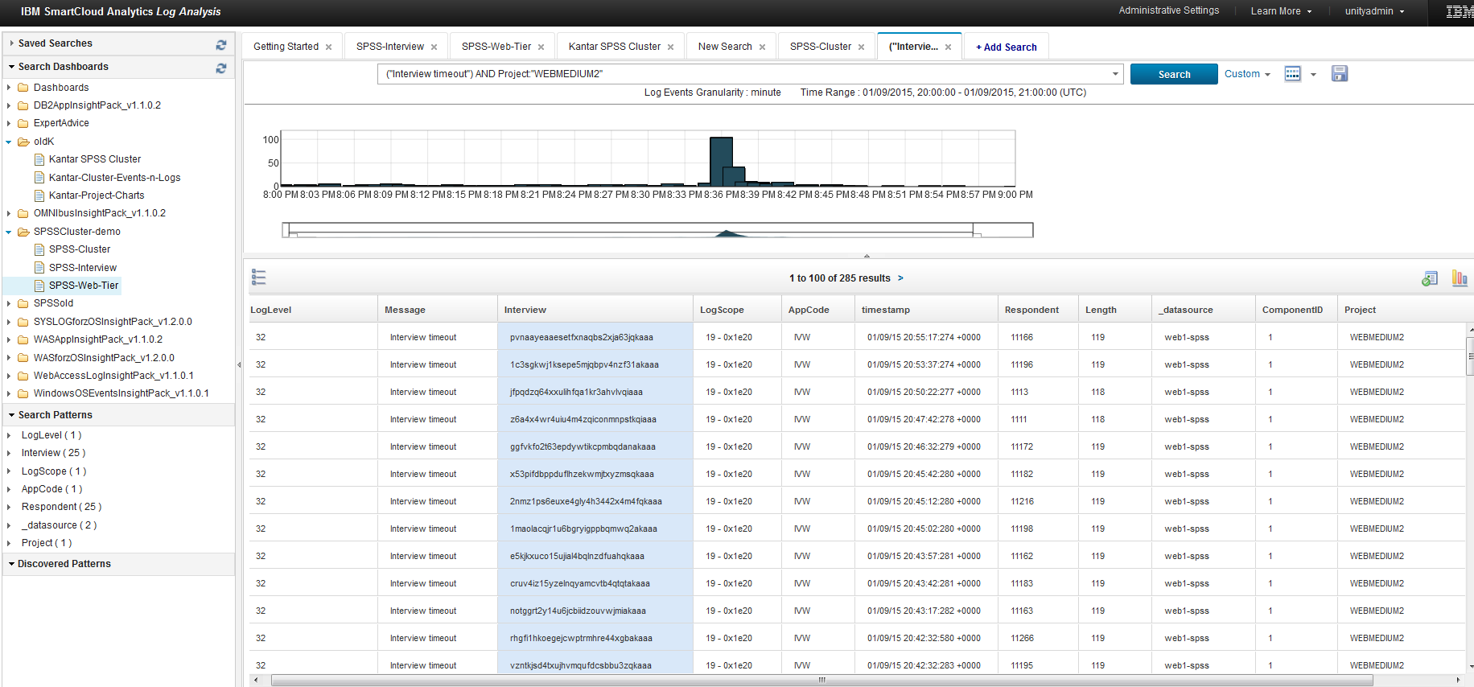
Drill Down into Interview Timeouts for WEBMEDIUM2 – “grid view”

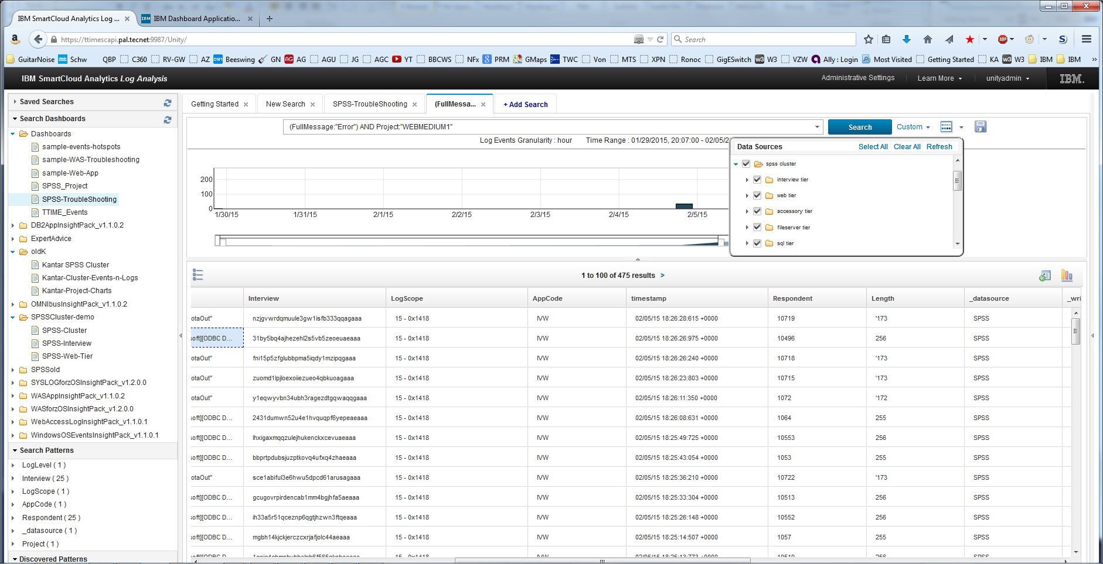
Search across the SPSS Cluster

