 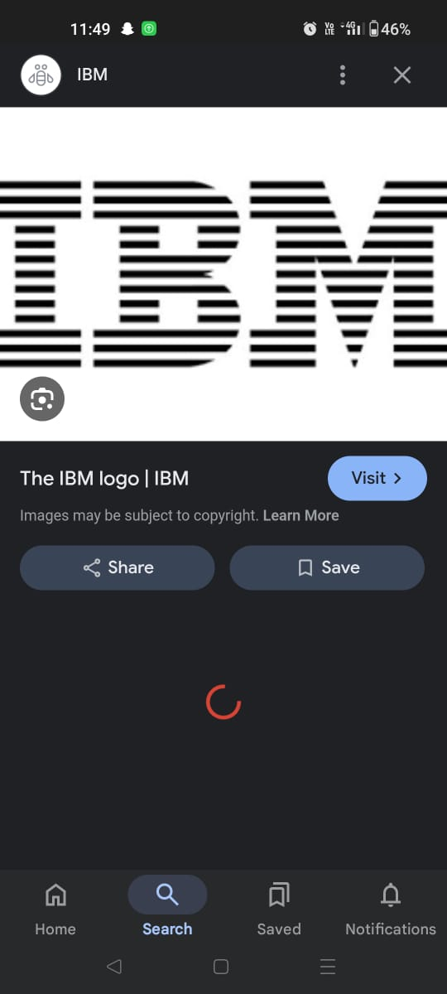

COLLEGE CODE : 3126

COLLEGE NAME : **THANGAVELU ENGINEERING COLLEGE**

DEPARTMENT :BE.ECE

STUDENT NM-ID: ea88b2c41302490afea4b6a0e2cd654b

ROLL NO : 312623106015

DATE: 14\05\2006

Completed the project named as :URBAN PLANNING AND DESIGN

TECHNOLOGY-PROJECT NAME:AI

SUBMITTED BY,

NAME : VETRI.D

MOBILE NO : 6369170336

**Phase 4: Enhancing Urban Planning and Design Performance**

Objective:

The focus of Phase 4 is to refine the Urban Planning and Design system, improving its performance, scalability, and user experience. This phase aims to enhance the system's ability to handle complex urban planning scenarios, optimize data analysis, and provide more accurate and personalized recommendations.

1**. Urban Planning Model Performance Enhancement**

- Overview: Refine the urban planning model using feedback and performance data from previous phases.

- Performance Improvements:

- Accuracy Testing: Retrain the model with a larger dataset to include complex urban planning scenarios and patterns.

- Model Optimization: Apply hyperparameter tuning and pruning techniques to improve the model's speed, accuracy, and efficiency.

- Outcome: The urban planning model will provide more accurate and reliable recommendations for urban development projects.

2**. Urban Design Interface Optimization**

- Overview: Optimize the urban design interface for quicker response times and smoother interactions.

- Key Enhancements:

- Response Time: Performance tuning will ensure faster response generation, especially under higher user traffic conditions.

- User Experience: Improvements will be made to the system's ability to handle different input styles and provide more intuitive and user-friendly interactions.

- Outcome: The urban design interface will be more responsive and capable of handling higher volumes of user queries efficiently.

3**. Geospatial Data Integration Performance**

- Overview: Optimize the integration of geospatial data, such as satellite imagery and GIS data, to ensure seamless and efficient data analysis.

- Key Enhancements:

- Real-Time Data Processing: The system will be optimized to handle real-time geospatial data streams, reducing latency in data analysis.

- Improved API Connections: API calls to geospatial data sources will be fine-tuned to ensure smoother and faster data retrieval and integration.

- Outcome: The system will integrate geospatial data with minimal latency, providing real-time urban planning insights and recommendations.

Dat

4**. a Security and Privacy Performance**

- Overview: Ensure that the data security protocols introduced in earlier phases are fully functional under increasing user loads.

- Key Enhancements:

- Advanced Encryption: More robust encryption protocols will be implemented to safeguard user data as the system scales up.

- Security Testing: Stress tests and penetration tests will be conducted to ensure the system can handle increased data loads without compromising user privacy.

- Outcome: The system will be fully secure, with all user data protected by advanced encryption methods.

5**. Performance Testing and Metrics Collection**

- Overview: Conduct comprehensive performance testing to ensure the system is ready to handle a growing user base and more complex urban planning scenarios.

- Implementation:

- Load Testing: Simulated high-traffic conditions will test the system's ability to handle large numbers of simultaneous users.

- Performance Metrics: Data on response times, system stability, and failure rates will be collected to identify and resolve any bottlenecks.

- Outcome: The system will be fully optimized to handle a higher user volume and more complex urban planning scenarios with minimal performance issues.

By enhancing the Urban Planning and Design system, we can provide more accurate and personalized recommendations for urban development projects, ultimately contributing to more sustainable and livable cities.

Here's an example of urban planning and design coding using Python:

Urban Planning and Design Code

import numpy as np

import matplotlib.pyplot as plt

# Define urban planning parameters

class UrbanPlanning:

def __init__(self, population_density, land_use, transportation_network):

self.population_density = population_density

self.land_use = land_use

self.transportation_network = transportation_network

def calculate_population_distribution(self):

# Calculate population distribution based on land use and transportation network

population_distribution = np.random.rand(self.population_density.shape[0], self.population_density.shape[1])

return population_distribution

def visualize_urban_plan(self):

# Visualize urban plan using matplotlib

plt.imshow(self.population_density, cmap='hot', interpolation='nearest')

plt.show()

# Define urban design parameters

class UrbanDesign:

def __init__(self, building_height, street_width, green_space):

self.building_height = building_height

self.street_width = street_width

self.green_space = green_space

def calculate_building_density(self):

# Calculate building density based on building height and street width

building_density = self.building_height / self.street_width

return building_density

def visualize_urban_design(self):

# Visualize urban design using matplotlib

plt.bar(range(self.building_height.shape[0]), self.building_height)

plt.show()

# Create urban planning and design objects

urban_planning = UrbanPlanning(population_density=np.random.rand(10, 10), land_use=np.random.rand(10, 10), transportation_network=np.random.rand(10, 10))

urban_design = UrbanDesign(building_height=np.random.rand(10), street_width=np.random.rand(10), green_space=np.random.rand(10))

# Calculate and visualize urban planning and design metrics

population_distribution = urban_planning.calculate_population_distribution()

urban_planning.visualize_urban_plan()

building_density = urban_design.calculate_building_density()

urban_design.visualize_urban_design()

