Low Level Design Document
for
Employee Management System (EMS)
Version 1.0

Table of Contents
Table of Contents……………………….……………………….……………………….……
1. Introduction……………………….……………………….……………………….……….
1.1 Purpose……………………….……………………….……………………….…..
1.2 Reading Suggestions……………………….……………………….……………..
2. Detailed System Design……………………….……………………….…………………...
2.1 EDLL Diagram……………………….……………………….……………………
2.2 EMS Diagram……………………….……………………….……………………
2.3 Class Description……………………….……………………….………………...
2.4 Relationship between Classes……………………….……………………….……

1. Introduction
1.1 Purpose
Employee Management System or EMS is created for management of employees of XYZ corporation. This EMS will provide a simplified menu-based interface for employee management operations including adding, removing or modifying employee details.

1.2 Reading Suggestions
Document is primarily intended for Review members for C++ Assignment 2.

2. Detailed System Design
2.1 EDLL Diagram
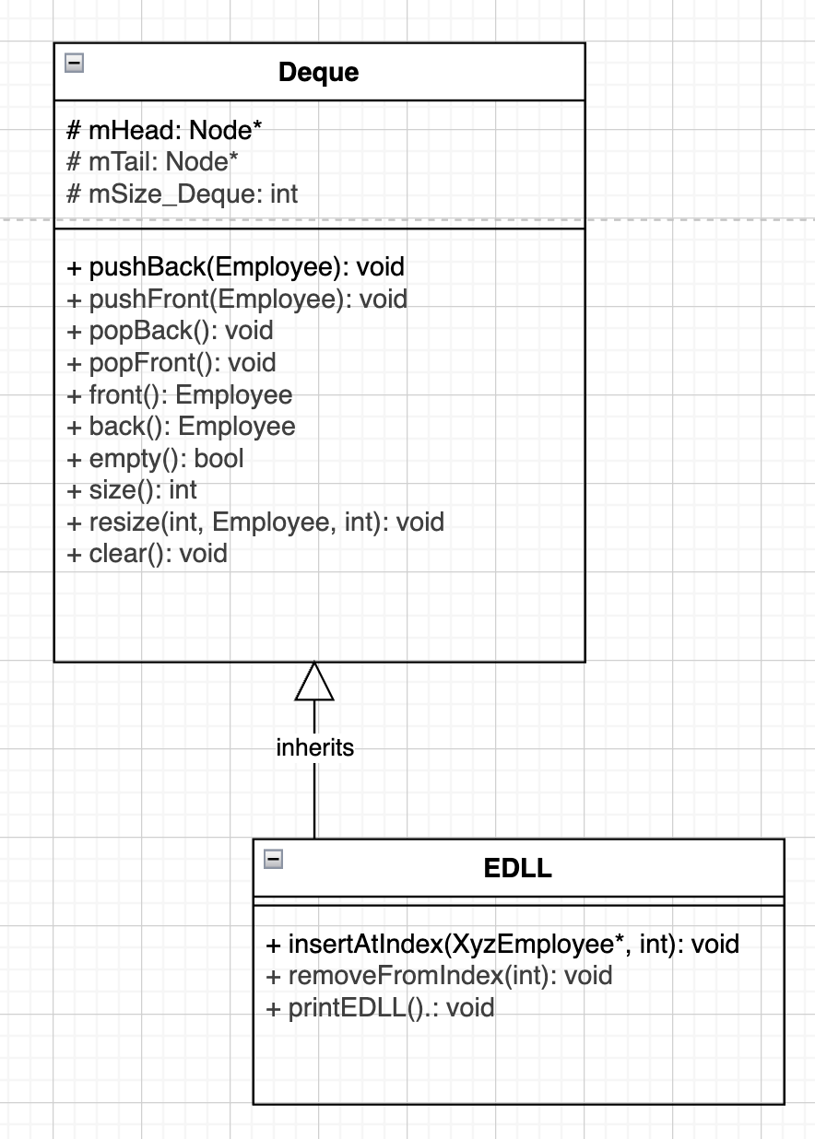

2.2 EMS Diagram
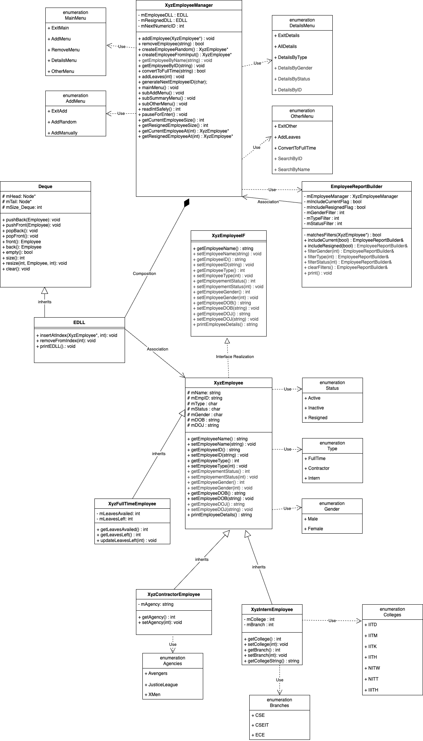
2.3 Class Description
2.3.1 XyzEmployeeManager
The management class of Employee Management System (EMS) that is responsible for adding, removing or modifying employee details according to user input from the main menu. XyzEmployeeManager maintains Employee Deque list of Active/Inactive and Resigned employees and performs operations over them.

Component | Description
mEmployeeDLL | Deque for Storing Active/Inactive Employees of all types – Full Time, Contractors and Interns
mResignedDLL | Deque for storing resigned employees of all types
mNextNumericID | Store value for incremental employee ID
addEmployee(XyzEmployee*) | Method to add Employee to EDLLs
removeEmployee(string) | Method to add Employee to mResignedDLL
createEmployeeRandom() | Create a random employee
createEmployeeFromInput() | Create an employee based on user input
getEmployeeByName(string) | Prints employee’s details by name
getEmployeeByID(string) | Prints employee’s details by employee ID
convertToFullTime(string) | Converts Contractor or Interns to Full Time Employee
addLeaves(int) | Update leaves for all full time employees
generateNextEmployeeID(char) | Generate next Employee ID
mainMenu() | EMS Main Menu
subAddMenu() | EMS Add Sub Menu
subSummaryMenu() | EMS Summary sub menu
subOtherMenu() | EMS Other sub menu
readIntSafely() | Read function for integer inputs
pauseForEnter() | Enter key buffer
getCurrentSize() | Returns size of mEmployeeDLL
getResignedSize() | Returns size of mResignedDLL
getCurrentEmployeeAt(int) | Returns XyzEmployee* at index in mEmployeeDLL
getResignedEmployeeAt(int) | Returns XyzEmployee* at index in mResignedDLL

2.3.2 XyzEmployeeIF
Employee Interface class which will be used to realize EmployeeBase class for creating and maintaining employee objects.

Component | Description
getEmployeeName() | Interface functions
setEmployeeName(string)
getEmployeeID()
setEmployeeID(string)
getEmployeeType()
setEmployeeType(int)
getEmployementStatus()
getEmployementStatus(int)
getEmployeeGender()
setEmployeeGender(int)
getEmployeeDOB()
setEmployeeDOB(string)
getEmployeeDOJ()
setEmployeeDOJ(string)
printEmployeeDetails(string)

2.3.3 XyzEmployee
Employee Base class which has all employee details’ instances.

Component | Description
mName | Instance to store Employee’s Name
mEmpID | Instance to store Employee’s ID
mDOB | Instance to store Employee’s Date of Birth
mDOJ | Instance to store Employee’s Date of Joining
mType | Instance to store Employee’s Type – Full Time, Contractor, Intern
mStatus | Instance to store Employee’s Status – Active/Inactive/Resigned
mGender | Instance to store Employee’s Name
getEmployeeName() | Returns Employee’s Name
setEmployeeName(string) | Sets Employee’s Name
getEmployeeID() | Returns Employee’s ID
setEmployeeID(string) | Sets Employee’s ID
getEmployeeType() | Returns Employee’s Type
setEmployeeType(int) | Sets Employee’s Type
getEmployementStatus() | Returns Employee’s Status
setEmployementStatus(int) | Sets Employee’s Status
getEmployeeGender() | Returns Employee’s Gender
setEmployeeGender(int) | Sets Employee’s Gender
getEmployeeDOB() | Returns Employee’s Date of Birth
setEmployeeDOB(string) | Sets Employee’s Date of Birth
getEmployeeDOJ() | Returns Employee’s Date of Joining
setEmployeeDOJ(string) | Sets Employee’s Date of Joining
printEmployeeDetails(string) | Print Employee details

2.3.4 XyzFullTimeEmployee
Full Time Employee class having XyzEmployee class instances and methods along with extended capabilities including leaves details and related methods.

Component | Description
mLeavesAvailed | Stores leaves availed by an employee
mLeavesLeft | Stores leaves left with an employee
getLeavesAvailed() | Returns leaves availed
getLeavesLeft() | Returns leaves left
updateLeavesLeft() | Updates by adding leaves to ‘leaves left’ with an employee

2.3.5 XyzContractorEmployee
Contractor Employee class having XyzEmployee class instances and methods along with extended capabilities including agency details and related methods.

Component | Description
mAgency | Stores Agency of the Contractor
getAgency() | Returns Agency of the Contractor
setAgency(int) | Sets Agency for the Contractor

2.3.6 XyzInternEmployee
Intern Employee class having XyzEmployee class instances and methods along with extended capabilities including college and branch details and related methods.

Component | Description
mCollege | Stores college name of intern
mBranch | Stores branch of Intern
getCollege() | Returns college of Intern
setCollege(int) | Sets college of Intern
getBranch() | Returns branch of intern
setBranch(int) | Sets branch of intern

2.3.7 Deque
Standard Deque template class implementation which will be used as a base class to implement EDLL class to store employee data nodes.

Component | Description
mHead | Pointer to head element of Deque
mTail | Pointer to tail element of Deque
mSize_Deque | Stores size of Deque
pushBack(S) | Pushes Employee object to back of deque
pushFront(S) | Pushes Employee object to front of deque
popBack() | Pops from back of deque
popFront() | Pops from front of deque
front() | Prints first element of deque
back() | Prints last element of deque
empty() | Returns true if deque is empty
clear() | Clears deque and sets its head and tail pointers to null
size() | Returns size of deque
resize(int, S, int) | Resizes deque based on direction and new size.

2.3.8 EDLL
Extended Doubly Linked List Class is used to create a Deque structure with extended capabilities which will be used by XyzEmployeeManager to create Deque to store employee data nodes.

Component | Description
insertAtIndex(XyzEmployee*, int) | Inserts a new employee at index n
removeFromIndex(int) | Removes the employee from deque at index n

2.3.9 EmployeeReportBuilder
Builder Design Class for using in Summary menu to filter data based on input

Component | Description
mEmployeeManager | XyzEmployeeManager instance (reference)
mIncludeCurrentFlag | Flag to filter Current employees
mIncludeResignedFlag | Flag to filter Resigned employees
mGenderFilter | Flag to filter Male/Female employees
mTypeFilter | Flag to filter Full-Time/Contractor/Intern employees
mStatusFilter | Flag to filter Active/Inactive/Resigned employees
includeCurrent(bool) | Check current flag
includeResigned(bool) | Check resigned flag
filterGender(int) | Check gender flag
filterType(int) | Check type flag
filterStatus(int) | Check status flag
clearFilters() | Clear all filters to default
print() | Print based on filters

2.4 Relationship between Classes
2.4.1 Interface Realization
- XyzEmployee class realizes XyzEmployeeIF interface to create a base class to create employee objects and hold its details.

2.4.2 Inheritance
- XyzEmployee base class is inherited into XyzFullTimeEmployee, XyzContractorEmployee, and XyzInternEmployee.
- EDLL class is inherited from Deque Template class for XyzEmployee* type.

2.4.3 Composition
- There is a composition relationship from EDLL to XyzEmployeeManager as XyzEmployeeManager has 2 class instances of EDLL class and EDLL class can only exist inside XyzEmployeeManager class.

2.4.4 Association
- There is an association relation between EDLL and XyzEmployee class as an EDLL class is associated with one or more XyzEmployee class objects.
- There is association relation between EmployeeReportBuilder and XyzEmployeeManager as there is an instance of EmployeeReportBuilder in XyzEmployeeManager.

2.4.5 Dependency
- XyzEmployeeManager uses EmployeeReportBuilder for one function.
- XyzEmployeeManager class depends on MainMenu, AddMenu, DetailsMenu, and OtherMenu enums.
- XyzEmployee base class depends upon Status, Type and Gender enums.
- XyzContractorEmployee class depends upon or uses Agencies enum.
- XyzInternEmployee class depends upon or uses Colleges and Branches enums.

