Employee Management System
LLDD
Version 0.1
10/09/2025
Isha Ashok

Table of Contents
- PROJECT MANAGEMENT
1.1 Document Review and Approval Process
1.2 Reviewers
- INTRODUCTION
2.1 Related Documents
2.2 Definitions, Acronyms, Terms, and Concepts
2.3 Overview and Scope
- ASSUMPTIONS AND REQUIREMENTS
3.1 Assumptions
3.2 Requirements
3.2.1 Functional Requirements
3.2.2 Non-Functional Requirements
- EMS COMPONENTS
4.1 Design Decisions
4.2 Implementation Overview
4.3 Class Descriptions
4.4 EMS Class Diagram
- TESTING
- DEPENDENCIES

To change the fields being used, go to the File – Properties – Summary and type in the new Title, Author, and Department (Keywords) information. Then right click on the field and choose Update Field and the newly typed in information will appear in the field. The date on the title page is the SaveDate (date that the document was last saved) and the date in the footer is the Print Date. The name of the document is also listed in the footer.

Project management

This section identifies the key project management elements of this function.
1.1 Document Review and Approval Process
Table 1 provides a list of reviewers across development and system consumers of this function.
provides the list of technical and management contacts, identified by the document owner and other document reviewers, with responsibility to approve final revisions of this document for general distribution. Those identified as approvers are implicitly included as reviewers.
Version numbers are composed of a major and minor revision number, M.m. Major revisions '1' and higher with minor revisions '0' represent revisions approved for publication.

Reviewers
Name, Location | Responsibility | Version
Aditya Saripalli | PHYP
Venumula Prabath Reddy | PHYP
Table 1: Required Reviewers

Introduction

This document details the low-level design of XYZ Corporation’s Employee Management System using an extended doubly linked list.

RelatedDocuments

GenericDeque

Definitions, Acronyms, Terms, and Concepts

Overview and scope
The Employee Management System for XYZ Corporation is a robust application designed to effectively handle employee records using a custom Extended Doubly Linked List (EDLL) data structure. This system categorizes employees into three types: Full-Time, Contractors, and Interns, each having distinct attributes and operational rules. It tracks the employment status of each employee, which can be Active, Inactive, or Resigned, and organizes employee data accordingly by maintaining separate lists for active/inactive employees and resigned employees.
The system provides dynamic insertion and deletion of employee records at any position in the list, allowing flexible and efficient management of the workforce. It captures detailed employee information, including general details such as name, employee ID, date of joining, and contact details, as well as type-specific details like leaves for full-time employees, agency names for contractors, and educational details for interns. When employees resign, their records are archived in a resigned employee list with limited data for historical reference.
Additionally, the EMS facilitates searching for employees based on unique identifiers or names and supports updates to employee data. It also allows for converting employee types, such as promoting interns to full-time employees, reflecting career progression. Batch operations like adding leaves to all full-time employees streamline administrative tasks.
This system is implemented without relying on standard library containers, focusing instead on custom-built data structures to ensure optimal performance and control over memory management. It is designed with modularity and scalability in mind to accommodate future enhancements and new employee categories, providing a comprehensive and maintainable solution for employee data management.

Assumptions and Requirements

3.1 Assumptions
A-1: Each employee has a unique employee ID for identification.
A-2: Input data for employees is assumed to be valid and properly formatted.
A-3: Employee types are strictly categorized as Full-Time, Contractor, or Intern.
A-4: Resigned employees are permanently archived and excluded from active or inactive lists.
A-5: Employee type conversion requires proper updating of employee details without data loss.
A-6: Batch operations, such as adding leaves, apply only to the relevant employee category (e.g., Full-Time).
A-7: No use of standard library containers; data management is implemented using custom Extended Doubly Linked List (EDLL).
A-8: Manual memory management and pointer handling are correctly implemented and error-free.

3.2 Requirements
R-1: Efficient insertion, deletion, and traversal operations within the EDLL structure.
R-2: Maintain separate lists for active/inactive employees and resigned employees.
R-3: Support dynamic operations (add, remove, convert) at any position within employee lists.
R-4: Input validation and robust error handling for all employee operations.
R-5: Ability to convert employees between types (Full-Time, Contractor, Intern) while maintaining data integrity.
R-6: Support batch updates on employee attributes (e.g., adding leaves for Full-Time employees).
R-7: Scalable and modular design allowing easy addition of new employee types or features.R-1: Efficient insertion, deletion, and traversal operations within the EDLL structure.
R-2: Maintain separate lists for active/inactive employees and resigned employees.
R-3: Support dynamic operations (add, remove, convert) at any position within employee lists.
R-4: Input validation and robust error handling for all employee operations.
R-5: Ability to convert employees between types (Full-Time, Contractor, Intern) while maintaining data integrity.
R-6: Support batch updates on employee attributes (e.g., adding leaves for Full-Time employees).
R-7: Scalable and modular design allowing easy addition of new employee types or features.HDAT Shared Library Design

EMS COMPONENT

The purpose of this assignment is to develop an Employee Management System for XYZ Corporation that effectively manages various types of employees, including Full-Time employees, Contractors, and Interns. The system uses a custom Extended Doubly Linked List (EDLL) as its core data structure to store and manage employee records dynamically. This EDLL extends the basic deque functionality by supporting insertion and removal of elements from the middle of the list based on a specified position.
The Employee Management System encapsulates employee details such as name, ID, gender, dates of birth and joining, status, and type-specific information like leave balances, external agencies, or educational details. Additionally, the system maintains separate lists for active/inactive employees and resigned employees, allowing seamless tracking and management of workforce status.
By avoiding the use of C++ Standard Template Library containers and implementing all data structures from scratch, the assignment emphasizes deep understanding of pointers, memory management, and object-oriented principles. The system is designed with extensibility and modularity in mind, allowing easy incorporation of additional employee types or management features in the future.
The assignment also includes a menu-driven interface to perform various operations such as adding, removing, updating employee records, searching, and generating summaries based on multiple criteria. Overall, this project aims to combine data structure design, OOP concepts, and practical software engineering principles to build a real-world applicable employee management solution.

4.1 Design Decision
The design of the Employee Management System (EMS) focuses on modularity, extensibility, and maintainability. Key decisions include the use of an abstract base class (Employee) to represent general employee attributes and behavior, allowing for specialization through derived classes like Fulltime, Contractor and Intern. This approach facilitates adding new employee types with minimal changes to existing code.
A Deque data structure is chosen for managing employees because it provides efficient insertion and removal of elements from both ends, which suits typical queue-like operations needed in employee management workflows. The EmployeeManager class encapsulates all operations related to employee management, promoting single responsibility and clean separation of concerns.
Error handling is implemented using custom exceptions to ensure robustness and clear communication of issues during runtime. Input validation utilities are included to maintain data integrity and improve user interaction.

Implementation Overview
The EMS is implemented using C++ templates to allow generic handling of different data types, including custom objects like Student and Employee. The system uses class inheritance and polymorphism to manage employee types, enabling uniform handling of diverse employee data.
The Deque template class manages the collection of employee objects, supporting dynamic resizing, insertion, deletion, and access operations. EmployeeManager interfaces with the Deque to perform CRUD operations, employee searches, and sorting.
A command-line interface provides a menu-driven interaction model, facilitating operations such as adding employees, removing them, viewing employee lists, searching by attributes, and sorting by salary or hours worked.
This modular structure ensures that the EMS can be extended or modified easily while maintaining clear separation between data structures, business logic, and user interaction components.
4.3 Class descriptions
1. XyzEmployeeIF (Interface)
- Defines the standard interface for all employee types.
- Ensures consistency in employee data handling across subclasses.
- Functions:
  - getName() – Returns employee name.
  - getID() – Returns employee ID.
  - getGender() – Returns employee gender.
  - getDOB() – Returns date of birth.
  - getDOJ() – Returns date of joining.
  - getDOL() – Returns date of leaving.
  - getStatus() – Returns employment status.
  - setStatus(Status) – Updates employment status.
  - setDOJ(Date) – Updates date of joining.
  - setDOL(Date) – Updates date of leaving.
  - printDetails() – Displays employee details.
2. XyzEmployeeBase (Abstract Class)
- Implements the XyzEmployeeIF interface.
- Serves as a base class for all employee types.
- Attributes:
  - name – Employee name.
  - empID – Employee ID.
  - gender – Gender of employee.
  - dob – Date of birth.
  - doj – Date of joining.
  - status – Employment status.
- Functions:
  - printDetails() – Prints basic employee information.
3. XyzFullTimeEmployee (Derived Class)
- Inherits from XyzEmployeeBase.
- Represents a full-time employee.
- Attributes:
  - leavesAvailed – Number of leaves taken.
  - maxLeaves – Maximum allowed leaves (default = 22).
- Functions:
  - getLeavesAvailed() – Returns number of leaves availed.
  - setLeavesAvailed(int) – Updates leaves availed.
  - printDetails() – Prints full-time employee details.
4. XyzContractorEmployee (Derived Class)
- Inherits from XyzEmployeeBase.
- Represents a contractor employee associated with an external agency.
- Attribute:
  - agency – Contractor’s agency name.
- Functions:
  - getAgency() – Returns agency name.
  - printDetails() – Prints contractor employee details.
5. XyzInternEmployee (Derived Class)
- Inherits from XyzEmployeeBase.
- Represents an intern linked to a college and branch.
- Attributes:
  - college – College name.
  - branch – Academic branch.
- Functions:
  - getCollege() – Returns college name.
  - getBranch() – Returns branch name.
  - printDetails() – Prints intern details.
6. XyzEmployeeManager (Manager Class)
- Handles storage and management of all employee data.
- Manages active/inactive and resigned employee lists.
- Attributes:
  - activeInactiveEmployees – EDLL<XyzEmployeeBase*> for current employees.
  - resignedEmployees – EDLL<XyzEmployeeBase*> for resigned employees.
- Functions:
  - addEmployeeRandom() – Adds a randomly generated employee.
  - addFullTimeEmployee() – Adds a new full-time employee.
  - addContractorEmployee() – Adds a new contractor employee.
  - addInternEmployee() – Adds a new intern employee.
  - removeEmployee(string) – Removes an employee by ID.
  - printAllEmployees() – Displays all employees.
  - printEmployeesByType(type) – Prints employees filtered by type.
  - printEmployeesByStatus(status) – Prints employees filtered by status.
  - printEmployeeById(string) – Prints details of a specific employee.
  - searchEmployeeByName(string) – Searches employee by name.
  - convertInternToFullTime(string) – Converts an intern to a full-time employee.
  - addLeavesToFullTime(int) – Adds leave days to full-time employees.
7. XyzEmployeeBuilder (Builder Class)
- Implements Builder design pattern for employee creation.
- Generates unique and random employee records.
- Attribute:
  - sSeq – Static counter for generating sequential IDs.
- Functions:
  - buildRandom() – Builds a random employee (any type).
  - buildResignedMinimal(XyzEmpBase*) – Builds a minimal resigned employee record.
8. EDLL<T> (Generic Doubly Linked List)
- Template-based implementation for storing employee data.
- Attributes:
  - head – Pointer to first node.
  - tail – Pointer to last node.
- Functions:
  - addFront(T) – Adds a node at the front.
  - addRear(T) – Adds a node at the rear.
  - addAtPosition(T, int) – Inserts a node at a given position.
  - removeFront() – Removes the first node.
  - removeRear() – Removes the last node.
  - removeAtPosition(int) – Removes node at a specific position.
  - isEmpty() – Checks if list is empty.

EMS Class Diagram
The UML class diagram provides a clear and organized visual representation of the core components and their relationships within the Employee Management System. It outlines the key classes such as the base Employee interface, specialized employee types like Salaried and Hourly employees, and the EmployeeManager class that handles employee operations. The diagram also shows how the Deque class is used as a container to store and manage employee objects. This overview helps to understand the system’s structure, inheritance, and interaction between classes, serving as a valuable guide for implementation and maintenance.
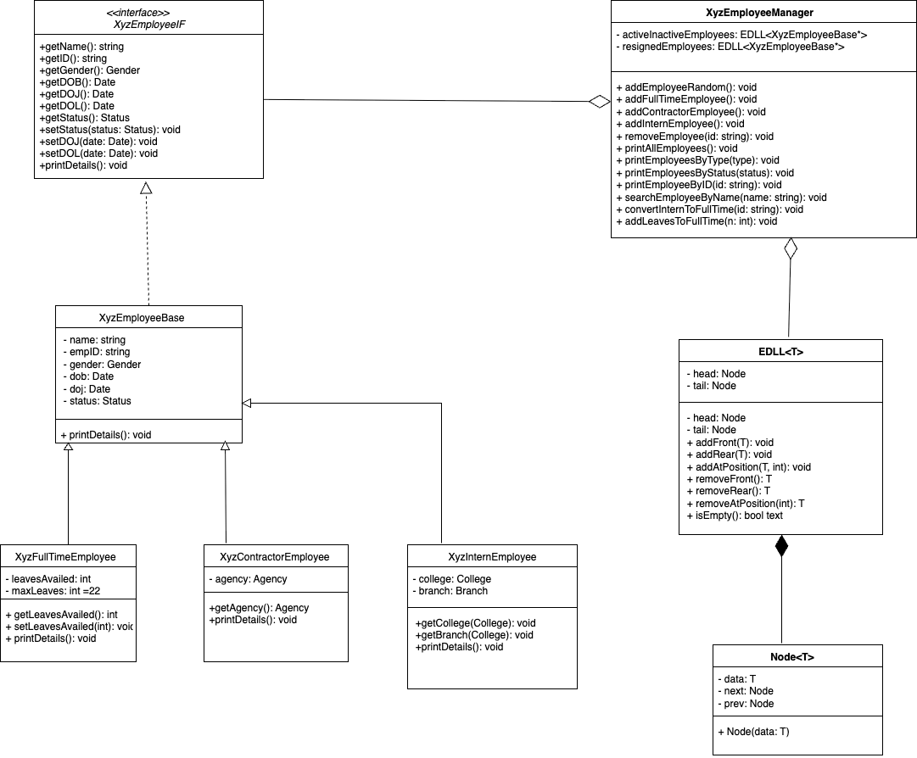

5 Testing :
• Unit tested core modules like EDLL and Employee classes.
• Verified add, remove, and search functionalities.
• Checked list size and memory management.
• Tested input validation and error handling.
• Performed integration testing with menu-driven interface.
• Validated display of employee data and status updates.

Dependencies:
• Custom Extended Doubly Linked List (EDLL) for employee storage and management.
• Employee classes (Full-Time, Contractor, Intern) inheriting from a common interface.
• Utility functions for input validation and enums for status/type management.
• Exception handling module for robust error management.
• Menu-driven main program to interact with the Employee Manager.

