Employee Management System (EMS)

- Overview
- Assumptions & Requirements
- Classes and their Description
- Class Diagram
- Functional Flow

Overview:
EMS (Employee Management System) maintains and manages the employee details of an organization.
EMS (Employee Management System) does the following things
- Creates Employees with random data, random data depends on the type of employee (full-timer, contractor, intern).
  - All type of employees contains common data such as Name, ID, Gender, DOB, DOJ.
  - Based on the employee type they will contain extra attributes.
    - Full-timer – Leave details
    - Contractor – Agency details
    - Intern – College and Branch details
- EMS maintains 2 lists for employees based on their present work status
  - Active/inactive employee list (who are working or on long leave)
  - Resigned employee list (who left the organization) (basic details)
- Adds new Full-timer/Contractor/Intern employee to the employee list.
- Removes Full-timer/Contractor/Intern employee from employee list.
Adds those employee details to the Resigned Employee list.
- Prints all Full-timer/Contractor/Intern Employee’s info.
- Prints all resigned employee’s info.
- Prints all employee info (active/inactive/resigned employees).
- Searches an employee with name/ID.
- Converts Contractor/Intern to Full-timer and updates employee info.
- Add additional number of leaves to Full-time employee.
Provision for testing:
- The System also provides a way to test/execute the functionalities implemented.
- Provides a menu-driven approach to test/execute functionalities.
Assumptions and Requirements:
- Generate random employee data.
  - While generating random employee data we use some predefined data as reference.
  - In case of generating a name,
    - Take a list of names (predefined data)
    - Generate 2 random numbers from 1 to length of list.
    - We use those indexes to form the name of Employee.
  - In case of generating ID,
    - Employee ID format : XYZ<4 digit ID val><type code>
Ex : XYZ0023F (F refers to full-timer)
    - We have some predefined ID conventions like
      - IDs should start with XYZ
      - A random 4 digit number (generated between 0 to 9999)
      - Employee type code (randomly picked from [F,C,I])
  - In case of generating Gender,
    - picked randomly from [male, female].
    - Might need to implement logic to pick name based on their gender or vice versa.
  - In case of generating Status of Employee,
    - Picked randomly from [Active, Inactive, Resigned]
  - DOB need to be generated randomly, age should be above 21
  - DOJ need to be generated randomly, keep the age in consideration
  - Contractors Agency names should be picked randomly from [Avengers, Justice League, X-Men]
  - Interns colleges should be picked from [IIT Delhi, IIT Mumbai, IIT Kanpur, IIT Hyderabad, NIT Warangal, NIT Tiruchi].
  - Interns branch should be randomly picked from [ECE, CSE, CSIT].
- Need a logic to generate random numbers.
Classes and their description:
- Class XyzEmployeeInterface:
  - Is an interface class, contains pure virtual functions related to all employee operations (Employee class and Xyz<type>Employee classes).
  - As this class is an interface it doesn’t contain any data(attributes).
- Class XyzEmployee:
  - is a derived class from EmployeeInterface class. (Abstract class)
  - contains attributes for basic details like Name, ID, Type, Status, Gender, DOB, DOJ.
  - contains function implementations for Employee common ops, virtual functions of Xyz<type>Employee ops (holder functions if we create objects of Employee class (useful for resigned employee details)).
- Class Xyz<type>Employee:
  - is a derived class from Employee class
  - Contains attributes specific to Employee type.
  - Contains function implementations for Xyz<type>Employee specific ops.
- Class Node:
  - Contains pointers to next, prev nodes and node data.
  - Node data can be of any type, Node is a template class.
  - Contains function implementations required for node ops (get and set methods, extraction operator)
- Class Deque:
  - Contains pointers to Head and Tail node of Deque.
  - Contains function implementations required for Deque ops
    - Get and set methods of Head and Tail nodes
    - Push and pop methods to add/remove nodes to/from deque.
    - Traversal methods to print deque contents
    - Indexing operator method to fetch nth node
    - Resize method to reduce/increase the deque size
    - Cleardeque method to properly clear deque (freeing mem).
- Class ExtDeque:
  - Contains methods to add/remove nodes at a index position
- Class XyZEmployeeManager:
  - Contains 2 ExtDeque pointers, they are
- Active/Inacative employees deque
- Resigned Employees deque
  - Contains function implementations required for EmployeeManager ops
    - Get methods for ExtDeque’s.
    - Methods to add/remove Full-timer/contractor/Intern Employees.
    - Methods to print employee details.
    - Search a employee with ID/name.

UML Class Diagram:
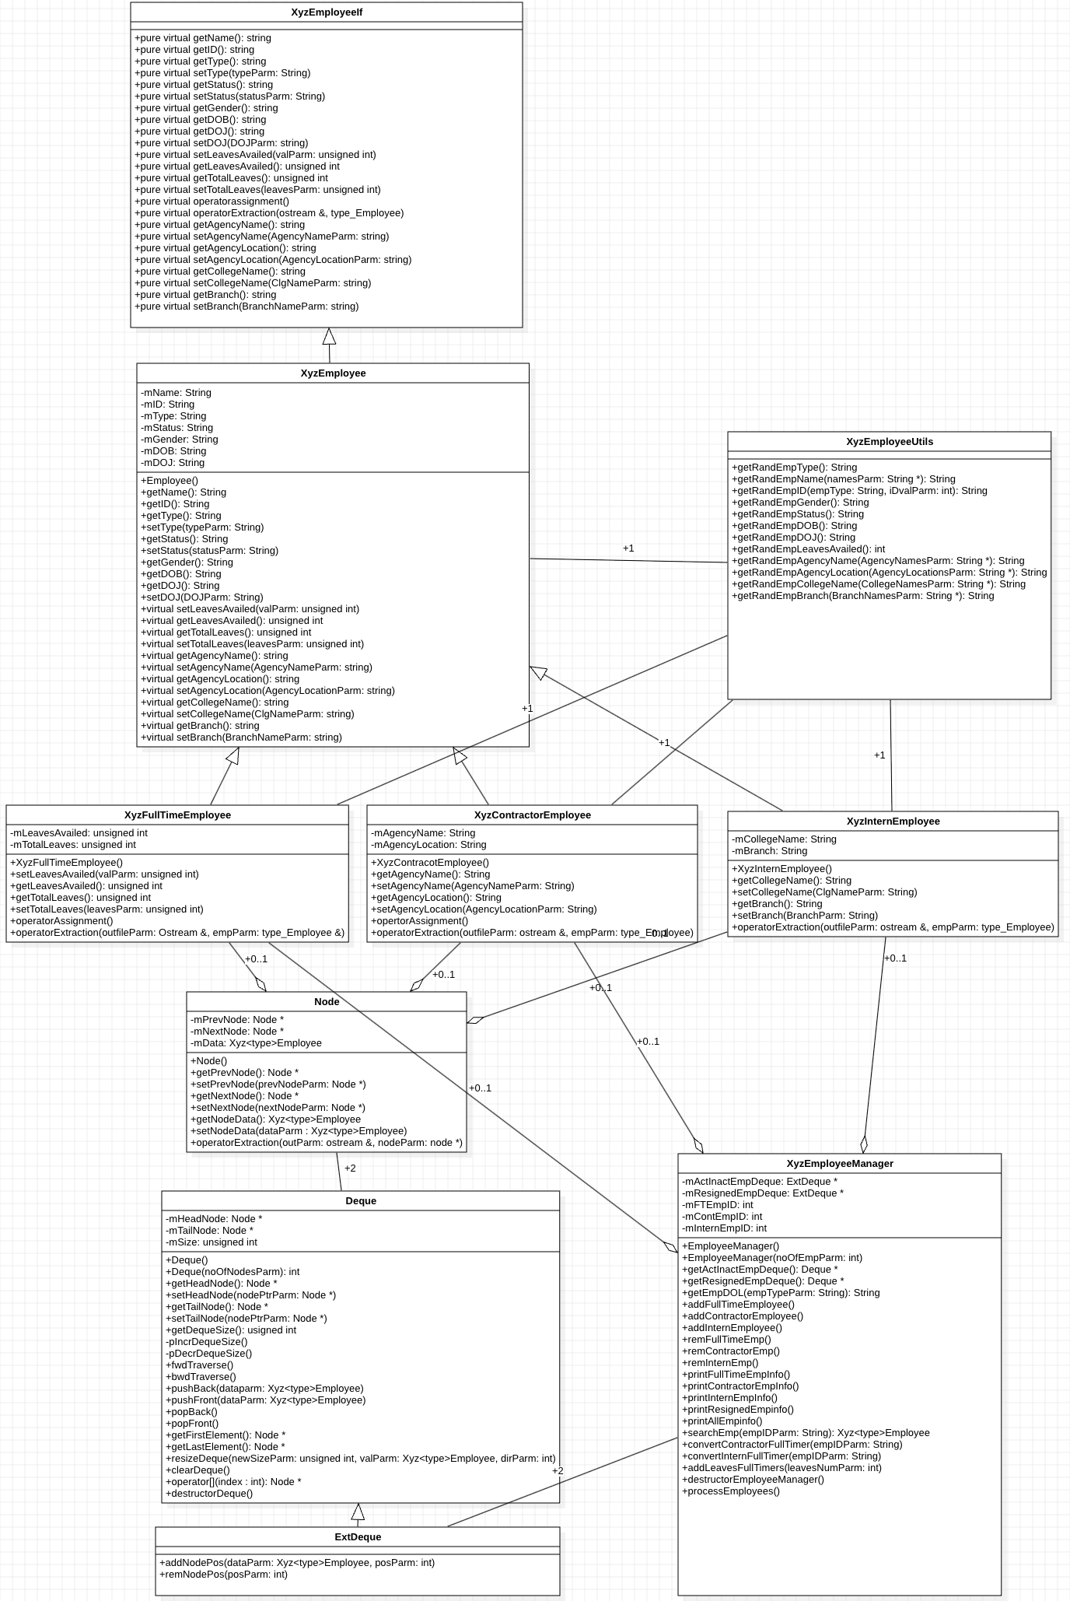
Overall system Functional Flow:
Stop

Perform EMS operation based on input
Show Option Menu

Read I/P from User
Create Employee Manager Object,
Creates employees list with random data
Start

- main() function creates a EmployeeManager object with or without number of employees as parameter.
- If number of employees is given as parameter then EmployeeManager constructor will generate random type of employee for number of employee times and calls corresponding method to add Employee.
- The add<type>Employee method creates a Xyz<type>employee object and keeps it in the respective deque (active/inactive or resigned) based on the status(active, inactive, resigned) of that employee.
- Employee class constructor and Xyz<type>Employee class constructor will fetch respective random data using the RandDataGenerator class methods. (We can make random functions as global functions)
- Then the menu options will be displayed to user.
- Based on the user choice corresponding methods will be called from EmployeeManager Class.

