Introducing Db2U Next Gen - Modernizing Db2 for OpenShift and Kubernetes
By Austin Clifford & Janpreet Singh Chandhok
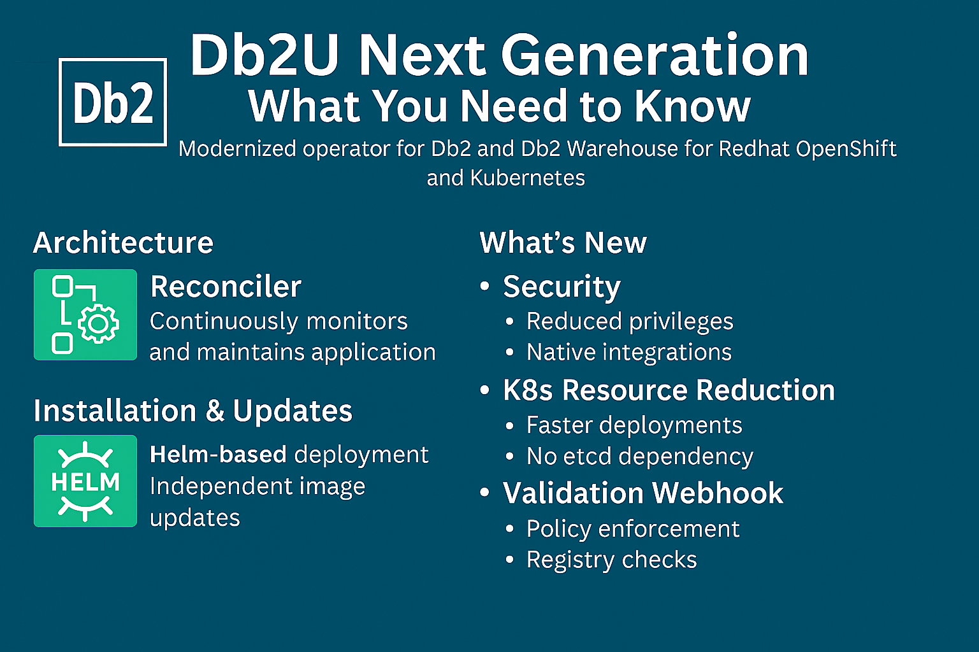
The current Db2 Operator has served us well, but the future demands more agility, security, and simplicity. Enter Db2U Next Gen—a modern operator designed for Kubernetes-native deployments of Db2 and Db2 Warehouse. This evolution replaces the legacy Operator Lifecycle Manager (OLM) with a Helm-based, GitOps-compatible installation model, making deployments faster and more aligned with cloud-native best practices.
This is the first in a series of blogs for Db2U Next Gen, that will cover topics including:
- Helm and GitOps
- Db2U Next Gen and the Kubernetes ecosystem
- User Management
- Certificate Management

Why Next Gen Matters
Next Gen isn’t just an upgrade—it’s a smarter way to manage Db2 for Kubernetes and OpenShift. It offers:
- Independent resource updates for flexibility
- Clear visibility into resource status
- Improved performance and serviceability for a better user experience

What’s at the Core?
At the heart of the operator is the reconciler—a component that continuously monitors your application state and ensures everything stays in sync. If something drifts, the reconciler steps in to correct it. The result? A consistent, reliable environment without manual intervention.

7 Key Improvements Over the Current Operator

1. Security First
- Reduced clusterrole privileges
- Support for custom SCCs, service accounts, and RBAC
- Fewer images, reducing the attack surface
- Integration with Kubernetes certificate managers and identity providers

2. Resource Efficiency
- Faster deployments with lower resource consumption
- Default Db2 configurations embedded in the image
- Simplified operator model with fewer intermediary resources
- No external dependencies like etcd

3. Validation & Mutating Webhooks
The validation webhook acts as a gatekeeper, intercepting API requests before they hit the cluster. It enforces policies such as:
- Validating image versions and registry sources
- Restricting downtime-causing changes unless annotated
- Ensuring SSL configurations and certificate integrity
- Mutate the Db2uInstance Custom Resource (CR) with the default settings

4. Streamlined Installation
Next Gen uses Helm instead of OLM, delivering:
- Reduced reliance on cluster-admin permissions
- No global pull secrets or ICSPs
- Support for Declarative GitOps toolchains like Argo CD
- Flexible RBAC options

5. Independent Updates & Semantic Versioning
Db2 images and the operator can now be updated independently. Images follow a clear semantic versioning scheme for predictable upgrades:
spec.image: icr.io/db2u/db2u.<DBTYPE>:VRMF-CSB
Example: icr.io/db2u/db2u.db2wh:12.1.3.0

6. High Availability (HA) Reimagined
Next Gen replaces built-in HA (a.k.a. Wolverine) which uses etcd for state, with a new HA framework which relies on runit (a lightweight process manager) and Kubernetes-native lifecycle probes. This design improves resiliency, recovery times as well as decentralizing failure detection, allowing pods to self-heal.

7. Storage Pre-checker
Avoid surprises during deployment with the storage pre-checker Init Container, which validates storage configurations before workloads start. Validation results are posted into the Db2uInstance CR status as well as into a log file on disk, helping you to understand any issues in your environment while deploying Db2.

Ready to Try It?
Db2U Next Gen is available as a technical preview supporting Db2 version 12.1.3. Contact IBM Technical Support to request access to the Helm chart and experience Next Gen for yourself.

About the Authors
Austin Clifford is a Senior Technical Staff Member in Hybrid Data Management based in the Ireland Lab. He has worked with database, data lake and warehousing technologies for more than two decades. In 2012, Austin led the team to achieve a Guinness World Record for the Largest Data Warehouse, a record that IBM held for two years. Austin has authored numerous papers and patents, advises clients on data warehouse, analytics and containerization best practices and is a regular speaker at technical conferences.
Janpreet Singh Chandhok is a software engineer working in the Db2 containerization offering with special focus on hybrid cloud technologies.
Aruna De Silva is the architect for Db2/Db2 Warehouse containerized offerings on IBM Cloud Pack for Data, OpenShift and Kubernetes. He has nearly two decades of database technology experience and is based off IBM Toronto software laboratory. Since 2015, he has been actively involved with modernizing Db2 bringing Db2 Warehouse – Common Container, the first containerized Db2 solution out into production in 2016. Since 2019, he has been primarily focused on bringing the success of Db2 Warehouse into cloud native platforms such as OpenShift and Kubernetes while embracing micro service architecture and deployment patterns. He can be reached at adesilva@ca.ibm.com.

References
https://www.ibm.com/support/pages/db2u-next-generation

