Effortless Db2 Modernization with Db2 Bridge: Achieve Zero Downtime Migration and Enterprise Grade Resilience

By Pranav Sridhar and Muskan Malhotra
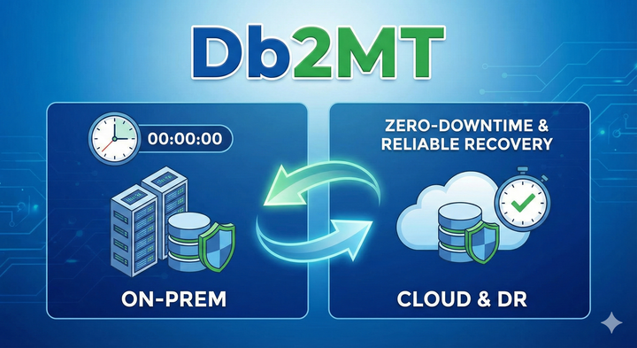

Introduction
Db2MT is a feature of Db2 Bridge that makes it easier to back up and restore Db2 databases. The backups are taken without any downtime and supports migration to IBM Cloud Db2 and AWS RDS for Db2. This feature is designed to address the critical gaps of slow, risky migrations and unreliable disaster recovery paths by enabling zero downtime migration and a guaranteed rollback capability.
This post explores how this feature can be used for database migration and disaster recovery. It dives into the benefits of zero downtime operations, cloud integration and direct streaming for speed and efficiency. It uses tools such as automated alias management and two-phase recovery to ensure reliability and zero data loss, making migrations safer and disaster recovery strategies stronger.

What is IBM Db2 Bridge?
IBM Db2 Bridge is a robust data movement tool designed to support wide range of enterprise migration scenarios. Whether you're upgrading hardware, shifting operating systems, or adopting cloud native environments, Db2 Bridge simplifies the process by leveraging ODBC connectivity, making it highly adaptable.
The tool offers several standout features, including support for diverse workloads both transactional and analytical across on-premises and cloud deployments. It operates seamlessly across different operating systems and hardware architectures, ensuring smooth migrations while maintaining data integrity.
Db2 Bridge integrates effortlessly into IBM’s data ecosystem, acting as a bridge between legacy systems and modern Db2 deployments. This enables organizations to modernize their infrastructure without rewriting applications or compromising data fidelity.

Use Cases
Db2MT is a powerful utility within Db2 Bridge that automates and simplifies backup and restore operations for Db2 databases across on-prem, hybrid and cloud environments. It supports direct streaming to S3 compatible storage, secure credential management via Storage Access Alias (SAA) and integrates with platform specific APIs for restore operations.
- Cloud Migration
Organizations moving workloads from on-premises to cloud environments can leverage direct streaming backups to S3 compatible storage for faster data transfer and immediate availability during migration.
- Disaster Recovery (DR)
Storing backups directly in the cloud ensures quick recovery in case of hardware failures or site outages. The two-phase restore process guarantees zero data loss and minimal downtime.
- Hybrid Deployments
Enterprises running Db2 across on-prem and cloud environments can use SAA based backups to maintain consistent, secure and automated backup workflows across both platforms.
- Regulatory Compliance
Secure credential management through Db2 keystore and IAM based authentication helps meet compliance requirements for data protection and encryption.

Db2MT: Backup
Db2 provides two primary options for creating database backups: local backups to on-premises storage and direct streaming to S3 compatible object storage. Traditionally, backups taken locally are later uploaded to cloud storage using third party tools such as MinIO or similar utilities. While this approach works, it introduces additional steps and delays because the backup must be written to disk and then transferred to the cloud.
In contrast, streaming backups directly to the cloud offers significant advantages. By eliminating intermediate steps, this method accelerates backup operations and ensures that backup images are immediately available in the cloud for restore. This is particularly beneficial for cloud migrations and disaster recovery scenarios, where time and accessibility are critical. With direct streaming, organizations can reduce downtime, simplify workflows and avoid the overhead of managing temporary local storage.

Storage Access Alias (SAA)
Before enabling direct streaming to cloud storage, Db2 ensures sensitive credentials are handled securely. This is achieved through its keystore configuration, which acts as an encrypted repository for storing authentication details. When you configure cloud backups, Db2 updates its keystore to securely store the access key and secret key required for S3 authentication. These credentials are encrypted and never exposed in plain text during backup or restore operations.
To simplify authentication and avoid hardcoding credentials in backup commands, Db2 uses a Storage Access Alias (SAA). An SAA is a credential object that encapsulates all necessary details for connecting to an S3 compatible storage service, including:
- S3 endpoint URL
- Bucket name
- Region
- Access key
- Secret key
Instead of embedding these values directly in commands, the SAA provides a secure, reusable and centralized mechanism for Db2 utilities to authenticate and stream backups to the target bucket. This abstraction improves security and makes automation easier, as scripts can reference the alias rather than sensitive credentials.
- For Db2 versions ≤ 11.5.9, the SAA must be created manually before initiating a backup. When running the backup command, the created alias is passed using the --backup-path parameter.
- For newer Db2 versions (> 11.5.9), the process is more streamlined. The backup utility automatically verifies and recatalogs the alias before starting the operation, reducing manual steps and improving reliability.

Benefits of Direct Streaming with SAA
By combining direct streaming with SAA, organizations gain:
- Faster backups: No intermediate local storage required.
- Improved security: Credentials are encrypted and managed securely.
- Cloud readiness: Backups are immediately available in the cloud for restoration.
- Simplified automation: No need to hardcode credentials or manage temporary files.
- Ideal for migrations and DR: Ensures quick recovery and smooth transition to cloud environments.
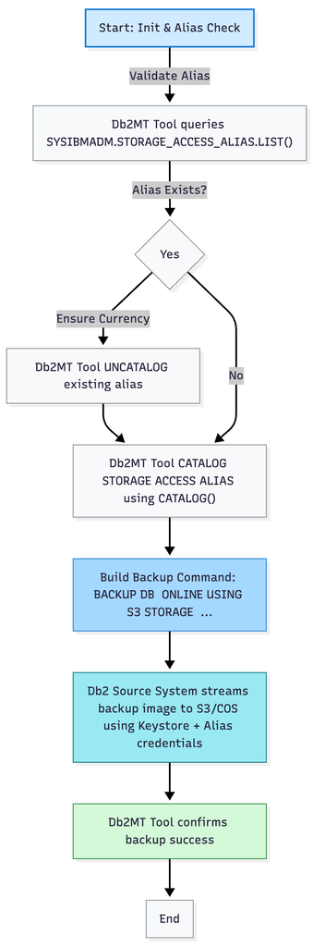
Figure 1. Backup Flow

Db2MT: Restore
The restoration methodology employed by Db2 establishes data integrity and system reliability as fundamental operational principles. The framework implements a comprehensive two-phase restoration strategy that ensures databases achieve consistent operational states while maintaining complete transactional integrity:
Phase 1: Backup Image Recovery Implementation
The initial restoration phase encompasses the systematic recovery of backup images to designated Db2 instances. These backup images represent comprehensive database snapshots captured at specific temporal intervals, containing complete structural and data elements necessary for system reconstruction.
Phase 2: Transaction Log Roll Forward Processing
Following successful image restoration, Db2 executes archived transaction log processing through advanced roll forward recovery mechanisms. This critical phase systematically applies all committed transactions that occurred subsequent to backup creation, thereby ensuring complete data preservation and maintaining transactional consistency across the entire database environment.

AWS RDS for Db2 Restoration Framework
The restoration architecture for AWS RDS for Db2 leverages integrated AWS infrastructure components and utilizes proprietary stored procedures designed specifically for cloud environments. The operational workflow encompasses the following systematic processes:
- Automated identification and retrieval of the most recent backup image from designated storage repositories
- Establishment of secure administrative connections to the 'rdsadmin' database, which serves as the primary administrative interface for RDS instances
- Execution of AWS-developed stored procedures that manage comprehensive restoration operations, including:
  - Complete backup image restoration to target database instances
  - Implementation of roll forward capabilities enabling systematic transaction replay
  - Integration of comprehensive monitoring systems that provide continuous status reporting throughout restoration operations, facilitating administrative oversight and enabling proactive troubleshooting protocols

IBM Db2 on Cloud Restoration Architecture
The restoration framework for IBM Db2 on Cloud environments utilizes Console API integration rather than stored procedure methodologies. The systematic workflow incorporates the following operational components:
- Implementation of Cloud Resource Name (CRN) identification protocols to ensure precise targeting of designated cloud database instances
- Systematic retrieval of current backup images from specified storage repositories
- Execution of restoration operations through secure API communication channels that require:
- Implementation of API key-based IAM authentication protocols for secure access management
- Provision of comprehensive API endpoints that facilitate:
  - Initiation of both restoration and roll forward operational processes
  - Continuous monitoring and status reporting throughout restoration cycles
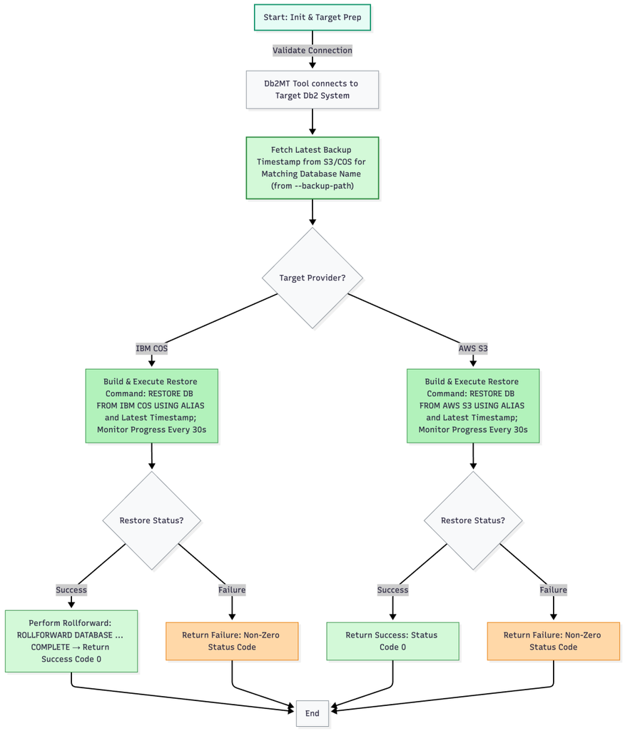
Figure 2. Restore Flow

Conclusion
Db2's contemporary backup and restoration architecture represents a sophisticated integration of performance optimization, security protocols and operational reliability specifically engineered for hybrid and cloud computing environments. The implementation of direct streaming capabilities to S3 compatible storage systems, enhanced through Storage Access Alias (SAA) functionality, ensures comprehensive encrypted credential management while supporting automated operational workflows. The dual-phase restoration methodology guarantees zero data loss scenarios, while platform specific integration frameworks, including AWS stored procedures and IBM Cloud API implementations, deliver seamless operational execution with comprehensive real time monitoring capabilities. These integrated capabilities position Db2 as an optimal solution for enterprise cloud migration initiatives, comprehensive disaster recovery planning and the development of resilient enterprise database architectures.

About the authors
Pranav Sridhar is a Software Developer at IBM India Software Lab, with experience of working with databases and cloud technologies. He holds a bachelor's degree in computer science and engineering from the PES University, Bangalore. Pranav can be reached at Pranav.Sridhar1@ibm.com
Muskan Malhotra is a Software Developer at IBM India Software Lab, with experience of working with databases and cloud technologies. Muskan can be reached at Muskan.Malhotra@ibm.com

