Introducing Log Analysis in IBM Db2 Genius Hub: Real-Time Diagnostics at Your Fingertips
By: Sami Ahmad Khan , John Gera

The Hidden Cost of Manual Log Analysis
Every database administrator knows the drill.
An alert fires. Users report slowdowns. Something is wrong—but where do you start?
You SSH into the server, navigate to log directories, grep through thousands of lines, cross-reference timestamps, filter by SQL codes, and piece together what happened. Minutes turn into hours. The incident escalates. The pressure mounts.
The question was simple: "What went wrong?"
The path to the answer was not.
Now imagine a different reality.
The same alert fires—but instead of terminal commands and manual searches, you open a unified console. Real-time diagnostics appear instantly. Errors and warnings are already categorized. Time ranges are adjustable. Filters reveal patterns in seconds. The root cause becomes clear before the incident escalates.
This is not just log viewing.
This is intelligent log analysis—and it is now built directly into IBM Db2 Genius Hub.

The Challenge: Logs That Overwhelm, Not Inform
Db2 diagnostic logs are essential for troubleshooting, but they present significant operational challenges:
- Volume: Enterprise databases generate thousands of log entries daily
- Complexity: Critical errors are buried among routine messages
- Accessibility: Logs require terminal access and manual parsing
- Time sensitivity: Finding the right entry during an incident is a race against time
Database teams need what they want to find—fast. Traditional log analysis creates a gap between problem detection and problem resolution.

A Platform for Proactive Diagnostics
The Log Analysis capability in Db2 Genius Hub transforms how teams interact with diagnostic data. It provides a structured, intelligent interface for viewing, filtering, and interpreting Db2 diagnostic logs in real time.
Instead of reactive terminal sessions, administrators gain a continuous diagnostic workflow where logs are accessible, searchable, and actionable—all from a unified console.

From Raw Logs to Actionable Intelligence
At its core, Log Analysis enables teams to monitor database health through a centralized interface that surfaces critical information when it matters most.
Key capabilities include:
- Real-time visibility into warnings and errors across your Db2 fleet
- Severity-based filtering to focus on critical issues (Info, Warning, Error, Severe, Critical, Event)
- Time-range filtering to investigate specific incidents or patterns with custom date/time selection
- SQL code tracking to identify recurring issues and error patterns
- Database and instance-specific views for targeted troubleshooting
- Configurable record limits to control the volume of logs retrieved (default: 100 records)
- Export functionality for compliance and deeper analysis
- Last 30 minutes default view with automatic statistics aggregation
Here is what the experience looks like—where complex diagnostic data becomes clear, navigable insights:
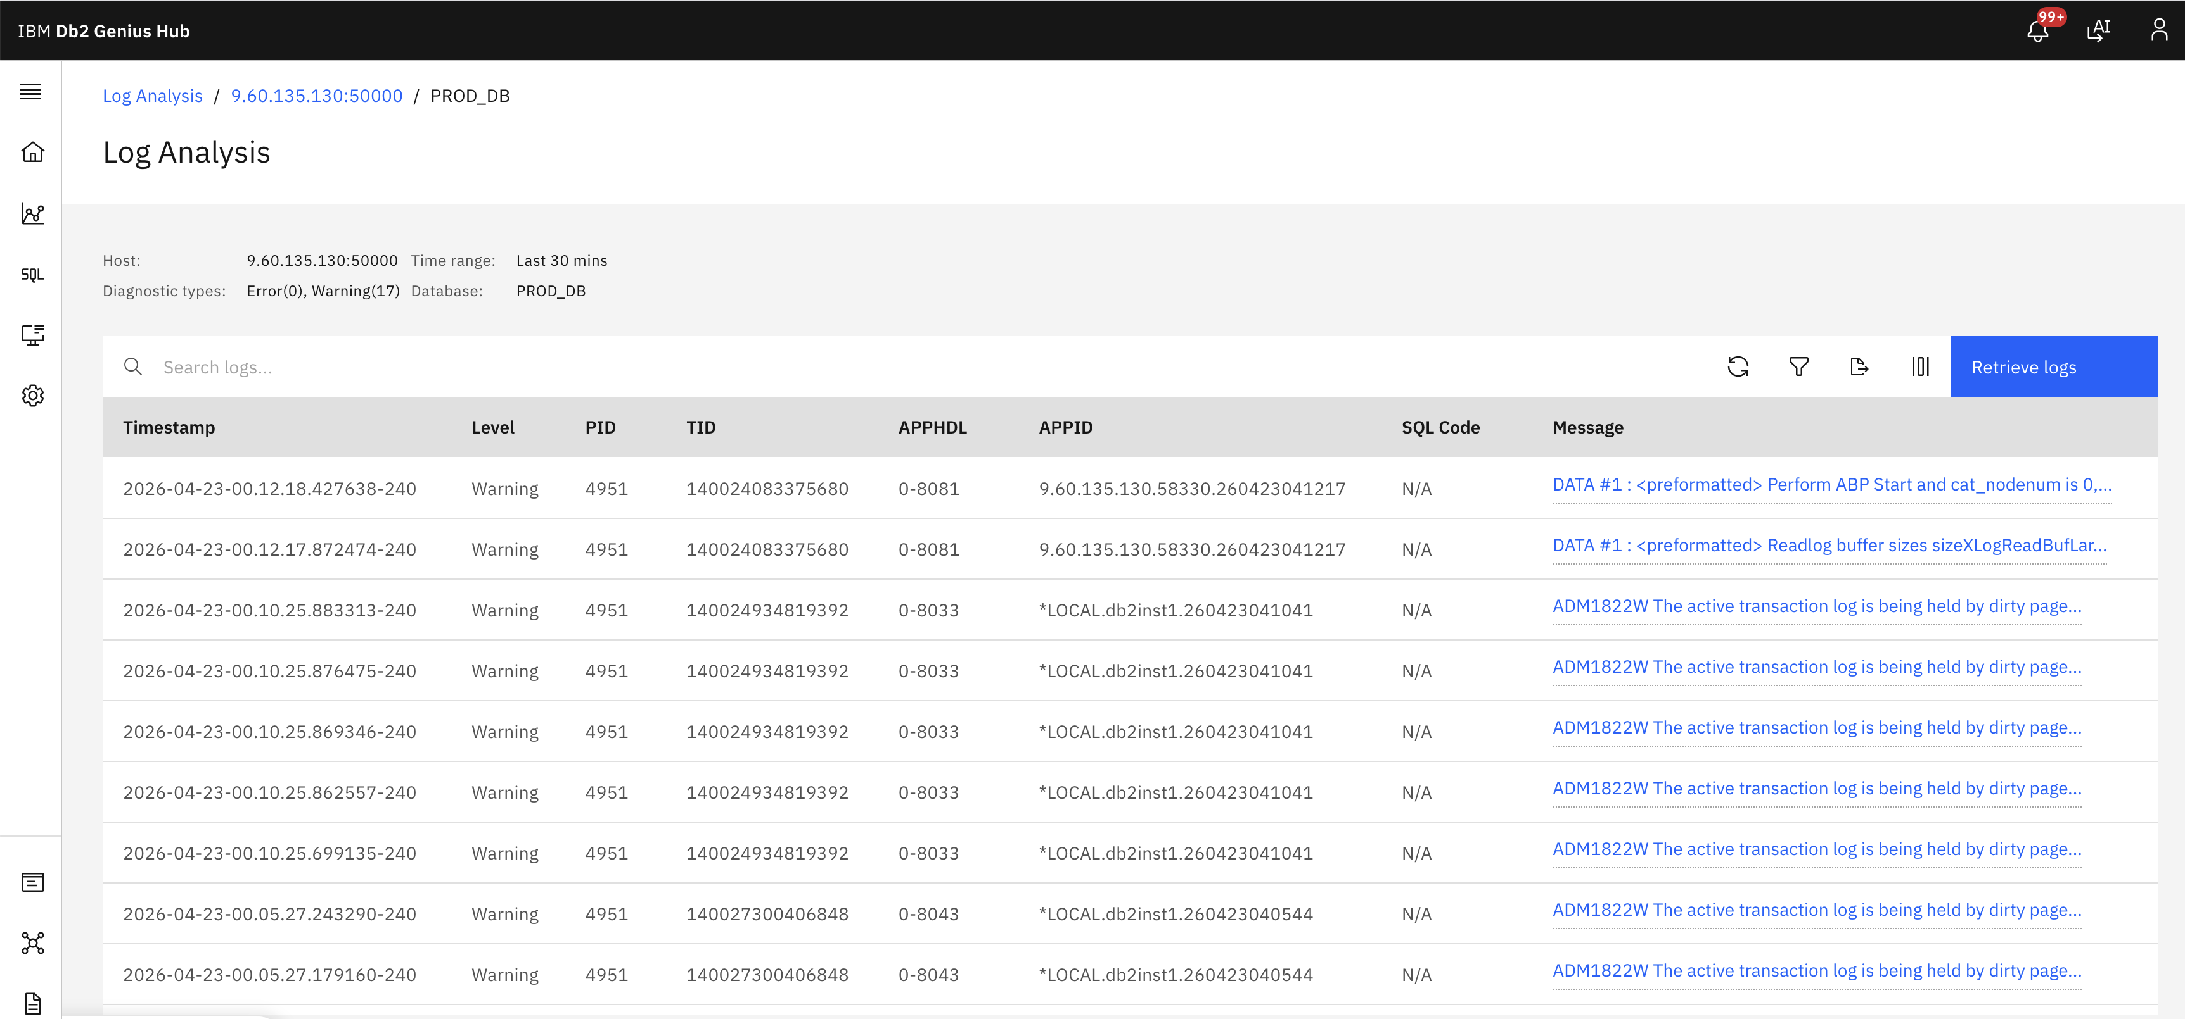

How It Works in Practice
The interaction begins with automatic log collection from your Db2 instances. The Genius Hub console displays statistics for the last 30 minutes by default, highlighting alert counts and top SQL codes that triggered warnings or errors.
What makes this powerful is its flexibility. Teams can:
- Expand log entries to see full details including timestamps, database names, SQL codes, process IDs (PID), severity levels, and complete messages
- Apply custom filters by database, SQL code, severity level, or error type with multi-rule support
- Retrieve historical logs for any custom time range with configurable record limits
- Group and analyze logs by host:port or top SQL codes for pattern identification
- Search across logs with real-time search functionality
- Customize visible columns to focus on relevant data (timestamp, level, PID, SQL code, database, message)
- Export log data as CSV for reporting or compliance requirements
The system provides transparency into database behavior without requiring terminal access or manual log parsing. All log timestamps are automatically converted to the user's browser timezone for consistent viewing.

Transparent Setup with Remote OS Service
A key enabler of Log Analysis is the Db2 Remote OS Service—a lightweight, standalone REST API service that runs on the same host as your Db2 instance.
This service acts as a secure bridge between your database environment and the Genius Hub console, enabling:
- Cross-platform support for Windows, AIX, and Linux systems
- Flexible authentication via username/password or API key (mutually exclusive - one method per configuration)
- HTTPS/TLS configuration for encrypted communication (recommended port: 8443)
- HTTP fallback for non-production environments (default port: 8080)
- Multi-instance support with unique port assignments per Db2 instance
- Automatic credential management with secure storage and placeholder support for editing
The setup process is straightforward:
- Download and extract the Remote OS Service package to the Db2 instance host
- Configure the .env file with:
- SERVER_PORT=8443 (for HTTPS) or 8080 (for HTTP)
- TLS_ENABLED=true (optional, for HTTPS)
- TLS_CERT and TLS_KEY paths (if using HTTPS)
- DB2_HOME path (Windows only - mandatory)
Note: A sample configuration template is available at .env.template in the installation directory. You can copy this file and modify it according to your environment requirements.
- Start the service using provided scripts:
- Linux/AIX: ./scripts/start.sh --jwt
- Windows: .\scripts\start.ps1 -JWT
- Enable Remote OS Service in your Genius Hub database connection with:
- Remote OS port (matching SERVER_PORT in .env)
- Authentication method (username/password or API key)
- HTTPS toggle (if TLS is enabled)
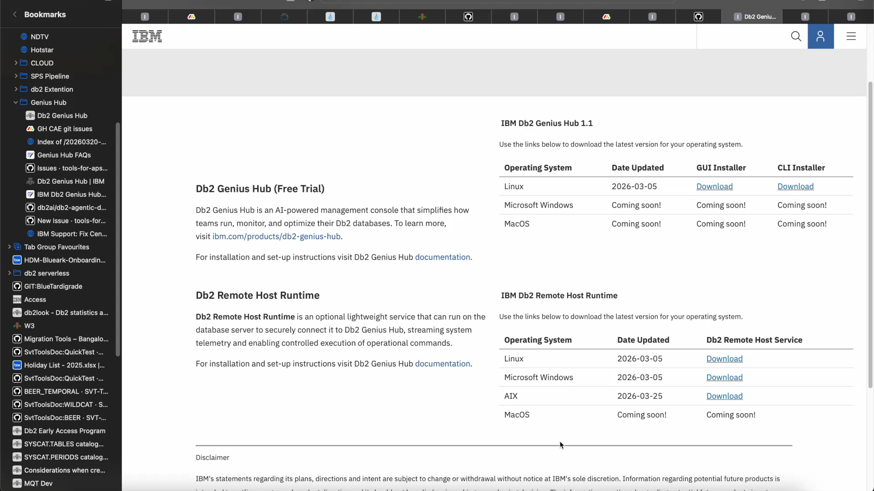
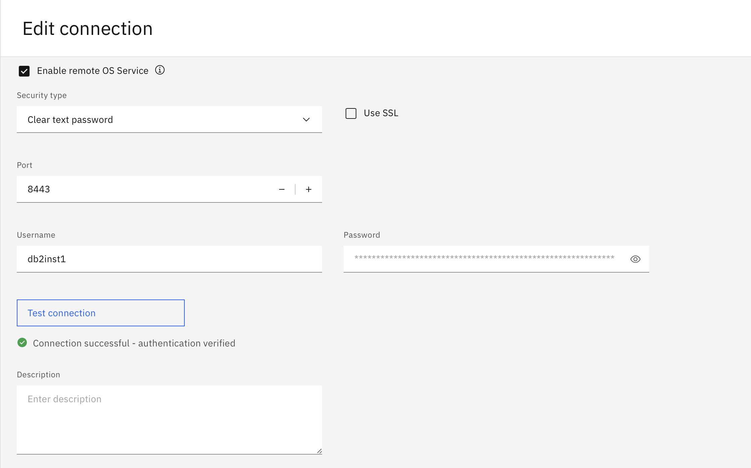

Once configured, log data flows automatically to the console—no manual log retrieval required. The service must run under the Db2 instance user on Linux/AIX, or as administrator on Windows.
To see this in action, here is a complete walkthrough showing the setup process and log analysis capabilities in real time:

Video Transcript Highlights:
- Installing the Remote OS Service on a Linux instance
- Configuring authentication and port settings
- Enabling the service in Genius Hub connections
- Navigating the Log Analysis interface
- Filtering logs by time range, SQL code, and severity
- Exporting diagnostic data for further analysis

Built for Real-World Database Operations
Enterprise database environments are inherently complex, with multiple instances, databases, and workloads running simultaneously. Log Analysis is designed to operate in this reality:
- Multi-database support: Monitor logs across all databases in your Db2 fleet from a single interface
- Multi-instance management: Deploy separate Remote OS services for each Db2 instance with unique ports
- Flexible time ranges: Investigate recent incidents (last 30 minutes default) or analyze historical patterns with custom date/time selection
- Advanced filtering: Narrow down thousands of entries using multi-rule filters with AND/OR logic
- Grouping capabilities: Analyze logs by host:port or aggregate by top SQL codes
- Customizable views: Tailor the interface to your team workflow with column customization
- Connection health monitoring: Automatic detection of missing or unreachable Remote OS configurations
Before presenting results, the system ensures that log data is accurately retrieved, timestamps are converted to the user's timezone, and proper formatting is applied—reducing the need for manual verification.

Secure by Design for Regulated Industries
For organizations operating in highly regulated environments, Log Analysis maintains strict security standards:
- On-premises deployment: All log data remains within your infrastructure—no external data transmission
- Encrypted communication: HTTPS/TLS support with configurable certificates for secure data transmission
- Dual authentication methods: Username/password or API key authentication (mutually exclusive for enhanced security)
- Credential protection: Passwords and API keys are encrypted at rest and masked in the UI
- Access management: Integration with existing Db2 security models and instance-level permissions
- Connection validation: Test connection capability before saving configurations
- Audit trail: All configuration changes and connection tests are logged
This makes Log Analysis suitable for financial services, healthcare, government, and other mission-critical workloads where data sovereignty is non-negotiable.

Why Genius Hub Log Analysis Is Different

Db2-Native Integration
Unlike generic log management tools, Log Analysis is purpose-built for Db2 diagnostic logs. It understands Db2 SQL codes, message formats, severity levels, and db2diag.log structure—providing context-aware insights that generic tools cannot deliver.
The system directly interfaces with Db2 diagnostic logs through REST API endpoints:
- /remoteos/db2diag/logs - Retrieves filtered diagnostic log entries
- /remoteos/db2diag/stats - Provides aggregated statistics and alert counts
- /remoteos/config - Manages Remote OS service configurations
- /remoteos/testconnection - Validates connectivity before deployment

Unified Console Experience
Log Analysis integrates seamlessly with other Genius Hub capabilities, creating a single pane of glass for database management. Teams can move from log investigation to query analysis to performance tuning without switching tools.

Zero Infrastructure Overhead
The Remote OS Service is lightweight and requires minimal resources. There is no need for separate log aggregation infrastructure, storage systems, or complex integrations.

Real-World Use Cases
Log Analysis proves invaluable in several common scenarios:
Incident Response: When alerts fire, quickly identify the root cause by filtering logs to the exact time range and SQL code associated with the incident.
Pattern Detection: Discover recurring warnings or errors that indicate underlying issues before they escalate into outages.
Compliance Reporting: Export log data for audit trails, compliance documentation, or post-incident reviews.
Proactive Monitoring: Track database health trends over time by analyzing historical log patterns.
Multi-Database Management: Monitor logs across multiple databases from a single interface, eliminating the need to SSH into individual servers.

A Clear Path to Intelligent Operations
Log Analysis represents a fundamental shift in how database teams interact with diagnostic data—from reactive terminal sessions to proactive, intelligent monitoring.
This capability is available today as part of Db2 Genius Hub, included with Db2 AI Standard and Db2 AI Advanced editions.
As Genius Hub continues to evolve, Log Analysis will integrate with agentic AI capabilities, enabling:
- Automated pattern recognition to detect anomalies before they impact users
- Intelligent recommendations based on historical log patterns
- Predictive diagnostics that anticipate issues before they occur

Get Started
Db2 Genius Hub with Log Analysis is available today with the new Db2 AI Standard and Db2 AI Advanced editions.
- Explore a free trial
- Schedule an executive briefing
- Read the technical documentation

Join the Db2 Community
Stay connected and continue learning:
- IBM TechXchange – Db2 LUW webinars and technical sessions
- IDUG – The global Db2 user community
- Db2 Documentation – Technical deep dives and best practices

Final Thought
The future of database management is not about writing better grep commands.
It is about having the right information, at the right time, in the right format—so teams can focus on solving problems instead of finding them.

________________________________________________________________________________
IBM Db2 Genius Hub is generally available as of March 5, 2026. Features and capabilities are subject to the terms of your license agreement.

About the Authors
Sami Ahmad khan is a QA Test Developer with over 8 years of experience in the SDET role, specializing in ensuring product quality through scalable automation. At IBM, he has contributed to products such as Db2Bridge and the VS Code Developer Extension, where he helped design and build end-to-end automation frameworks and automated key functionalities to significantly reduce manual testing efforts. He is currently part of the CAE team, working on the Genius Hub product.

John Gera is a Lead Architect in IBM's Hybrid Data Management Client Adoption Engineering team with over 17 years of experience spanning Data & AI technologies—from Db2 and BigSQL to modern cloud-native appliances.. John has expertise in Netezza installation, setup, and multi-cloud deployments across AWS, Azure, and IBM Cloud, along with deep knowledge of OpenShift and Cloud Pak for Data implementations. At IBM, John has led the Center of Excellence (COE) team for IIAS, managed the DevOps team for Netezza SaaS, and served as Serviceability Architect for IIAS. His work encompasses executing proof-of-concepts, performance optimization, and leveraging cloud object storage for scalable data management solutions. John also brings valuable expertise in UI/UX research, design thinking, and enterprise-level troubleshooting to deliver comprehensive architectural solutions.

