Db2 Genius Hub: From Automation to Agentic Operations for Mission‑Critical Data
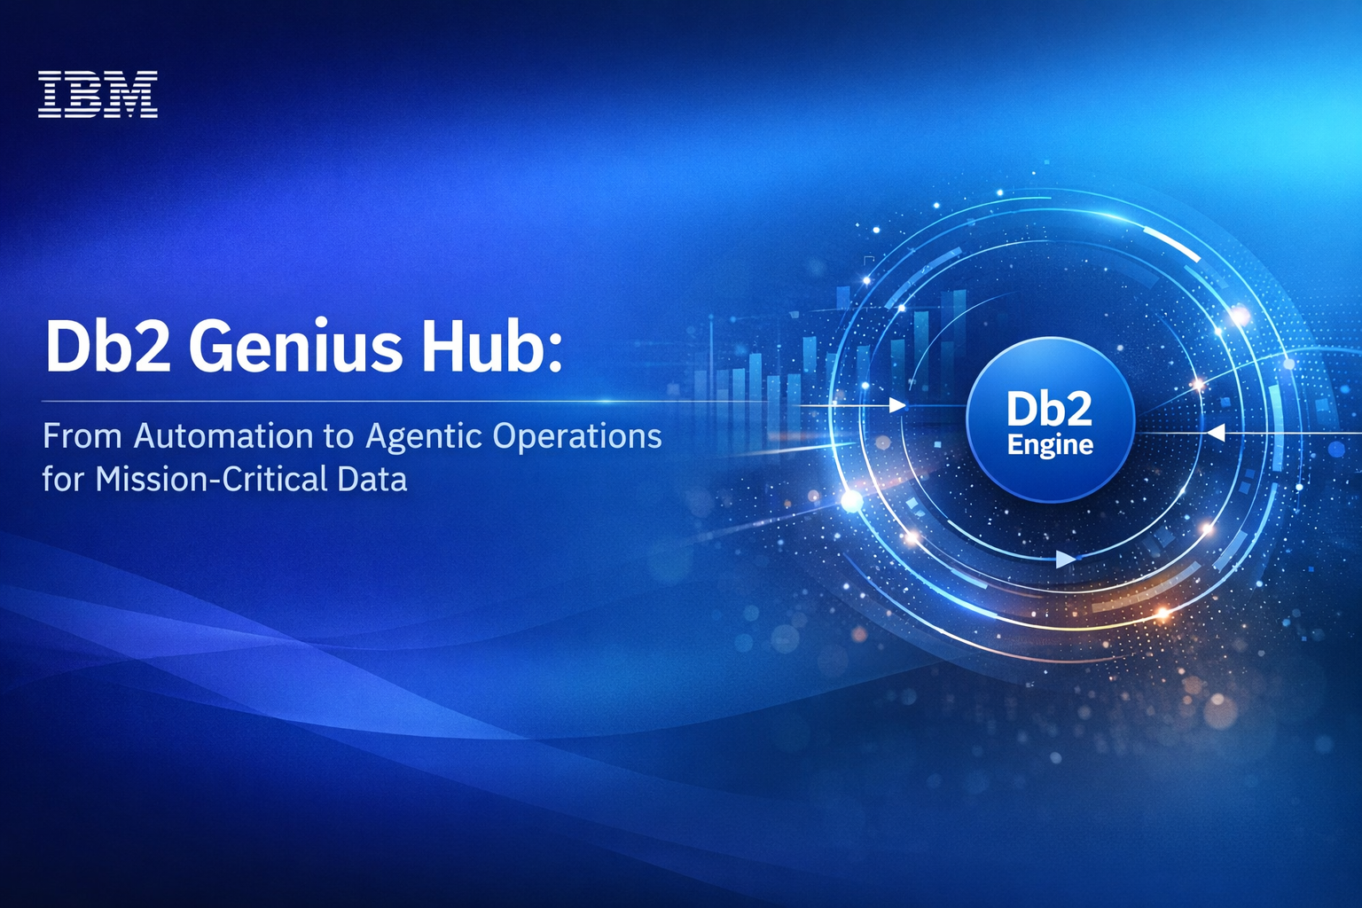

Enterprise databases have always been expected to deliver near-perfect reliability. For platforms like Db2—powering governments, financial systems, airlines, and national infrastructure—failure is not merely an inconvenience; it is systemic risk. For decades, that risk has been mitigated by human expertise: teams of highly skilled DBAs continuously tuning configurations, managing recovery, diagnosing anomalies, and responding to incidents under extreme time pressure.
Db2 Genius Hub represents a fundamental shift in how that operational responsibility is shared between humans and software. Rather than automating individual tasks in isolation, Genius Hub introduces agentic operational intelligence—systems that reason over history, context, and real-time behavior to act proactively across the database lifecycle. This is not about replacing DBAs. It is about redefining what it means to operate mission-critical data infrastructure in an AI-driven era.
Watch the following analyst perspective from Sanjeev Mohan - founder of Sanjmo and a long-time observer of modern data architectures— as he offers his view on what Db2 Genius Hub means for mission-critical data operations.
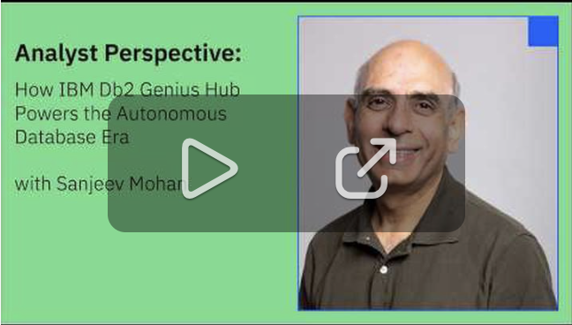
(Embedded Video: Analyst Perspective on Db2 Genius Hub with Sanjeev Mohan)

The Limits of Traditional Database Automation
Most database automation today is reactive and narrow in scope:
- Threshold-based alerts that trigger after a problem emerges
- Scripts that execute predefined actions without situational awareness
- General-purpose LLM assistants that lack database-specific context
While helpful, these approaches fail under the conditions that define enterprise Db2 environments: massive scale, heterogeneous deployments, strict governance, and zero tolerance for error. Automation without context increases operational risk. Acting too late leads to outages; acting incorrectly can be worse than doing nothing at all.
Db2 Genius Hub addresses this gap by shifting from rule-driven automation to context-aware, agentic systems purpose-built for Db2 estates.

Agentic Operations: What Makes Db2 Genius Hub Different
At its core, Db2 Genius Hub is an operational intelligence layer trained and tuned specifically for Db2. It continuously builds a rich operational graph that includes:
- Historical workload behavior
- Configuration and tuning decisions
- Incident patterns and root-cause knowledge
- Fleet-wide health trends across deployments
This allows Genius Hub to function not as a chatbot or dashboard overlay, but as a system of agents working across three tightly integrated capabilities:
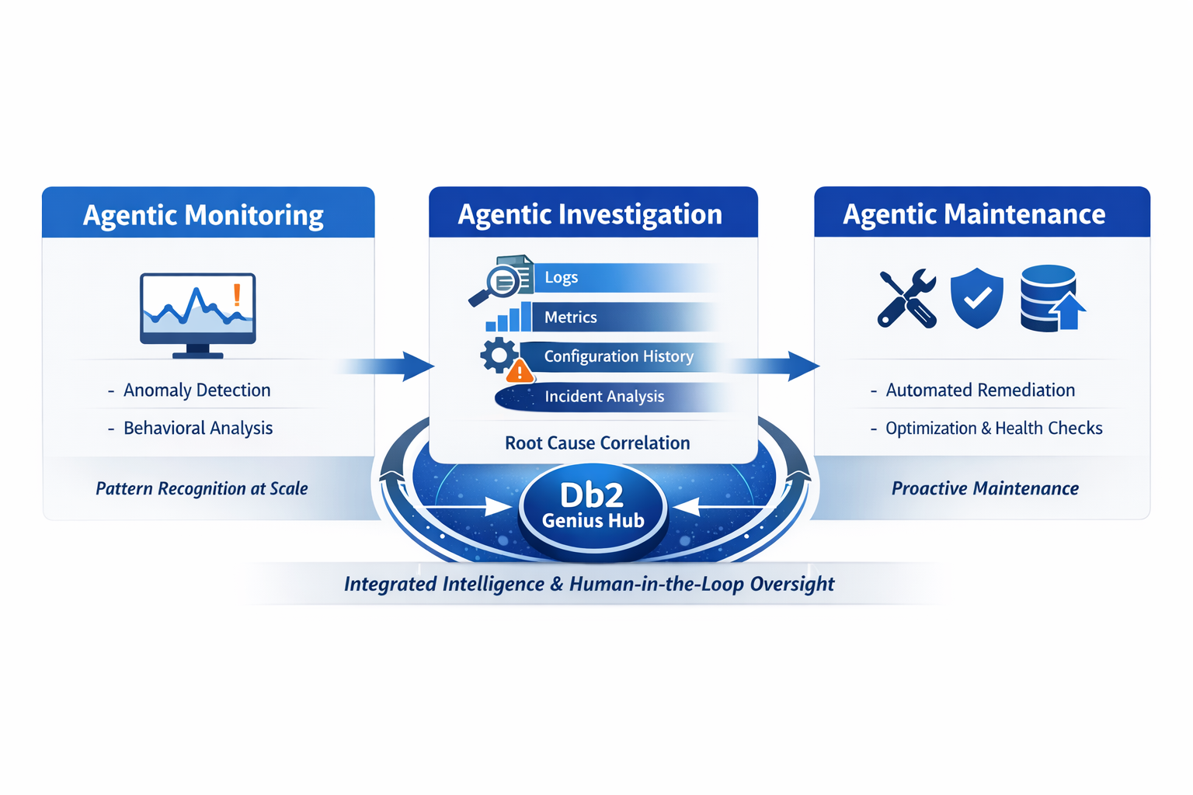

1. Agentic Monitoring
Instead of reacting to static thresholds, Genius Hub continuously analyzes behavioral patterns across the Db2 fleet. It detects anomalies in performance, capacity, and usage trends before they manifest as incidents.
The key distinction is pattern recognition at scale, informed by years of Db2 operational knowledge—not generic statistical noise detection.

2. Agentic Investigation
When anomalies emerge, Genius Hub performs multi-step investigation automatically. It correlates logs, metrics, configuration history, and prior incidents to narrow down likely causes.
This is fundamentally different from connecting an external LLM to logs. The intelligence lives with the database, informed by domain-specific expertise accumulated inside IBM and across Db2 deployments over decades.

3. Agentic Maintenance
Genius Hub goes beyond detection and diagnosis to perform—or recommend—remedial actions: updates, patches, health checks, capacity adjustments, and performance optimizations.
Crucially, these capabilities are designed to operate initially with humans in the loop, supporting gradual trust-building and governance alignment.

Why Context Beats General-Purpose AI
General AI models excel at broad reasoning, but they lack the institutional memory that database operations require. They do not inherently know:
- How Db2 behaves under specific workload mixes
- Which changes are safe in regulated environments
- How past operational decisions shaped current system state
Db2 Genius Hub treats context as a first-class asset. It accumulates knowledge over time—retaining operational history, system behavior, and causality—so recommendations improve continuously instead of starting fresh with every prompt.
In analyst discussions around modern data architectures, this idea is often described as context engineering or context graphs. Db2 Genius Hub operationalizes this concept for enterprise databases.

Redefining the DBA Role in an Agentic World
As operational heavy lifting becomes increasingly automated, the DBA role evolves—not disappears.
With Genius Hub managing repetitive, low-value tasks, DBAs increasingly focus on:
- Architectural decision-making across on-prem, hybrid, SaaS, and emerging serverless deployments
- Business alignment, ensuring database behavior supports revenue-critical initiatives
- Cost and performance optimization, balancing reliability with total cost of ownership
- Agent orchestration, overseeing how intelligent agents operate across the Db2 estate
Rather than responding to incidents after they occur, DBAs participate earlier in strategic decisions, armed with real-time insight into how systems will behave under future workload scenarios.

The Path to Autonomous Databases Is Incremental—and Intentional
Db2 Genius Hub does not promise full autonomy overnight. Enterprises running their most valuable data require trust, governance, and clear accountability.
The journey begins with:
- Human-approved recommendations
- Assisted execution with auditability
- Selective autonomy in time-critical scenarios
This phased approach reflects a core principle of enterprise AI adoption: autonomy must be earned through transparency, accuracy, and proven reliability.

Why This Matters Now
The pace of AI-driven innovation across businesses has accelerated dramatically. Workloads spike unpredictably. Expectations for availability continue to rise. Meanwhile, experienced DBAs are harder to find and increasingly expensive to retain.
Db2 Genius Hub arrives at a moment when operational excellence can no longer rely on human vigilance alone.
By embedding agentic intelligence directly into the database platform, IBM is extending Db2’s legacy of enterprise trust into the AI era—transforming operations from reactive maintenance into proactive, intelligent control.
Sign up for a free trial at: https://early-access.ibm.com/software/support/trial/cst/programwebsite.wss?siteId=2220&h=null&p=null

About the Authors
Jana J Wong is a principal performance focal for Db2 LUW at the IBM Silicon Valley Lab, with over 20 years of experience in Databases, SQL, QA, and Project Management. She also leads the external outreach and product enablement efforts across Data Core Products. Jana can be reached at jfitzge@us.ibm.com.

