How to run automated eclipse tooling test cases

1) The information below are copied from this link:
https://w3-connections.ibm.com/wikis/home?lang=en#!/wiki/W9756dcc571eb_4a09_ba7c_29f2d8956ee0/page/How%20to%20run%20automated%20eclipse%20tooling%20test%20cases
The zip file UnitTests.zip contains the 2 projects, SWTBotFramework and SWTBotTestCasesNew, mentioned in 2).

2) Setup:
For eclipse4.2.2 please follow comment#7 in https://sdijazzccm04.svl.ibm.com:9446/jazz/web/projects/BigInsights#action=com.ibm.team.workitem.viewWorkItem&id=46111 for installation or follow the steps below
Install steps for Eclipse4.2.2(in short) from InfoSphere BigInsights v2.1.2 onwards:
- Install org.hamcrest matchers v1.1.0 (Hamcrest Library of Matchers 1.1.0.v20090501071000 id=org.hamcrest) from http://download.eclipse.org/tools/orbit/downloads/drops/R20120526062928/repository/
- Install SWTBot v2.1.0 from http://download.eclipse.org/technology/swtbot/releases/2.1.0/ for Eclipse4.2.2
(With eclipse v3.6.2 (only supported by InfoSphere BigInsights v2.1 and older releases) use update site: http://download.eclipse.org/technology/swtbot/helios/dev-build/update-site) by selecting the following components:
SWTBot Eclipse Features (incubation)
SWTBot GEF Features (incubation)
SWTBot IDE Support (incubation)
SWTBot JUnit 4.x Headless Execution (incubation)
SWTBot SWT Features (incubation)
- From Jazz Repository URI: https://sdijazzccm04.svl.ibm.com:9446/jazz/ , create a new repository workspace with “BigInsights Main Stream Workspace”. From the Components select “QATestScripts” and load the following projects: SWTBotFramework and SWTBotTestCasesNew

3) To Run Eclipse Tooling Test Cases:
- Create a new run configuration under SWTBot Test category by selecting
SWTBotTestCasesNew project and then select com.ibm.biginsights.testcases.textanalytics.AllFunctionalTestSuite as the test class. Also set the Test runner to JUnit 4
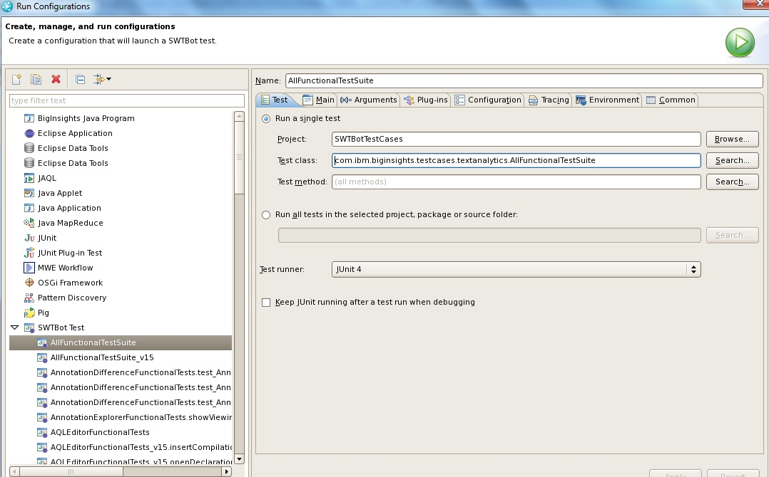
- Set the JUnit workspace, by navigating to Main tab and set the Location which is by default set to “${workspace_loc}/../junit-workspace” and set the Runtime JRE to IBM JRE shipped with BigInsights v2.0 or any IBM Java 6 JRE . Select Run a product and set it to “org.eclipse.platform.ide “.Also ensure that Clear workspace option is checked
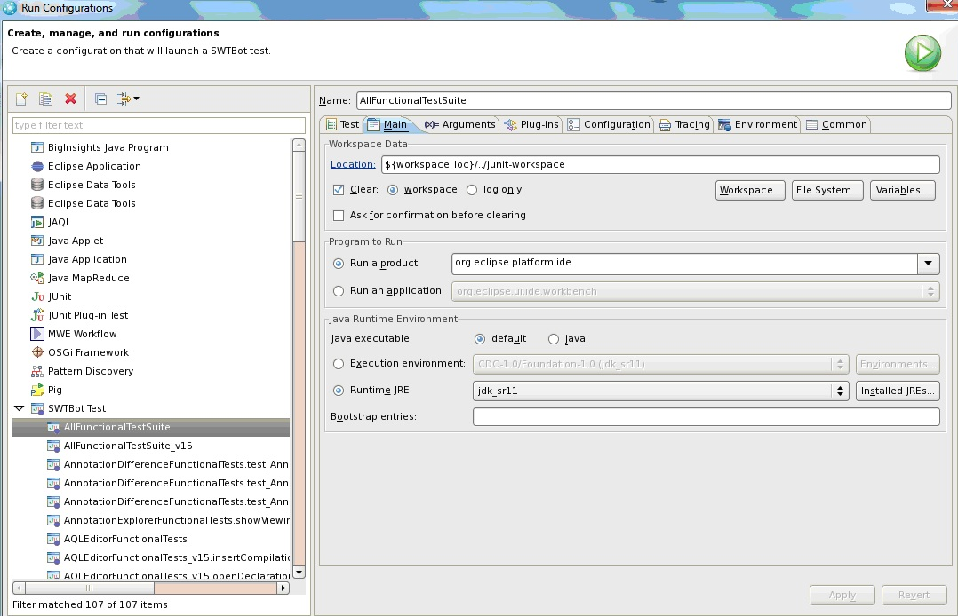
- Set the VM parameters, by navigating to the Arguments tab and ensure that it has the following:
-Dosgi.requiredJavaVersion=1.5 -XX:MaxPermSize=512m -Xmx40m -Xmx1024m
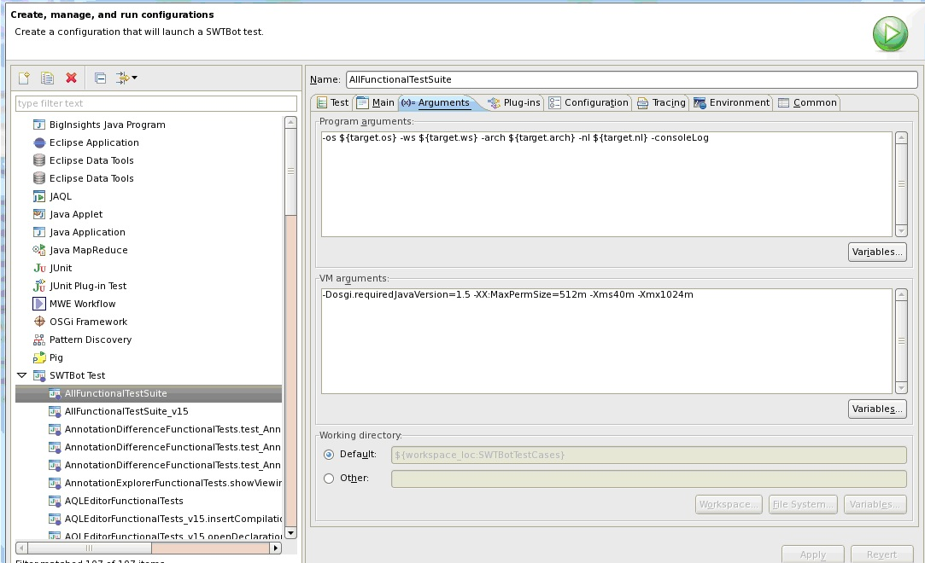
- Save and Run. This will launch a new eclipse workspace where SWTBot tests are run. Please ensure that you click once over the Title bar of the newly launched Eclipse to make it active.

FAQs
- Does SWTBot run headlessly? No, SWTBot run will launch a forked eclipse using the workspace location by default ${workspace_loc}/../junit-workspace. Further more, few SWTBot APIs used will simulate a mouse button click by navigating to a pixel location of the objects which will require that the forked eclipse IDE to be active while tests are run.
- Can the main eclipse IDE be used while running SWTBot tests? No, SWTBot run will look for widgets by its properties such as labels to identify and then perform action. Therefore, the forked eclipse ide which SWTBot run lauches must remain active IDE till the end
- How long does the SWTBot run take to complete? On an average, it takes approximately 1 minute to complete a test case. There are around 80 test cases at the moment, which will be grow. Hence , it might take around 80-90 minutes.
- How to get the Test results? Once the SWTBot run is complete , test result is shown in the JUnit tab with the list of tests that were run.
- How to get the JUnit test results in a file? In the JUnit tab , open the Test Run History toolbar button and select Export and export the JUnit results as a .xml

Troubleshooting:
- If there are any OOM error in the console of the main eclipse IDE while running the swtbot tests, increase the heap size for the forked eclipse IDE by increasing the value for MaxPermSize in the SWTBot Run configuration . The VM argument 'MaxPermSize' can be added in the Arguments tab for this purpose and can be set to 256m or 512m depending on the Physical Memory available.The system default value for MaxPermSize is 128m, increase this value -XX:MaxPermSize=512m or even more
- If there are SWTBot tests which fails because of Assertions, it might be a timing issue which happens rarely. Hence to reassure that it fails rerun the failing test case individually. If it happened to fail again, then it is actually a defect.
- If test is to be run on Linux machine using VNC , ensure that screensaver setting is turned off. Set this by running following command:
vncconfig -display :1 IdleTimeout=0
- In cases the test case failure stack trace has widgets.TimedoutException, it might be because the forked eclipse IDE was not active at that moment. To ensure if it is a genuine failure (not because of a timing problem or other non-functional issue), rerun the test individually.
Known Failures:
- com.ibm.biginsights.testcases.textanalytics.runconfig.RunConfigFunctionalTests.runConfigWithDependentProjects (pass on rerun - fails due to troubleshooting #5)
- com.ibm.biginsights.testcases.textanalytics.runconfig.RunConfigFunctionalTests.runConfigWithDependentTams (pass on rerun, fails due to defect 30089 which is likely a timing issue again)
- com.ibm.biginsights.testcases.textanalytics.modules.ModularFunctionalTests.testModuleAQLCreationRules (timing issue, will pass on rerun troubleshooting #2)
- com.ibm.biginsights.testcases.textanalytics.annotationdifference.AnnotationDifferenceFunctionalTests.test_AnnotationDifference_6_CompareWithLabeledCollection (timing issue, will pass on rerun troubleshooting #2)
- com.ibm.biginsights.testcases.textanalytics.refactoring.RefactoringFunctionalTests - (passes on rerunning any failing test).
- RegressionTests.cyclicDependencyCheckWithProjectReferences() - This test will fail in automation since the 'Cyclic Dependency error' is not thrown during automation run, so this particular test has to be run manually
- RunConfigFunctionalTests.runConfigwithInvalidData() - This test will fail in automation since the warning message is not thrown during automation run, so this particular test has to run manually
- PaginationFunctionalTests - Many tests fail in this class (however will pass on rerun them individually)
In general rerun the individual failing test case once, it might succeed If those tests are still failing, send the list of failing tests by exporting the JUnit results in a xml file (follow FAQs#5) and mail it to: padkrish@in.ibm.com

Tests covered by automation:
The RQM TestSuite id:67 has the list of test cases which are covered by the automated suite "AllFunctionalTestSuite" till date.
https://sdijazzqm04.svl.ibm.com:9447/jazz/web/console/BigInsights%20QA#action=com.ibm.rqm.planning.home.actionDispatcher&subAction=viewTestSuite&id=67

Tests to run manually:
Apart from the automated test cases, the following are the test cases that needs to be tested manually since they could not be accommodated.
- Provenance Viewer tests - the Provenance viewer is a JAVA Swing object which is not supported by SWTBot - refer https://sdijazzqm04.svl.ibm.com:9446/jazz/web/projects/BigInsights#action=com.ibm.team.workitem.viewWorkItem&id=22275
- AQL Doc Hover tests - No SWTBot API available to get the Pixel location of the editor's cursor, alternate way to use F2 is not implemented in v2.0 - https://sdijazzqm04.svl.ibm.com:9446/jazz/web/projects/BigInsights#action=com.ibm.team.workitem.viewWorkItem&id=22272
- Import Text Analytics Results to Project - Involves native OS dialog which is not supported by SWTBot - https://sdijazzqm04.svl.ibm.com:9447/jazz/web/console/BigInsights%20QA#action=com.ibm.rqm.planning.home.actionDispatcher&subAction=viewTestCase&id=1172
- Migrating Project Properties of a non-modular project to a modular project using 'Migrate Text Analytics Properties" option - Uses native OS dialog again not supported by SWTBot - https://sdijazzccm04.svl.ibm.com:9446/jazz/web/projects/BigInsights#action=com.ibm.team.workitem.viewWorkItem&id=33914
- BigInsights Application Publish - It is not covered in this automation suite.
- Context Sensitive Help on all dialogs in Text Analytics tooling - It is not covered in this automation suite
- Labelled Collection using import document collection -It is not covered in this automation suite. RQM test case: https://sdijazzqm04.svl.ibm.com:9447/jazz/web/console/BigInsights%20QA#action=com.ibm.rqm.planning.home.actionDispatcher&subAction=viewTestCase&id=921
- Open Declaration on alias - Tests automation in progress (https://sdijazzqm04.svl.ibm.com:9447/jazz/web/console/BigInsights%20QA#action=com.ibm.rqm.planning.home.actionDispatcher&subAction=viewTestCase&id=1149)
- Tokenizer Configuration Changes - Tests automation in progress (https://sdijazzqm04.svl.ibm.com:9447/jazz/web/console/BigInsights%20QA#action=com.ibm.rqm.planning.home.actionDispatcher&subAction=viewTestCase&id=1141)
- Testing AQL source code.zip after build and deployment to webconsole - Cant be automated https://sdijazzqm04.svl.ibm.com:9447/jazz/web/console/BigInsights%20QA#action=com.ibm.rqm.planning.home.actionDispatcher&subAction=viewTestCase&id=1101
- Open Dictionary Editor from Extraction Plan view - It is not covered in this automation suite, can be added : https://sdijazzqm04.svl.ibm.com:9447/jazz/web/console/BigInsights%20QA#action=com.ibm.rqm.planning.home.actionDispatcher&subAction=viewTestCase&id=1161
- Right click on existing label and create a child label in Extraction Plan view - Test case: test_WorkflowUI_3_SelectDocumentCollection in TextAnalyticsWorkflowFunctionalTests class adds child labels from the document collection not from the Extraction plan view. But it can be added as a test case for automation :
:https://sdijazzqm04.svl.ibm.com:9447/jazz/web/console/BigInsights%20QA#action=com.ibm.rqm.planning.home.actionDispatcher&subAction=viewTestCase&id=1163
- Converting extraction plan of a non-modular project to modular - It is not covered in this automation suite and costly to include this test, better to try manually :https://sdijazzqm04.svl.ibm.com:9447/jazz/web/console/BigInsights%20QA#action=com.ibm.rqm.planning.home.actionDispatcher&subAction=viewTestCase&id=1159
- Alternate view for Extraction Plan - It is not covered in this automation suite, but could be added :https://sdijazzqm04.svl.ibm.com:9447/jazz/web/console/BigInsights%20QA#action=com.ibm.rqm.planning.home.actionDispatcher&subAction=viewTestCase&id=1165
- Open Regex Generator from Extraction Plan - It is not covered in this automation suite, but could be added :https://sdijazzqm04.svl.ibm.com:9447/jazz/web/console/BigInsights%20QA#action=com.ibm.rqm.planning.home.actionDispatcher&subAction=viewTestCase&id=1162
- Stackoverflow when trying to add BI natrue to Streams SPL project (54097 - Cyclic Dependency using Project references tab)

