
LAB-2752: Build Reusable Agentic AI Patterns for Cold Chain: Predictive & Autonomous Workflows

Hands-on lab guide



Author name
XXXXX

author.email@ibm.com

Role, Department

Table of Contents
1 Introduction 5
1.1 About this hands-on lab 6
2 <Information section for the author. Remove when no longer needed> Options for creating screen caps with callouts and labels 6
2.1 Creating screen captures using PowerPoint 6
3 Timing (for lab creators) 8
4 Did not complete the lab...?? (for Students) 8
5 Major task in the lab 8
5.1 Architecture 9
5.2 Familiarization Walkthrough 11
5.3 Sub task – Use to break up major tasks into smaller sets of steps 11
5.4 Sub task – Use to break up additional major tasks into smaller sets of steps 11
6 Major task example –Creating a virtual assistant 11
6.1 Creating the virtual assistant 12
6.2 Adding search skills to the assistant 12
6.3 Testing the assistant 12
7 Feedback section 12
8 Getting help and troubleshooting 12
8.1 Reach out to the Lab instructor. 12
8.2 Common troubleshooting tips 12
8.3 Getting help 12
9 Lab Reference Materials (for instructor) 12
Remember to refresh the table of contents as you build your document. Right-click the table of contents, click Update field, select Update entire table, and click OK.

Notices and disclaimers
© 2026 International Business Machines Corporation. No part of this document may be reproduced or transmitted in any form without written permission from IBM.
U.S. Government Users Restricted Rights — use, duplication or disclosure restricted by GSA ADP Schedule Contract with IBM.
This document is current as of the initial date of publication and may be changed by IBM at any time. Not all offerings are available in every country in which IBM operates.
Information in these presentations (including information relating to products that have not yet been announced by IBM) has been reviewed for accuracy as of the date of initial publication and could include unintentional technical or typographical errors. IBM shall have no responsibility to update this information.
This document is distributed “as is” without any warranty, either express or implied. In no event, shall IBM be liable for any damage arising from the use of this information, including but not limited to, loss of data, business interruption, loss of profit or loss of opportunity. IBM products and services are warranted per the terms and conditions of the agreements under which they are provided. The performance data and client examples cited are presented for illustrative purposes only. Actual performance results may vary depending on specific configurations and operating conditions.
IBM products are manufactured from new parts or new and used parts.
In some cases, a product may not be new and may have been previously installed. Regardless, our warranty terms apply.”
Any statements regarding IBM's future direction, intent or product plans are subject to change or withdrawal without notice.
Performance data contained herein was generally obtained in a controlled, isolated environments. Customer examples are presented as illustrations of how those customers have used IBM products and the results they may have achieved. Actual performance, cost, savings or other results in other operating environments may vary.
References in this document to IBM products, programs, or services does not imply that IBM intends to make such products, programs or services available in all countries in which IBM operates or does business.
Workshops, sessions and associated materials may have been prepared by independent session speakers, and do not necessarily reflect the views of IBM. All materials and discussions are provided for informational purposes only, and are neither intended to, nor shall constitute legal or other guidance or advice to any individual participant or their specific situation.
It is the customer’s responsibility to ensure its own compliance with legal requirements and to obtain advice of competent legal counsel as to the identification and interpretation of any relevant laws and regulatory requirements that may affect the customer’s business and any actions the customer may need to take to comply with such laws. IBM does not provide legal advice or represent or warrant that its services or products will ensure that the customer follows any law.

Notices and disclaimers (Continued)
Questions on the capabilities of non-IBM products should be addressed to the suppliers of those products. IBM does not warrant the quality of any third-party products, or the ability of any such third-party products to interoperate with IBM’s products. IBM expressly disclaims all warranties, expressed or implied, including but not limited to, the implied warranties of merchantability and fitness for a purpose.
The provision of the information contained herein is not intended to, and does not, grant any right or license under any IBM patents, copyrights, trademarks or other intellectual property right.
IBM, the IBM logo, and ibm.com are trademarks of International Business Machines Corporation, registered in many jurisdictions worldwide. Other product and service names might be trademarks of IBM or other companies. A current list of IBM trademarks is available on the Web at “Copyright and trademark information” at: www.ibm.com/legal/copytrade.shtml.

Introduction
Use IBM Plex Mono Light for text that users must enter. This is consistent with IBM Style and avoids using quotation marks, which can be ambiguous as to whether they are meant to be included or not.
Cold-chain logistics is no longer just a transportation problem — it is an operational risk management challenge where timing is everything. When a temperature breach, a storm, and a cooling system fault converge on the same truck, an operator has minutes to act. In this workshop you will build the intelligence layer of a cold-chain logistics platform using IBM Bob and IBM AI building blocks.
The fleet backend is already built and running in your lab environment. Your job is to build three things on top of it: a forecasting service that predicts temperature breach risk using IBM Granite TTM-R2, a five-agent watsonx Orchestrate pipeline that autonomously decides and acts on that risk, and a live dashboard that lets you trigger and track everything in real time.
You will use two IBM Bob build modes that are bundled in the lab repository under bob-modes-skills/ — install them in Lab 0 before starting:
TTM Forecasting Mode — guides you through building the forecast service with IBM Granite TTM-R2
FleetOps Agent Builder Mode — guides you through building the five watsonx Orchestrate agents and their Python tools
These modes know the cold-chain domain, the agent orchestration patterns, and the exact API contracts. Let Bob guide you — answer its questions, review the generated code, apply it, and move forward.

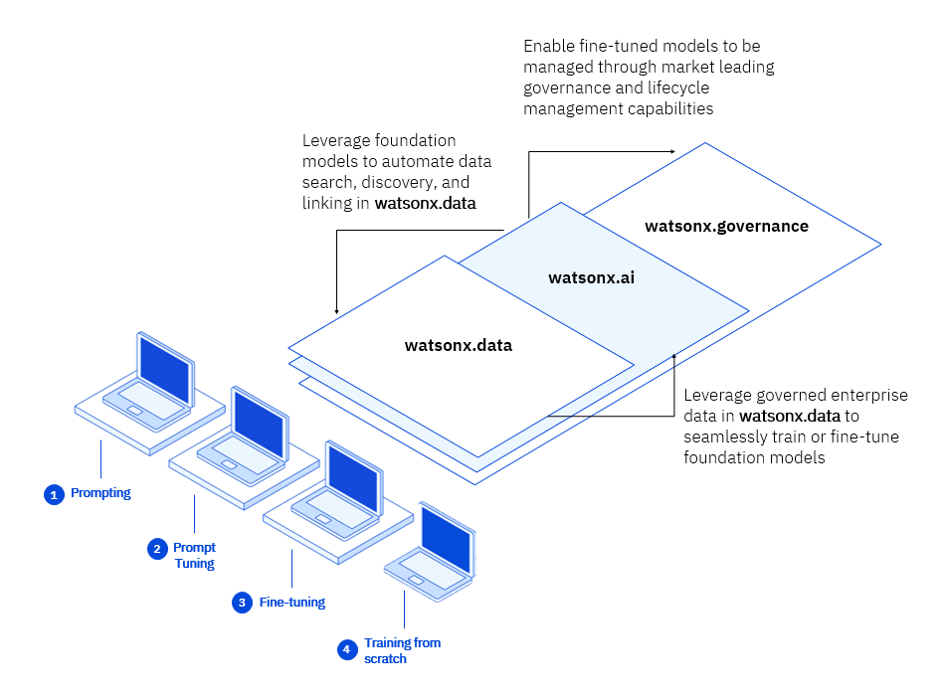
Leave a space before and after your screen captures. This will help the reader.
If you have a large screen cap that cannot fit with the text before it. Add a page break to the paragraph so that it begins on a new line. To add the page break, position the cursor at the start of the paragraph and press Command + Return (Mac) or Ctrl + Enter (Windows).
You can also
try resizing the
screen capture.

About this hands-on lab
By the end of this 90-minute lab you will be able to:
01 Configure and start the pre-built FleetOps backend and verify its REST APIs via Swagger UI
02 Build a FastAPI temperature-forecasting service using IBM Granite TTM-R2 with IBM Bob
03 Define five watsonx Orchestrate agents (weather · station · route · decision · notification) and upload their Python tools
04 Register watsonx Orchestrate connections and wire all five agent IDs to the fleet backend
05 Complete a Carbon-based live dashboard using IBM Bob in Agent mode
06 Run the end-to-end agentic pipeline on TRUCK-003 and observe the autonomous reroute decision

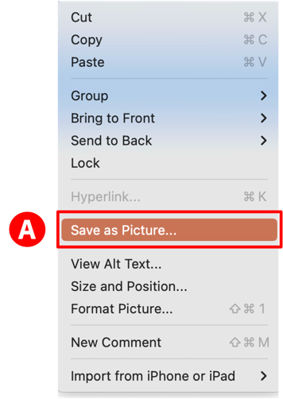
For more information about style tips,
see the Style guidelines page
on the Centre of Excellence
(http://w3.ibm.com/w3publisher/getting-started-in-technology-sales/resources/style-guidelines).

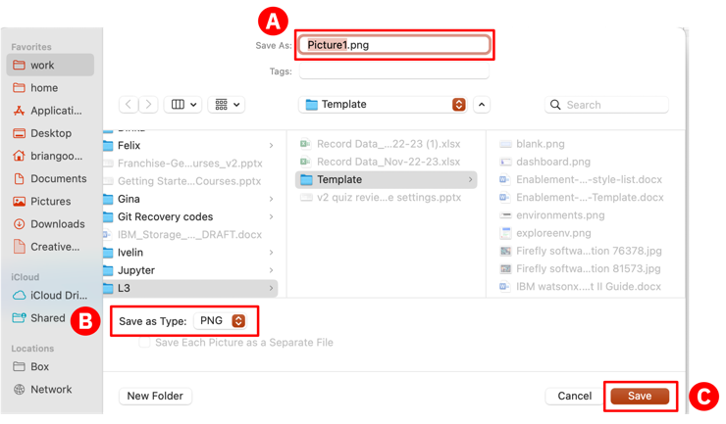

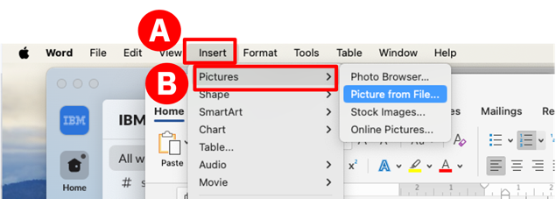

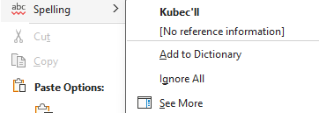

Did Not Complete the Lab? (for Students)
If you did not finish during the session, you can continue in the self-paced lab room using the same environment. Ask your instructor for the self-paced room access details before leaving.

5 Phase 1: Explore the Fleet Backend
The workshop has four phases:
Phase 1 — Explore the Fleet Backend: The backend is pre-built and running. Learn what it exposes, verify the APIs, and understand TRUCK-003 — the critical incident truck you will build intelligence around.
Phase 2 — Build the Forecast Service: Use the TTM Forecasting Bob mode to build a FastAPI forecasting service powered by IBM Granite TTM-R2. It will predict temperature breach risk for TRUCK-003 over a 24-hour horizon.
Phase 3 — Build the Agents and Tools: Use the FleetOps Agent Builder Bob mode to build five watsonx Orchestrate agents and their Python tools. Upload them to watsonx Orchestrate and record the agent IDs.
Phase 4 — Build the Dashboard and Run the Live Pipeline: Wire the agent IDs to the backend, build the Carbon dashboard, and run the full end-to-end agentic workflow on TRUCK-003 — watching the route change live.
Suggested time budget: Phase 1 — 10 min | Phase 2 — 20 min | Phase 3 — 30 min | Phase 4 — 15 min | Buffer — 5 min
⚡ Checkpoint: If Phase 2 fails (pip install errors or missing WML credentials), ask IBM Bob (in TTM Forecasting mode) to regenerate the forecast service and continue to Phase 3.
Acronyms: API — Application Programming Interface | TTM — Tiny Time Mixer (IBM Granite forecasting model) | IAM — IBM Identity and Access Management | ADK — Agent Development Kit (watsonx Orchestrate)
Prerequisites: IBM Bob available in your lab environment with the lab-2752-reusable-agentic-patterns workspace open | Python 3.12+ | Node.js 18+ | watsonx Orchestrate SaaS access — credentials provided by instructor | Lab repository cloned from https://github.ibm.com/shanmsel/lab-2752-reusable-agentic-patterns
git clone https://github.ibm.com/shanmsel/lab-2752-reusable-agentic-patterns

5.1 What is Already Built
Architecture
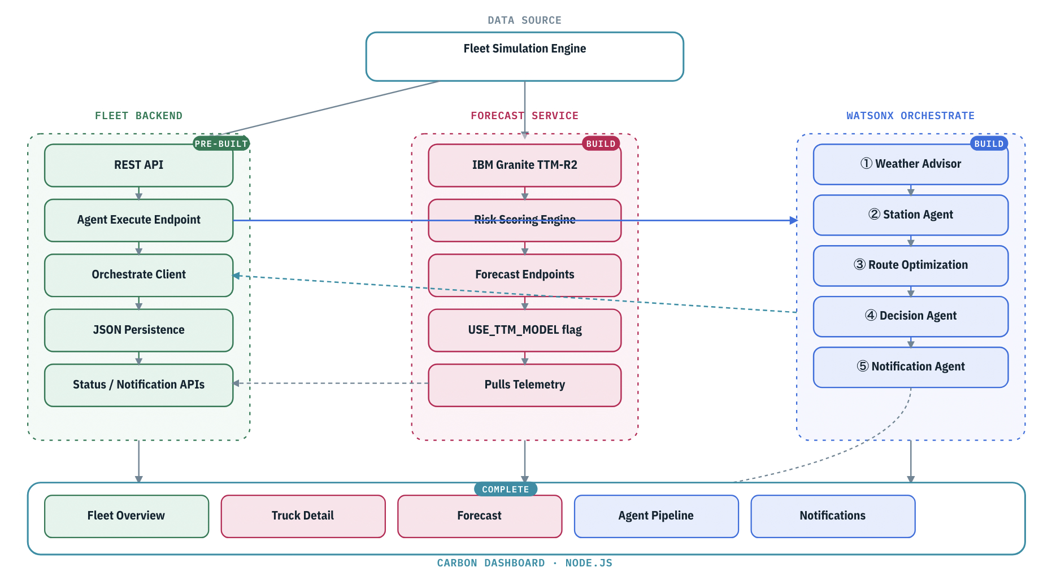
The fleet backend (01-fleet-backend) is fully built and running at http://localhost:8085. It provides:
- GET /api/trucks — returns live telemetry for 10 simulated cold-chain trucks
- GET /api/trucks/{truck_id} — single truck detail with temperature, location, cargo, route
- GET /api/alerts — active temperature and weather alerts
- POST /api/agents/execute — triggers the five-agent watsonx Orchestrate pipeline for a truck
- GET /api/agents/status/{execution_id} — polls the pipeline execution status
- GET /api/agents/notifications/{truck_id} — retrieves notifications sent by the pipeline
- GET /api/agents/history — historical pipeline executions
The simulation engine runs a background loop every 5 seconds, advancing truck positions and drifting temperatures. Four trucks have pre-assigned incidents. TRUCK-003 is your critical scenario truck.

ISIM Components as Container Pods | Components of Identity Manager Container
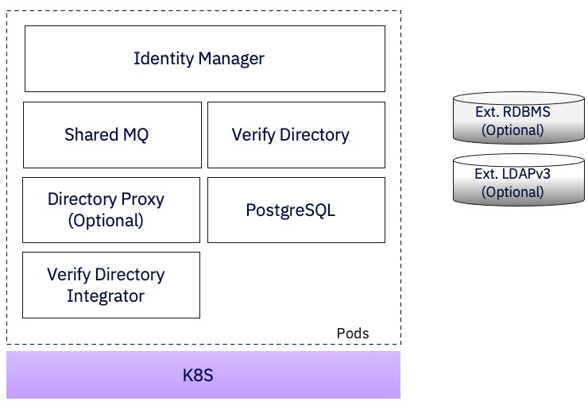  ** May use LDAP and DB as containers or point to external LDAP or DB ** | 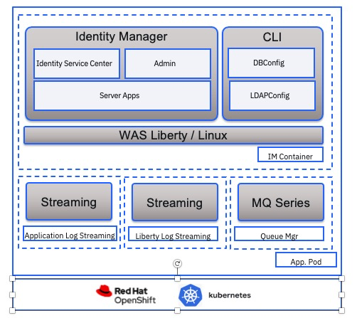

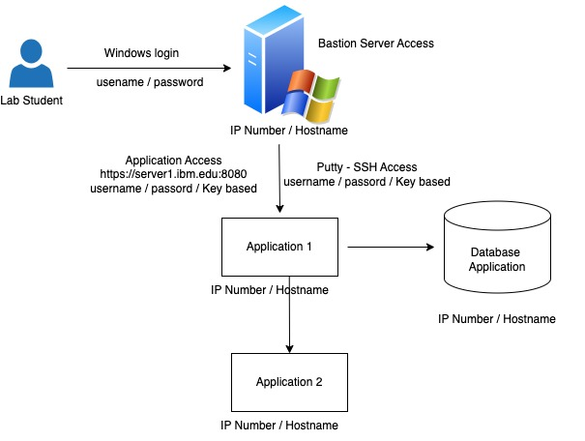

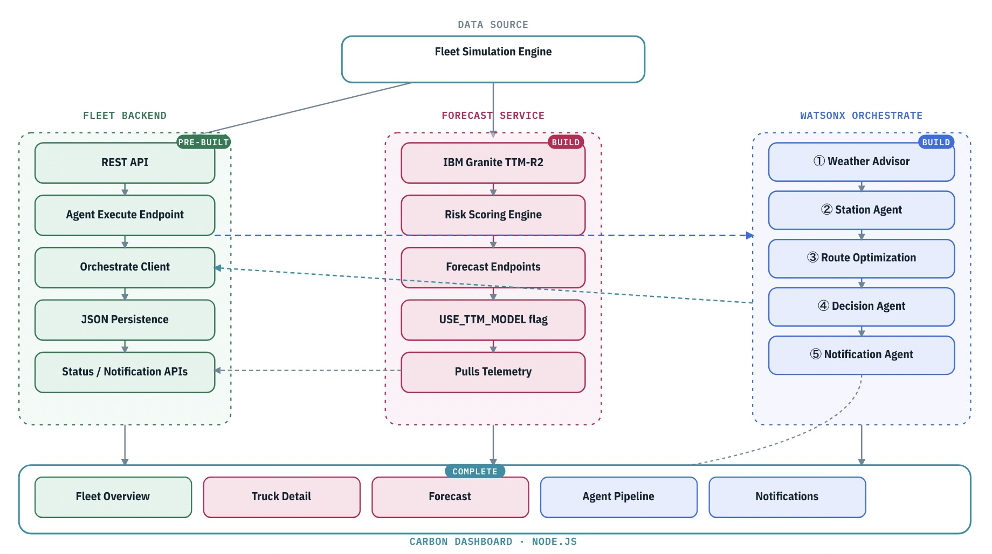
Architecture overview — three services: Fleet Backend (:8085, pre-built) · Forecast Service (:5001, you build) · watsonx Orchestrate Agents (you build) · Carbon Dashboard (:4000, you complete). See lab-2752-architecture.html.

5.2 Verify the APIs
- First, start the fleet backend (if not already running):
cd 01-fleet-backend
python3.12 -m venv venv
source venv/bin/activate # Windows: venv\Scripts\activate
pip install -r requirements.txt
uvicorn app.main:app --host 127.0.0.1 --port 8085 --reload
Open http://localhost:8085/docs in your browser. This is the Swagger UI for the fleet backend.
1. Expand GET /api/trucks. Click Try it out → Execute. You should receive a list of 10 trucks. Each has a truckId, telemetry (temperature, coolantStatus, currentLocation, speed), cargo (type, value, criticalThreshold), currentTrip (origin, destination, plannedRoute, estimatedArrival), and status.
2. Expand GET /api/alerts. Execute. Note any active alerts — look for type TEMPERATURE_BREACH and severity CRITICAL.
3. Ask IBM Bob (in Agent mode): 'Explain the fleet backend API structure — what does each endpoint return and how do the trucks, alerts, and agents endpoints connect to each other?'
Review the explanation before continuing.

5.3 Understand TRUCK-003
TRUCK-003 is your incident truck for this workshop. Call GET /api/trucks/TRUCK-003 in the Swagger UI.
Key values to note:
- temperature: ~9.2°C and rising (threshold is 8.0°C — already in breach)
- coolantStatus: NORMAL (this is a WEATHER incident, not a coolant failure)
- cargo type: pharmaceuticals, cargo value: ~€180,000
- currentTrip: Atlanta, GA → Macon, GA on I-75, ~100 km remaining
- estimatedArrival: approximately 1.5 hours from now
- incidentType: WEATHER_FAILURE (severe weather system directly on route)
This is the scenario: the cargo is already above threshold, a severe weather system sits directly on the I-75 corridor, and there is under 2 hours to act before the pharmaceutical cargo is unrecoverable. The agents you will build in Phase 3 will analyse this situation and recommend an emergency reroute to the nearest cold storage facility.

5.4 Run the Pipeline in Mock Mode
Before building the real agents, run the pipeline in mock mode to understand the full flow.
1. In the Swagger UI, expand POST /api/agents/execute. Click Try it out. Enter the request body:
{ "truck_id": "TRUCK-003" }
Click Execute. You will receive an execution_id and status RUNNING.
2. Copy the execution_id. Expand GET /api/agents/status/{execution_id}. Enter the execution_id. Execute. You will see the five agents — weather, station, route, decision, notification — each with a status field. Poll this endpoint every 5 seconds until status is COMPLETED.
3. When COMPLETED, read the decision agent output. In mock mode it returns:
decision: EMERGENCY_REROUTE, urgency: CRITICAL, riskScore: 85
recommendation: Reroute to nearest cold storage facility
4. Call GET /api/trucks/TRUCK-003 again. The status field should now show DIVERTED. The simulation engine has applied the mock decision to the truck.
5. Call GET /api/agents/notifications/TRUCK-003. You should see the mock notification stored for the driver.
This is the exact same flow you will run in Phase 4 — but with real agents making intelligent decisions based on actual weather, station, and route data. Phase 1 complete.

6 Phase 2: Build the Forecast Service
Phase 2 builds the forecast service using IBM Bob's TTM Forecasting mode. The mode is bundled under bob-modes-skills/ttm-forecast/ in the lab repository — install it now (Lab 0 Step 4a) — it knows how to scaffold a complete FastAPI service with IBM Granite TTM-R2 integration, risk scoring, and all the endpoints the dashboard will need.

6.1 Install the TTM Forecasting Mode
- The TTM Forecasting mode files are at bob-modes-skills/ttm-forecast/. You need to install the mode into IBM Bob before using it.
1. In your terminal, copy the mode config to the Bob workspace configuration:
mkdir -p .bob
cp bob-modes-skills/ttm-forecast/custom_modes.yaml .bob/custom_modes.yaml
cp -r bob-modes-skills/ttm-forecast/skills .bob/skills
2. In IBM Bob, click the mode selector (bottom left). You should now see 🔮 TTM Forecasting in the list. Select it.
3. Bob will confirm: 'You are now in TTM Forecasting mode. I specialise in building production-ready time-series forecasting services using IBM Granite TTM models.'
Note: The mode restricts file edits to .py, .yaml, .yml, .md, .txt, .json, .env, and Dockerfile — exactly what you need for this phase.
- With the TTM Forecasting mode active, type this prompt into IBM Bob:
I need to build a cold-chain temperature forecast service for a fleet management platform. The service should predict temperature breach risk for pharmaceutical cargo trucks using IBM Granite TTM-R2. It will connect to the fleet backend at http://localhost:8085 to get truck telemetry. The critical temperature threshold is 8.0°C. I need the following API endpoints:
- GET /api/forecast/temperature/{truck_id} — predict breach risk over 24 hours
- GET /api/forecast/station — station availability forecast
- GET /api/forecast/weather/{truck_id} — weather impact forecast
- GET /api/forecast/fleet — fleet-wide optimisation summary
Build the complete service in a folder called 02-forecast-service/.
IBM Bob will ask you 2–3 discovery questions about your data and UI requirements. Answer as follows:
- Data source: The service should fetch truck telemetry from the fleet backend API at http://localhost:8085/api/trucks/{truck_id} and generate synthetic 512-point temperature history based on current temperature.
- UI: No dashboard UI needed — API only. The main dashboard is built separately in Phase 4.
- Model: Use IBM Granite TTM-R2 with USE_TTM_MODEL=False (mock/local fallback — no model download, instant startup. Set True only if you have WML credentials and want the real Granite TTM-R2 model) as the default, with local model as fallback.
Bob will then present a checklist plan. Review it, confirm, and let Bob build the complete service. Apply all generated files to 02-forecast-service/.

6.2 Build the Forecast Service with Bob
- After Bob has generated and you have applied all the 02-forecast-service files:
1. Fill in your credentials. Open 02-forecast-service/.env (created by Bob). Set:
FLEETOPS_API_BASE_URL=http://localhost:8085
USE_TTM_MODEL=False # WML creds not needed when False
# WML_SPACE_ID=<provided by instructor — only if USE_TTM_MODEL=True>
# WML_API_KEY=<provided by instructor — only if USE_TTM_MODEL=True>
# IBM_CLOUD_REGION=us-south
2. Install dependencies and start the service:
cd 02-forecast-service
python3.12 -m venv venv
source venv/bin/activate # Windows: venv\Scripts\activate
pip install -r requirements.txt
uvicorn main:app --host 127.0.0.1 --port 5001 --reload
3. Open http://localhost:5001/docs.
4. Call GET /api/forecast/temperature/TRUCK-003. Confirm the response contains:
- truck_id: TRUCK-003
- breach_predicted: true
- risk_level: CRITICAL or HIGH
- recommendations: list of action strings
5. Call GET /api/forecast/fleet. Confirm trucks_at_risk includes TRUCK-003.
If anything is missing or incorrect, ask IBM Bob (still in TTM mode): 'The forecast endpoint for TRUCK-003 is not returning breach_predicted — help me debug this.' Bob will read the files and fix the issue.
Phase 2 complete.

6.3 Verify the Forecast Service
- Phase 3 builds the five watsonx Orchestrate agents and their Python tools using IBM Bob's FleetOps Agent Builder mode. You will then upload everything to watsonx Orchestrate and collect the five agent IDs needed to wire the live pipeline.
INSTALL THE MODE
1. Copy the agent builder mode files:
cat bob-modes-skills/agent-modes/custom_modes.yaml >> .bob/custom_modes.yaml
cp -r bob-modes-skills/agent-modes/rules-fleetops-agent-builder .bob/rules-fleetops-agent-builder
2. In IBM Bob, click the mode selector and choose 🚛 FleetOps Agent Builder. Bob confirms it is active.
BUILD ALL FIVE AGENTS AND TOOLS
Type this single prompt into IBM Bob:
Build the complete five-agent pipeline for a cold-chain logistics emergency rerouting workflow. The agents run sequentially: weather_advisor → station_agent → RouteOptimizationAgent → decision_agent → notification_agent. The fleet backend API is at http://localhost:8085. Build all five agent YAML files and all five Python tools with proper @tool decorators, Pydantic models, and API integration. Output everything into an agents/ folder.
Bob will ask discovery questions — answer as follows:
- Backend URL: http://localhost:8085
- Cargo type: pharmaceutical (temperature range 2–8°C)
- WhatsApp notification: include the tool but use demo/mock mode (no real Twilio credentials needed)
- Plan file: Yes, create plan.md first
Review the plan.md Bob creates. Approve it. Bob will then generate:
agents/weather_advisor.yaml + tools/weather_forecast/weather_forecast_tool.py
agents/station_agent.yaml + tools/station_tool/station_search_tool.py
agents/RouteOptimizationAgent.yaml + tools/route_tool/route_optimizer_tool.py
agents/decision_agent.yaml + tools/decision_tool/decision_analysis_tool.py
agents/notification_agent.yaml + tools/notification_tool/whatsapp_notification_tool.py
Apply all generated files.
- UPLOAD TO WATSONX ORCHESTRATE AND GET AGENT IDs
1. Open the watsonx Orchestrate console (URL provided by instructor). Log in.
2. Navigate to Agents → Create Agent → Import from YAML.
Import agents/weather_advisor.yaml. After import open the agent.
Copy the Agent ID from the URL — it looks like: a1b2c3d4-e5f6-7890-abcd-ef1234567890
Write it here: weather_advisor Agent ID: ________________________
3. Navigate to Tools → Create Tool → Upload Python file.
Upload tools/weather_forecast/weather_forecast_tool.py.
Create the connection object (required):
orchestrate connections set-credentials -a fleetops_api --env draft \
-e "FLEETOPS_API_URL=http://localhost:8085" \
-e "FLEETOPS_API_BASE_URL=http://localhost:8085"
This connection is what the tool uses to inject the backend URL at runtime. Without it the tool will start but silently return empty data.
Connect this tool to the weather_advisor agent.
4. Repeat steps 2–3 for all five agents and tools:
station_agent.yaml + station_search_tool.py
Station Agent ID: ________________________
RouteOptimizationAgent.yaml + route_optimizer_tool.py
Route Agent ID: ________________________
decision_agent.yaml + decision_analysis_tool.py
Decision Agent ID: ________________________
notification_agent.yaml + whatsapp_notification_tool.py
⚠️ No real Twilio credentials needed — the forecast backend automatically
runs in mock mode when TWILIO_AUTH_TOKEN is absent. The notification is
stored in memory and visible in the dashboard Notifications tab.
Notification Agent ID: ________________________
5. Test each agent individually in the watsonx Orchestrate console before wiring them to the backend. Ask IBM Bob (still in FleetOps Agent Builder mode): 'What test input should I use to verify the weather_advisor agent is working correctly?' Use the suggested test input.
WIRE THE AGENT IDs TO THE FLEET BACKEND
6. Open 01-fleet-backend/config.yaml (or create a .env file in that directory). Set:
WATSONX_ORCHESTRATE_URL=<your-orchestrate-instance-url>
WATSONX_ORCHESTRATE_API_KEY=<your-ibm-cloud-api-key>
WATSONX_ORCHESTRATE_AGENT_WEATHER=<weather_advisor Agent ID>
WATSONX_ORCHESTRATE_AGENT_STATION=<station_agent Agent ID>
WATSONX_ORCHESTRATE_AGENT_ROUTE=<RouteOptimizationAgent ID>
WATSONX_ORCHESTRATE_AGENT_DECISION=<decision_agent Agent ID>
WATSONX_ORCHESTRATE_AGENT_NOTIFICATION=<notification_agent Agent ID>
7. Restart the fleet backend. In the startup log you should see:
✓ WatsonX Orchestrate configuration validated
with all five agent IDs printed.
Phase 3 complete. The live pipeline is wired.

7 Phase 3: Build the Agents and Tools
Phase 3 uses IBM Bob's FleetOps Agent Builder mode to build five watsonx Orchestrate agents and their Python tools, upload them to watsonx Orchestrate, collect the five agent IDs, and wire them to the fleet backend to enable the live pipeline.
Phase 4 wires everything together. You will build the Carbon dashboard, point it at the fleet backend and forecast service, and run the full end-to-end agentic pipeline on TRUCK-003 in live mode — watching the route change in real time.

8 Phase 4: Build the Dashboard and Run the Live Pipeline

8.1 Build the Dashboard
1. Click the Agent Pipeline tab on the dashboard.
2. Click the Run Pipeline button for TRUCK-003. The dashboard calls POST /api/agents/execute with truck_id: TRUCK-003 and begins polling GET /api/agents/status/{execution_id} every 3 seconds.
3. Watch the pipeline progress indicator. You should see five stages light up sequentially:
☁️ Weather Advisor — fetches live weather along the Atlanta→Macon I-75 route
🏢 Station Agent — searches for cold storage stations near the storm diversion point
🗺️ Route Optimization Agent — calculates the optimal reroute avoiding the storm
✓ Decision Agent — scores the risk and issues a recommendation
📩 Notification Agent — sends an alert to the driver
4. When status reaches COMPLETED, read the Decision Agent output. In live mode you should see:
decision: EMERGENCY_REROUTE, urgency: CRITICAL
recommended_route: Nearest cold storage diversion off I-75
confidence: 0.94
5. Switch to the Fleet Overview tab. TRUCK-003 status should now show DIVERTED. The route on the map panel should show the diversion off I-75.
6. Click the Notifications tab. You should see the WhatsApp-style notification stored for TRUCK-003 with the reroute instruction.

This completes the full end-to-end workflow: live telemetry → 96-hour forecast → five-agent agentic pipeline → autonomous reroute decision → dashboard update. Phase 4 complete. Lab complete.

8.2 Wire Services to the Dashboard

8.3 Run the Live Pipeline
1. Click the TRUCK-003 Detail tab. Confirm you see:
- Temperature: ~9.2°C and rising (threshold 8.0°C — already in breach, shown in red)
- Coolant Status: NORMAL
- Cargo: pharmaceuticals · ~€180,000
- Route: Atlanta, GA → Macon, GA · ~100 km remaining
- Incident: WEATHER_FAILURE — storm 60 km west
2. Click the Forecast tab. Confirm you see the 24-hour temperature prediction for TRUCK-003 with breach_predicted: true and risk_level: CRITICAL or HIGH. The chart should show temperature rising toward 10°C by hour 6.
3. If any tab shows an error or empty data, ask IBM Bob: 'The Forecast tab is not loading data — the fetch to /forecast/api/forecast/temperature/TRUCK-003 is failing. Debug and fix the proxy configuration in server.js.' Apply the fix and refresh.
The dashboard is a Carbon-based Node.js application located at 04-carbon-dashboard/. It is already scaffolded with five tabs — Fleet Overview, TRUCK-003 Detail, Forecast, Agent Pipeline, and Notifications — but the data bindings are empty. Use IBM Bob to complete the dashboard.
1. Switch IBM Bob back to Agent mode (default mode).
2. Type this prompt:
I have a Carbon dashboard at 04-carbon-dashboard/public/. It has five tabs: Fleet Overview, TRUCK-003 Detail, Forecast, Agent Pipeline, and Notifications. The fleet backend runs at http://localhost:8085 and the forecast service at http://localhost:5001. The Node.js proxy in server.js forwards /api/* to 8085 and /forecast/* to 5001. Wire up all five tabs so each one fetches live data from the correct endpoint and updates every 5 seconds. Use vanilla JavaScript with the fetch API — no React framework needed.
3. Bob will generate or patch the JavaScript files in public/. Apply all changes.
4. Start the dashboard:
cd 04-carbon-dashboard
npm install
node server.js
5. Open http://localhost:4000 in your browser. You should see the Fleet Overview tab populate with 10 trucks within 5 seconds.

9 Getting Help and Troubleshooting

Reach out to the Lab instructor.

Common troubleshooting tips
Fleet backend not starting: confirm Python 3.12+ with python3 --version. Create a Python 3.12 venv and reinstall: python3.12 -m venv venv && source venv/bin/activate && pip install -r requirements.txt. Check the terminal for import errors — these usually mean a model file has a wrong relative import path.
Forecast service slow on first start: pip install takes 3–5 minutes for torch and transformers. If USE_TTM_MODEL=False the model does not download — startup should be under 5 seconds.
watsonx Orchestrate agent failing: in the startup log look for WatsonX Orchestrate configuration validated. If you see a missing env var error, check 01-fleet-backend/.env has all five agent IDs and the correct URL and API key.
Agent pipeline stuck on RUNNING: in mock mode (no WATSONX_ORCHESTRATE_URL set) the pipeline completes in 2–3 seconds. In live mode allow 30 seconds. If it is stuck after 60 seconds, check logs for IAM token errors — your API key may be invalid.
Notification tab empty after pipeline: the forecast backend runs WhatsApp in mock mode when TWILIO_AUTH_TOKEN is absent. Call GET http://localhost:5001/api/notifications/whatsapp/history to confirm the notification was stored. The dashboard Notifications tab reads this endpoint.
Dashboard not showing trucks: confirm the fleet backend is running on port 8085 and the forecast service is running on port 5001. The proxy in server.js forwards requests to these ports.

Getting help
For self-paced work: the IBM Bob prompts in this guide are complete and self-contained — you can run them again to regenerate any file. If a generated file has an import error, ask IBM Bob: Explain this error and fix the import in this file. For additional help visit community.ibm.com/techxchange.

10 Lab Reference Materials
IBM Bob (watsonx Code Assistant): https://www.ibm.com/products/watsonx-code-assistant
IBM Granite TTM-R2 model: https://huggingface.co/ibm-granite/granite-timeseries-ttm-r2
watsonx Orchestrate documentation: https://www.ibm.com/docs/en/watsonx/watson-orchestrate
IBM Carbon Design System: https://carbondesignsystem.com
FastAPI documentation: https://fastapi.tiangolo.com
Lab reference repository: https://github.ibm.com/shanmsel/lab-2752-reusable-agentic-patterns
IBM TechXchange 2026 lab download site: provided by your instructor.
Folder structure:
00-setup/ — credentials, Bob modes, env files
01-fleet-backend/ — pre-built FastAPI backend (pre-built, read-only)
02-forecast-service/ — forecast service source + checkpoint/
03-watsonx-orchestrate/ — agent YAMLs, tools, connections
04-carbon-dashboard/ — Carbon dashboard source
bob-modes-skills/ — TTM Forecasting + FleetOps Agent Builder modes

