Netcool Impact Lab Guide
The guide has been split into section files in the guides/ directory.
- 1. Impact fundamentals and UI navigation
- 2. Impact data source adapters (DSAs)
- 3. Impact policy language (IPL)
- 4. Event enrichment
- 5. Scheduled automation
- 6. Event escalation
- 7. Automation and hibernation
- 8. Making a Java call
- 9. Using the Eval function
- 10. Organizing artifacts using projects
- 11. Granting users access to Impact
- Addendum. Managing policies and services
- Lab completion summary

1. Impact fundamentals and UI navigation

1.1 Netcool Impact overview
IBM Netcool Impact is an event enrichment and automation engine that extends the capabilities of Netcool/OMNIbus. While OMNIbus collects and consolidates events from across the IT environment, Impact adds intelligence to those events by retrieving external data, running policy-driven automation, and writing results back to the ObjectServer or to other target systems.
The core value of Impact is that it can reach outside the event stream and pull in contextual information that the probe or ObjectServer cannot provide on its own. A probe receives a raw event from a device and populates standard fields such as Node, Summary, and Severity. Impact can then look up that node in a CMDB, a SQL database, or a REST API, discover the customer it belongs to, the service it supports, and the on-call engineer responsible for it, and write all of that context back to the alert. Operators see enriched, actionable alerts rather than raw device events.
Beyond enrichment, Impact can perform automated actions: opening or updating tickets in ServiceNow or Remedy, running runbooks, sending notifications, suppressing known maintenance events, and escalating unacknowledged alerts based on time-based rules. These actions are driven by policies — units of IPL (Impact Policy Language) logic that define what to do and when.

1.2 Core architecture and components
The Impact architecture is built around a central server that runs policies against event data and connects to external systems through a configurable set of adapters.
Key architecture components:
- Impact Server: The core processing engine that receives event triggers from OMNIbus, runs IPL policies, and communicates with external data sources.
- Impact GUI: The browser-based administration interface used to create and manage data source adapters (DSAs), services, and policies.
- ObjectServer DSA: A built-in adapter that connects Impact to the OMNIbus ObjectServer, allowing policies to read event data and write enriched values back to alerts.
- Data source adapters (DSAs): Named connectors that give policies access to external systems such as SQL databases, REST APIs, LDAP directories, and JDBC data sources.
- Services: Named entry points that define when and how policies are triggered — for example, in response to ObjectServer events, on a schedule, or by an external call.
- Policies: Units of IPL logic that perform the actual enrichment and automation work when invoked by a service.
- Impact Policy Language (IPL): The scripting language used to write policy logic. IPL provides variables, conditionals, loops, data source lookups, and built-in functions for working with event data.

1.3 How Impact fits into the OMNIbus architecture
Impact does not replace OMNIbus — it extends it. In a typical deployment, OMNIbus probes continue to collect events and store them in the ObjectServer as they always have. Impact sits alongside the ObjectServer and subscribes to changes in the event stream through a service connected to the ObjectServer DSA.
When a new event arrives in the ObjectServer and matches the service filter, Impact receives a copy of the event data and begins policy processing. The policy can query external systems, perform calculations, and then write results back to the ObjectServer by updating fields in alerts.status. From the operator’s perspective, the enriched fields simply appear on the alert as though the probe had populated them from the start.
This separation of concerns is important: probes handle ingestion and normalization, the ObjectServer handles storage and deduplication, and Impact handles enrichment and automation. Each component focuses on its own job, and they work together through well-defined interfaces.

1.4 Key terms and concepts
The following terms appear throughout the Impact lab guide and should be understood before beginning the hands-on exercises:
- Policy: A named unit of IPL code that performs enrichment or automation logic when invoked by a service.
- Service: An Impact configuration object that defines when policies run and what event data they receive.
- DSA (Data Source Adapter): A named connector that provides policies with access to an external data source.
- IPL (Impact Policy Language): The scripting language used to write Impact policy logic.
- Event reader: A service type that subscribes to the ObjectServer event stream and triggers policies when events match a defined filter.
- Event trigger: The event data object passed to a policy when a service fires. It contains the field values of the triggering alert.
- GetByFilter: An IPL function that queries a data source and returns rows matching a specified condition.
- GetByKey: An IPL function that queries a data source and returns rows matching a unique key value.
- Log: An IPL function that writes a message to the Impact server log for debugging or auditing purposes.

1.5 Lab environment and assumptions
This lab environment uses the same virtual machine as the OMNIbus labs. Netcool Impact is installed on the lab server alongside OMNIbus and is accessible through a web browser. The lab server runs both the OMNIbus ObjectServer and the Impact Server.
The lab virtual machines include the following pre-installed components relevant to Impact:
- IBM Netcool/Impact server.
- The Impact GUI, accessible through a browser on port 17311 at http://<your-server>:17311/ibm/console.
- The OMNIbus ObjectServer (EVENTS), which Impact uses as its primary event source.
- A sample SQL database pre-loaded with device inventory and customer records used in the enrichment labs.
You should be comfortable with the OMNIbus ObjectServer from the previous lab chapters. Impact builds directly on that knowledge — the same events, the same alert fields, and the same alerts.status table are used throughout the Impact exercises.

1.6 UI navigation overview

Objective
In this exercise, you will log in to the Netcool Impact GUI, explore the main navigation areas, and become familiar with the layout and purpose of each section. By the end of the exercise, you will be able to navigate to the Data Model panel, the Services panel, and the Policy editor, and understand what each section of the interface is used for.

Prerequisites
- SSH access to the assigned lab server.
- The OMNIbus ObjectServer (EVENTS) is running (completed in the OMNIbus labs).
- A web browser is available on the workstation.

Background
The Impact GUI is a web-based administration interface that provides a single location for all Impact configuration tasks. It is organized into several panels that map directly to Impact concepts: data sources, services, and policies are each managed in their own dedicated section.
The Impact GUI is organized around a top navigation bar with tabs. Clicking a tab loads its management panel in the main workspace, with a list pane on the left and a configuration detail area on the right. The primary tabs are:
- Data Model: Create and manage DSAs that connect policies to external systems.
- Policies: Access the policy editor, where IPL code is written, saved, and organized by policy group.
- Services: Manage services that define when and how policies are invoked.
- Operator View: A lightweight event list view pulled directly from the connected ObjectServer, useful for verifying that enrichment results are appearing on alerts.
- Maintenance Window: Configure maintenance windows for suppression of alerts during planned outages.
- Reports: View operational reports and policy execution statistics.

Tasks
- Connect to the lab server by using SSH as root.
- Set the required Impact environment variables if they are not already set from the OMNIbus labs:
- export NCHOME=/opt/IBM/tivoli/netcool
export OMNIHOME=$NCHOME/omnibus
export IMPACT_HOME=/opt/IBM/tivoli/impact
- To persist these values across new shell logins, add them to your ~/.bash_profile and source it:
- echo 'export IMPACT_HOME=/opt/IBM/tivoli/impact' >> ~/.bash_profile
source ~/.bash_profile
- The NCHOME and OMNIHOME variables should already be present from the OMNIbus labs. If they are not, add them as well:
- echo 'export NCHOME=/opt/IBM/tivoli/netcool' >> ~/.bash_profile
echo 'export OMNIHOME=$NCHOME/omnibus' >> ~/.bash_profile
source ~/.bash_profile
- Verify that all three environment variables are set correctly:
- echo $IMPACT_HOME
echo $NCHOME
echo $OMNIHOME
- You should see:
- /opt/IBM/tivoli/impact
/opt/IBM/tivoli/netcool
/opt/IBM/tivoli/netcool/omnibus
- If any variable prints as blank, return to step 2 and ensure the relevant line was added to ~/.bash_profile and sourced correctly before continuing.
- Before starting the Impact Server, verify that the OMNIbus ObjectServer EVENTS is running:
- $OMNIHOME/bin/nco_ping EVENTS
- Confirm that the output includes: NCO_PING: Server available.
- If the ObjectServer is not running, start it before proceeding:
- $OMNIHOME/bin/nco_objserv -name EVENTS &
- Then re-run nco_ping to confirm it is available before continuing.
- Start the Impact Server:
- $IMPACT_HOME/bin/startImpactServer.sh
- The command outputs startup progress directly to the terminal. Confirm that the output includes the following lines before proceeding:
- Starting server NCI.
Server NCI started with process ID 2402167.
- The process ID in your output will differ — this is expected. What matters is that both lines appear, confirming the server started successfully.
- Start the Impact GUI server:
- $IMPACT_HOME/bin/startGUIServer.sh
- Confirm that the output includes the following lines before proceeding:
- Starting server ImpactUI.
Server ImpactUI started with process ID 2403600.
- The process ID in your output will differ — this is expected. What matters is that both lines appear, confirming the GUI server started successfully.
- Open a browser and navigate to the Impact GUI: http://<your-server>:17311/ibm/console Log in using the Impact administrator credentials for this lab:
  - User: impactadmin
  - Password: netcool
- 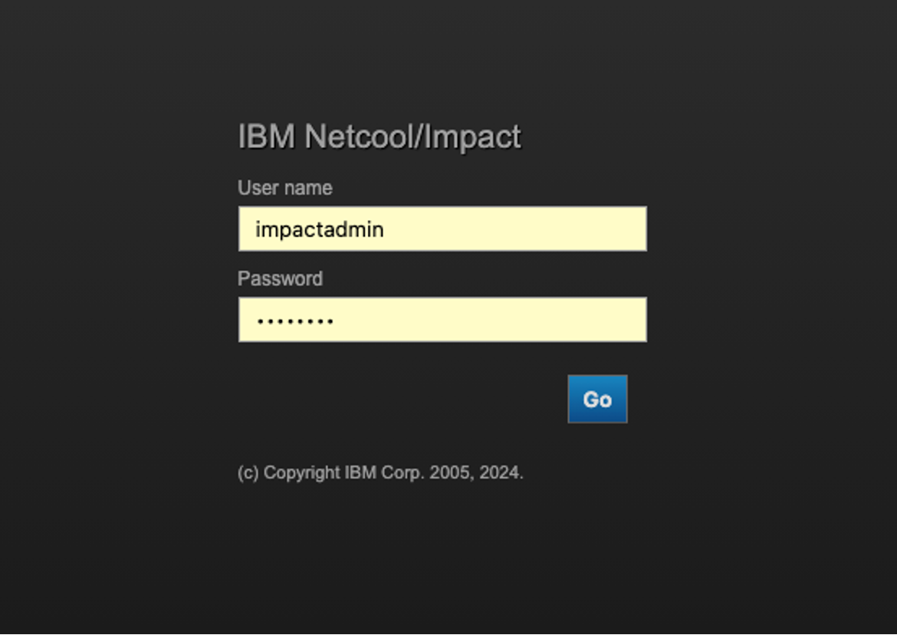
- Impact GUI login screen
- After successfully logging in, you will be presented with the main landing page for Netcool Impact.
- 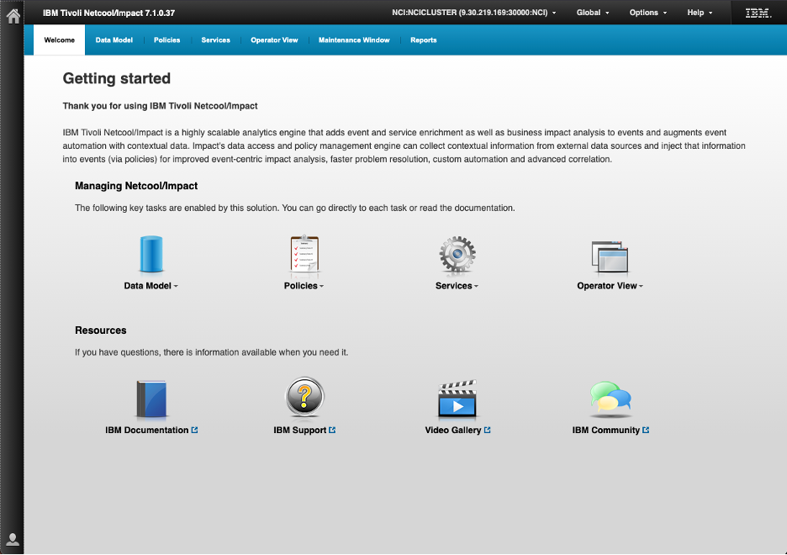
- Impact GUI dashboard after login
- Navigating Netcool/Impact
- Use the navigation controls at the top of the IBM Tivoli Netcool/Impact window to move between functional areas.
  - Select Welcome to return to the starting page. This page provides large shortcut icons to common areas of the product.
  - Select Data Model to work with data types, data sources, and related model objects.
  - Select Policies to view, create, or manage Impact policies.
  - Select Services to access configured services and service-related functions.
  - Select Operator View to open the operator-facing event and service views.
  - Select Maintenance Window to configure or review scheduled maintenance periods.
  - Select Reports to access reporting functions.
  - Use the drop-down arrows next to the large Data Model, Policies, Services, and Operator View icons on the Welcome page to open shortcuts within those areas.
- The black bar above the main navigation provides global controls:
  - Use the Home icon at upper left to return to the main starting point.
  - Use the NCI connection drop-down to identify or change the active Netcool/Impact server connection.
  - Use Global for global settings or actions.
  - Use Options for user or interface options.
  - Use Help to access product help and documentation.
- At the bottom of the Welcome page, use the Resources links to open IBM Documentation, IBM Support, Video Gallery, or IBM Community resources.
- Select the Data Model tab from the top navigation bar. The Data Model area is where data types and data sources are defined and managed. Observe the available sub-sections and note that this is where DSAs are configured for use by Impact policies. Return to the Welcome page when done by selecting Welcome from the top navigation bar.
- 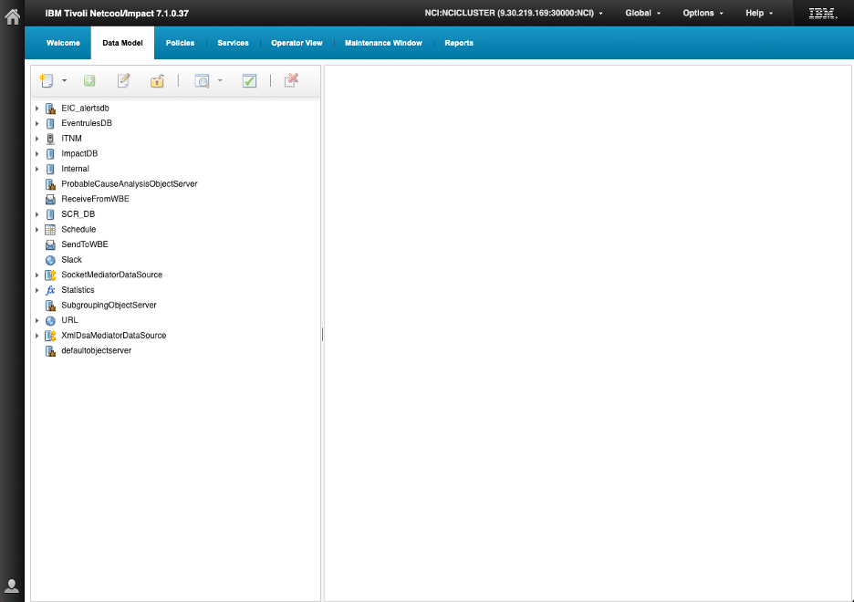
- Impact Data Model tab
- The left navigation pane lists configured data sources, while the workspace on the right remains blank until you select an item.
- A data source is the connection or integration that gives Netcool/Impact access to external or internal information — for example, an ObjectServer, database, ITNM, web service, or URL. A data type is the defined structure or view of records exposed through that source, including the fields Impact policies can retrieve, evaluate, or update.
- Visible data sources include EIC_alertsdb, EventrulesDB, ITNM, ImpactDB, Internal, Schedule, Slack, URL, and several ObjectServer-related DSAs. Expand a data source with the arrow beside it to display its data types. We will explore data sources, DSAs, and data types in more detail in later tasks.
- Next, select the Policies tab from the top navigation bar.
- 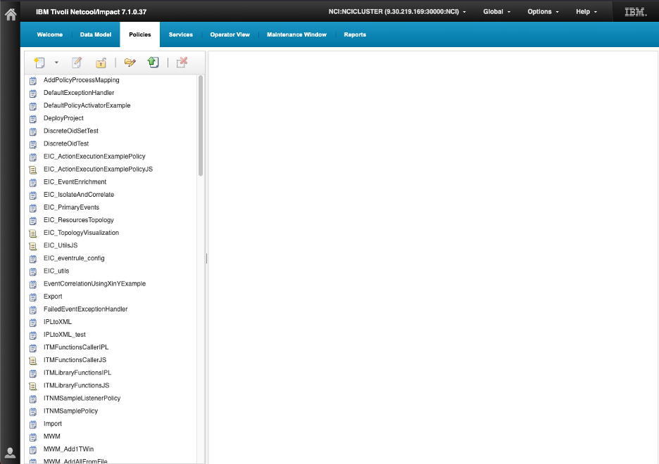
- Impact Policies section
- The screen is divided into two main areas:
- The left pane contains a scrollable list of the policies currently available in Impact. You can see policies such as AddPolicyProcessMapping, DefaultExceptionHandler, various EIC_... policies, and other sample or utility policies. The icons identify the policy object or format, such as standard policies, JavaScript policies, or folders.
- The toolbar above the policy list provides actions for working with policies, including creating, opening, saving, importing or exporting, and deleting policy objects.
- The workspace on the right is blank until you select or open a policy. When you open one, its configuration and policy logic are displayed here for review or editing.
- You will work with Impact policies in more detail in later tasks.
- Next, select the Services tab from the top navigation bar.
- 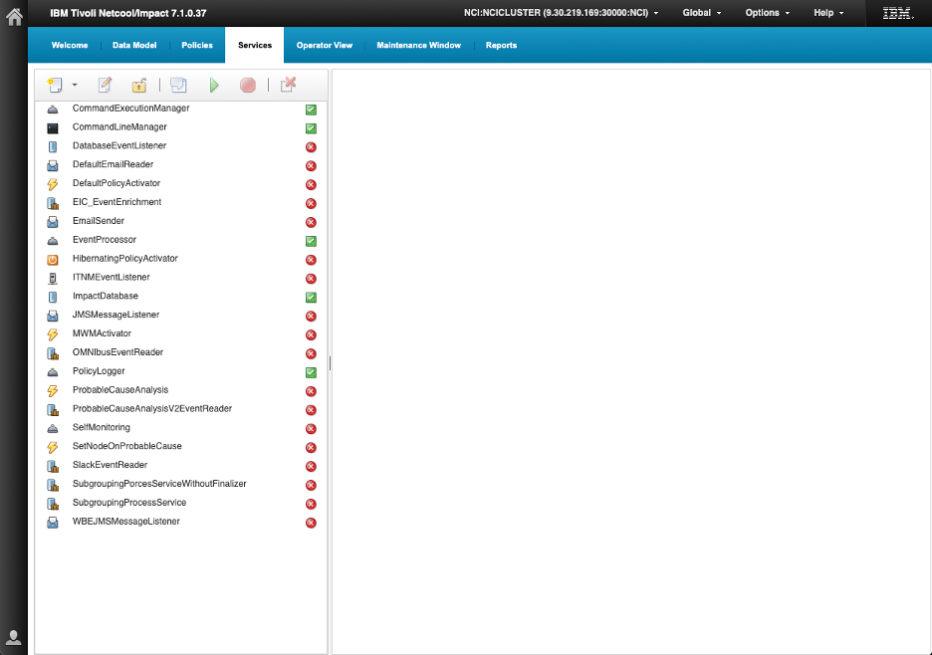
- Impact Services tab
- Select the Services tab to view and manage the Netcool/Impact services configured in the environment. The left pane lists the available services, and the status icon beside each service indicates whether it is running: a green check mark shows the service is active, while a red X shows it is stopped or unavailable. Select a service to view its details in the workspace on the right.
- The service types shown include:
  - Managers — Coordinate and manage a related service function, such as command execution or database activity.
  - Listeners and readers — Receive or read information from external systems, for example database events, JMS messages, emails, or ITNM events.
  - Activators — Trigger policy execution when a defined event or condition occurs.
  - Processors — Process incoming event data and invoke appropriate Impact logic.
  - Senders — Send information or notifications to another system, such as email.
  - Policy Logger — Records policy activity and messages for monitoring and troubleshooting.
  - Specialized services — Provide functions for specific integrations or workflows, such as event enrichment, probable-cause analysis, self-monitoring, Slack event reading, or event sub-grouping.
- The toolbar above the list lets you work with the selected service, including starting or stopping it.
- Select the Operator View tab to view and manage the operator views available in Netcool/Impact.
- 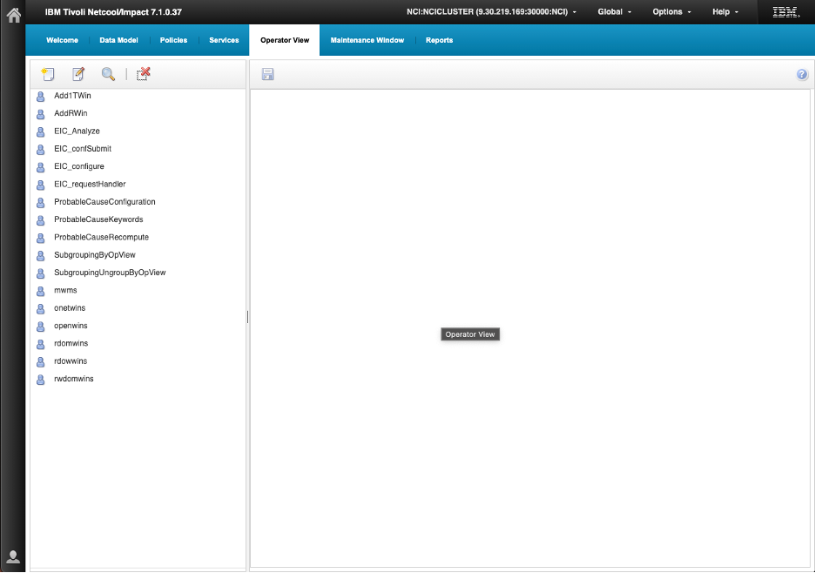
- Impact Operator View tab
- Operator views provide tailored interfaces that let operators interact with Impact functions, such as initiating workflows, submitting requests, viewing event-related information, or running specific operational actions.
- Select an operator view from the list to display its configuration in the workspace on the right. The toolbar above the list lets you create, edit, search for, or delete operator views.
- Select the Maintenance Window tab from the top navigation bar.
- 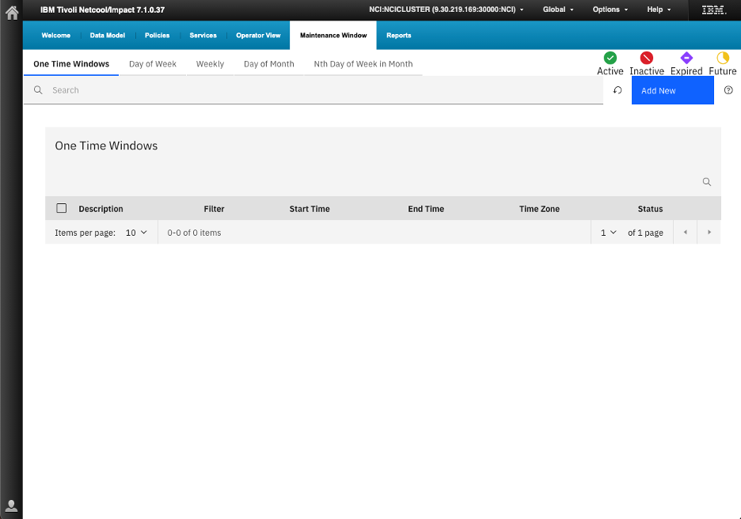
- Impact Maintenance Window tab
- Maintenance windows let you identify events that occur during approved maintenance so that they can be handled differently from unexpected operational events — for example, placed into maintenance rather than treated as active incidents.
- The page opens on One Time Windows, which lists maintenance windows that apply for a single defined start and end time. Use the other tabs to manage recurring windows by Day of Week, Weekly, Day of Month, or Nth Day of Week in Month.
- The table displays each window’s Description, event Filter, Start Time, End Time, Time Zone, and current Status. The status indicators identify windows that are Active, Inactive, Expired, or Future. Use Add New to define a maintenance window, and use the search field to locate an existing one.
- Netcool/Impact Maintenance Window Management marks a matching event as in maintenance by setting the ObjectServer alerts.status.SuppressEscl integer field to 6. This is the field that downstream Event List views, automations, and Impact policies can use to identify and suppress maintenance-related alerts.
- By default, MWM’s Policy Activator evaluates active windows about every seven seconds, so an event can briefly appear normally before SuppressEscl is updated to 6. When the window ends, MWM can clear the maintenance flag, unless its clearFlag setting is configured not to mark events as out of maintenance.

Validation
The exercise is successful when all of the following are true:
- The Impact Server and GUI server start successfully.
- You can log in to the Impact GUI and reach the dashboard.
- You can navigate to the Policies, Services, and Data Model tabs using the top navigation bar.
- You can describe the purpose of each main navigation tab.
- You can identify any pre-configured DSAs in the Data Model panel.
- You can open the policy editor and identify the key input areas without saving a policy.
- You can access the Operator View tab and confirm it is displaying current ObjectServer alerts.

Expected result
At the end of this exercise, you will be familiar with the Impact GUI layout and will be able to navigate confidently between the main tabs. This provides the foundation for all subsequent exercises, which use the Data Model panel, the Services panel, and the Policy editor to build working Impact configurations.

10. Organizing Impact artifacts using projects
As an Impact environment grows, the set of policies, services, and data types that make it work becomes a significant asset in its own right. Impact projects give you a way to organize that set of artifacts into named scopes, keeping related configuration together and making it straightforward to work on one area of the system without the clutter of everything else. Projects also serve as the unit of export and import — packaging a project produces a ZIP archive that can be transferred to another server, stored as a backup, or used to promote configuration from a test environment to production.
Every Impact server has a built-in scope called Global. Policies, services, and data types that are not assigned to a named project live in Global and are always visible regardless of which project is selected. All of the artifacts created in this lab currently live in Global.
This section walks through the full project lifecycle: understanding how the project selector works, creating a project and populating it with the lab artifacts, and exporting and re-importing the project to understand how the import process handles existing artifacts.

10.1 Create a project and add lab artifacts

Objective
In this exercise, you will open the project selector, create a new project, and populate it with all of the data sources, data types, policies, and services from this lab. By the end of the exercise, you will understand how the project selector scopes the Policies and Services views and how to build a project that captures a complete lab configuration.

Prerequisites
- Completion of sections 4 through 9.
- All lab policies and services are present: AA_EnrichAlert, AA_DeferredEnrichment, AA_EscalatePlatinum, AA_PingVerify, AA_JavaSortDemo, AA_EvalActionPolicy.
- You are logged in to the Impact GUI.

Background

The project selector
The project selector is a dropdown in the top-right area of the Impact GUI header bar, immediately to the right of the server name (for example, NCI:NCICLUSTER (192.168.2.67:30000:NCI)). It is labelled with the name of the currently active project — Global by default.
Clicking the dropdown opens a two-panel menu:
- Select Project (left panel): lists all projects defined on this server, including Global. Click any entry to switch the active scope. The currently active project is shown in bold.
- Manage Projects (right panel): provides the available actions.
Action | Purpose
Create Project | Opens the Create Project dialog
Edit Current Project | Opens the current project’s configuration for export or import
Delete Current Project | Permanently removes the current project and all its artifact references (the artifacts themselves are not deleted)
Refresh | Refreshes the project list
Clear my locks | Releases any editor locks held by your current session

What switching projects does
When you switch to a named project, the Policies and Services tabs show only the artifacts assigned to that project. This is a view filter — artifacts in other projects or in Global are not deleted; they are simply not displayed in the current scope. Switching back to Global shows all artifacts on the server.

What a project contains
A project holds references to policies, services, operator views, data sources, and data types. The underlying artifacts remain on the server; the project records which ones belong to it. Removing an artifact from a project removes the reference only — the artifact itself is unaffected.
A project export/import includes the Impact objects associated with the project, including data-source definitions, data types, policies, services, and project metadata. After import, validate and, where necessary, update environment-specific data-source settings — such as hostnames, ports, database names, credentials, certificates, driver files, filesystem paths, and external endpoints — before enabling services in the target environment. The target Impact server must also have the required DSA implementation, drivers, and supporting configuration installed.

The Create Project dialog
The Create Project dialog is a single page with:
- Project Name: the name for the new project.
- List By: a dropdown that switches which type of artifact is shown in the picker below. Available options include Services, Policies, Data Types, Data Sources, and others.
- Available Members (left column): all artifacts of the selected type that are not yet in the project. Click an item to move it to Project Members.
- Project Members (right column): artifacts assigned to the project. Click an item to move it back to Available Members.
- Execute: creates the project with the current member list.
- Close: cancels without creating the project.
You work through each member type in turn using the List By dropdown, moving items into Project Members before clicking Execute.

Tasks
- Locate the project selector in the top-right of the Impact GUI header bar. It currently reads Global.
- Click the Global dropdown to open the project selector menu. Take a moment to observe the layout:
  - The Select Project panel on the left lists the available projects. Global is shown in bold as the active project.
  - The Manage Projects panel on the right lists the available actions.
- 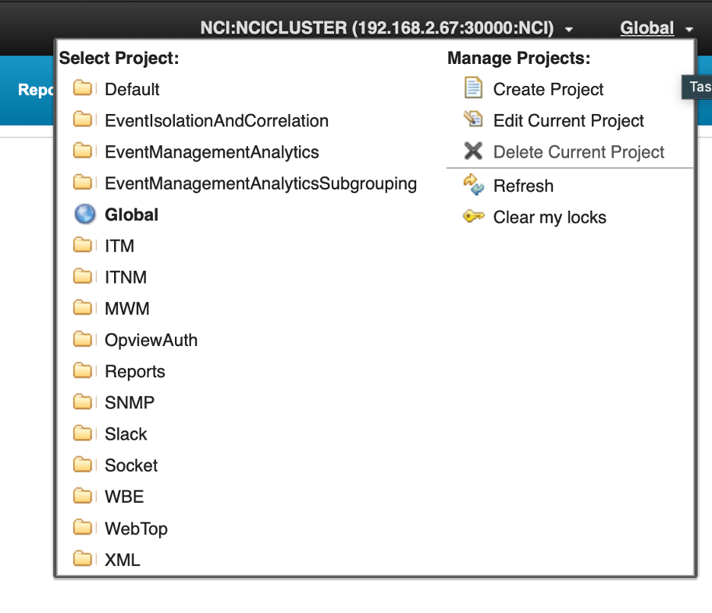
- The project selector dropdown showing the Select Project list on the left and the Manage Projects actions on the right, with Global shown as the active project.
- Click Create Project in the Manage Projects panel.
- The Create Project dialog opens. Enter ImpactLabProject in the Project Name field.
- Use the List By dropdown to select Data Sources. The Available Members list will populate with all data sources defined on this server. Move the following items to Project Members by clicking each one:
  - CMDB
  - defaultobjectserver
- Use the List By dropdown to select Data Types. A Data Source dropdown appears below it to filter which data source’s types are listed.
- First, select CMDB in the Data Source dropdown. Move the following items to Project Members:
  - DEVICE_INVENTORY
  - TAKEACTION
- Then select defaultobjectserver in the Data Source dropdown. Move the following item to Project Members:
  - EVENTS
- Use the List By dropdown to select Policies. Move the following items to Project Members:
  - AA_EnrichAlert
  - AA_DeferredEnrichment
  - AA_EscalatePlatinum
  - AA_PingVerify
  - AA_JavaSortDemo
  - AA_EvalActionPolicy
- Use the List By dropdown to select Services. Move the following items to Project Members:
  - EnrichmentEventReader
  - DeferredEnrichmentActivator
  - EscalationActivator
  - HibernatingPolicyActivator
  - EvalActionEventReader
  - EmailSender
- Review the Project Members column for each member type to confirm all items are present, then click Execute to create the project.
- ImpactLabProject now appears in the project selector dropdown.
- Click the project selector dropdown and select ImpactLabProject to switch to that scope. The header label changes from Global to ImpactLabProject.
- Select the Data Model tab. Confirm that DEVICE_INVENTORY, EVENTS, and TAKEACTION are listed under their respective data sources.
- 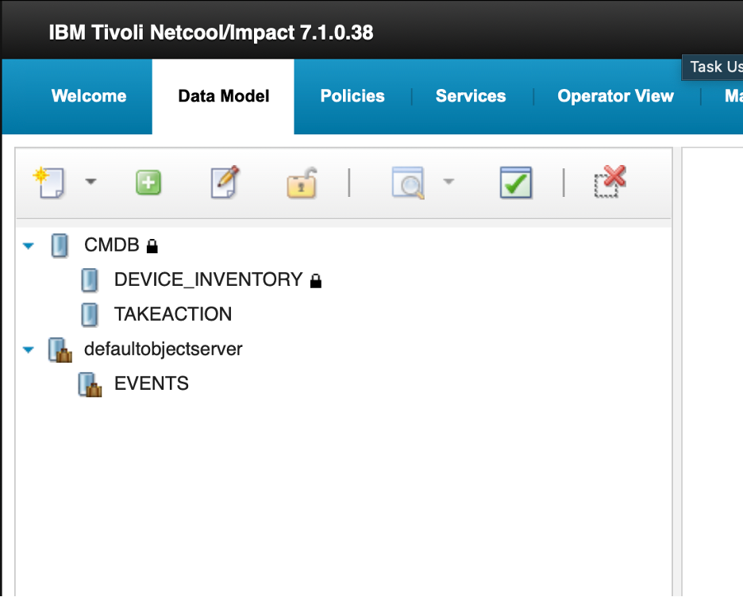
- Data Model tab with ImpactLabProject active, showing the three lab data types.
- Select the Policies tab. Confirm that all six lab policies are listed.
- 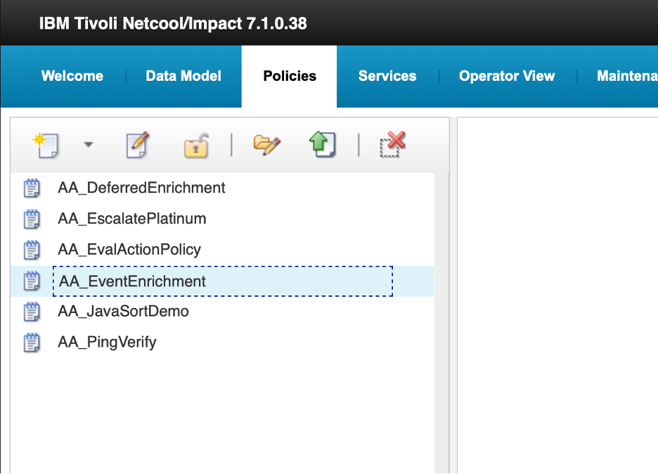
- Policies tab with ImpactLabProject active, showing the six lab policies.
- Select the Services tab. Confirm that all six lab services are listed.
- 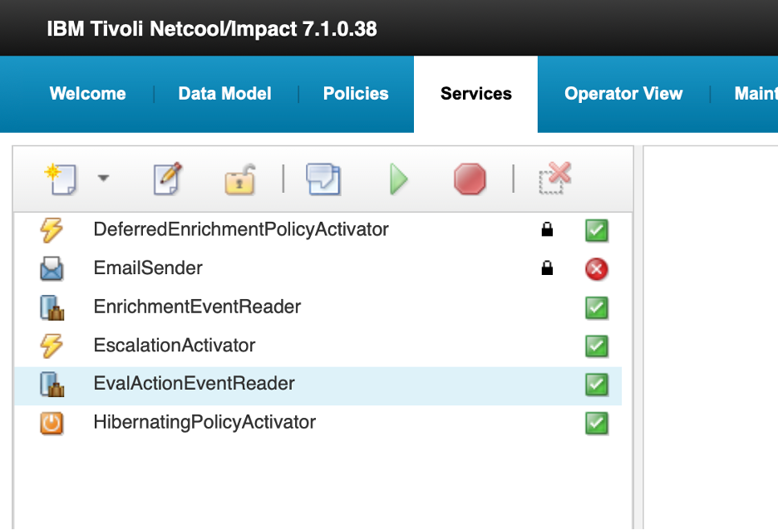
- Services tab with ImpactLabProject active, showing the six lab services.
- Click the project selector dropdown and select Global to return to the full scope view.

Validation
The exercise is successful when all of the following are true:
- ImpactLabProject appears in the project selector dropdown.
- Switching to ImpactLabProject shows the six lab policies and six lab services in their respective tabs.
- Switching back to Global restores the full artifact list.
- You can describe what the Global scope is and why it exists.
- You can explain the purpose of each step in the Create Project dialog.

Expected result
You have a populated project that captures all of the lab data sources, data types, policies, and services in a single named scope. The next exercise exports this project as a portable archive.

10.2 Export and import the project

Objective
In this exercise, you will export ImpactLabProject to a directory on the server using the nci_export command-line tool, inspect the output, then deliberately delete two lab artifacts to simulate a configuration loss, and restore them using nci_import. By the end of the exercise, you will have directly observed how export and import can be used for rollback and recovery, and you will understand the broader use cases for these tools in production environments.

Prerequisites
- Completion of section 10.1.
- ImpactLabProject is populated with all lab artifacts.
- SSH access to the lab server.
- The Impact server is running.

Background

nci_export and nci_import
Export and import of Impact projects are performed from the command line using nci_export and nci_import, located in $IMPACT_HOME/bin.
nci_export connects to the running Impact server instance and writes the project’s artifact definitions — data sources, data types, policies, services, and project metadata — to a directory on the filesystem. The export must be run on the primary Impact server; it will fail on a secondary cluster member.
The basic syntax for a single-project export is:
nci_export <server_name> --project <project_name> <output_directory>
To import, nci_import reads from a previously exported directory and loads the artifacts back into the running Impact server:
nci_import <server_name> <export_directory>
After import, validate and where necessary update any environment-specific data-source settings — such as hostnames, ports, database names, and credentials — before starting services on the target server.

Typical use cases
- Rollback: A configuration change to an exported Impact artifact introduced a problem. After stopping or controlling affected services and assessing conflicts, import a verified earlier export to restore the exported object definitions to a known-good state. Revalidate services, data-source connectivity, and policy behavior afterward.
- Promotion: Policies and their associated project artifacts developed and validated in a lower environment are exported and imported into the next environment, such as staging to production. Before enabling imported services, review target-specific endpoints, credentials, certificates, drivers, local configuration files, and external dependencies.
- Bootstrap: A new or otherwise empty Impact environment receives an initial project import so that the project’s exported artifacts are created there. Configure and validate server-local and external dependencies before activating services.
- Configuration backup: Run a scheduled or pre-change nci_export to preserve a point-in-time copy of exported Impact repository artifacts for recovery, comparison, migration, or rollback.
- Audit and change control: Export a project before and after a planned change, retain both versions under controlled storage, and compare or review them as evidence of what changed.

Tasks
- SSH into the lab server and change to the Impact binary directory:
- cd $IMPACT_HOME/bin
- Create an export destination directory:
- mkdir -p /tmp/impact-exports
- Run the export for ImpactLabProject:
- ./nci_export NCI --project ImpactLabProject /tmp/impact-exports/ImpactLabProject
- The command connects to the running Impact server instance NCI and writes the project artifacts to the specified directory. You should see output confirming the export completed successfully.
- Verify the export directory is populated:
- find /tmp/impact-exports/ImpactLabProject -type f | sort
- The listing will show individual files for each exported artifact — data sources, data types, policies, and services are each written as separate files. Confirm the file count matches the number of artifacts you added to the project.
- Before importing, simulate a configuration loss by removing two artifacts from the server. In the Impact GUI, select the Services tab.
- Right-click EnrichmentEventReader and select Stop. Wait for the state to change to Stopped, then right-click it again and select Delete. Confirm the deletion. EnrichmentEventReader should no longer appear in the Services list.
- Select the Policies tab. Right-click AA_EnrichAlert and select Delete. Confirm the deletion. AA_EnrichAlert should no longer appear in the Policies list.
- Confirm both artifacts are gone. Switch to ImpactLabProject in the project selector — AA_EnrichAlert should be absent from the Policies tab and EnrichmentEventReader should be absent from the Services tab. Switch back to Global before continuing.
- Return to the terminal and run the import:
- ./nci_import NCI /tmp/impact-exports/ImpactLabProject
- The command restores all exported artifacts. AA_EnrichAlert and EnrichmentEventReader were absent on the server, so they will be created. Artifacts that were already present will be skipped or overwritten. Review the command output and confirm both deleted artifacts appear in the import log.
- If the import reports lock errors, one or more artifacts are held by a version-control lock. Resolve this before retrying:
- 1. Check which items are currently locked:
- cat "$IMPACT_HOME/etc/NCI_versioncontrol.locks"
- 2. Clear all version-control locks on instance NCI:
- "$IMPACT_HOME/bin/nci_version_control" NCI uncoall ""
- 3. Confirm the lock list is clear or reduced as expected:
- cat "$IMPACT_HOME/etc/NCI_versioncontrol.locks"
- Then re-run the nci_import command above.
- Back in the Impact GUI, confirm the two deleted artifacts have been restored:
  - Select the Policies tab and confirm AA_EnrichAlert is present.
  - Select the Services tab and confirm EnrichmentEventReader is present.
- Start EnrichmentEventReader. Right-click it and select Start. Confirm it returns to Running state.
- Confirm that all other services that should be running are also in Running state. If any were stopped by the import, right-click each and select Start:
  - DeferredEnrichmentActivator
  - EscalationActivator
  - EvalActionEventReader
- Insert a smoke-test event to confirm the enrichment pipeline is intact after the restore:
- $OMNIHOME/bin/nco_sql -server EVENTS -user root -password netcool << 'EOF'
INSERT INTO alerts.status (Node, Summary, AlertKey, AlertGroup, Severity, Type, Identifier, Manager, OwnerUID)
VALUES ('router-lon-01', 'Post-import smoke test', 'import-test-01', 'TrainingAlerts', 3, 1, 'router-lon-01:import-test-01:TrainingAlerts', 'ImpactLab', 65534);
go
EOF
- Check the enrichment policy log:
- tail -10 $IMPACT_HOME/logs/NCI_policylogger_AA_EnrichAlert.log
- You should see an entry for router-lon-01 showing CUST-1001 and ImpactFlag = 1, confirming the restored policy is running correctly.
- Switch to the OMNIbus Web GUI in your private/incognito browser. Select the ImpactLab Events filter and the SyslogdView view. Locate the router-lon-01 smoke-test event and confirm the enrichment fields are populated — CustomerID, CustomerName, Service, and Location should all reflect the values from the CMDB, and ImpactFlag should be 1.
- 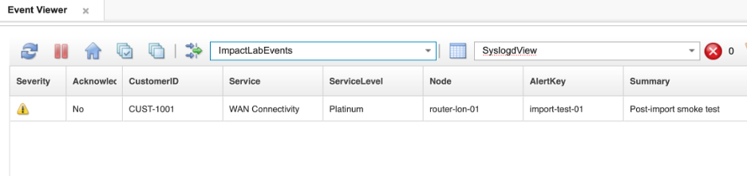
- SyslogdView showing the router-lon-01 smoke-test event with enrichment fields populated after the import restore.

Validation
The exercise is successful when all of the following are true:
- The nci_export command completed without errors and the export directory is populated with artifact files.
- AA_EnrichAlert and EnrichmentEventReader were successfully deleted before the import.
- The nci_import command completed without errors and the import log confirms both deleted artifacts were recreated.
- EnrichmentEventReader is running and the smoke-test event was enriched correctly.
- You can describe a real-world scenario for each of the five use cases: rollback, promotion, bootstrap, configuration backup, and audit and change control.
- You can explain what must be validated in the imported data-source definitions before enabling services on a new target server.
- You can state where nci_export must be run in a clustered Impact environment and why.

Expected result
You have completed the full project lifecycle: create, populate, export, and import. By deliberately removing artifacts and restoring them via nci_import, you directly observed how the import behaves when artifacts are missing — exactly the pattern used for rollback and recovery in production. You also understand how the project selector scopes the Policies and Services views to show only the artifacts relevant to the work at hand.

11. Granting users access to Impact
In a fresh Impact installation, the only Impact user is impactadmin, which is created during the installation process. All other users must be explicitly granted access before they can do anything in the Impact GUI.
Impact authenticates users against a configured user repository. In this lab, Impact is configured to authenticate against the OMNIbus EVENTS ObjectServer. This means any user defined in the ObjectServer — including ncoadmin, which you have been using throughout the lab to log into the OMNIbus Web GUI and manipulate events — can present valid credentials at the Impact login page. However, being able to authenticate is not the same as having access: a user who can log in but has no Impact role mappings is presented with a completely blank workspace.
Note: ObjectServer-based authentication is used in this lab for simplicity. Impact also supports authentication via LDAP and via Keycloak/OIDC for environments with centralized identity management.
Access is controlled through role mappings, managed from the command line using mapRoles.sh, located in /opt/IBM/tivoli/impact/install/security/. Each mapping associates a username with one or more Impact roles that determine which parts of the GUI are visible and what actions the user can perform. Roles are additive — a user can hold a narrow functional role and a broader administrative role at the same time. Changes take effect at the next login with no server restart required.
This section walks through the role-mapping workflow using the ncoadmin account: first observing the blank experience of an unmapped user, then granting a scoped functional role, and finally granting full administrative access.

11.1 Observe the default experience of an unmapped user

Objective
In this exercise, you will log in to the Impact GUI as ncoadmin and observe what an unmapped user sees. By the end of the exercise, you will understand the distinction between authentication and access in Impact, and why role mapping is required before a user can work with the product.

Prerequisites
- You are currently logged in to the Impact GUI as impactadmin in your private/incognito browser session.

Background
ncoadmin is an ObjectServer user that you have used throughout this lab to log into the OMNIbus Web GUI. Because Impact in this lab is configured to authenticate against the EVENTS ObjectServer, ncoadmin can also log into the Impact GUI — but authentication alone grants no access. The user has no Impact role mappings, so Impact has nothing to display.
This two-layer model — authenticate first, then authorize via role mappings — is standard Impact behavior. It means that adding a new user to Impact does not require creating a separate Impact account; you simply map an existing authenticated identity to the appropriate roles.

Tasks
- In your private/incognito browser, click the user menu in the top-right corner of the Impact GUI and select Logout. Confirm you are returned to the login page.
- Log in with the following credentials:
  - Username: ncoadmin
  - Password: netcool
- If you see a “Connection Failed — Unable to reach the nameserver to get the list of clusters” error, the browser is carrying stale session state from the previous login. Click Close, then close the private/incognito browser window entirely and open a fresh one. Navigate back to the Impact GUI URL and log in again. This clears the cached session and the error will not recur. The same applies to any subsequent login in this section.
- 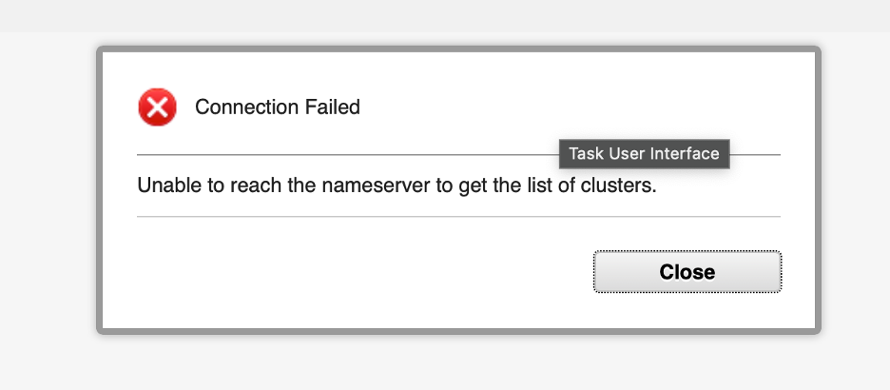
- Connection Failed dialog showing “Unable to reach the nameserver to get the list of clusters”.
- Observe the result. The workspace is blank — no tabs, no navigation, no content. Authentication succeeded, but ncoadmin has no Impact role mappings, so there is nothing to show.
- Log out of the Impact GUI.

Validation
The exercise is successful when all of the following are true:
- You were able to log in as ncoadmin without an authentication error.
- The workspace was blank with no tabs or navigation visible.
- You can explain why ncoadmin can authenticate but sees a blank page.
- You can explain why no separate Impact account was needed for ncoadmin to log in.

Expected result
You have confirmed the default state for an unmapped user and understand the distinction between authentication and access. The next exercise grants ncoadmin a scoped functional role and demonstrates the resulting change in access.

11.2 Grant Maintenance Window Manager access

Objective
In this exercise, you will use mapRoles.sh to grant ncoadmin the Impact Maintenance Window Manager roles, then log in to confirm the access. By the end of the exercise, you will understand what the Maintenance Window Manager function does and how scoped role mapping works.

Prerequisites
- Completion of section 11.1.
- SSH access to the lab server.
- You are logged out of the Impact GUI.

Background

Maintenance Window Manager
The Maintenance Window Manager (MWM) is a built-in Impact feature that lets operators schedule and manage maintenance windows — defined time periods during which event processing rules or escalation policies are suppressed or modified. During a maintenance window, events from a node or group of nodes that would normally trigger policies can be held back, preventing alert storms during planned outages such as patching, reboots, or infrastructure changes.
The MWM has two associated roles:
Role | Purpose
impactMWMUser | Allows the user to view maintenance windows and their schedules
impactMWMAdminUser | Allows the user to create, edit, and delete maintenance windows
Both roles are typically granted together so that operators can both view and manage windows.

mapRoles.sh
mapRoles.sh is the command-line tool for adding and removing Impact role mappings. It is located in /opt/IBM/tivoli/impact/install/security/ and must be run as root on the Impact server. The basic syntax for adding roles is:
./mapRoles.sh -add -user <username> -roles "<role1>|<role2>"
Multiple roles are separated by a pipe character (|) within the quoted string. Changes take effect at the next login.

Tasks
- SSH into the lab server as root and navigate to the security directory:
- cd /opt/IBM/tivoli/impact/install/security
- Grant ncoadmin the Maintenance Window Manager roles:
- ./mapRoles.sh -add -user ncoadmin -roles "impactMWMAdminUser|impactMWMUser"
- You should see the following confirmation:
- Adding user ncoadmin to role impactMWMAdminUser
Adding user ncoadmin to role impactMWMUser
- Return to your private/incognito browser and log in to the Impact GUI as ncoadmin / netcool.
- Observe the result. The Maintenance Window tab is now visible in the top navigation bar. ncoadmin can view and manage maintenance windows, but no other areas of Impact are accessible.
- Explore the Maintenance Window tab briefly — note that it is the only tab present. The Policies, Services, Data Model, and other administrative tabs are not visible because ncoadmin has not been granted the corresponding roles.
- Log out of the Impact GUI.

Validation
The exercise is successful when all of the following are true:
- The mapRoles.sh command completed without errors.
- Logging in as ncoadmin shows the Maintenance Window tab and no other tabs.
- You can explain the difference between impactMWMUser and impactMWMAdminUser.
- You can explain why the Policies and Services tabs are not visible.

Expected result
You have granted a scoped functional role and confirmed the result. ncoadmin can now manage maintenance windows and nothing else. The next exercise grants full administrative access.

11.3 Grant full administrative access

Objective
In this exercise, you will grant ncoadmin the impactAdminUser role and confirm that full access is available. By the end of the exercise, you will understand how the administrative role relates to the narrower functional roles already assigned.

Prerequisites
- Completion of section 11.2.
- You are logged out of the Impact GUI.

Background
The impactAdminUser role grants access to all areas of the Impact GUI — Policies, Services, Data Model, Operator View, Maintenance Window, and administrative functions. It is the equivalent of the built-in impactadmin account’s access level and is appropriate for Impact administrators and developers who need full control over the environment.
Assigning impactAdminUser to a user who already holds narrower roles (such as impactMWMAdminUser) is additive — the narrower role mappings remain in place and the user simply gains the additional access that impactAdminUser provides.

Tasks
- In your SSH session, confirm you are still in the /opt/IBM/tivoli/impact/install/security directory, then grant ncoadmin the administrative role:
- ./mapRoles.sh -add -user ncoadmin -roles "impactAdminUser"
- You should see:
- Adding user ncoadmin to role impactAdminUser
- Return to your private/incognito browser and log in to the Impact GUI as ncoadmin / netcool.
- Observe the result. The full navigation bar is now visible — Policies, Services, Data Model, Operator View, Maintenance Window, and Reports tabs are all present. ncoadmin now has the same level of access as impactadmin.
- Browse the Policies tab and confirm the lab policies are visible. Browse the Services tab and confirm the lab services are visible.
- Log out of the Impact GUI in your private/incognito browser and log back in as impactadmin / netcool to restore the original session.

Validation
The exercise is successful when all of the following are true:
- The mapRoles.sh command completed without errors.
- Logging in as ncoadmin shows the full navigation bar with all tabs.
- You can confirm the lab policies and services are visible to ncoadmin.
- You can explain what impactAdminUser grants and how it relates to the narrower roles already assigned.
- You can describe a scenario where granting only impactMWMAdminUser — rather than impactAdminUser — is the correct choice.

Expected result
You have granted full administrative access to ncoadmin and confirmed the result. You understand the Impact role model: access is controlled entirely by role mappings, mappings are additive, and /opt/IBM/tivoli/impact/install/security/mapRoles.sh is the tool used to manage them from the command line.

2. Impact data source adapters (DSAs)
Data source adapters (DSAs) are the connectors that give Impact policies access to external systems. In most cases, when a policy needs to look up data from a database, query an API, read from LDAP, or interact with an OMNIbus ObjectServer, it does so through a named DSA. There are a few exceptions — for example, policies can make direct HTTP calls or execute inline logic without a DSA — but for the majority of integration scenarios a DSA is the standard mechanism. Without at least one DSA configured, a policy has no way to reach any data outside of the event it received when it was triggered.
DSAs are defined once at the server level and then referenced by name in policy code. This means policies do not need to include connection strings, credentials, or hostname details — those are managed centrally in the DSA configuration, and policies simply call the DSA by name. If the target system changes, only the DSA configuration needs to be updated, rather than every policy that uses it. This also improves security, since credentials are stored and managed in one place rather than embedded in policy code where they could be more easily exposed or overlooked during a rotation.
Impact ships with a set of built-in adapter types that cover the most common integration scenarios. The most frequently used adapter types in OMNIbus environments are:
- ObjectServer DSA: Connects to a Netcool/OMNIbus ObjectServer. Used both to receive triggering events and to write enriched values back to alerts.status.
- JDBC DSA: Connects to any relational database with an available JDBC driver, including MySQL, DB2, Oracle, and Microsoft SQL Server.
- HTTP/REST DSA: Connects to REST APIs over HTTP or HTTPS, supporting GET, POST, PUT, and DELETE operations.
- LDAP DSA: Connects to an LDAP directory, such as Microsoft Active Directory or IBM Directory Server.
- File DSA: Reads data from a delimited flat file, useful for simple lookup tables that do not require a live database connection.

2.1 The ObjectServer DSA

Objective
In this exercise, you will review the pre-configured ObjectServer DSA and verify that Impact can connect to the OMNIbus ObjectServer. By the end of the exercise, you will understand what the ObjectServer DSA is used for, how to inspect its configuration, and how to confirm that the connection state is active.

Prerequisites
- Completion of section 1.6.
- The Impact Server is running.
- The OMNIbus ObjectServer (EVENTS) is running.

Background
The ObjectServer DSA is one of the most important DSAs in any Impact deployment because it provides the primary link between Impact and the OMNIbus event stream. It serves two distinct purposes:
- Event source: Services that monitor the ObjectServer use the ObjectServer DSA to receive a stream of events that match a defined filter condition. When a new alert arrives or an existing alert is updated in alerts.status, the service receives the event data and passes it to the configured policies.
- Write-back target: After a policy has looked up enrichment data or performed automation, it uses the ObjectServer DSA to write results back to alerts.status. This is how Impact-enriched fields such as CustomerID, Service, or CircuitID appear on an alert in the OMNIbus event list.
The ObjectServer DSA is typically pre-configured during Impact installation and should already point to the EVENTS ObjectServer used in this lab.

Tasks
- Open the Impact GUI at http://<your-server>:17311/ibm/console and log in as impactadmin with password netcool.
- Select the Data Model tab from the top navigation bar. In the data source list on the left, locate the defaultobjectserver entry and double-click it. The DSA configuration will open as a tabbed window in the workspace on the right.
- 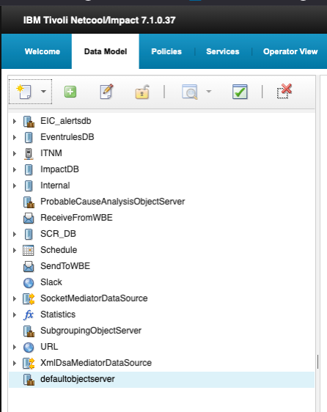
- Data Sources panel showing ObjectServer DSA
- Review the configuration tabs that open in the workspace on the right.
- 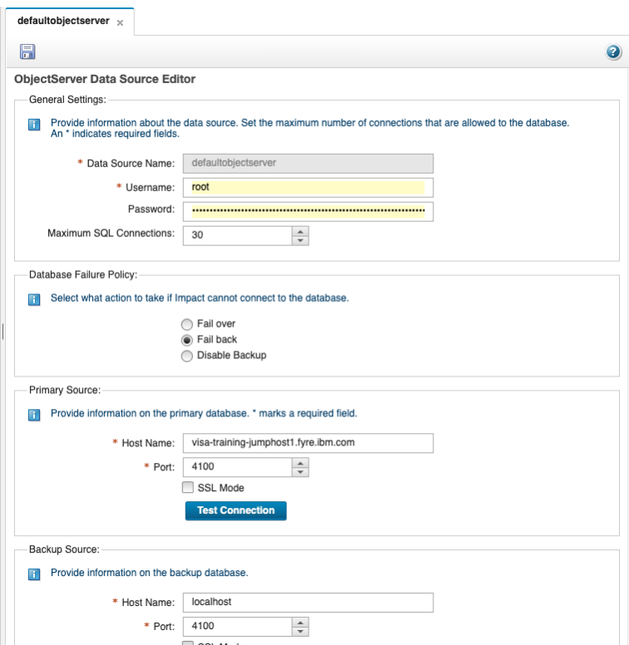
- ObjectServer DSA configuration details
- The ObjectServer Data Source Editor configures how Netcool/Impact connects to the default ObjectServer. It is organized into three main sections: General Settings, Database Failure Policy, and Primary/Backup Source connection details.
  - Data Source Name: defaultobjectserver — the internal name by which Impact policies refer to this data source.
  - Username and Password: The database credentials Impact uses to authenticate to the ObjectServer. The configured username is root, while the password is masked.
  - Maximum SQL Connections: Set to 30, this limits the number of concurrent SQL connections that Impact can open to this data source.
  - Database Failure Policy: Controls Impact’s behavior if it cannot connect to the ObjectServer. Fail back is selected, meaning Impact will attempt to return to the primary source after using the backup source.
  - Primary Source: Defines the main ObjectServer connection. The host is visa-training-jumphost1.fyre.ibm.com on port 4100. SSL Mode is available but not selected. The Test Connection button can be used to validate the supplied primary connection settings.
  - Backup Source: Defines a secondary ObjectServer connection for resilience if the primary source becomes unavailable. In the screenshot, it points to localhost on port 4100.
- Note: Fields marked with an asterisk are required.
- Click the Test Connection button in the Primary Source section. Impact uses the username and password configured in the General Settings section to attempt a live connection to the ObjectServer at the specified host and port. A popup window will appear with the result of the connection attempt. Confirm that it displays Connection OK.
- 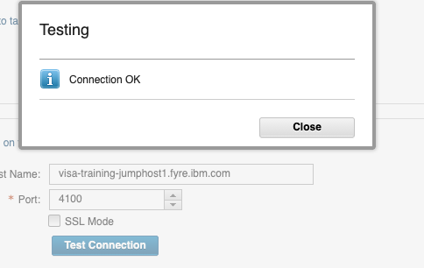
- Test Connection result popup
- If the result does not say Connection OK, verify that the EVENTS ObjectServer is running on the lab server before retrying.
- The defaultobjectserver data source provides the underlying connection to the ObjectServer database. On its own, it can be used by policies to execute direct SQL calls against any table that the configured user has access to — for example, querying alerts.status or updating fields on specific alerts.
- In addition to direct SQL access, Impact also supports data types. A data type is defined on top of a data source and targets a specific table or view. It exposes that table to policies through simplified built-in functions such as GetByFilter, GetByKey, AddDataItem, and DeleteDataItem, without requiring the policy to write raw SQL. This makes policy code cleaner, easier to read, and less prone to errors.
- The distinction is important:
  - A data source defines the connection — the server, credentials, and database to connect to.
  - A data type defines a structured view of a specific table within that connection, giving policies a higher-level interface to work with.
- To create a new data type on this data source, right-click on defaultobjectserver in the data source list on the left and select New Data Type.
- 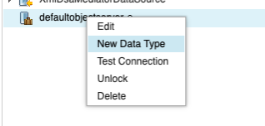
- New Data Type context menu
- A new tab labelled New Data Type for defaultobjectserver will open in the workspace on the right, showing the SQL Data Type Config Page. Configure the new data type as follows:
  - Data Type Name: EVENTS
  - Data Source Name: leave as defaultobjectserver
  - Base Table: alerts.status
- Once the base table is entered, click the Refresh Fields button. Impact will query the ObjectServer and populate the field list below with the structure of the alerts.status table. Each row in the list shows the field ID, Field Name, Format, Display Name, Description, and a Key Field column.
- The Key Field setting identifies which field uniquely identifies a record in this data type. Impact uses this field when performing key-based lookups with functions such as GetByKey. Scroll through the field list to locate the Identifier field and set its Key Field column to Yes.
- When complete, your configuration should match the following screenshot:
- 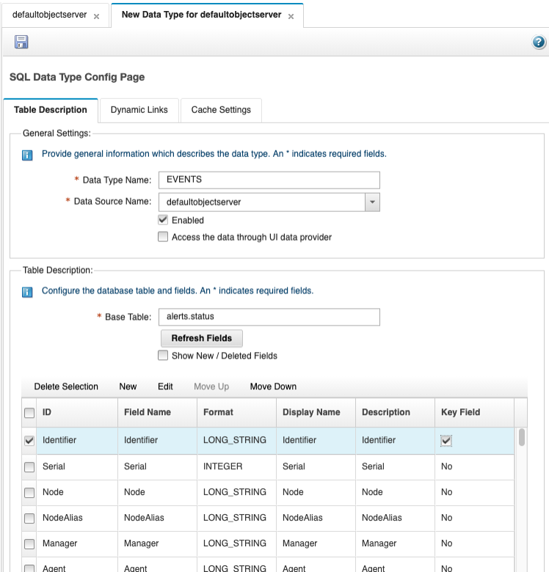
- SQL Data Type Config Page for EVENTS data type
- Save the data type by clicking the floppy disk icon at the top left of the configuration tab. Once saved, the EVENTS data type will appear nested under defaultobjectserver in the data source list on the left.
- 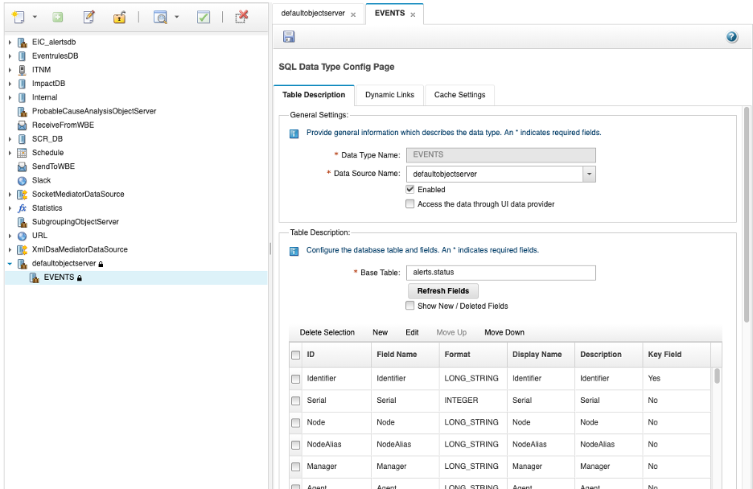
- EVENTS data type saved and visible in data source list

Validation
The exercise is successful when all of the following are true:
- You can navigate to the Data Model tab and locate the defaultobjectserver entry in the data source list.
- You can open the DSA configuration by double-clicking and identify the General Settings, Database Failure Policy, and Primary/Backup Source sections.
- The Test Connection result displays Connection OK for the primary source.
- You can explain the difference between a data source and a data type.
- You can explain that the defaultobjectserver DSA serves both as an event source and as a write-back target for enrichment results.
- A new EVENTS data type has been created targeting the alerts.status table, with Identifier set as the key field.
- The EVENTS data type is saved and visible nested under defaultobjectserver in the data source list.

Expected result
At the end of this exercise, you will understand the role of the ObjectServer DSA in an Impact deployment, know how to inspect and test its configuration, and be able to explain the difference between a data source and a data type. You will also have created the EVENTS data type targeting alerts.status with Identifier as the key field — a foundation that will be used by policies in later exercises to query and update alerts directly through a structured, simplified interface.

2.2 Creating a JDBC DSA for event enrichment

Objective
In this exercise, you will create an enrichment database in DB2, populate it with sample device inventory data, and then connect Impact to that database by creating a JDBC DSA and a corresponding data type. By the end of the exercise, you will have a working enrichment data source that Impact policies can query in later exercises to look up customer and service information for incoming alerts.

Prerequisites
- Completion of section 2.1.
- SSH access to the lab server as root.
- DB2 is installed on the lab server and the db2inst1 instance is available.
- The DB2 JDBC driver (db2jcc4.jar) is available to the Impact server.

Background
A common use case for Impact is event enrichment — the process of adding contextual information to an alert that the probe could not provide on its own. For example, a probe may insert an alert with a Node value of router-lon-01, but an operator needs to know which customer owns that device, what service it supports, and who to contact. Rather than building that knowledge into the probe rules, Impact can look it up at runtime from an external database and write the results directly back to the alert.
To support this pattern, the lab environment will use a DB2 database named CMDB with a single enrichment table called DEVICE_INVENTORY. This table maps device hostnames to customer and service context. Once the table is created and populated, Impact will connect to it through a JDBC DSA, and a data type will be defined on top of that connection so that policies can query the table using simplified built-in functions.
The DEVICE_INVENTORY table has the following structure:
Column | Type | Description
NODE_NAME | VARCHAR(128) | Device hostname — matches the Node field in OMNIbus alerts
CUSTOMER_ID | VARCHAR(64) | Customer identifier associated with the device
CUSTOMER_NAME | VARCHAR(128) | Full customer name
SERVICE | VARCHAR(64) | Business service supported by the device
LOCATION | VARCHAR(64) | Physical or logical location of the device
CONTACT | VARCHAR(128) | On-call contact name for the device

Tasks
- SSH into the lab server as root. Switch to the DB2 instance user:
- su - db2inst1
- Then verify that the DB2 instance is running:
- db2gcf -s
- The output should show the instance status as Available. If the instance is not running, start it before proceeding:
- db2start
- Create the enrichment database from the bash shell — do not open the db2 interactive session yet:
- db2 CREATE DATABASE CMDB
- Wait for the command to complete. You should see:
- DB20000I The CREATE DATABASE command completed successfully.
- Now connect to the new database and create the DEVICE_INVENTORY table. Run the following as a single script by saving it to a file and executing it:
- db2 CONNECT TO CMDB
db2 "CREATE TABLE DEVICE_INVENTORY ( \
NODE_NAME VARCHAR(128) NOT NULL, \
CUSTOMER_ID VARCHAR(64), \
CUSTOMER_NAME VARCHAR(128), \
SERVICE VARCHAR(64), \
LOCATION VARCHAR(64), \
CONTACT VARCHAR(128), \
PRIMARY KEY (NODE_NAME) )"
- Confirm that the output includes:
- DB20000I The SQL command completed successfully.
- Populate the table by writing the INSERT statements to a script file and running it with db2 -tf. Create the file with the following command:
- cat > /tmp/load_cmdb.sql << 'EOF'
CONNECT TO CMDB;
INSERT INTO DEVICE_INVENTORY VALUES ('router-lon-01', 'CUST-1001', 'Acme Corporation', 'WAN Connectivity', 'London DC', 'noc@acme.com');
INSERT INTO DEVICE_INVENTORY VALUES ('router-lon-02', 'CUST-1001', 'Acme Corporation', 'WAN Connectivity', 'London DC', 'noc@acme.com');
INSERT INTO DEVICE_INVENTORY VALUES ('switch-nyc-01', 'CUST-1002', 'Globex Industries', 'LAN Infrastructure', 'New York DC', 'ops@globex.com');
INSERT INTO DEVICE_INVENTORY VALUES ('switch-nyc-02', 'CUST-1002', 'Globex Industries', 'LAN Infrastructure', 'New York DC', 'ops@globex.com');
INSERT INTO DEVICE_INVENTORY VALUES ('server-fra-01', 'CUST-1003', 'Initech Solutions', 'App Hosting', 'Frankfurt DC', 'support@initech.com');
INSERT INTO DEVICE_INVENTORY VALUES ('server-fra-02', 'CUST-1003', 'Initech Solutions', 'App Hosting', 'Frankfurt DC', 'support@initech.com');
INSERT INTO DEVICE_INVENTORY VALUES ('fw-sin-01', 'CUST-1004', 'Pinnacle Networks', 'Network Security', 'Singapore DC', 'security@pinnacle.com');
INSERT INTO DEVICE_INVENTORY VALUES ('db-tok-01', 'CUST-1005', 'Soylent Systems', 'Database Services', 'Tokyo DC', 'dba@soylent.com');
COMMIT;
EOF
- Then run the script:
- db2 -tf /tmp/load_cmdb.sql
- Each INSERT statement should return DB20000I The SQL command completed successfully.
- Verify that the data was inserted correctly:
- db2 CONNECT TO CMDB
db2 "SELECT * FROM DEVICE_INVENTORY"
- Confirm that eight rows are returned with the expected values.
- Return to the Impact GUI at http://<your-server>:17311/ibm/console and log in as impactadmin with password netcool. Select the Data Model tab from the top navigation bar. Click the New Data Source icon (the star/page icon at the top left of the data source toolbar) and from the dropdown menu select Database (SQL) → DB2.
- 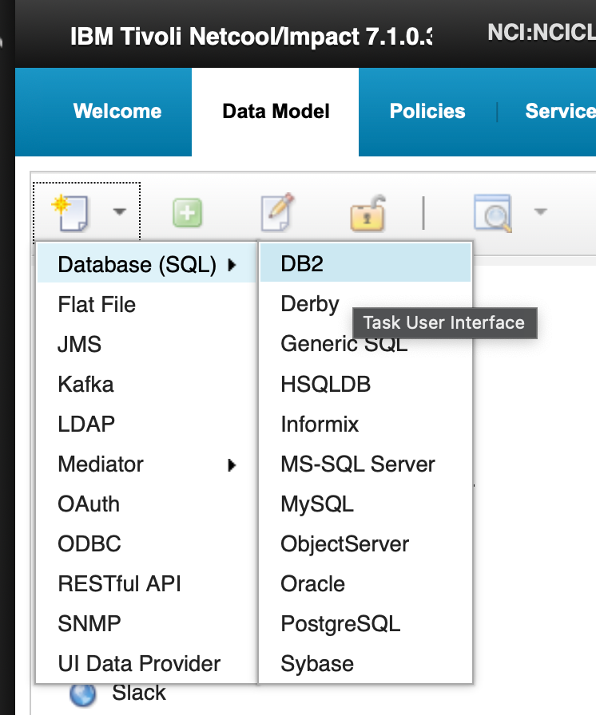
- New Data Source menu - Database SQL DB2
- The SQL Data Source Config Page will open as a new tab in the workspace. Configure the DB2 JDBC connection with the following settings:
  - Data Source Name: CMDB
  - JDBC URL: jdbc:db2://localhost:50000/CMDB
  - JDBC Driver: com.ibm.db2.jcc.DB2Driver
  - Username: db2inst1
  - Password: N3tc00l2024N3tc00l20204!
  - Maximum SQL Connections: 10
- 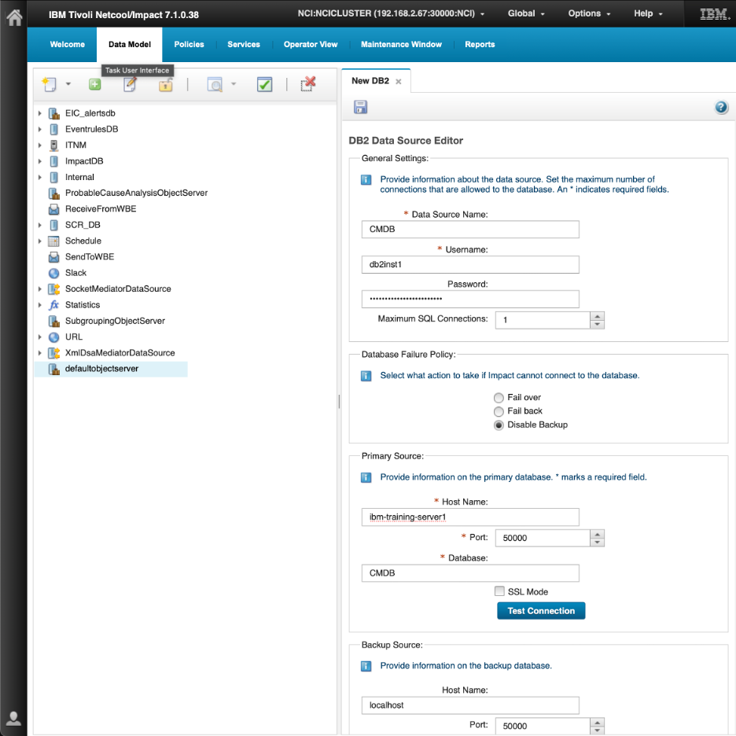
- JDBC DSA configuration for CMDB
- Click the Test Connection button. Confirm that the result popup displays Connection OK. If it does not, verify that the DB2 instance is running and that the database CMDB was created successfully in the previous steps.
- Save the data source by clicking the floppy disk icon at the top left of the configuration tab. Confirm that CMDB now appears in the data source list on the left.
- Right-click on CMDB in the data source list and select New Data Type to create a data type for the enrichment table.
- 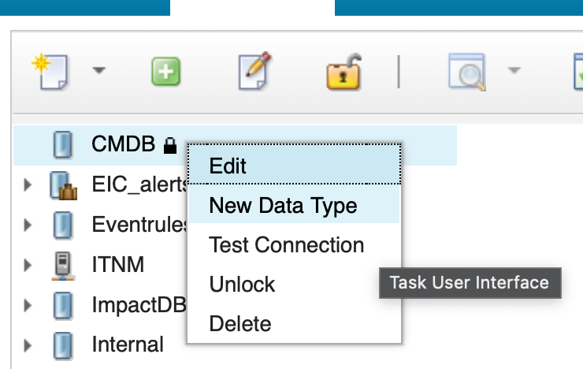
- New Data Type for CMDB
- Configure the new data type on the SQL Data Type Config Page as follows:
  - Data Type Name: DEVICE_INVENTORY
  - Data Source Name: leave as CMDB
  - Base Table: DEVICE_INVENTORY
- Click Refresh Fields to populate the field list with the table structure. Locate the NODE_NAME field and set its Key Field column to Yes, since NODE_NAME is the unique identifier that policies will use to look up enrichment data by device hostname.
- 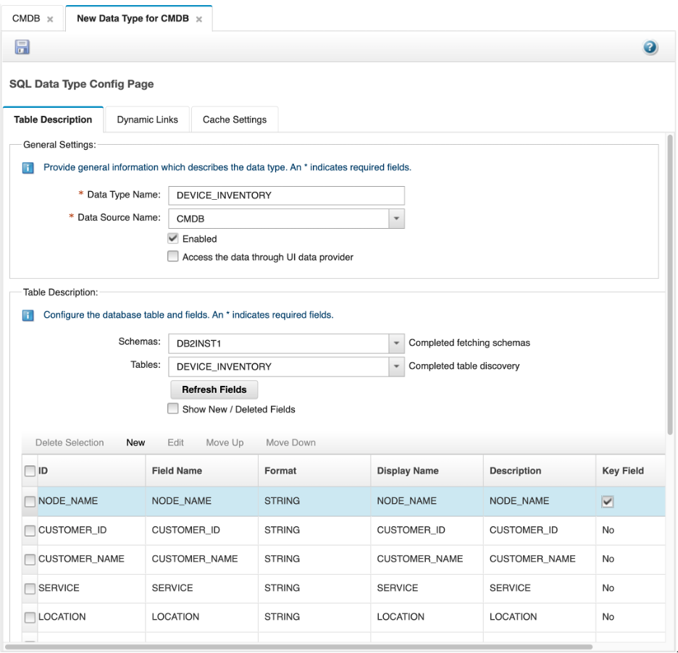
- DEVICE_INVENTORY data type configuration
- Save the data type by clicking the floppy disk icon. Confirm that DEVICE_INVENTORY appears nested under CMDB in the data source list.
- 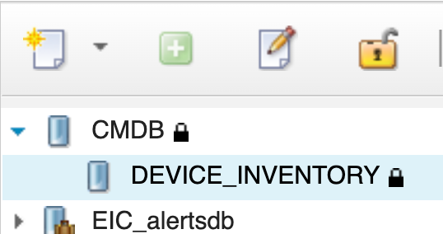
- DEVICE_INVENTORY saved under CMDB

Validation
The exercise is successful when all of the following are true:
- The CMDB database exists in DB2 and the DEVICE_INVENTORY table contains eight rows of sample enrichment data.
- The CMDB JDBC DSA is configured and the Test Connection result shows Connection OK.
- The CMDB data source appears in the Data Model data source list.
- The DEVICE_INVENTORY data type is created with NODE_NAME set as the key field.
- The DEVICE_INVENTORY data type is saved and visible nested under CMDB in the data source list.

Expected result
At the end of this exercise, you will have a fully configured enrichment data source in Impact. The CMDB JDBC DSA connects Impact to the DB2 enrichment database, and the DEVICE_INVENTORY data type provides policies with a structured, key-based interface to look up customer and service data by device hostname. This data source and data type will be used directly in the policy enrichment exercises in later sections.

2.3 Validating the CMDB data source and data type

Objective
In this exercise, you will validate that the CMDB data source and DEVICE_INVENTORY data type created in section 2.2 are working correctly and are ready for use in policies. You will test the data source connection directly from the Data Model tab, confirm that the data type can return rows from the enrichment table, and review the data type performance report.

Prerequisites
- Completion of section 2.2.
- The CMDB JDBC DSA and DEVICE_INVENTORY data type are configured.
- The DB2 instance is running and the CMDB database is available.

Background
Before using a data source in a policy, it is good practice to verify that both the data source and its data types are working as expected. In Impact, these are two distinct layers that can be validated independently.
The data source represents the physical connection to the external system — in this case, the DB2 CMDB database. Validating the data source confirms that Impact can reach the database using the configured credentials and connection settings. If the data source connection fails, no policy that depends on it will be able to retrieve or write data.
The data type sits on top of the data source and defines the structure of a specific table or view. Validating the data type confirms that Impact can query the underlying table and that the field definitions are correct. The View Data Items function executes a live query against the table through the data type and returns the current rows, giving you immediate confirmation that the data type is functional and the enrichment data is accessible to policies.
The Performance Report provides a view of how the data type has been used over time, including query counts, response times, and error rates. While this is most useful in a production environment where policies are actively querying the data type, reviewing it after initial setup establishes a baseline and confirms that the data type is being tracked by the Impact monitoring framework.
Understanding both layers — and knowing how to validate each one — is an important part of working with Impact data sources. A data source that connects successfully does not guarantee that a data type defined on top of it will return data correctly; the table may not exist, the field mapping may be wrong, or the key field may be misconfigured. Validating each layer separately makes it straightforward to isolate the cause of any issue.

Tasks
- In the Impact GUI, select the Data Model tab from the top navigation bar. In the data source list on the left, locate the CMDB data source entry. To test the connection, either right-click on CMDB and select Test Connection, or select CMDB and click the green check icon in the toolbar at the top of the data source list. A popup will appear with the result — confirm that it displays Connection OK. If it does not, verify that the DB2 instance is running and that the CMDB database exists before continuing.
- 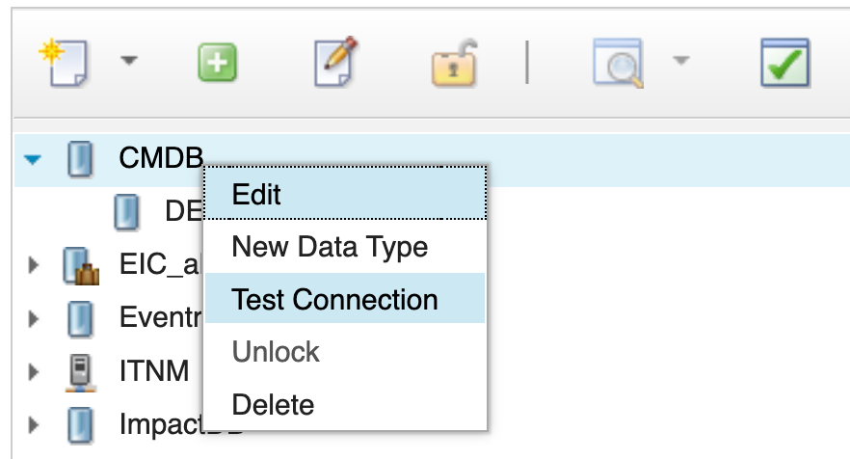
- Test Connection result for CMDB
- Now validate the data type. In the data source list, expand CMDB to reveal the DEVICE_INVENTORY data type nested beneath it. Right-click on DEVICE_INVENTORY and select View Data Items.
- 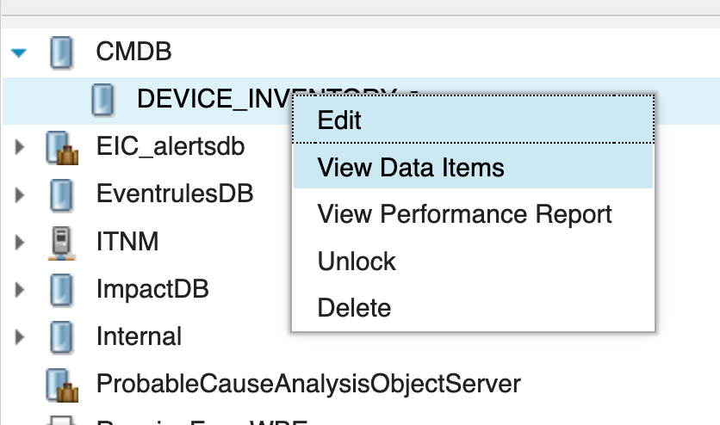
- View Data Items option on DEVICE_INVENTORY data type
- A results panel will open displaying the current rows in the DEVICE_INVENTORY table. Confirm that all eight rows inserted in section 2.2 are returned, with the correct values for NODE_NAME, CUSTOMER_ID, CUSTOMER_NAME, SERVICE, LOCATION, and CONTACT.
- 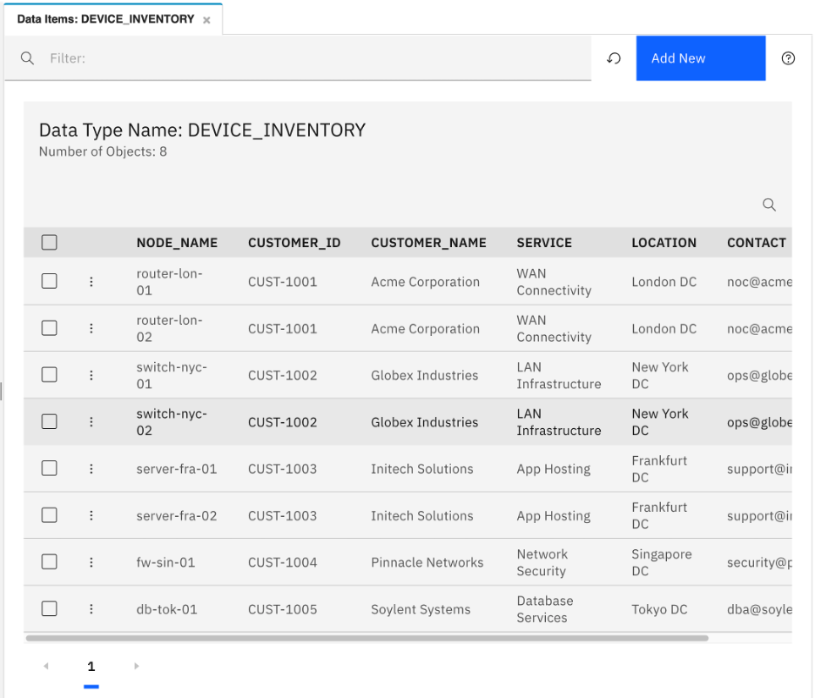
- View Data Items results for DEVICE_INVENTORY
- Right-click on DEVICE_INVENTORY again and select Show Performance Report.
- 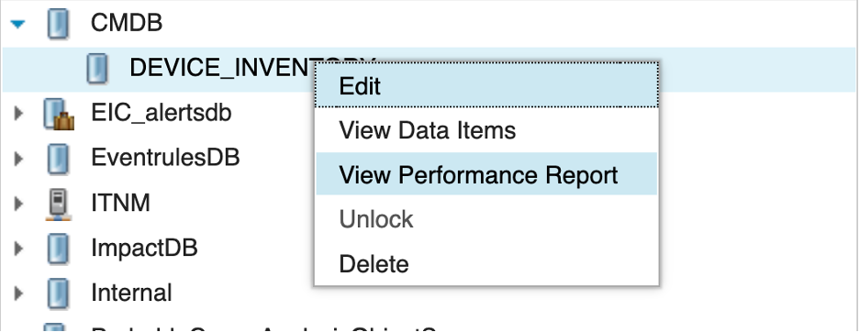
- Show Performance Report option on DEVICE_INVENTORY
- The performance report displays utilization and performance metrics for this data type, including query counts, average response times, and any errors encountered. Review the report and note the available metrics. At this stage the counts will be low since the data type has not yet been used by any policies — this report will become more informative once enrichment policies are actively running in later exercises.

Validation
The exercise is successful when all of the following are true:
- Right-clicking CMDB and selecting Test Connection returns Connection OK.
- Right-clicking DEVICE_INVENTORY and selecting View Data Items returns all eight enrichment rows.
- The Show Performance Report option opens the performance report for the data type without error.
- You can explain the difference between validating a data source and validating a data type.

Expected result
At the end of this exercise, you will have confirmed that the CMDB data source has an active connection to the DB2 database and that the DEVICE_INVENTORY data type can successfully retrieve enrichment data. Both layers are now validated and ready to be used by Impact policies in the exercises that follow.

3. Impact policy language (IPL)
The Impact Policy Language (IPL) is the scripting language used to write all Impact automation logic. Every policy in Impact is a block of IPL code that defines what happens when the policy is invoked by a service. IPL is a procedural language — code runs from top to bottom in the order it is written, with conditionals and loops controlling flow.
IPL is purpose-built for event enrichment and automation tasks. It provides direct access to event fields through the triggering event object, built-in functions for querying data sources, string manipulation, date and time handling, logging, and writing results back to the ObjectServer. It does not require knowledge of a general-purpose programming language, but familiarity with basic programming concepts such as variables, conditions, and loops is helpful.

3.1 IPL basics — variables, types, and assignment

Objective
In this section, you will be introduced to the fundamental elements of IPL: variables, data types, and assignment syntax. By the end of the section, you will understand how to declare and assign variables, what data types are available, and how to write basic IPL expressions.

Background
IPL variables are declared and assigned using the following syntax:
variableName = value;
There is no explicit type declaration — IPL infers the type from the assigned value. The primary data types used in IPL are:
Type | Description | Example
String | Text value enclosed in double quotes | "CRITICAL"
Integer | Whole number | 5
Float | Decimal number | 3.14
Boolean | True or false value | True or False
Array | Ordered list of values | [1, 2, 3]
EventContainer | An object holding event field values | Retrieved from the service trigger
Variable names are case-sensitive. A variable assigned in one part of a policy is available for the remainder of that policy’s execution. Variables do not persist across separate policy invocations — each time the service triggers the policy, a fresh execution context begins.
Comments are written using the // prefix for single-line comments, or using /* ... */ for block comments that span multiple lines:
// This is a single-line comment
nodeName = "router01"; // inline comment after a statement
/*
* This is a block comment.
* Use it for policy headers, longer explanations,
* or to comment out a section of code during testing.
*/
Block comments are commonly used at the top of a policy to describe its purpose, prerequisites, and how to run it.

String concatenation
Strings are concatenated using the + operator:
greeting = "Hello " + "World";
fullKey = nodeValue + ":" + alertKeyValue;

Conditional logic
IPL uses if, else if, and else for conditional branching:
if (severity == 5)
{
priority = "Critical";
}
elseif (severity >= 3) {
priority = "High";
}
else
{
priority = "Normal";
}
Comparison operators available in IPL:
Operator | Meaning
== | Equal to
!= | Not equal to
> | Greater than
< | Less than
>= | Greater than or equal to
<= | Less than or equal to
Logical operators:
Operator | Meaning
&& | Logical AND
\|\| | Logical OR
! | Logical NOT

Loops
IPL supports while loops and for each loops for iterating over arrays and result sets:
// while loop
counter = 0;
while (counter < 5)
{
counter = counter + 1;
log("Counter is " + counter);
}
/// use index and length to iterate over arrays
// arrays are declared in curly braces {}
items = {"a", "b", "c"};
index = 0;
itemCount = Length(items);
while (index < itemCount)
{
Log("Item: " + item);
index = index + 1;
}

Tasks
- Open a text editor and write the following IPL variable assignment expressions:
- // String variable
hostName = "router01";
// Integer variable
retryCount = 3;
// Boolean variable
enrichmentRequired = True;
// String concatenation
alertKey = hostName + ":interface-down:" + "TrainingAlerts";
- Add a conditional block that logs a message based on retryCount:
- if (retryCount > 2)
{
Log("Retry threshold reached for host: " + hostName);
}
else
{
Log("Retry count within normal range: " + retryCount);
}
- Add a while loop that iterates over a small array and logs each value:
- severities = {3, 4, 5};
index = 0;
itemCount = Length(severities);
while (index < itemCount)
{
Log("Processing severity level: " + sev);
index = index + 1;
}
- Note: You do not need to run this code yet. In section 4.1 you will paste policy code directly into the Impact policy editor. These exercises build your familiarity with IPL syntax before you write live policies.

Validation
You have completed this section when:
- You can write a valid variable assignment for each of the four primary data types.
- You can write an if / else if / else block using at least two comparison operators.
- You can write a while loop that iterates over an array.
- You understand that IPL variables are not explicitly typed — type is inferred from the assigned value.

Expected result
You now understand some basic foundational IPL syntax used to create and maintain policies in Impact. The variable, conditional, and loop patterns covered here appear throughout the enrichment and automation policies you will write in section 4.

3.2 Accessing event data in a policy

Objective
In this section, you will learn how to access the fields of the triggering alert within a policy. By the end of the section, you will understand how to read event fields, store them in local variables, and use those values in conditional logic.

Background
When a service triggers a policy, it passes the current values of the triggering event’s fields into the policy execution context. The policy can access these values through the EventContainer object, which is available as a special variable that holds all alerts.status field values for the event that fired the service.
The standard syntax for reading a field from the triggering event is:
localVar = EventContainer.FieldName;
For example, to read the Node, Severity, and Summary fields:
nodeValue = EventContainer.Node;
sevValue = EventContainer.Severity;
summaryValue = EventContainer.Summary;
Once stored in local variables, these values can be used in conditions, string operations, data source lookups, and write-back operations.
Note: Field names in EventContainer are case-sensitive and must match the exact column names from alerts.status. Common fields used in policies include Node, AlertKey, AlertGroup, Summary, Severity, Manager, Identifier, and Service.

Example policy reading event fields
The following is a minimal IPL policy that reads key fields from a triggering event and logs them for inspection:
// Read fields from the triggering event
nodeValue = EventContainer.Node;
sevValue = EventContainer.Severity;
summaryValue = EventContainer.Summary;
alertKey = EventContainer.AlertKey;
// Log the values for diagnostic purposes
Log("Policy triggered for node: " + nodeValue);
Log("Severity: " + sevValue);
Log("Summary: " + summaryValue);
Log("AlertKey: " + alertKey);
The Log function writes a message to the Impact policy log. Its syntax is Log(message) — pass a single string expression and the message is always written to the policy log file. It is common practice to prepend the policy name to the message string, for example Log("AA_EnrichAlert: enrichment started for Node=" + nodeValue), so that output from different policies is easy to identify when reading the log file or filtering with grep.

Tasks
- Review the field list for the alerts.status table used in this lab. The fields you will access in enrichment policies are:
Field name | Type | Description
Node | String | Hostname or IP address of the source device
AlertKey | String | Unique key for the alert condition
AlertGroup | String | Logical grouping for the alert
Summary | String | Human-readable description of the alert
Severity | Integer | Numeric severity (1=Indeterminate, 2=Warning, 3=Minor, 4=Major, 5=Critical)
Identifier | String | Unique identifier combining node, key, and group
CustomerID | String | Custom field — populated by the enrichment policy
Service | String | Custom field — populated by the enrichment policy
- Review the IPL code below that reads Node, Severity, AlertKey, and Summary from the triggering event and stores each in a local variable:
- nodeValue = EventContainer.Node;
sevValue = EventContainer.Severity;
alertKey = EventContainer.AlertKey;
summaryValue = EventContainer.Summary;
- The following adds a conditional check that logs different messages depending on severity:
- if (sevValue >= 4)
{
Log(2, "High severity event on node: " + nodeValue + ", Key: " + alertKey);
}
else
{
Log(2, "Event received on node: " + nodeValue + ", Severity: " + sevValue);
}

Validation
You have completed this section when:
- You can write a valid EventContainer.FieldName expression for at least four alerts.status fields.
- You understand that field names in EventContainer are case-sensitive.
- You can explain what happens if you attempt to read a field that does not exist in alerts.status.
- You can use a severity value read from EventContainer in a conditional expression.

Expected result
You now know how to read any field from the triggering event inside a policy. This is the first step in every enrichment policy: read the event fields you need, then use those values to drive the lookup and write-back logic that follows.

3.3 Querying data sources from IPL

Objective
In this section, you will learn about the GetByFilter IPL function to query Impact data types. By the end of the section, you will understand how to call the function, process the results, and handle the case where no matching rows are found.

Background
IPL provides the GetByFilter function to retrieve data items from a configured Impact data type. The function queries the data source associated with the named data type and returns an array of matching data items.
[Array =] GetByFilter(DataType, Filter, [CountOnly]);
The arguments are:
Argument | Type | Description
dataTypeName | String | The Impact data type name as configured in the Data Model tab (not the DSA name or table name)
filterCondition | String | A filter expression used to select matching data items. For SQL data sources, this is typically an SQL-style condition such as Location = ‘New York’; do not include the WHERE keyword.
countOnly | Boolean | Optional. Retained for compatibility with earlier releases. Specify False; it does not return a matching-row count.
For example:
DataType = "DEVICE_INVENTORY";
Filter = "Location = 'New York' AND Facility = 'Manhattan'";
MyNodes = GetByFilter(DataType, Filter, False);
Note: The first argument to GetByFilter is the Impact data type name — the name you gave the data type when you created it in section 2.2 (DEVICE_INVENTORY). It is not the DSA name and not the underlying database table name. Impact uses the data type configuration to resolve which DSA and table to query.

Checking for empty results
Always check the result array length before accessing elements. Accessing index [0] on an empty array will cause the policy to throw an error:
filterCondition = "NODE_NAME = '" + nodeValue + "'";
results = GetByFilter("DEVICE_INVENTORY", filterCondition, False);
if (Length(results) > 0) {
firstRow = results[0];
customerID = firstRow.CUSTOMER_ID;
service = firstRow.SERVICE;
Log("Found inventory record for node: " + nodeValue
+ ", customer: " + customerID
+ ", service: " + service);
} else {
Log("No inventory record found for node: " + nodeValue);
}

Building filter strings safely
When constructing a filter expression from a string value, ensure that embedded single quotes do not terminate the quoted value prematurely. For SQL-backed data types, a single quote within a string literal is represented by two single quotes.
For example, if nodeValue is it’s-router-01, the value must become it’’s-router-01 before it is included in the filter expression:
nodeFilterValue = Replace(nodeValue, "'", "''", 0);
filterCondition = "NODE_NAME = '" + nodeFilterValue + "'";
results = GetByFilter("DEVICE_INVENTORY", filterCondition, False);
The final filter expression then becomes:
NODE_NAME = 'it''s-router-01'
The final 0 argument tells Replace() to replace every matching occurrence. Replace() uses regular expressions for its pattern argument and requires the expression, pattern, replacement value, and maximum number of replacements.

Tasks
- Review the following IPL code along with its comments. Note the GetByFilter IPL function call that looks up nodeValue in the DEVICE_INVENTORY data type. Store the result and guard against an empty response:
- // Read the Node value from the event that invoked this policy.
// EventContainer is the policy context object containing the incoming event fields.
nodeValue = EventContainer.Node;
// Replace embedded single quotes in the node name with two single quotes.
// For an SQL-backed data type, this prevents a single quote from prematurely
// ending the quoted value in the filter expression.
nodeFilterValue = Replace(nodeValue, "'", "''", 9999);
// Build the GetByFilter expression used to locate an inventory row whose
// NODE_NAME field exactly matches the event's Node value.
//
// Example:
// nodeValue = "router01"
// filter = "NODE_NAME = 'router01'"
//
// If nodeValue = "it's-router-01", the escaped filter becomes:
// "NODE_NAME = 'it''s-router-01'"
filter = "NODE_NAME = '" + nodeFilterValue + "'";
// Query the configured Impact data type named DEVICE_INVENTORY.
// The result is an array containing zero or more matching data items.
// False is the optional CountOnly argument and should normally be specified
// as False; it is retained for backward compatibility.
results = GetByFilter("DEVICE_INVENTORY", filter, False);
// Check that at least one inventory record was returned before attempting
// to access the first element of the result array.
if (Length(results) > 0)
{
// Retrieve the first matching data item from the returned array.
// If duplicate NODE_NAME values exist, this selects only the first row.
inventoryRow = results[0];
// Copy the CUSTOMER_ID field from the matching inventory record
// into a policy variable for later use.
customerID = inventoryRow.CUSTOMER_ID;
// Copy the SERVICE field from the matching inventory record
// into a policy variable for later use.
serviceName = inventoryRow.SERVICE;
// Write a diagnostic message at log level 2. This message is recorded only
// when the Policy Logger service is configured with a highest log level
// of 2 or greater.
Log("Inventory record found for node: " + nodeValue);
}
else
{
// Write a level-2 diagnostic message when no DEVICE_INVENTORY record
// matches the event Node value.
Log("No inventory record for node: " + nodeValue);
}
- Review this GetByFilter call that retrieves all events from the ObjectServer data type EVENTS where Severity equals 5. Log the count of matching rows:
- criticalEvents = GetByFilter("defaultobjectserver", "Severity = 5", False);
Log("Critical events found: " + Length(criticalEvents));
- Extend the example from task 2 to iterate over the results and log the Node and Summary for each row:
- criticalEvents = GetByFilter("defaultobjectserver", "Severity = 5", False);
if (Length(criticalEvents) > 0)
{
for each event in criticalEvents
{
Log("Critical: Node=" + event.Node + ", Summary=" + event.Summary);
}
}
else
{
Log("No critical events found.");
}
- Note: You do not need to run these snippets yet. You will use these patterns directly in the policies you build in section 4.

Validation
You have completed this section when:
- You can write a GetByFilter call with the correct three-argument signature.
- You understand that the first argument is the Impact data type name, not the DSA or table name.
- You can check the length of a GetByFilter result before accessing its elements.
- You can explain why single quotes in field values must be escaped before building a filter string.
- You can iterate over a GetByFilter result array using a for each loop.

Expected result
You now understand the data retrieval function and the empty-check pattern required to use it safely. These patterns form the lookup step in every enrichment policy — reading event fields is step one; looking up matching inventory data is step two.

3.4 Writing values back to the ObjectServer

Objective
In this section, you will learn how to write values from a policy back to the OMNIbus ObjectServer by updating fields on the triggering alert. By the end of the section, you will understand how to assign new values directly to EventContainer fields and use ReturnEvent to commit those changes back to the ObjectServer.

Background
The primary purpose of most Impact enrichment policies is to update alert fields in alerts.status with data retrieved from an external source. This write-back operation is performed in two steps:
- Assign the new value directly to the EventContainer field using standard assignment syntax.
- Commit the changes back to the ObjectServer by calling ReturnEvent(EventContainer).
The assignment syntax mirrors the read syntax from section 3.2:
EventContainer.FieldName = newValue;
For example, after looking up customer data from the inventory database, the following code writes the customer ID and service name back to the alert:
EventContainer.CustomerID = customerID;
EventContainer.Service = serviceName;
After all assignments are complete, call ReturnEvent to push the updated EventContainer back to the ObjectServer:
ReturnEvent(EventContainer);
Without ReturnEvent, the changes exist only in the local execution context — the ObjectServer alert is not updated.

Important considerations
- Field names are case-sensitive: CustomerID is not the same as customerid. The field name must exactly match the column name in alerts.status.
- Custom fields must exist: Fields written to EventContainer must already exist as columns in alerts.status. Writing to a non-existent field will not create the column. The ImpactFlag, CustomerID, and Service fields added in earlier exercises are examples of custom fields that must be created before Impact can write to them.
- Only the triggering event is updated: ReturnEvent(EventContainer) updates the specific alert that triggered the policy. To update other alerts, a separate GetByFilter against the ObjectServer data type followed by explicit assignments on each returned row is required.
- Call ReturnEvent once, after all assignments: Assign all the field values you need first, then call ReturnEvent a single time to commit the complete set of changes in one operation.

Example write-back snippet
// Read the node from the triggering event
nodeValue = EventContainer.Node;
// Look up customer information in the inventory database
nodeFilterValue = Replace(nodeValue, "'", "''");
filter = "NODE_NAME = '" + nodeFilterValue + "'";
results = GetByFilter("DEVICE_INVENTORY", filter, False);
if (Length(results) > 0) {
inventoryRow = results[0];
// Assign enrichment fields directly to EventContainer
EventContainer.CustomerID = inventoryRow.CUSTOMER_ID;
EventContainer.Service = inventoryRow.SERVICE;
EventContainer.ImpactFlag = 1;
Log(2, "Enriched alert for node: " + nodeValue
+ " with customer: " + inventoryRow.CUSTOMER_ID);
} else {
EventContainer.CustomerID = "NOT_FOUND";
EventContainer.Service = "NOT_FOUND";
EventContainer.ImpactFlag = 2;
Log(2, "No inventory record found for node: " + nodeValue
+ " — enrichment skipped");
}
// Commit all changes back to the ObjectServer
ReturnEvent(EventContainer);

Tasks
- Review the important considerations listed in the background section. In your own words, answer the following:
  - What happens if you assign a value to an EventContainer field that does not exist as a column in alerts.status?
  - Can you use ReturnEvent to update a different alert (not the one that triggered the policy)? If not, what would you need to do instead?
  - Why should all field assignments be made before calling ReturnEvent rather than calling ReturnEvent after each individual assignment?

Validation
You have completed this section when:
- You can write a complete enrichment write-back block using EventContainer.Field = value assignment syntax.
- You understand that ReturnEvent(EventContainer) is required to commit the changes to the ObjectServer.
- You understand that field names in EventContainer are case-sensitive and must match existing alerts.status columns.
- You can explain the difference between updating the triggering event and updating another alert.
- You can describe the read → look up → assign → ReturnEvent pattern that all enrichment policies follow.

Expected result
You now know how to write data back to the ObjectServer from a policy. Combined with reading event fields (section 3.2) and querying data sources (section 3.3), you have all three building blocks of a complete enrichment policy. Section 4 puts these blocks together into policies that run against live event data.

3.5 Built-in IPL functions reference
The following table summarizes some commonly used IPL built-in functions. These functions will be used throughout the policy-building exercises in section 4.
Function | Signature | Description
Log | Log(message) | Writes a message to the Impact policy log. Pass a string expression; the message is always written to the policy log file.
GetByFilter | GetByFilter(dataTypeName, filter, [countOnly]) | Returns an array of data items from the named Impact data type that match the filter expression. The optional countOnly parameter is retained for compatibility; specify False for normal retrieval. The filter is interpreted by the DSA associated with the data type.
ReturnEvent | ReturnEvent(EventContainer) | Returns an event container to its event source. For an incoming ObjectServer event, this commits updates made to event fields; it can also be used to add a journal entry or delete an event when the appropriate EventContainer state variables are set.
Replace | Replace(string, pattern, replacement, maxReplacements) | Returns a new string after replacing occurrences that match the specified regular-expression pattern. The final argument controls the maximum number of replacemednts.
Length | Length(array) | Returns the number of elements in an array. Use to check GetByFilter results before accessing elements.
ToUpper | ToUpper(str) | Returns the input string converted to uppercase.
ToLower | ToLower(str) | Returns the input string converted to lowercase.
Trim | Trim(str) | Returns the input string with leading and trailing whitespace removed.
Contains | Contains(str, substr) | Returns True if str contains substr, otherwise False.
GetDate | GetDate() | Returns the current date/time value as seconds since the UNIX epoch. It is commonly passed to LocalTime() for formatting.
LocalTime | LocalTime(timestamp, [pattern]]) | Converts an epoch time value to a formatted local date/time string.
IsNull | IsNull(value) | Returns True if the value is NULL, otherwise False.
ToString | ToString(value) | Converts a non-string value to its string representation.
ToInteger | ToInteger(str) | Converts a string to an integer value.
This is only a subset of all functions available in Impact Policy Language. For a complete listing, consult the Netcool/Impact functions list available at the following link: https://www.ibm.com/docs/en/tivoli-netcoolimpact/7.1.0?topic=policies-working-functions

4. Event enrichment
Before you begin: This section involves writing IPL policy code. If you have not already done so, review section 3 (Impact Policy Language) before starting — in particular sections 3.2 (accessing event data), 3.3 (querying data sources), and 3.4 (writing values back to the ObjectServer).
Event enrichment is the most common use case for Impact in OMNIbus environments. When a probe inserts a new alert into the ObjectServer, the alert typically contains only what the probe could detect — the node name, a summary message, and a severity. It has no knowledge of which customer owns that node, which business service it supports, or who is responsible for it. Enrichment solves this by automatically looking up that context from an inventory or CMDB source and writing it back to the alert, so operators see a fully populated event the moment it arrives.
The enrichment pattern has three steps:
- Read — the policy reads key fields from the triggering alert (for example, Node).
- Look up — the policy queries an inventory data source to find the record matching that node.
- Write back — the policy writes the returned fields (CustomerID, Service, etc.) back to the alert in the ObjectServer.

Workflow control with flag fields
A key design question in any enrichment implementation is: how does the service know which events still need to be processed? Filtering on Severity > 0 would match every active alert — including ones that have already been enriched — causing the policy to run repeatedly on the same events.
The solution is a dedicated workflow flag field on alerts.status. This pattern is common across Impact deployments and is not limited to enrichment:
- An enrichment flag controls which events have been looked up in the CMDB.
- A ticketing flag tracks whether a ticket has been raised for an alert.
- A notification flag records whether an on-call notification has been sent.
- A maintenance flag marks alerts that were suppressed during a planned outage window.
In each case, the flag starts at a default value (typically 0) for every new event, and the policy updates it when it acts on the alert. The service filter targets only events where the flag is still at its default value, ensuring each event is processed exactly once.
In this lab, you will add an ImpactFlag integer column to alerts.status with a default value of 0. The enrichment policy will set it to 1 when enrichment succeeds, and to 2 when enrichment is attempted but no inventory record is found. You will then create a service — the component in Impact that watches the ObjectServer and triggers policies — configured to match only alerts where ImpactFlag = 0, so that each event is passed to the enrichment policy exactly once.
This section walks through the complete end-to-end implementation: add the flag field, write the policy, configure the service, connect them, and validate the result with live test events.

4.1 Write the enrichment policy

Objective
In this exercise, you will create the enrichment policy in the Impact GUI. By the end of the exercise, you will have a saved, enabled policy that reads the Node field from the triggering alert, looks up the matching record in the DEVICE_INVENTORY table, and writes CustomerID and Service back to the alert.

Prerequisites
- Completion of sections 1, 2, and 3.
- The defaultobjectserver ObjectServer DSA is configured and connected (section 2.1).
- The EVENTS data type is configured in the Data Model, using the defaultobjectserver DSA against the alerts.status table (section 2.1).
- The CMDB DB2 DSA is configured and connected (section 2.2).
- The OMNIbus ObjectServer is running.

Tasks
- SSH into the lab server and add the ImpactFlag column to the alerts.status table. This column will be used to track whether each alert has been processed by Impact:
- $OMNIHOME/bin/nco_sql -server EVENTS -user root -password netcool << 'EOF'
ALTER TABLE alerts.status ADD COLUMN ImpactFlag INTEGER;
go
EOF
- Note: Integer fields that are not explicitly set by a probe rule are automatically populated with 0 when an event is inserted into the ObjectServer. This means any new alert will have ImpactFlag = 0 without requiring any changes to probes or gateways.
- Verify the column was added:
- $OMNIHOME/bin/nco_sql -server EVENTS -user root -password netcool << 'EOF'
DESCRIBE alerts.status;
go
EOF
- Confirm that ImpactFlag appears in the column list with type integer.
- Open a private/incognito browser window and navigate to the Impact GUI at http://<your-server>:17311/ibm/console. Log in as impactadmin with password netcool.
- Note: A private window is used throughout this lab to keep the Impact GUI session separate from other browser sessions. Keep this window open for all remaining tasks in this section.
- Select the Policies tab from the top navigation bar. The policies list will appear in the left pane. In the toolbar at the top of the list, click the dropdown arrow next to the New Policy icon and select IPL Policy.
- 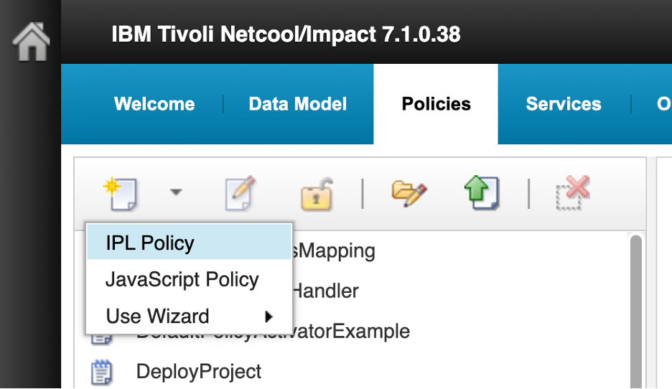
- New Policy dropdown with IPL Policy selected
- A blank IPL code editor opens titled New IPL Policy. Before entering any code, click the Save icon (floppy disk, top-left). A Save dialog appears with a single Policy Name field. Enter AA_EnrichAlert and click Save.
- Note: The AA_ prefix causes the policy to sort to the top of the alphabetical policy list, making it easy to find during this lab. This is a common convention when working in shared Impact environments that contain many pre-existing policies.
- 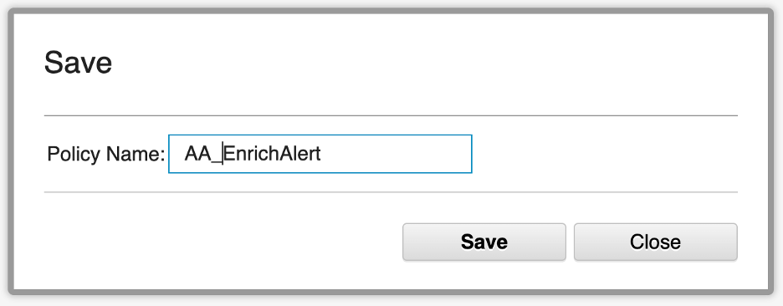
- Save dialog with Policy Name AA_EnrichAlert
- The editor tab updates to show AA_EnrichAlert. Notice that the policy now appears at the top of the policy list in the left pane with a lock icon (🔒) next to its name. The lock indicates that the policy is currently open for editing by you. Other users cannot edit it while it is locked. The lock is released when you close the editor tab.
- Now enter the following IPL code in the editor:
- // Policy: AA_EnrichAlert
//
// Prerequisites:
// - CustomerID, Service, and ImpactFlag exist in the ObjectServer table.
// - Those fields are included in the OMNIbusEventReader event mapping.
// - DEVICE_INVENTORY is an Impact data type using the CMDB datasource.
// - DEVICE_INVENTORY exposes NODE_NAME, CUSTOMER_ID, and SERVICE.
if (EventContainer.ImpactFlag != 0) {
Log("AA_EnrichAlert: Serial=" + EventContainer.Serial
+ " already processed; ImpactFlag=" + EventContainer.ImpactFlag);
} else {
nodeValue = EventContainer.Node;
Log("AA_EnrichAlert: enrichment started for Serial="+ EventContainer.Serial + ", Node=" + nodeValue);
// Escape embedded single quotes before building the SQL filter string.
nodeFilterValue = Replace(nodeValue, "'", "''");
filter = "NODE_NAME = '" + nodeFilterValue + "'";
// GetByFilter(DataType, Filter, CountOnly)
inventoryRows = GetByFilter("DEVICE_INVENTORY", filter, False);
if (Length(inventoryRows) > 0) {
inventoryRow = inventoryRows[0];
EventContainer.CustomerID = inventoryRow.CUSTOMER_ID;
EventContainer.Service = inventoryRow.SERVICE;
EventContainer.ImpactFlag = 1;
Log("AA_EnrichAlert: enrichment applied for Serial=" + EventContainer.Serial
+ ", CustomerID=" + EventContainer.CustomerID
+ ", Service=" + EventContainer.Service);
} else {
EventContainer.CustomerID = "NOT_FOUND";
EventContainer.Service = "NOT_FOUND";
EventContainer.ImpactFlag = 2;
Log("AA_EnrichAlert: no inventory record found for Serial="
+ EventContainer.Serial + ", Node=" + nodeValue
+ "; ImpactFlag set to 2");
}
ReturnEvent(EventContainer);
}
- 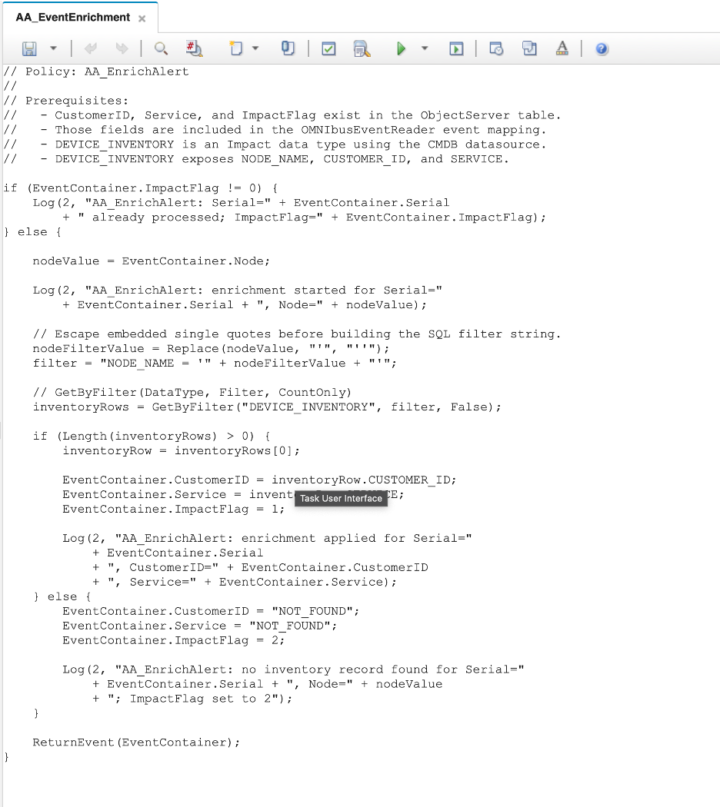
- EnrichAlert policy code in the editor
- Before saving, click the Syntax Check icon in the toolbar (the green checkmark icon). The syntax checker parses the IPL code and reports any errors — mismatched braces, invalid function calls, or malformed expressions — without executing the policy. A successful check confirms the code is syntactically valid and ready to run. An Information dialog will appear with the message Syntax check successful. No errors found. Click Close.
- 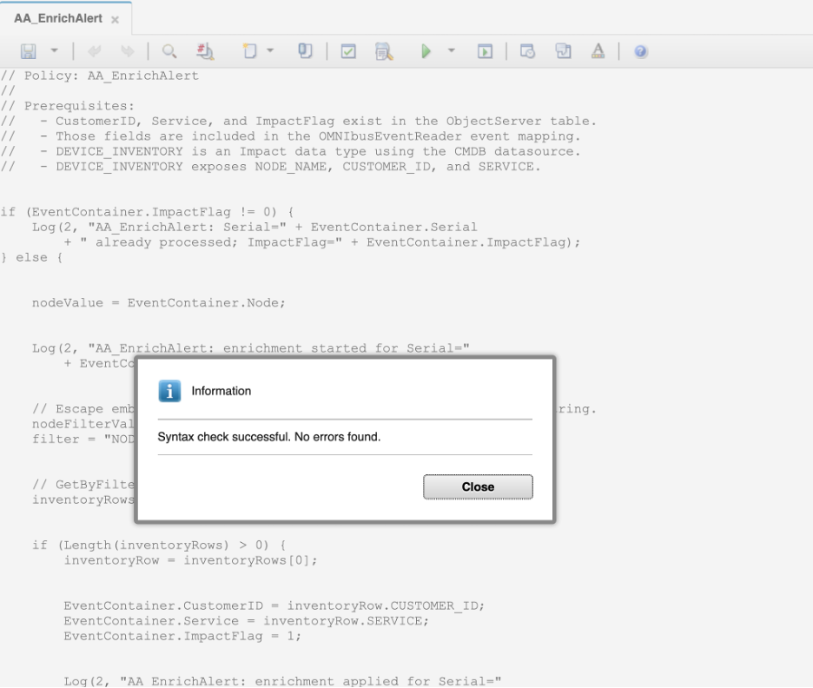
- Syntax check successful dialog
- Click the Save icon to save the policy code. Confirm that AA_EnrichAlert appears at the top of the policies list in the left pane.

Validation
The exercise is successful when all of the following are true:
- The ImpactFlag column exists in alerts.status with type integer.
- The AA_EnrichAlert policy is saved and visible at the top of the policies list.
- You can explain the purpose of the if (@ImpactFlag != 0) guard at the top of the policy.
- You can describe the difference between @FieldName (direct field assignment) and the GetByFilter / ReturnEvent pattern used here.
- You can explain what ImpactFlag is set to in each outcome and why both non-zero values prevent re-processing.

Expected result
You now have a complete enrichment policy saved in Impact. It is not yet connected to a service, so it will not run automatically. The next exercise creates the OMNIbusEventReader service and wires it to this policy.

4.2 Create and configure the OMNIbusEventReader service

Objective
In this exercise, you will create an OMNIbusEventReader service, configure it to poll the ObjectServer, and assign the AA_EnrichAlert policy to it. By the end of the exercise, the service will be running and ready to trigger the policy when new alerts arrive.

Prerequisites
- Completion of section 4.1.
- The AA_EnrichAlert policy is saved and enabled.

Background
A policy on its own does nothing — it needs a service to trigger it. Impact supports several service types, each designed for a different trigger source or integration pattern:
Service type | Trigger source | Typical use
OMNIbusEventReader | OMNIbus ObjectServer (alerts.status) | Event enrichment, correlation, escalation, ticket automation, suppression, and lifecycle processing. The standard service type for OMNIbus-to-Impact integrations.
DatabaseEventReader | External SQL database table or view | Polling a CMDB, inventory, or OSS table; importing workflow items; or reacting to externally staged events.
PolicyActivator | Time / schedule | Periodic housekeeping, aged-event escalation checks, cache refresh, CMDB synchronization, and reconciliation jobs.
KafkaMessageListener | Apache Kafka topics | Modern streaming and event-bus integration — telemetry, application events, or a CP4AIOps-adjacent event pipeline.
JMSMessageListener | JMS topic or queue | IBM MQ / WebSphere enterprise messaging integration.
EmailReader | POP3 or IMAP mailbox | Email-based acknowledgements, approval workflows, or ingestion from legacy systems that only emit email.
EventListener | Impact event-listener endpoint | Custom integrations where an external application submits an Impact-compatible event directly.
OMNIbusEventListener | OMNIbus AEN fast-track channels | Specialized low-latency handling for explicitly fast-tracked ObjectServer events. Legacy or special-purpose use.
For enrichment, the OMNIbusEventReader is the right choice. When an alert appears or changes in alerts.status and matches the service’s filter, the service passes all fields of that alert to the assigned policy through the EventContainer object. The service configuration has two tabs:
- General Settings: sets the service name, the ObjectServer data source to poll, and the polling interval.
- Event Mapping: defines one or more filter conditions that determine which events are matched, and maps each filter to the policy that should run when it matches. All fields of a matching event are automatically passed to the assigned policy.

Tasks
- Select the Services tab from the top navigation bar. The services list will appear in the left pane.
- In the toolbar at the top of the services list, click the dropdown arrow next to the New Service icon and select OMNIbusEventReader. The New OMNIbusEventReader Service configuration page opens showing the General Settings tab.
- 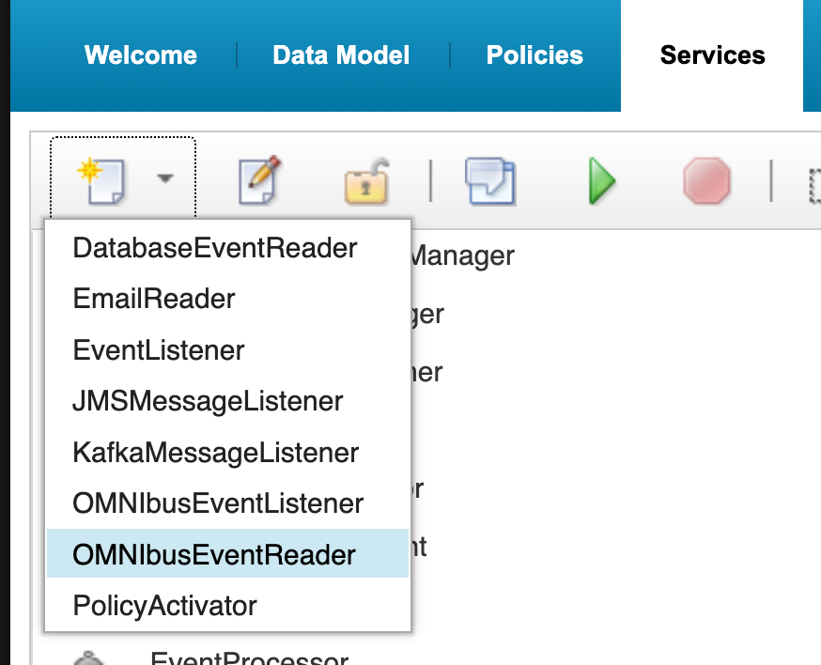
- New Service dropdown with OMNIbusEventReader selected
- On the General Settings tab, configure the following:
  - Service Name: EnrichmentEventReader
  - Data Source Name: defaultobjectserver
  - Polling Interval (milliseconds): 3000 (default)
  - Leave Starts automatically when server starts unchecked.
- 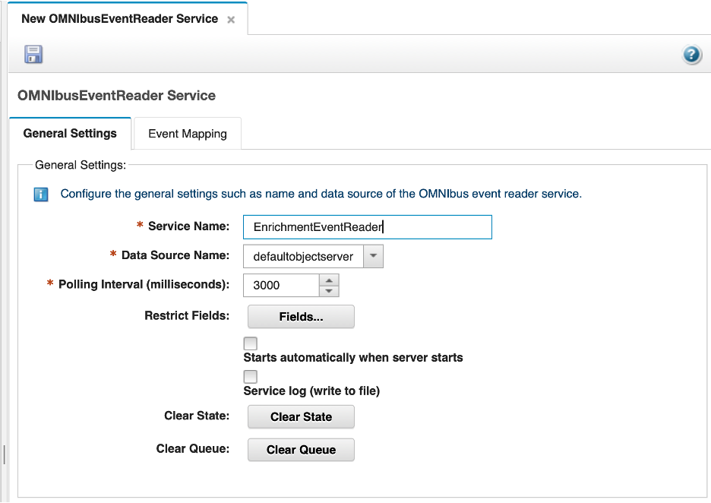
- General Settings tab configured
- Click the Event Mapping tab. Review the sections:
  - Event Matching: leave set to Stop testing after first match.
  - Action: leave Get updated events and Get Status Events unchecked — the service will process newly created events only.
  - Deletion and Event Locking: leave at defaults.
- In the Event Mapping Table, click New to add a mapping row. Configure the row as follows:
  - Restriction Filter: ImpactFlag = 0
  - Policy Name: select AA_EnrichAlert from the dropdown
  - Active: ensure this is checked
- 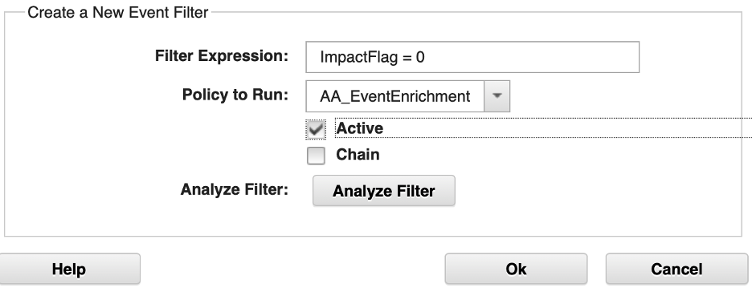
- Event Mapping row configured before clicking OK
- Click OK to confirm the row.
- Note: The filter ImpactFlag = 0 targets only alerts that have not yet been processed by Impact. Once the policy runs and sets ImpactFlag to 1 or 2, the alert no longer matches the filter and will not be re-processed on subsequent polling cycles.
- Confirm that the new row appears in the Event Mapping Table at the bottom of the page, showing ImpactFlag = 0 in the Restriction Filter column and AA_EnrichAlert in the Policy Name column.
- 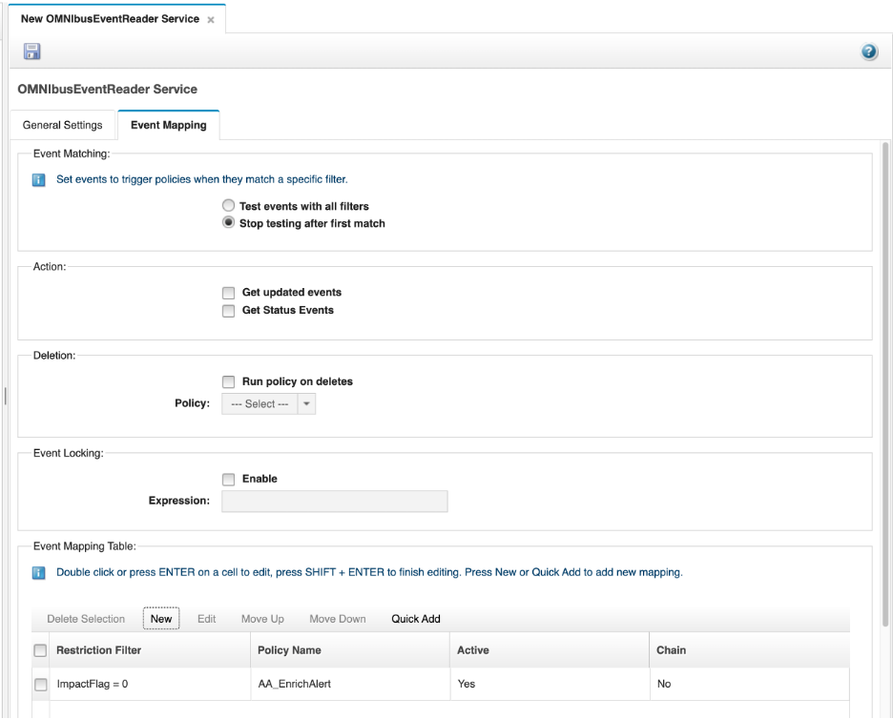
- Event Mapping Table with EnrichAlert policy assigned
- Click the Save icon (floppy disk, top-left) to save the service.
- With the EnrichmentEventReader service selected in the left pane, click the Start button (green triangle in the toolbar) to start the service. Confirm the service state changes to Running.
- 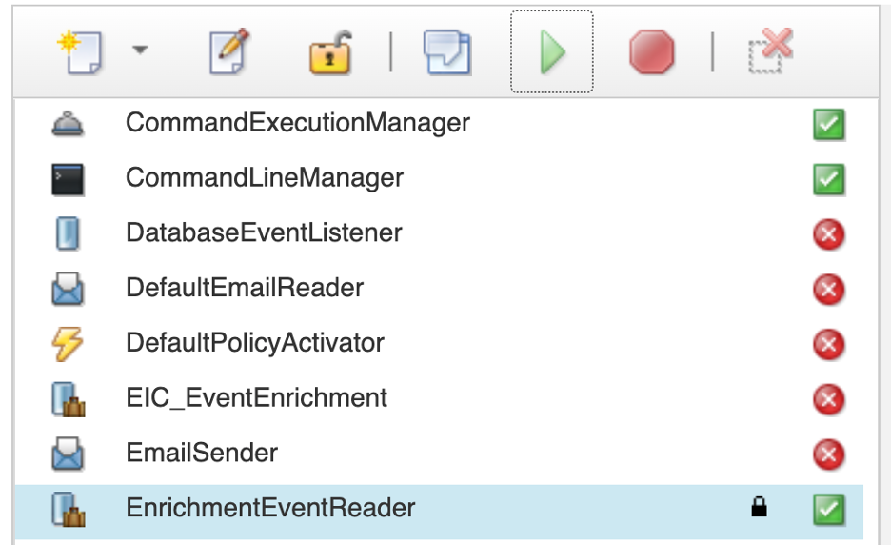
- EnrichmentEventReader service in Running state

Validation
The exercise is successful when all of the following are true:
- The EnrichmentEventReader service is saved with data source defaultobjectserver.
- The Event Mapping Table contains one row: filter ImpactFlag = 0 mapped to AA_EnrichAlert, Active.
- The service state is Running.
- You can explain why ImpactFlag = 0 is a better filter than Severity > 0 for an enrichment service.

Expected result
The enrichment pipeline is now active. Any new alert that enters the ObjectServer will have ImpactFlag = 0 by default, which will be picked up by the service and passed to the AA_EnrichAlert policy. Once processed, ImpactFlag is updated and the alert is not re-processed.

4.3 Configure the policy logger

Objective
In this exercise, you will configure the Impact PolicyLogger service to write each policy’s log output to its own dedicated log file. By the end of the exercise, any Log() call in a policy will write to a dedicated file under $IMPACT_HOME/logs/, making it straightforward to isolate and review the output from a specific policy without wading through a shared log.

Background
By default, all Log() calls from all policies write to the shared ImpactServer.log file. When several policies are running simultaneously, their output is interleaved and can be difficult to follow. The PolicyLogger service has an option — Append policy name to log file name — that causes each policy to write to its own file instead. With this option enabled, a policy named AA_EnrichAlert writes to $IMPACT_HOME/logs/NCI_policylogger_AA_EnrichAlert.log, a policy named AA_EscalatePlatinum writes to $IMPACT_HOME/logs/NCI_policylogger_AA_EscalatePlatinum.log, and so on. You configure this once and it applies to all policies on the server.

Prerequisites
- Completion of section 4.2.
- You are logged in to the Impact GUI in your private browser window.

Tasks
- Select the Services tab from the top navigation bar.
- In the services list, locate the PolicyLogger service. It is a built-in service that is present on every Impact server by default.
- 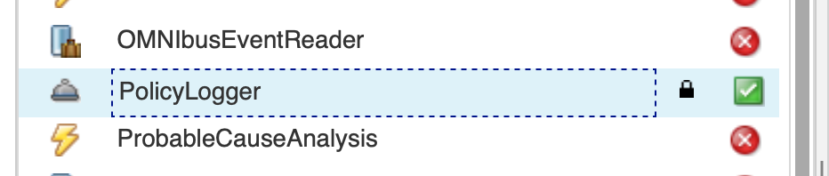
- PolicyLogger service in the services list
- Double-click the PolicyLogger service to open its configuration page.
- Check the Append policy name to log file name checkbox.
- 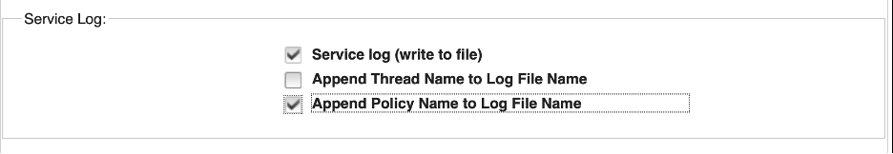
- PolicyLogger configuration with Append policy name checked
- Click the Save icon (floppy disk, top-left) to save the configuration.
- SSH into the lab server as root and stop the Impact server:
- $IMPACT_HOME/bin/stopImpactServer.sh
- Wait for the command to return. The Impact GUI session in your browser will become unresponsive — this is expected.
- Start the Impact server:
- $IMPACT_HOME/bin/startImpactServer.sh
- You should see:
- Starting server NCI.
Server NCI started with process ID 526361.
- Note: The process ID in your output will differ from the example above.
- Wait approximately 60 seconds, then refresh the Impact GUI in your private browser window and log back in as impactadmin / netcool. Confirm that the Services tab shows the PolicyLogger and EnrichmentEventReader services in a Running state.

Validation
The exercise is successful when all of the following are true:
- The Append policy name to log file name checkbox is checked and saved.
- The Impact server has been restarted and the GUI is accessible.
- The PolicyLogger and EnrichmentEventReader services are both in a Running state after the restart.
- You can explain why per-policy log files are more useful than a single shared log when multiple policies are running.

Expected result
From this point on, every Log() call in any policy will write to a dedicated file in $IMPACT_HOME/logs/. When you run test events in the next exercise, you will be able to check $IMPACT_HOME/logs/NCI_policylogger_AA_EnrichAlert.log directly to see the output from the enrichment policy.

4.4 Run test events and validate enrichment

Objective
In this exercise, you will insert test events into the ObjectServer and confirm that the AA_EnrichAlert policy correctly enriches matching alerts and handles nodes with no inventory record.

Prerequisites
- Completion of section 4.3.
- The EnrichmentEventReader service is running.
- The DEVICE_INVENTORY table in the CMDB database is populated (section 2.2).

Tasks
- Return to your original OMNIbus Web GUI browser window (non-private) at https://<your-server>:16311/ibm/console. Log in as ncoadmin with password netcool if your login has timed out.
- Open the event viewer again, and create an event filter named ImpactLabEvents with the condition Manager = 'ImpactLab' and apply it.
- Create an event view named EnrichmentView with the following columns in order: Severity, Acknowledged, Customer, Location, Service, Node, Summary, FirstOccurrence, Contact. Apply it.
- SSH into the lab server. Switch to the db2inst1 user and confirm that db-tok-01 exists in the DEVICE_INVENTORY table:
- su - db2inst1
- Then run:
- db2 "CONNECT TO CMDB"
db2 "SELECT NODE_NAME, CUSTOMER_ID, SERVICE FROM DEVICE_INVENTORY WHERE NODE_NAME = 'db-tok-01'"
- You should see one row with CUSTOMER_ID = CUST-1005 and SERVICE = Database Services. This record was inserted in section 2.2.
- Type exit to return to your root shell, then use the nco_sql tool to insert a test alert for db-tok-01 into the ObjectServer:
- $OMNIHOME/bin/nco_sql -server EVENTS -user root -password netcool << 'EOF'
INSERT INTO alerts.status (Node, Summary, AlertKey, AlertGroup, Severity, Type, Identifier, Manager, OwnerUID)
VALUES ('db-tok-01', 'Enrichment test event', 'enrich-key-01', 'TrainingAlerts', 4, 1, 'db-tok-01:enrich-key-01:TrainingAlerts', 'ImpactLab', 65534);
go
EOF
- Confirm you see that one row has been affected (your insert).
- Switch to the OMNIbus Web GUI. The db-tok-01 alert should appear in the ImpactLabEvents filter view. Within a few seconds the enrichment fields should populate. Confirm that the Enrichment View columns show:
  - Customer shows CUST-1005
  - Service shows Database Services
- Double-click the alert to open the full event details and confirm ImpactFlag shows 1.
- 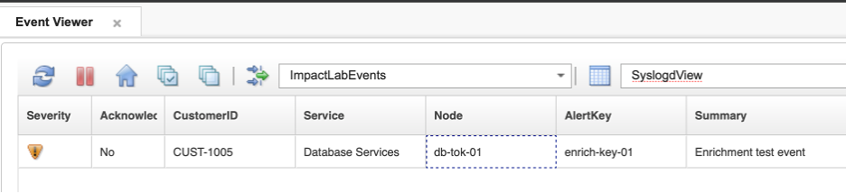
- Enriched db-tok-01 alert in the event list
- Check the policy log to confirm the enrichment message was written:
- tail -30 $IMPACT_HOME/logs/NCI_policylogger_AA_EnrichAlert.log
- Look for: AA_EnrichAlert: enrichment applied for Serial=..., CustomerID=CUST-1005, Service=Database Services
- Now test the not-found path. Insert a test alert for a node that does not exist in the inventory:
- $OMNIHOME/bin/nco_sql -server EVENTS -user root -password netcool << 'EOF'
INSERT INTO alerts.status (Node, Summary, AlertKey, AlertGroup, Severity, Type, Identifier, Manager, OwnerUID)
VALUES ('unknownhost99', 'Event from unknown node', 'unknown-key-01', 'TrainingAlerts', 3, 1, 'unknownhost99:unknown-key-01:TrainingAlerts', 'ImpactLab', 65534);
go
EOF
- In the event list, locate the unknownhost99 alert and confirm the Enrichment View columns show:
  - Customer shows NOT_FOUND
  - Service shows NOT_FOUND
- Double-click the alert and confirm ImpactFlag shows 2.
- 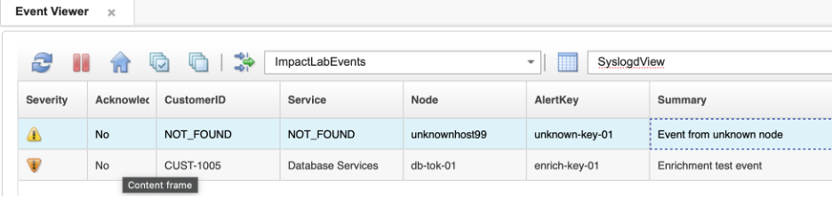
- unknownhost99 alert showing NOT_FOUND enrichment and ImpactFlag=2
- Confirm in the policy log that the warning message was written:
- tail -30 $IMPACT_HOME/logs/NCI_policylogger_AA_EnrichAlert.log
- Look for: AA_EnrichAlert: no inventory record found for Serial=..., Node=unknownhost99; ImpactFlag set to 2

Validation
The exercise is successful when all of the following are true:
- A test alert for db-tok-01 results in CustomerID = CUST-1005, Service = Database Services, and ImpactFlag = 1 on the alert.
- The Impact server log shows the enrichment confirmation message for db-tok-01.
- A test alert for unknownhost99 results in CustomerID = NOT_FOUND, Service = NOT_FOUND, and ImpactFlag = 2 on the alert.
- The Impact server log shows the warning message for unknownhost99.
- You can describe the complete path an event takes from ObjectServer insertion to enriched alert: probe → alerts.status → OMNIbusEventReader service → AA_EnrichAlert policy → ReturnEvent → updated alert.
- You can explain what the three ImpactFlag values mean and why this pattern prevents re-processing.

Expected result
You now have a working end-to-end event enrichment pipeline. New alerts that arrive in the ObjectServer are automatically enriched with customer and service context within seconds of insertion, without any manual intervention. This is the core automation pattern that Impact is built around.

5. Scheduled automation
Some automation tasks need to run on a schedule rather than in response to a specific event. Impact’s PolicyActivator service fills this role. It runs an assigned policy at a defined interval, independently of any inbound event, making it the Impact equivalent of a scheduled task or cron job.
Common use cases include:
- Deferred or retry enrichment: Reprocess unresolved events whose initial lookup failed because a CMDB, DNS, REST endpoint, or data source was temporarily unavailable at insert time.
- Aging and escalation: Query active events based on FirstOccurrence, LastOccurrence, severity, ownership, or acknowledgment state, then add journal context, change severity, send a notification, or create and update a ticket.
- Periodic reconciliation: Compare ObjectServer event state with an external ITSM, inventory, maintenance window, or CMDB source and repair drift.
- Maintenance and retention: Purge stale Impact reporting data or perform controlled cleanup. IBM specifically documents attaching a recurring reporting purge policy to a PolicyActivator for this purpose.
- Batch state evaluation: Run a periodic health or compliance calculation across a population of devices or services, then update event fields or trigger downstream automation.
Unlike the OMNIbusEventReader, the PolicyActivator has a 1:1 relationship with its policy — each PolicyActivator service runs exactly one policy. The policy is selected from a dropdown on the service configuration page and there is no event filter or mapping table.
In this section, you will implement deferred enrichment — a scheduled policy that retries CMDB lookups for alerts that previously failed enrichment because the data source was unavailable. This is one of the most common practical uses of the PolicyActivator in production OMNIbus environments.

5.1 Write the deferred enrichment policy

Objective
In this exercise, you will create a policy that scans the ObjectServer for alerts where enrichment previously failed and retries the CMDB lookup for each one. By the end of the exercise, you will have a policy that uses GetByFilter to find a specific population of alerts and acts on each result.

Prerequisites
- Completion of section 4.
- The defaultobjectserver ObjectServer DSA is configured and connected.
- The EVENTS data type is configured against the alerts.status table (section 2.1).
- The CMDB DB2 DSA and DEVICE_INVENTORY data type are configured (section 2.2).
- The ImpactFlag, CustomerID, and Service columns exist in alerts.status (section 4.1).

Background
Recall from section 4 that the enrichment policy sets ImpactFlag = 2 when no inventory record is found for an alert’s Node value. There are two reasons an alert might reach this state:
- The node genuinely does not exist in the CMDB — it is unknown or out of scope.
- The CMDB was temporarily unavailable at the time the alert arrived — a database restart, a network blip, or a DSA reconnection in progress.
In the second case, the alert was not enriched through no fault of its own. A scheduled deferred enrichment policy handles this by periodically retrying the CMDB lookup for all ImpactFlag = 2 alerts. If the CMDB is now available and the record is found, enrichment is applied and ImpactFlag is updated to 1. If the record still cannot be found, the alert remains at ImpactFlag = 2 for the next cycle.
A PolicyActivator policy does not receive a triggering event — there is no EventContainer passed in by the service. Instead, the policy queries the ObjectServer directly using GetByFilter to build the list of alerts to process. Write-back to each alert is done using ReturnEvent on the individual row objects returned from the query.

Tasks
- In your private browser window, ensure you are logged in to the Impact GUI. If your session has expired, navigate to http://<your-server>:17311/ibm/console and log in as impactadmin with password netcool.
- Select the Policies tab from the top navigation bar. In the toolbar at the top of the policy list, click the dropdown arrow next to the New Policy icon and select IPL Policy. A blank IPL code editor opens titled New IPL Policy.
- Before entering any code, click the Save icon (floppy disk, top-left). A Save dialog appears with a single Policy Name field. Enter AA_DeferredEnrichment and click Save.
- In the IPL code editor, enter the following policy code:
- /*
* Policy: AA_DeferredEnrichment
* Purpose: Retry CMDB enrichment for alerts where ImpactFlag = 2
* (previous enrichment attempt failed — no record found).
* Trigger: PolicyActivator (scheduled, not event-driven).
*/
// Find all alerts where enrichment previously found no record
pendingAlerts = GetByFilter("EVENTS", "ImpactFlag = 2", False);
//Get the number of rows returned
alertCount = Length(pendingAlerts);
Log("AA_DeferredEnrichment: found " + alertCount + " alert(s) pending re-enrichment");
if (alertCount > 0)
{
counter = 0; // set a counter as an index to loop through the returned alerts
while(counter < alertCount)
{
nodeValue = pendingAlerts[counter].Node;
nodeFilterValue = Replace(nodeValue, "'", "''");
filter = "NODE_NAME = '" + nodeFilterValue + "'";
inventoryRows = GetByFilter("DEVICE_INVENTORY", filter, False);
if (Length(inventoryRows) > 0)
{
inventoryRow = inventoryRows[0]; // for simplicty only assume 1 return
Log("AA_DeferredEnrichment: enrichment applied for Node=" + nodeValue
+ ", CustomerID=" + inventoryRow.CustomerID );
// Update this alert using the Identifier as our where clause:
DirectSQL("defaultobjectserver", "update alerts.status set CustomerID='"
+ inventoryRow.CUSTOMER_ID + "', Service='"
+ inventoryRow.SERVICE + "', ImpactFlag=1 where Identifier='"
+ pendingAlerts[counter].Identifier + "'", false);
}
else
{
Log("AA_DeferredEnrichment: still no record for Node=" + nodeValue
+ "; leaving ImpactFlag=2");
}
counter = counter + 1;
}
}
else
{
Log("AA_DeferredEnrichment: no alerts pending re-enrichment");
}
- Note: In a PolicyActivator policy there is no EventContainer — the service does not pass a triggering event. Instead, each row returned by GetByFilter is its own object. Field assignments are made directly on the referenced row (pendingAlerts[counter].CustomerID = ...) and we use DirectSQL function against the data source for our ObjectServer (defaultobjectserver), not against the data type EVENTS. This is purely to illustrate that you can run queries, inserts, and updates using Impact functions such as GetByFilter(), AddDataItem(), and BatchUpdate(), but you can also construct SQL queries and run those queries against the data source itself.
- Click the Syntax Check icon in the toolbar. Confirm the Syntax check successful dialog appears, then click Close.
- Click the Save icon to save the policy code. Confirm that AA_DeferredEnrichment appears at the top of the policy list in the left pane.
- 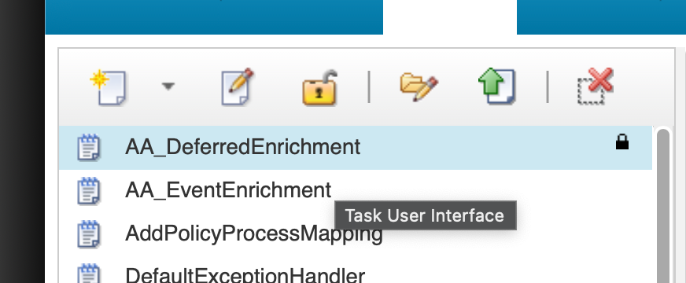
- Saved AA_DeferredEnrichment in policy list

Validation
The exercise is successful when all of the following are true:
- The AA_DeferredEnrichment policy is saved and appears at the top of the policy list.
- The syntax check passes with no errors.
- You can explain why this policy uses GetByFilter rather than EventContainer.
- You can describe what happens when a retry succeeds versus when no record is still found.
- You can explain the difference between ReturnEvent(EventContainer) in the enrichment policy and ReturnEvent(alert) here.

Expected result
You now have a deferred enrichment policy that can recover alerts missed by the real-time enrichment pipeline. The next exercise creates the PolicyActivator service and connects it to this policy.

5.2 Create and configure the PolicyActivator service

Objective
In this exercise, you will create a PolicyActivator service and configure it to run the AA_DeferredEnrichment policy every 60 seconds.

Prerequisites
- Completion of section 5.1.
- The AA_DeferredEnrichment policy is saved.

Tasks
- Select the Services tab from the top navigation bar.
- In the toolbar at the top of the services list, click the dropdown arrow next to the New Service icon and select PolicyActivator. The New PolicyActivator Service configuration page opens.
- 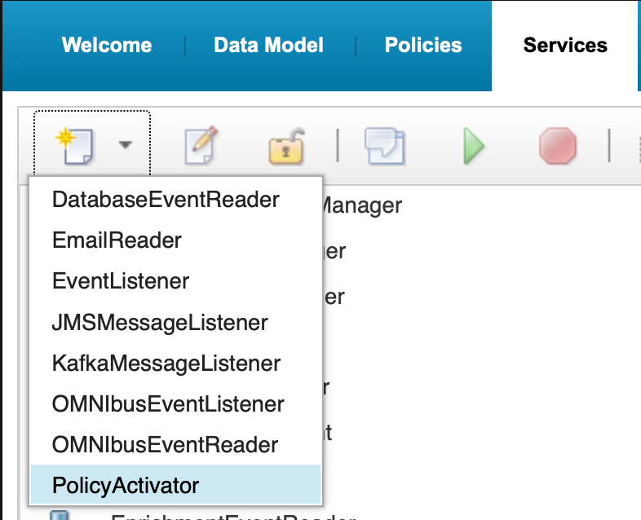
- New Service dropdown with PolicyActivator selected
- Configure the following fields:
  - Service Name: DeferredEnrichmentActivator
  - Activation Interval (seconds): 60
  - Policy: select AA_DeferredEnrichment from the dropdown
  - Leave Starts automatically when server starts unchecked.
- 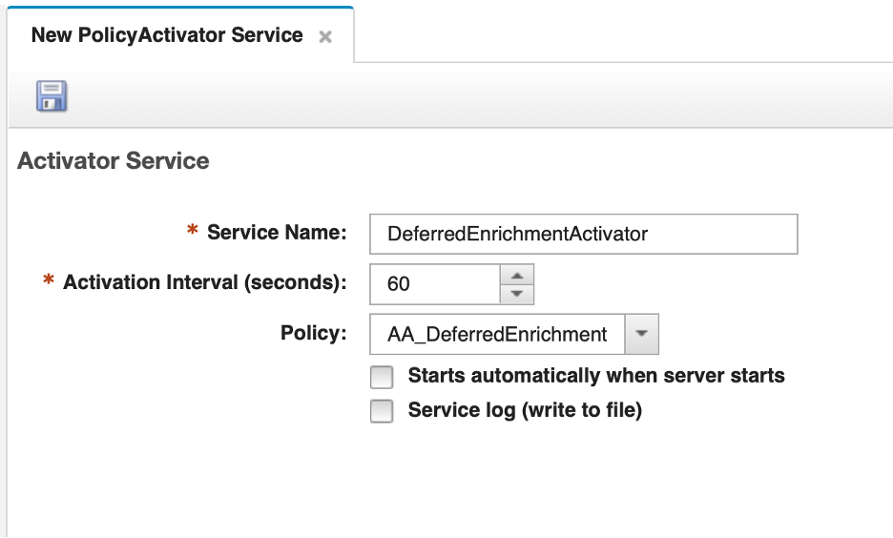
- PolicyActivator configuration page
- Click the Save icon (floppy disk, top-left) to save the service.
- Select your new service in the service, and click the Start button (green triangle in the toolbar) to start the service. Alternatively, right-click on the service and select “Confirm the state changes to Running.
- 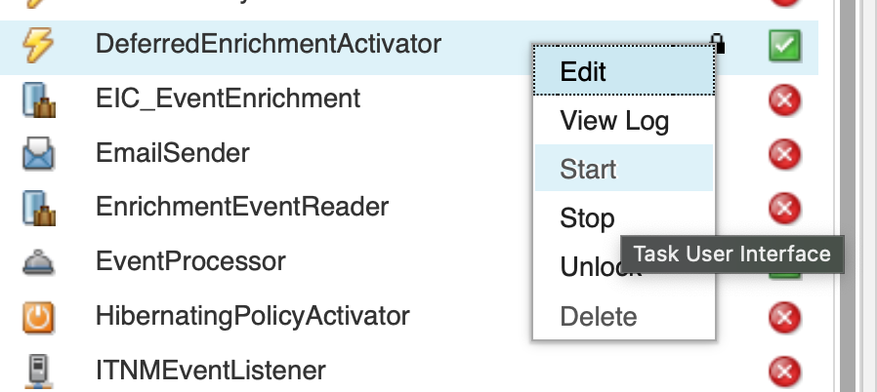
- DeferredEnrichmentActivator service in Running state

Validation
The exercise is successful when all of the following are true:
- The DeferredEnrichmentActivator service is saved with activation interval 60 seconds.
- The policy is set to AA_DeferredEnrichment.
- The service state is Running.
- You can explain the difference between this service and the EnrichmentEventReader in terms of what triggers the policy.

Expected result
The deferred enrichment pipeline is now active. Every 60 seconds, the PolicyActivator will invoke AA_DeferredEnrichment, which scans for ImpactFlag = 2 alerts and retries the CMDB lookup for each one.

5.3 Validate deferred enrichment

Objective
In this exercise, you will simulate a failed enrichment by inserting a test alert for an unknown node, then update the CMDB to add that node, and confirm that the deferred enrichment policy picks it up on its next cycle.

Prerequisites
- Completion of section 5.2.
- The DeferredEnrichmentActivator service is running.
- The EnrichmentEventReader service from section 4 is also running.

Tasks
- Insert a test alert for a node that does not exist in the CMDB. The enrichment policy will process it, fail to find a record, and set ImpactFlag = 2:
- $OMNIHOME/bin/nco_sql -server EVENTS -user root -password netcool << 'EOF'
INSERT INTO alerts.status (Node, Summary, AlertKey, AlertGroup, Severity, Type, Identifier, Manager, OwnerUID)
VALUES ('newnode-ams-01', 'Deferred enrichment test', 'deferred-key-01', 'TrainingAlerts', 3, 1, 'newnode-ams-01:deferred-key-01:TrainingAlerts', 'ImpactLab', 65534);
go
EOF
- In the OMNIbus Web GUI, locate the newnode-ams-01 alert in your ImpactLabEvents filter, and switch to your SyslogdView. Within a few seconds the EnrichmentEventReader should process it. Confirm that Customer and Service both show NOT_FOUND and that ImpactFlag shows 2 in the event details.
- Now add newnode-ams-01 to the CMDB so the next deferred enrichment cycle can find it. The DB2 commands must be run as the db2inst1 user:
- su - db2inst1
- Then run:
- db2 "CONNECT TO CMDB" && \
db2 "INSERT INTO DEVICE_INVENTORY (NODE_NAME, CUSTOMER_ID, CUSTOMER_NAME, SERVICE, LOCATION, CONTACT) \
VALUES ('newnode-ams-01', 'CUST-1001', 'Acme Corporation', 'WAN Connectivity', 'Amsterdam DC', 'noc@acme.com')"
- You should see:
- DB20000I The SQL command completed successfully.
- Then type exit to return to your root shell.
- Wait up to 120 seconds for the DeferredEnrichmentActivator to fire. Then refresh the event in the OMNIbus Web GUI and confirm:
  - Customer now shows CUST-1001
  - Service now shows WAN Connectivity
  - ImpactFlag now shows 1
- Check the policy log to confirm the retry succeeded:
- tail -30 $IMPACT_HOME/logs/NCI_policylogger_AA_DeferredEnrichment.log
- Look for: AA_DeferredEnrichment: enrichment applied for Node=newnode-ams-01, CustomerID=CUST-1001
- 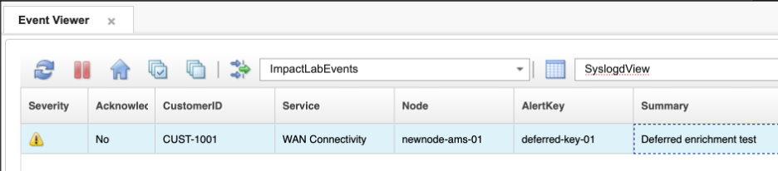
- Deferred enrichment showing successful retry

Validation
The exercise is successful when all of the following are true:
- The newnode-ams-01 alert initially shows NOT_FOUND and ImpactFlag = 2.
- After adding the node to the CMDB, the deferred enrichment policy updates the alert to ImpactFlag = 1 with correct customer and service values.
- The policy log confirms the enrichment retry message.
- You can explain the difference between ImpactFlag = 1 (enriched at arrival) and ImpactFlag = 1 after a deferred retry — from the alert’s perspective, the outcome is identical.
- You can describe a real-world scenario where deferred enrichment would recover alerts that the real-time policy could not process.

Expected result
You have now seen how the PolicyActivator complements the OMNIbusEventReader. The real-time enrichment pipeline handles the normal path; the scheduled deferred pipeline handles recovery. Together they ensure that all alerts eventually carry the context operators need, regardless of whether the CMDB was available at the moment each alert arrived.

5.4 Add a retry limit to the deferred enrichment policy

Objective
In this exercise, you will update the AA_DeferredEnrichment policy to limit the number of times it will retry a failed enrichment. By the end of the exercise, the policy will use the standard Poll field as a retry counter, and alerts that have been attempted three times will be automatically excluded from further processing.

Background
The policy as written will retry every ImpactFlag = 2 alert on every cycle, indefinitely. In most cases this is fine — a transient CMDB outage resolves quickly and the alert is enriched on the next attempt. But for alerts whose Node value will never exist in the CMDB, this creates unnecessary processing overhead that compounds over time as more unknown-node alerts accumulate.
The solution is to use the Poll field — a standard integer field already present on every alerts.status row — as a retry counter. On each failed lookup, the policy increments Poll by 1 and uses DirectSQL to write that value back to the ObjectServer immediately. The GetByFilter query is updated to include AND Poll < 3, which means alerts that have already been attempted three times are never retrieved in the first place. Filtering at the query level is more efficient than pulling all ImpactFlag = 2 alerts and checking Poll inside the loop — alerts beyond the limit simply never enter the processing path.

Prerequisites
- Completion of section 5.3.
- The DeferredEnrichmentActivator service is running.

Tasks
- In the Impact GUI, select the Policies tab and open AA_DeferredEnrichment for editing. Replace the entire policy body with the following:
- /*
* Policy: AA_DeferredEnrichment
* Purpose: Retry CMDB enrichment for alerts where ImpactFlag = 2
* (previous enrichment attempt failed — no record found).
* Trigger: PolicyActivator (scheduled, not event-driven).
*/
// Find all alerts where enrichment previously found no record
pendingAlerts = GetByFilter("EVENTS", "ImpactFlag = 2 AND Poll < 3", False);
//Get the number of rows returned
alertCount = Length(pendingAlerts);
Log("AA_DeferredEnrichment: found " + alertCount + " alert(s) pending re-enrichment");
if (alertCount > 0)
{
counter = 0; // set a counter as an index to loop through the returned alerts
while(counter < alertCount)
{
nodeValue = pendingAlerts[counter].Node;
nodeFilterValue = Replace(nodeValue, "'", "''");
filter = "NODE_NAME = '" + nodeFilterValue + "'";
inventoryRows = GetByFilter("DEVICE_INVENTORY", filter, False);
if (Length(inventoryRows) > 0)
{
inventoryRow = inventoryRows[0]; // for simplicty only assume 1 return
Log("AA_DeferredEnrichment: enrichment applied for Node=" + nodeValue
+ ", CustomerID=" + inventoryRow.CustomerID );
// Update this alert using the Identifier as our where clause:
DirectSQL("defaultobjectserver", "update alerts.status set CustomerID='"
+ inventoryRow.CUSTOMER_ID + "', Service='"
+ inventoryRow.SERVICE + "', ImpactFlag=1 where Identifier='"
+ pendingAlerts[counter].Identifier + "'", false);
}
else
{
currentPollValue = pendingAlerts[counter].Poll;
newPollValue = currentPollValue + 1;
DirectSQL("defaultobjectserver", "update alerts.status set Poll="
+ newPollValue + " where Identifier='"
+ pendingAlerts[counter].Identifier + "'", false);
Log("AA_DeferredEnrichment: still no record for Node=" + nodeValue
+ "; Poll=" + pendingAlerts[counter].Poll);
}
counter = counter + 1;
}
}
else
{
Log("AA_DeferredEnrichment: no alerts pending re-enrichment");
}
- Save your updated policy, then review the changes in the updated policy against the original. For each of the following, identify where it appears in the code and explain its purpose:
Change | Where | Why
"ImpactFlag = 2 AND Poll < 3" added to GetByFilter | The GetByFilter filter string at the top of the policy | Excludes alerts that have already been retried three times before they are even retrieved. Filtering at the query level means those alerts never enter the loop — no wasted iterations.
Poll increment in the failure branch | currentPollValue / newPollValue calculation in the else block | Tracks how many times enrichment has been attempted for this alert. Each failed lookup advances the counter by 1.
DirectSQL in the failure branch | DirectSQL("defaultobjectserver", "update alerts.status set Poll=...") | Writes the incremented Poll value directly back to the ObjectServer using a SQL UPDATE statement.
Poll is only incremented in the failure branch | Success branch updates CustomerID, Service, and ImpactFlag = 1 via DirectSQL — Poll is left untouched | Once an alert is successfully enriched, ImpactFlag changes to 1 and it will never be retrieved by this policy again (ImpactFlag = 2 AND Poll < 3 will not match). There is no need to increment Poll on the success path.
- Click the Syntax Check icon. Confirm the Syntax check successful dialog appears, then click Close.
- Click the Save icon to save the updated policy (in case you forgot to save it as directed in task 2).

Validation
The exercise is successful when all of the following are true:
- The GetByFilter filter string reads "ImpactFlag = 2 AND Poll < 3".
- Poll is incremented only on the failure path.
- DirectSQL is used on both paths to write changes back to the ObjectServer.
- The syntax check passes with no errors.
- You can explain why DirectSQL is used instead of ReturnEvent in a PolicyActivator context.
- You can explain why filtering Poll < 3 at the query level is more efficient than checking it inside the loop.

Expected result
The policy now limits itself to three attempts per alert. Alerts that cannot be enriched are retried up to three times and then silently excluded from further processing, keeping the policy focused on alerts that still have a realistic chance of recovery.

5.5 Validate the retry limit

Objective
In this exercise, you will confirm that the updated policy correctly limits retries to three attempts for an alert that will never have a CMDB entry.

Prerequisites
- Completion of section 5.4.
- The DeferredEnrichmentActivator service is running.
- The EnrichmentEventReader service from section 4 is running.

Tasks
- Insert a test alert for a node that does not exist in the CMDB and will not be added — this simulates a genuinely unknown node:
- $OMNIHOME/bin/nco_sql -server EVENTS -user root -password netcool << 'EOF'
INSERT INTO alerts.status (Node, Summary, AlertKey, AlertGroup, Severity, Type, Identifier, Manager, OwnerUID)
VALUES ('ghost-node-99', 'Retry limit test', 'retry-limit-01', 'TrainingAlerts', 3, 1, 'ghost-node-99:retry-limit-01:TrainingAlerts', 'ImpactLab', 65534);
go
EOF
- In the OMNIbus Web GUI, locate the ghost-node-99 alert in the ImpactLabEvents filter. Confirm that EnrichmentEventReader processes it and sets Customer = NOT_FOUND, Service = NOT_FOUND, and ImpactFlag = 2. Note that Poll starts at 0.
- Watch the policy log over the next three minutes. Each time the DeferredEnrichmentActivator fires you should see a log entry with the Poll counter incrementing:
- tail -f $IMPACT_HOME/logs/NCI_policylogger_AA_DeferredEnrichment.log
- After the first attempt: Poll=1
After the second attempt: Poll=2
After the third attempt: Poll=3
- After the third attempt, open the ghost-node-99 alert in the Web GUI and confirm Poll shows 3 and ImpactFlag still shows 2.
- Wait for at least one more DeferredEnrichmentActivator cycle (60 seconds). Confirm that ghost-node-99 no longer appears in the policy log output — it is now excluded by the Poll < 3 filter.
- 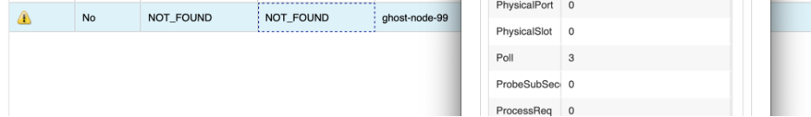
- ghost-node-99 excluded after Poll reaches 3

Validation
The exercise is successful when all of the following are true:
- ghost-node-99 is retried exactly three times, with Poll incrementing from 0 to 3.
- After Poll reaches 3, the alert no longer appears in the policy log on subsequent cycles.
- ImpactFlag remains 2 — the alert is preserved as unenriched for operator visibility.
- You can explain why filtering at the query level is more efficient than retrieving all ImpactFlag = 2 alerts and checking Poll inside the loop.

Expected result
The retry limit ensures that genuinely unknown nodes do not generate processing overhead indefinitely. Alerts with Poll = 3 and ImpactFlag = 2 remain visible in the event list so operators can investigate, but they are silently excluded from further automated retry attempts.

6. Event escalation
Not every alert that arrives in the ObjectServer demands immediate action. But an alert that has been sitting open and unacknowledged for an extended period is a signal that something has been missed. Impact can automate the response to that condition — detecting aged, unacknowledged events and escalating them by raising their severity or setting a visual flag to draw operator attention.
This section extends the enrichment pipeline from sections 4 and 5 with a service-level dimension: a SERVICE_LEVEL field is added to both the CMDB and the ObjectServer, the enrichment policy is updated to populate it, and a new scheduled escalation policy targets only Platinum-tier events that have aged past a threshold without acknowledgment.
This section introduces two important ideas that extend what you have already learned:
- Scheduled escalation with a PolicyActivator: Alerts that age past a threshold do not generate an ObjectServer update event — time simply passes. A PolicyActivator polls on a fixed interval and queries for qualifying alerts, making it the right tool for age-based escalation.
- Severity modification and the Flash flag: Writing back to Severity and Flash using DirectSQL to change how an alert appears to operators.
In production, a reasonable escalation threshold might be 10 minutes or more. For this lab, you will use 60 seconds so the behavior is immediately observable.

6.1 Preparing the scenario

Objective
In this exercise, you will extend the existing enrichment data model and pipeline to carry a service level classification. You will add a SERVICE_LEVEL field to the DB2 CMDB table and the ObjectServer schema, re-discover the affected data types in Impact, populate the CMDB with test data, and update the enrichment policy to write the new field to each alert.

Prerequisites
- Completion of sections 4 and 5.
- The defaultobjectserver ObjectServer DSA is configured and connected.
- The CMDB DB2 DSA is configured and connected.
- The AA_EnrichAlert policy exists and is working correctly.

Tasks
- SSH into the lab server and switch to the DB2 instance user:
- su - db2inst1
- Add the SERVICE_LEVEL column to the DEVICE_INVENTORY table in DB2:
- db2 connect to CMDB
db2 "ALTER TABLE DEVICE_INVENTORY ADD COLUMN SERVICE_LEVEL VARCHAR(32)"
db2 connect reset
exit
- You should see DB20000I The SQL command completed successfully. after the ALTER TABLE statement.
- Add the ServiceLevel field to the alerts.status table in the ObjectServer:
- $OMNIHOME/bin/nco_sql -server EVENTS -user root -password netcool << 'EOF'
ALTER TABLE alerts.status ADD COLUMN ServiceLevel VARCHAR(32);
go
EOF
- Verify that the ServiceLevel column was added successfully:
- $OMNIHOME/bin/nco_sql -server EVENTS -user root -password netcool << 'EOF'
describe alerts.status;
go
EOF
- Confirm that ServiceLevel appears in the output as a VARCHAR(32) column.
- In the Impact GUI, re-discover the DEVICE_INVENTORY data type so Impact picks up the new SERVICE_LEVEL column.
  - Select the Data Model tab from the top navigation bar.
  - Locate the CMDB data source in the DSA list and open it by clicking on the arrow to the left of the titel. Double-click DEVICE_INVENTORY to open it. 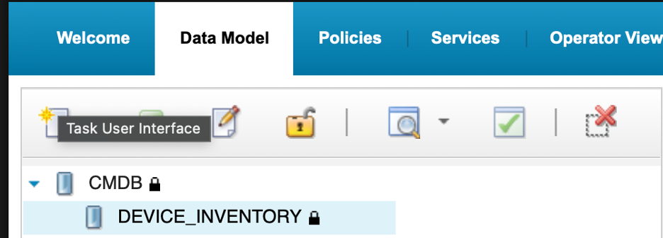
  - Click the Refresh Fields button in the Table Description section of the data type configuration window.
  - Confirm that SERVICE_LEVEL now appears in the field list. 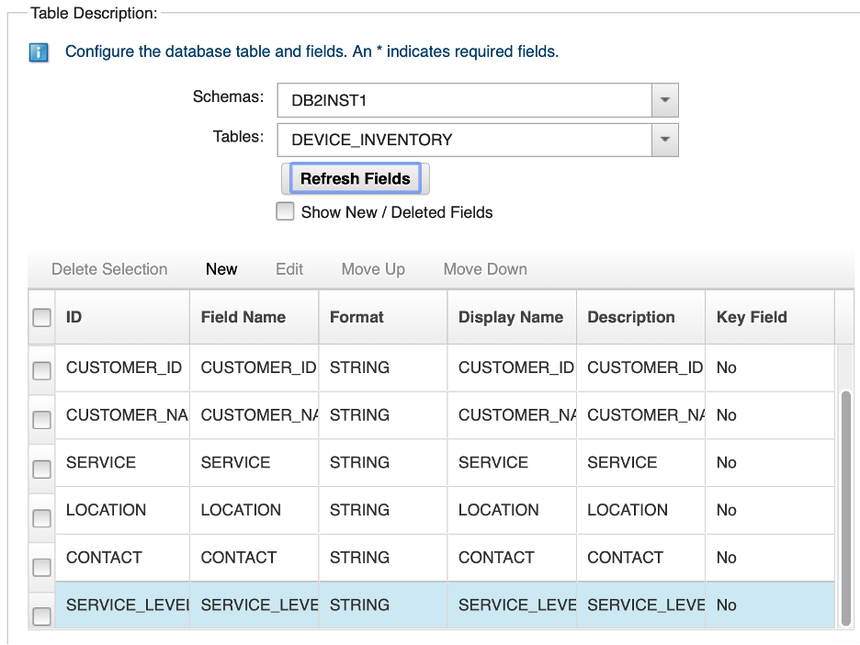
  - Click Save to save the updated data type using the disk icon at the top-left of the data type config window.
- Next, in the same Data Model tab, re-discover the EVENTS data type to pick up the new ServiceLevel column from alerts.status.
  - Locate the defaultobjectserver DSA, open the tree view and double-click on the EVENTS data type to open it.
  - Click the Refresh Fields button in the Table Description section of the data type configuration window.
  - Confirm that ServiceLevel now appears in the field list.
  - Click Save by clicking on the disk icon.
- 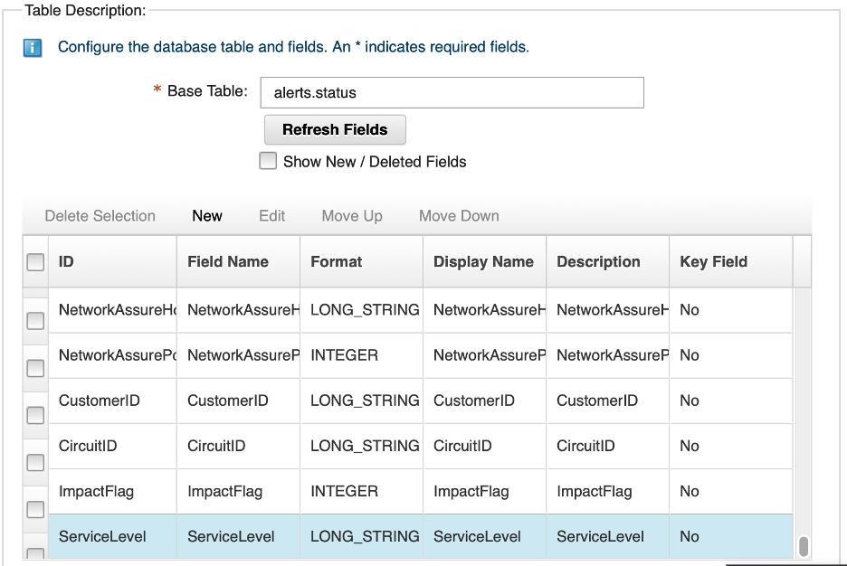
- EVENTS data type after re-discovery showing ServiceLevel field
- Populate the SERVICE_LEVEL field in the CMDB for Acme Corporation nodes. In the lab, Acme Corporation holds nodes router-lon-01 and router-lon-02 (customer CUST-1001):
- First, switch to the db2inst1 user:
- su - db2inst1
- Next, populate the Acme Corporation nodes with the Platinum service level:
- db2 connect to CMDB
db2 "UPDATE DEVICE_INVENTORY SET SERVICE_LEVEL = 'Platinum' WHERE CUSTOMER_ID = 'CUST-1001'"
db2 connect reset
- You should see DB20000I The SQL command completed successfully.
- Verify the update:
- db2 connect to CMDB
db2 "SELECT NODE_NAME, CUSTOMER_NAME, SERVICE_LEVEL FROM DEVICE_INVENTORY"
- Confirm that router-lon-01 and router-lon-02 show Platinum in the SERVICE_LEVEL column. All other rows should show a null value.
- Exit the db2inst1 user to return to the root user:
- exit
- Open the AA_EnrichAlert policy in the Impact GUI and add ServiceLevel to the enrichment write-back.
  - Select the Policies tab and click AA_EnrichAlert in the policy list to open it.
  - In the if (Length(inventoryRows) > 0) branch, add the following line immediately after the existing EventContainer.Service assignment:
  - EventContainer.ServiceLevel = inventoryRow.SERVICE_LEVEL;
  - In the not-found else branch, add:
  - EventContainer.ServiceLevel = "NOT_FOUND";
  - Click Syntax Check. Confirm the check passes, then click Save.
- 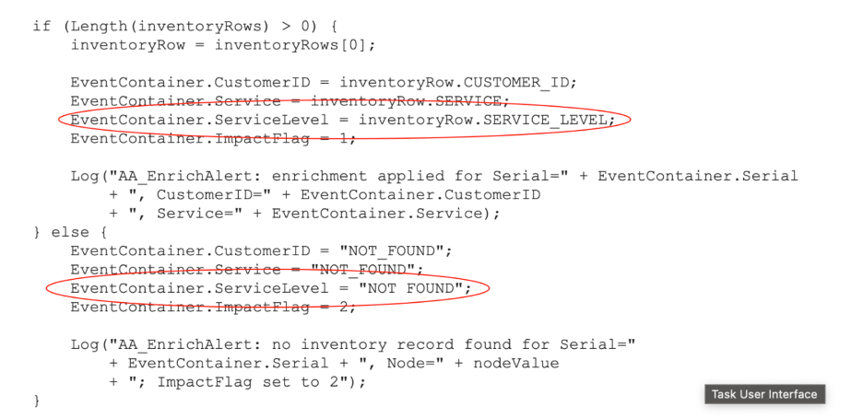
- AA_EnrichAlert policy updated with ServiceLevel assignment

Validation
The exercise is successful when all of the following are true:
- SERVICE_LEVEL VARCHAR(32) exists in the DEVICE_INVENTORY DB2 table.
- ServiceLevel VARCHAR(32) exists in alerts.status.
- Both DEVICE_INVENTORY and EVENTS data types in the Impact Data Model show the new field.
- router-lon-01 and router-lon-02 have SERVICE_LEVEL = 'Platinum' in the CMDB.
- The AA_EnrichAlert policy includes ServiceLevel in both the found and not-found branches, and the syntax check passes.

Expected result
The enrichment pipeline now carries service level classification. Any alert from a Platinum-tier node will have ServiceLevel = 'Platinum' set at enrichment time. The next exercise uses this field to build a targeted escalation policy.

6.2 Write the escalation policy

Objective
In this exercise, you will create a policy that runs on a schedule, queries the ObjectServer for unacknowledged Platinum-tier alerts that have been open longer than the age threshold, and escalates each one — either raising its severity by one level or, if it is already at severity 5, setting Flash = 1. By the end of the exercise, you will understand how to apply the GetByFilter and DirectSQL pattern to targeted, time-based escalation.

Prerequisites
- Completion of section 6.1.
- The OMNIbus ObjectServer is running.
- You are logged in to the Impact GUI.

Background

Time calculations in IPL
IPL provides several functions for working with time. One that is particularly useful in working with events is:
- GetDate() — returns the current server time as a Unix epoch integer (seconds since 1 January 1970).
ObjectServer timestamp fields such as FirstOccurrence and LastOccurrence are also stored as Unix epoch integers, so you can compare them directly against GetDate() using plain arithmetic. For example, to calculate how many seconds an alert has been open:
ageSeconds = GetDate() - alert.FirstOccurrence;
This arithmetic is used directly in the GetByFilter filter to select only alerts that have been open long enough to qualify for escalation.

Severity and Flash
Severity in alerts.status is an integer field with values from 1 (Indeterminate) to 5 (Critical). The policy checks the current value before acting — if it is below 5, severity is raised by one; if it is already at 5, the policy sets Flash = 1 instead. Write-back is done with DirectSQL:
if (alert.Severity < 5)
{
DirectSQL("defaultobjectserver", "update alerts.status set Severity=" + (alert.Severity + 1)
+ " where Identifier='" + alert.Identifier + "'", false);
}
else
{
DirectSQL("defaultobjectserver", "update alerts.status set Flash=1"
+ " where Identifier='" + alert.Identifier + "'", false);
}
Flash is a standard integer field in alerts.status. Setting it to 1 signals to compatible event consoles that the alert row should flash to attract attention. It is also a useful filter condition — once Flash = 1 is set on a severity 5 alert, the GetByFilter filter excludes it from future cycles.

Why a PolicyActivator, not an OMNIbusEventReader
An OMNIbusEventReader fires when an alert is inserted or updated. An alert that is simply aging — sitting unacknowledged with no field changes — will not trigger an update event, so an OMNIbusEventReader would never see it cross the time threshold.
A PolicyActivator runs on a fixed schedule regardless of event activity. On each cycle it queries the ObjectServer using GetByFilter with a filter that includes the age condition, finds all currently qualifying alerts, and processes each one. This is the correct pattern for any escalation logic where the trigger is the passage of time rather than a field change.

Tasks
- Select the Policies tab from the top navigation bar. In the toolbar, click the dropdown arrow next to the New Policy icon and select IPL Policy.
- Click the Save icon, enter AA_EscalatePlatinum in the Policy Name field, and click Save.
- Enter the following policy code in the editor:
- /*
* Policy: AA_EscalatePlatinum
* Purpose: Escalate unacknowledged Platinum-tier alerts open longer than
* the age threshold.
* - Severity < 5: raise severity by 1.
* - Severity = 5: set Flash = 1 (already at maximum severity).
* Trigger: PolicyActivator (scheduled — not event-driven).
*/
ageThreshold = 60;
filter = "ServiceLevel = 'Platinum'"
+ " AND Acknowledged = 0"
+ " AND Severity >= 3"
+ " AND FirstOccurrence < getdate() - " + ageThreshold
+ " AND NOT (Severity = 5 AND Flash = 1)";
alerts = GetByFilter("EVENTS", filter, False);
alertCount = Length(alerts);
Log("AA_EscalatePlatinum: " + alertCount + " Platinum alert(s) qualify for escalation");
if (alertCount > 0) {
counter = 0;
while (counter < alertCount) {
alert = alerts[counter];
ageSeconds = GetDate() - alert.FirstOccurrence;
if (alert.Severity < 5) {
DirectSQL("defaultobjectserver",
"update alerts.status set Severity=" + (alert.Severity + 1)
+ " where Identifier='" + alert.Identifier + "'", false);
Log("AA_EscalatePlatinum: severity raised to " + (alert.Severity + 1)
+ " for Node=" + alert.Node
+ " (age=" + ageSeconds + "s)");
} else {
DirectSQL("defaultobjectserver",
"update alerts.status set Flash=1"
+ " where Identifier='" + alert.Identifier + "'", false);
Log("AA_EscalatePlatinum: Flash set for Node=" + alert.Node
+ " (Severity=5, age=" + ageSeconds + "s)");
}
counter = counter + 1;
}
} else {
Log("AA_EscalatePlatinum: no Platinum alerts qualify — nothing to do");
}
- Note: The ageThreshold variable is defined at the top of the policy so it is easy to find and change. In a production deployment you would set this to 600 (10 minutes) or higher. For this lab, 60 seconds allows you to observe the escalation without waiting. To escalate different service tiers at different rates, create separate policies — one per tier — each with its own GetByFilter filter and ageThreshold, and bind each to its own PolicyActivator service with an independent polling interval.
- Click the Syntax Check icon. Confirm the Syntax check successful dialog appears, then click Close.
- Click the Save icon to save the policy. Confirm that AA_EscalatePlatinum appears near the top of the policy list.
- 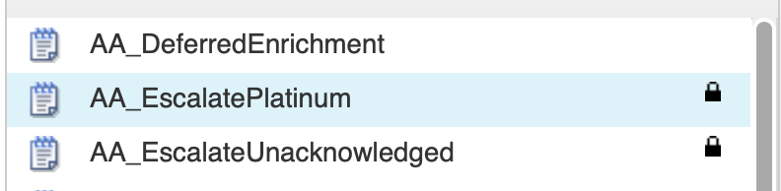
- AA_EscalatePlatinum policy in policy list

Validation
The exercise is successful when all of the following are true:
- The AA_EscalatePlatinum policy is saved and the syntax check passes.
- You can describe the two escalation paths — severity bump for alerts below 5, Flash for alerts already at 5.
- You can explain why a PolicyActivator is used instead of an OMNIbusEventReader for age-based escalation.
- You can explain why DirectSQL is used for write-back rather than ReturnEvent.
- You can explain what each clause of the GetByFilter filter does.

Expected result
You have a scheduled escalation policy that queries for qualifying Platinum-tier alerts on each cycle and escalates each one. The next exercise creates the PolicyActivator service that runs it.

6.3 Create and configure the escalation service

Objective
In this exercise, you will create a PolicyActivator service that runs the AA_EscalatePlatinum policy on a 60-second interval.

Prerequisites
- Completion of section 6.2.
- The AA_EscalatePlatinum policy is saved.

Background
The PolicyActivator service is deliberately simple: it invokes one assigned policy when the service starts, if configured to do so, and then at a fixed activation interval. Unlike an OMNIbusEventReader, it does not process an inbound event stream and therefore has no event filter or event-to-policy mapping table. The policy receives no triggering event, so it must select the records it will process. In this lab, the escalation policy uses GetByFilter to identify Platinum alerts that are eligible for escalation.
This lab uses a 60-second activation interval so you can observe the escalation workflow promptly. The activation interval determines the policy’s evaluation cadence, not the escalation threshold itself. In production, select an interval based on the acceptable delay after an alert becomes eligible: with a 300-second interval, an alert that crosses the threshold immediately after a run may not be evaluated until nearly five minutes later. IBM notes that smaller PolicyActivator intervals provide more accurate timing for scheduled work.

Tasks
- Select the Services tab from the top navigation bar.
- In the toolbar, click the dropdown arrow next to the New Service icon and select PolicyActivator.
- 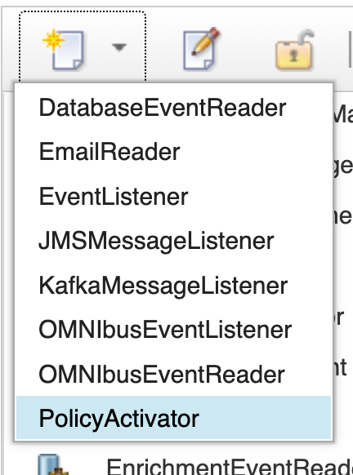
- New Service dropdown with PolicyActivator selected
- Configure the following fields:
  - Service Name: EscalationActivator
  - Activation Interval (seconds): 60
  - Policy: select AA_EscalatePlatinum from the dropdown
  - Leave Starts automatically when server starts unchecked.
- 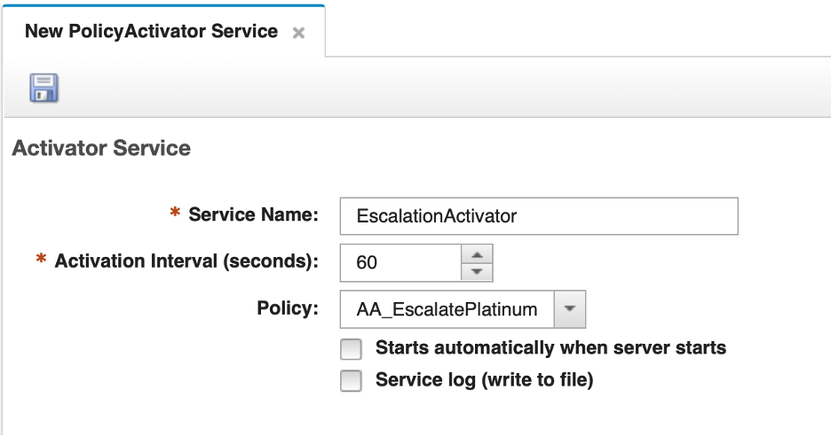
- EscalationActivator PolicyActivator configuration
- Click the Save icon to save the service.
- Right-click on your new EscalationActivator serice and select the Start menu item to start the service. Confirm the state changes to Running.
- 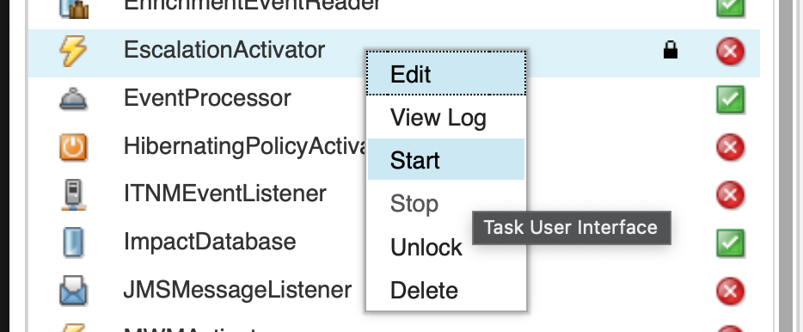
- EscalationActivator service in Running state
- The EnrichmentEventReader service caches the alerts.status schema at startup. Because you added the ServiceLevel column after it was started, it needs to be restarted to pick up the new field — otherwise it will not populate ServiceLevel when writing events back to the ObjectServer.
- In the services list, right-click EnrichmentEventReader and select Stop. Wait for the state to change to Stopped, then right-click again and select Start. Confirm the state returns to Running.
- 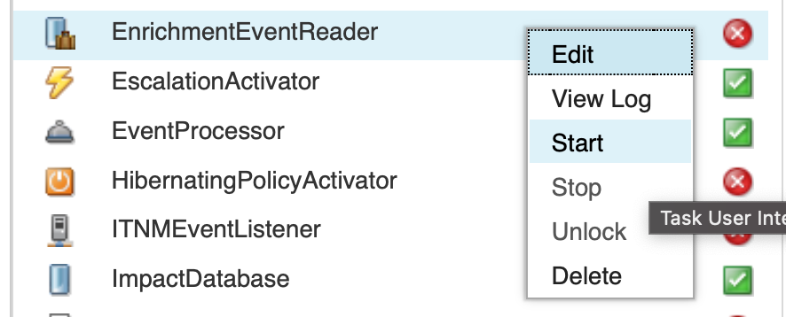
- EnrichmentEventReader restarted and Running

Validation
The exercise is successful when all of the following are true:
- The EscalationActivator service is saved with a 60-second activation interval and AA_EscalatePlatinum assigned.
- Both EscalationActivator and EnrichmentEventReader are in Running state.
- You can explain why the PolicyActivator has no filter or event mapping, and where the targeting logic lives instead.
- You can explain why the EnrichmentEventReader needed to be restarted.

Expected result
The escalation pipeline is now active. Every 60 seconds the EscalationActivator wakes up and runs AA_EscalatePlatinum, which queries for qualifying Platinum-tier alerts and escalates each one found.

6.4 Validate event escalation

Objective
In this exercise, you will insert test alerts for a Platinum-tier node and confirm that the escalation policy correctly raises severity for aged alerts and sets Flash for severity 5 alerts. You will also confirm that alerts from non-Platinum nodes are not escalated.

Prerequisites
- Completion of section 6.3.
- The EscalationActivator service is running.

Tasks
- In the OMNIbus Web GUI, enable Flash notifications in your event viewer so you will see the visual effect when Flash = 1 is set on an alert:
  - Click the Workspace Preferences icon in the event viewer toolbar (the slider/equaliser icon to the left of the quick filter text box).
  - Click the Notifications tab.
  - Check Enable Notifications and Flashing.
  - Click Apply and Save button at the bottom of the Workspace Preferences window.
- 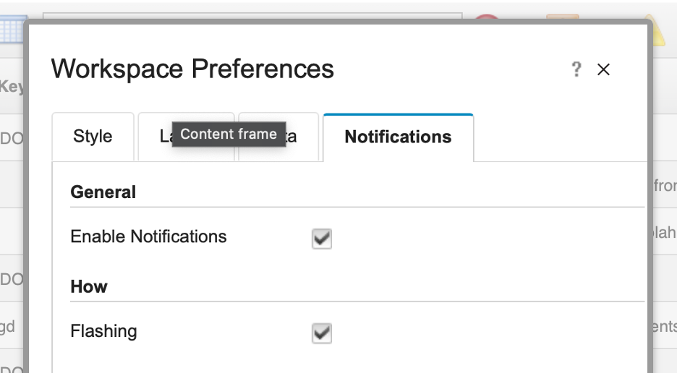
- Workspace Preferences — Notifications tab with Enable Notifications and Flashing checked
- In the OMNIbus Web GUI, set up your event view to show the ServiceLevel field:
  - Navigate to the Event Viewer and select the ImpactLab Events filter.
  - Select the SyslogdView view.
  - Click the Edit View icon to open the view editor.
  - In the column list, locate the Service field. Add a new column for ServiceLevel immediately after it.
  - Set the column width to 10 characters.
- 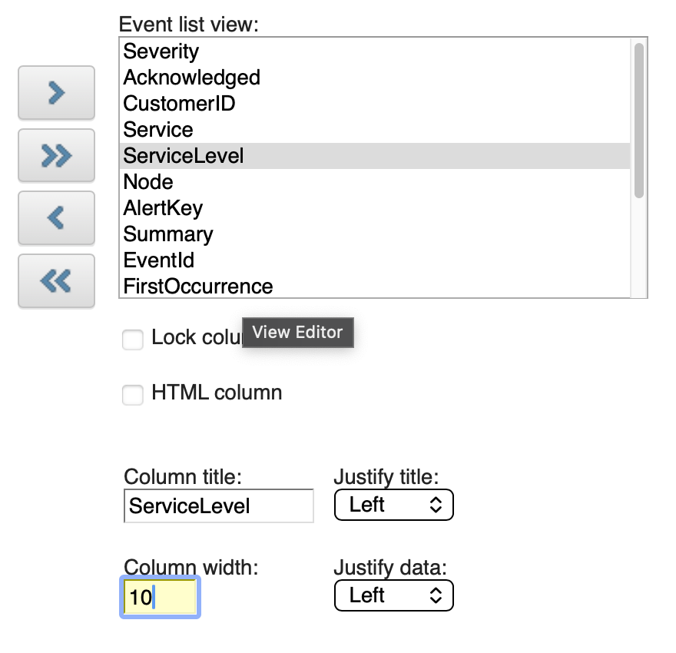
- SyslogdView editor showing ServiceLevel column with width set to 10
  - Save and close the view editor.
- 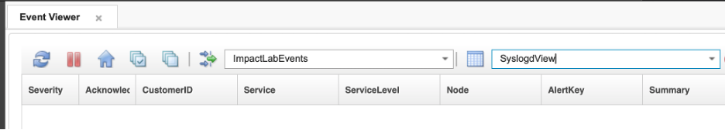
- SyslogdView with ServiceLevel column added between Service and Node
- Insert a severity 3 test alert for router-lon-01 — a Platinum-tier node:
- $OMNIHOME/bin/nco_sql -server EVENTS -user root -password netcool << 'EOF'
INSERT INTO alerts.status (Node, Summary, AlertKey, AlertGroup, Severity, Type, Identifier, Manager, OwnerUID)
VALUES ('router-lon-01', 'Escalation test — Platinum node', 'escalate-platinum-01', 'TrainingAlerts', 3, 1, 'router-lon-01:escalate-platinum-01:TrainingAlerts', 'ImpactLab', 65534);
go
EOF
- Insert a severity 3 test alert for switch-nyc-01 — a non-Platinum node — to confirm it is not escalated:
- $OMNIHOME/bin/nco_sql -server EVENTS -user root -password netcool << 'EOF'
INSERT INTO alerts.status (Node, Summary, AlertKey, AlertGroup, Severity, Type, Identifier, Manager, OwnerUID)
VALUES ('switch-nyc-01', 'Escalation test — non-Platinum node', 'escalate-nonplatinum-01', 'TrainingAlerts', 3, 1, 'switch-nyc-01:escalate-nonplatinum-01:TrainingAlerts', 'ImpactLab', 65534);
go
EOF
- Insert a severity 3 test alert for router-lon-02 — the second Platinum-tier node:
- $OMNIHOME/bin/nco_sql -server EVENTS -user root -password netcool << 'EOF'
INSERT INTO alerts.status (Node, Summary, AlertKey, AlertGroup, Severity, Type, Identifier, Manager, OwnerUID)
VALUES ('router-lon-02', 'Escalation test — Platinum node', 'escalate-platinum-02', 'TrainingAlerts', 3, 1, 'router-lon-02:escalate-platinum-02:TrainingAlerts', 'ImpactLab', 65534);
go
EOF
- Wait 60–90 seconds for the enrichment service to process all three alerts. In the OMNIbus Web GUI, locate them in the ImpactLab Events filter. Confirm:
  - router-lon-01 and router-lon-02 both have ServiceLevel = Platinum.
  - switch-nyc-01 has ServiceLevel populated with its own service level (or NOT_FOUND if not in the CMDB).
- 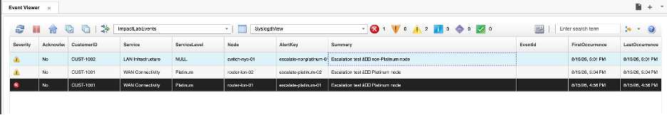
- All three test alerts in the event list after enrichment
- Wait a further 60–90 seconds for the EscalationActivator to fire. Once the Platinum alerts have been open for more than 60 seconds, they will match the GetByFilter query and their severity will be raised.
- Confirm in the event list that:
  - router-lon-01 and router-lon-02 severity has changed from 3 to 4.
  - switch-nyc-01 severity remains at 3.
- Wait another 60–90 seconds. Confirm both router-lon-01 and router-lon-02 severity raises again from 4 to 5.
- Wait another 60–90 seconds. Both Platinum alerts are now at severity 5. The policy will set Flash = 1 on each. Double-click one of them and confirm Flash shows 1 in the event details.
- On the next cycle both alerts no longer match the GetByFilter filter (NOT (Severity = 5 AND Flash = 1) excludes them), so escalation stops.
- 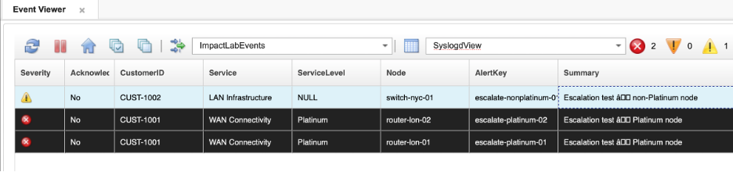
- Platinum alerts at severity 5 with Flash=1
- Check the policy log to review the escalation trail:
- tail -50 $IMPACT_HOME/logs/NCI_policylogger_AA_EscalatePlatinum.log
- You should see log entries for router-lon-01 and router-lon-02 at each cycle showing severity being raised, then the Flash entries, then silence as both alerts drop out of the filter. You should see no entries for switch-nyc-01.
- Acknowledge router-lon-01 in the event list. Confirm that on the next cycle the alert does not appear in the policy log — it no longer matches Acknowledged = 0 in the GetByFilter filter.

Validation
The exercise is successful when all of the following are true:
- router-lon-01 progresses from severity 3 → 4 → 5 → Flash=1 across successive polling cycles.
- switch-nyc-01 is not escalated at any point.
- Once Flash = 1 is set on router-lon-01, the alert no longer matches the GetByFilter filter and escalation stops.
- After acknowledgment, router-lon-01 is excluded from the GetByFilter filter and no longer appears in the policy log.
- The policy log shows entries only for Platinum-tier alerts.
- You can describe the complete escalation path and explain why each step stops at the right point.

Expected result
You have now built a service-level-aware, scheduled escalation pipeline. The PolicyActivator fires on a fixed interval, the policy queries for qualifying Platinum-tier alerts, and each one is escalated one step per cycle until it reaches maximum escalation state or is acknowledged. Non-Platinum alerts are unaffected. This pattern extends naturally to more complex scenarios: tiered escalation across multiple service levels, on-call notifications, ticket creation, or routing alerts to different teams based on service classification.

7. Automation and hibernation
Not every alert that arrives in the ObjectServer represents a genuine, persistent fault. Network devices can throw transient errors that clear within seconds — a momentary link flap, a brief CPU spike, or a probe timeout that does not repeat. Treating every one of these as a real incident wastes operator time and generates noise.
Impact can handle this automatically using hibernation. A policy can set a flag on an event, pause mid-execution for a specified number of seconds, and then resume exactly where it left off — at which point it can re-test the condition and decide what to do. This section uses a ping verification scenario to demonstrate the pattern: when a down event is received, Impact pings the node immediately, waits 60 seconds, and pings again. Only if the node is still unreachable after the second check does the event remain open.
This section also introduces JRExecAction, the IPL function for running local commands and scripts on the Impact server and capturing their output.

7.1 Write the hibernation ping policy

Objective
In this exercise, you will write a policy that pings the node from a down event, hibernates for 60 seconds if the first ping fails, pings again after waking up, and updates the event with a journal entry recording the outcome. By the end of the exercise, you will understand how Hibernate, RemoveHibernation, JRExecAction, and a re-entry guard work together in a single policy.

Prerequisites
- Completion of sections 4 and 5.
- The ImpactFlag integer field exists in alerts.status (added in section 4.1). Verify with:
- $OMNIHOME/bin/nco_sql -server EVENTS -user root -password netcool << 'EOF'
describe alerts.status;
go
EOF
- Confirm ImpactFlag appears as an INTEGER column. If it is missing, add it:
- $OMNIHOME/bin/nco_sql -server EVENTS -user root -password netcool << 'EOF'
ALTER TABLE alerts.status ADD COLUMN ImpactFlag INTEGER;
go
EOF
- The HibernatingPolicyActivator service is running. This service is not started by default and must be started manually before any policy that uses Hibernate can wake up. In the Impact GUI, select the Services tab, locate HibernatingPolicyActivator in the list, right-click it, and select Start. Confirm the state changes to Running.
- 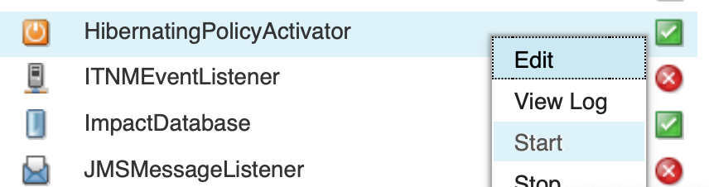
- HibernatingPolicyActivator service in Running state
- The nci_jrexec process is running on the Impact server. This is a background process launched from the command line — it does not appear in the Impact GUI Services tab. SSH into the lab server and run:
- nohup "$IMPACT_HOME/bin/nci_jrexec" \
> "$IMPACT_HOME/logs/nci_jrexec.out" 2>&1 &
ps -ef | grep '[n]ci_jrexec'
- The ps output should show a running nci_jrexec process. If no output is returned, the process did not start — check $IMPACT_HOME/logs/nci_jrexec.out for errors.
- The value of the Node field in your test events must be pingable from the Impact server (or deliberately unpingable, to test the down path).

Background

JRExecAction
JRExecAction runs a local command on the Impact server and returns the output as a string:
output = JRExecAction("/path/to/command", {arg1, arg2, ...}, false, timeoutSeconds);
For ping, the command path is /usr/sbin/ping and the node name is passed as the first argument. The output string will contain the full ping response, including newline characters. Use Strip(output, "\n") to collapse newlines before doing a pattern match.

Hibernate and RemoveHibernation
Hibernate(ActionKey, Reason, TimeoutSeconds);
Hibernate suspends the executing policy thread at that exact line for TimeoutSeconds seconds. When the timer expires, execution continues on the very next line — the policy does not restart. All variables set before Hibernate are still available after waking up.
- ActionKey must be a unique string across all simultaneously hibernating policies. A common pattern combines a fixed prefix with GetDate() in combination with the Identifier field of the alert to make it unique per invocation.
- Reason is a descriptive string written to the audit log. It can be null.
- RemoveHibernation(ActionKey) cleans up the hibernation record after the policy resumes. Always call it.
The HibernatingPolicyActivator service manages the hibernation timer queue. Without it running, policies that call Hibernate will sleep indefinitely.

Re-entry guard
The OMNIbusEventReader fires on every insert or update to a matching event. If the policy sets ImpactFlag = 88 and calls ReturnEvent before hibernating, that write triggers an update on the event — which would normally cause the EventReader to fire again. Setting ImpactFlag = 88 as the guard value ensures the sleeping event is excluded by the ImpactFlag <> 88 clause in the ping mapping filter, preventing the policy from being triggered a second time on the same event while it sleeps.

Ping output pattern
On Linux/Unix, a successful ping produces output that includes 0% packet loss when the host responds. The Strip + like pattern used in the policy collapses newlines and then matches against this string:
If (Strip(PingOutput, "\n") like ".*received, 0% packet loss.*")

Tasks
- Select the Policies tab from the top navigation bar. In the toolbar, click the dropdown arrow next to the New Policy icon and select IPL Policy.
- Click the Save icon, enter AA_PingVerify in the Policy Name field, and click Save.
- Enter the following policy code in the editor:
- /*
* Policy: AA_PingVerify
* Purpose: When a down event is received, ping the node immediately.
* If the first ping fails, hibernate for 60 seconds then ping again.
* Update the event with a journal entry recording the outcome.
* ImpactFlag values:
* 0 = unprocessed (EventReader filter target)
* 88 = in progress (set before hibernating — excluded by mapping filter)
* 2 = processing complete
* Trigger: OMNIbusEventReader (event-driven).
*/
/* Set ImpactFlag = 88 immediately to prevent the EventReader from
* re-triggering this policy while it is sleeping. */
EventContainer.ImpactFlag = 88;
ReturnEvent(EventContainer);
Log("AA_PingVerify: first ping attempt for Node=" + EventContainer.Node);
/* Ping the node. Output is returned as a string. */
PingOutputOne = JRExecAction("/usr/sbin/ping", { "-c", "1", "-W", "2", EventContainer.Node}, false, 120);
/* Strip newlines and check whether the node responded. */
if (Strip(PingOutputOne, "\n") like ".*received, 0% packet loss.*") {
/* Node is reachable — clear the event and mark complete. */
EventContainer.Severity = 0;
EventContainer.JournalEntry = "AA_PingVerify: node is reachable on first ping — event cleared";
Log("AA_PingVerify: Node=" + EventContainer.Node + " is alive on first ping");
} else {
/* First ping failed — hibernate for 60 seconds then try again. */
Log("AA_PingVerify: Node=" + EventContainer.Node + " did not respond — hibernating 60s");
ActionKey = "PingVerify:" + EventContainer.Identifier + GetDate();
WaitTime = 60;
Hibernate(ActionKey, "Waiting 60s before second ping", WaitTime);
/* ---- Policy resumes here after 60 seconds ---- */
Log("AA_PingVerify: woke up — second ping attempt for Node=" + EventContainer.Node);
PingOutputTwo = JRExecAction("/usr/sbin/ping", { "-c", "1", "-W", "2", EventContainer.Node}, false, 120);
if (Strip(PingOutputTwo, "\n") like ".*received, 0% packet loss.*") {
/* Node recovered during the wait — clear the event. */
EventContainer.Severity = 0;
EventContainer.JournalEntry = "AA_PingVerify: node recovered — alive on second ping";
Log("AA_PingVerify: Node=" + EventContainer.Node + " recovered on second ping");
} else {
/* Node is still unreachable — increase severity, mark complete. */
if(EventContainer.Severity == 5) {
EventContainer.Flash = 1;
} else {
EventContainer.Severity = EventContainer.Severity + 1;
}
EventContainer.JournalEntry = "AA_PingVerify: node unreachable on both pings — confirmed down";
Log("AA_PingVerify: Node=" + EventContainer.Node + " still unreachable after second ping");
}
RemoveHibernation(ActionKey);
}
/* Commit all field changes back to the ObjectServer. */
ReturnEvent(EventContainer);
- Click the Syntax Check icon. Confirm the Syntax check successful dialog appears, then click Close.
- Click the Save icon. Confirm AA_PingVerify appears in the policy list.

7.2 Configure the EnrichmentEventReader to trigger the ping policy

Objective
In this exercise, you will extend the existing EnrichmentEventReader service to also trigger AA_PingVerify. Rather than creating a new service, you will enable Get Updated Events on the service and add a second event mapping row that targets enriched ping-failure events by their EventId and ImpactFlag value. By the end of the exercise, a single OMNIbusEventReader handles both the enrichment mapping and the ping verification mapping.

Prerequisites
- Completion of section 7.1.
- The AA_PingVerify policy is saved.
- The EnrichmentEventReader service exists and is running (created in section 4.2).

Background
An OMNIbusEventReader service can hold multiple rows in its Event Mapping table. Each row has its own filter and its own policy. When an event is inserted or updated, the service evaluates every row in order and invokes the policy for each row whose filter matches.
By default, an OMNIbusEventReader only fires on inserted events. Enabling Get Updated Events causes it to also fire whenever an existing event is updated — which is necessary here because AA_PingVerify is triggered by an update to an already-enriched event (when ImpactFlag is written back by AA_EnrichAlert), not by the original insert.
The filter ImpactFlag > 0 AND ImpactFlag <> 88 AND EventId = 'PingFailure' targets events that:
- Have already been processed by the enrichment policy (ImpactFlag > 0 — not new/unprocessed)
- Have not been excluded by an administrative hold (ImpactFlag <> 88 — a sentinel value reserved for events that should be left alone)
- Specifically identify themselves as ping failure events (EventId = 'PingFailure')
This means AA_PingVerify will only run on events that have been enriched first and carry the PingFailure identifier — not on every event the service sees.

Tasks
- Select the Services tab from the top navigation bar. Double-click EnrichmentEventReader to open it.
- In the Event Mapping tab, check the Get Updated Events checkbox to enable firing on event updates as well as inserts.
- In the Event Mapping table, add a second mapping row beneath the existing AA_EnrichAlert row:
  - Filter: ImpactFlag > 0 AND ImpactFlag <> 88 AND EventId = 'PingFailure'
  - Policy: AA_PingVerify
- 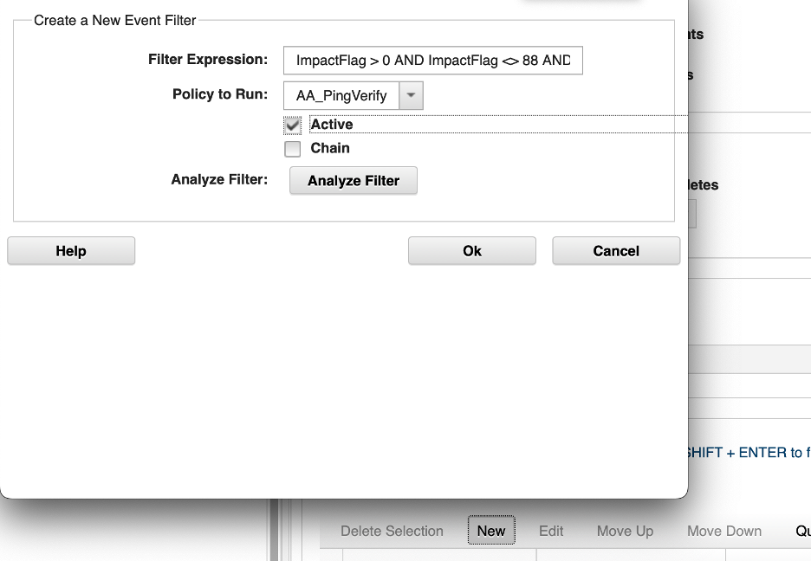
- New AA_PingVerify mapping row being entered in the Event Mapping table
- Confirm the Event Mapping table now shows both rows — the original AA_EnrichAlert row and the new AA_PingVerify row with its filter:
- 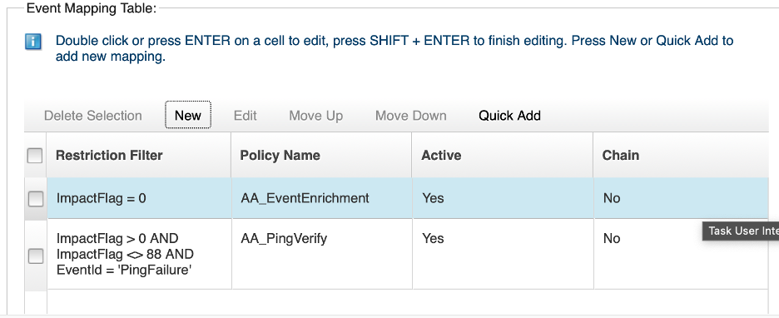
- Event Mapping table showing both AA_EnrichAlert and AA_PingVerify rows
- Click the Save icon to save the service changes.
- Right-click EnrichmentEventReader and select Stop. Wait for the state to change to Stopped, then right-click again and select Start. Confirm the state returns to Running.
- 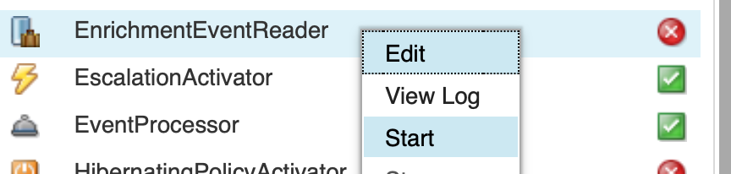
- EnrichmentEventReader service in Running state after restart
- Note: A stop/start is required whenever you change an OMNIbusEventReader’s Event Mapping configuration. The service loads its mapping table at startup; changes made while the service is running do not take effect until it is restarted.

Validation
The exercise is successful when all of the following are true:
- The EnrichmentEventReader service has Get Updated Events enabled.
- The Event Mapping table contains two rows: the existing AA_EnrichAlert row and the new AA_PingVerify row with filter ImpactFlag > 0 AND ImpactFlag <> 88 AND EventId = 'PingFailure'.
- The service has been stopped and restarted and is in Running state.
- The HibernatingPolicyActivator service is Running and the nci_jrexec process is running on the Impact server.
- You can explain why Get Updated Events is needed for this mapping.
- You can explain what ImpactFlag <> 88 guards against.

7.3 Validate the hibernation policy

Objective
In this exercise, you will insert test events for a reachable node and an unreachable node and observe the policy outcome in both cases. You will also verify the hibernation behavior through the policy log.

Prerequisites
- Completion of section 7.2.
- At least one hostname that is pingable from the Impact server and one that is not.

Background
Test events need EventId = 'PingFailure' set at insert time so the EnrichmentEventReader mapping filter matches them. The enrichment policy (AA_EnrichAlert) runs first (on ImpactFlag = 0), sets ImpactFlag = 1, and calls ReturnEvent. That update then triggers the second mapping row, which fires AA_PingVerify because ImpactFlag > 0 AND ImpactFlag <> 88 AND EventId = 'PingFailure' now matches. A ping falure alert that is hibernating will have their ImpactFlag set to 88 to ensure it is not processed whilst already being worked on.

Tasks
- In the OMNIbus Web GUI (open in your private/incognito browser), navigate to the Event Viewer. Select the ImpactLab Events filter and the SyslogdView view. Leave this window visible so you can observe events being processed in real time as you work through the tasks below.
- Insert a test event for a reachable node. Use localhost — the Impact server can always ping itself:
- $OMNIHOME/bin/nco_sql -server EVENTS -user root -password netcool << 'EOF'
INSERT INTO alerts.status (Node, Summary, AlertKey, AlertGroup, Severity, Type, Identifier, Manager, OwnerUID, EventId)
VALUES ('127.0.0.1', 'Ping verify test — reachable node', 'ping-test-01', 'TrainingAlerts', 3, 1, 'localhost:ping-test-01:TrainingAlerts', 'ImpactLab', 65534, 'PingFailure');
go
EOF
- Wait 30–60 seconds for enrichment to run, then wait a further 30–60 seconds for AA_PingVerify to complete. Check the event in the OMNIbus Web GUI. Confirm:
  - Severity has been set to 0 (cleared).
  - ImpactFlag is 2.
  - The journal entry reads AA_PingVerify: node is reachable on first ping — event cleared.
- 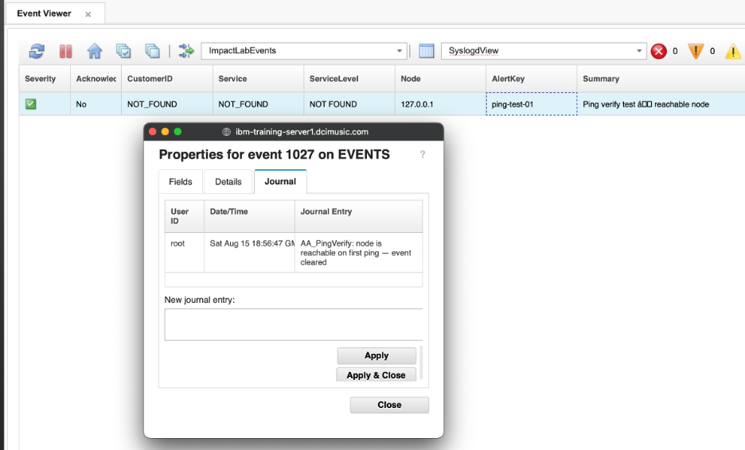
- Event list showing 127.0.0.1 alert cleared at Severity 0 after first ping
- This event was cleared on the first ping without hibernating.
- Insert a test event for an unreachable node:
- $OMNIHOME/bin/nco_sql -server EVENTS -user root -password netcool << 'EOF'
INSERT INTO alerts.status (Node, Summary, AlertKey, AlertGroup, Severity, Type, Identifier, Manager, OwnerUID, EventId)
VALUES ('192.0.2.1', 'Ping verify test — unreachable node', 'ping-test-02', 'TrainingAlerts', 3, 1, '192.0.2.1:ping-test-02:TrainingAlerts', 'ImpactLab', 65534, 'PingFailure');
go
EOF
- Note: 192.0.2.1 is from the TEST-NET-1 range (RFC 5737), reserved for documentation and unlikely to be routable in most environments. However, depending on your network configuration it may respond. If the policy clears the event instead of hibernating, choose a different address that is definitively unreachable from the Impact server and repeat this task with that address.
- Watch the policy log to observe the hibernation in real time:
- tail -f $IMPACT_HOME/logs/NCI_policylogger_AA_PingVerify.log
- You should see the following sequence of entries:
  - AA_PingVerify: first ping attempt for Node=192.0.2.1
  - AA_PingVerify: Node=192.0.2.1 did not respond — hibernating 60s
  - (~60 second pause)
  - AA_PingVerify: woke up — second ping attempt for Node=192.0.2.1
  - AA_PingVerify: Node=192.0.2.1 still unreachable after second ping
- Press Ctrl+C to stop tailing the log once you have seen all entries.
- After the policy completes, confirm in the OMNIbus Web GUI that:
  - Severity has been raised from 3 to 4 (the policy bumped it on the confirmed-down path).
  - The journal entry reads AA_PingVerify: node unreachable on both pings — confirmed down.
- 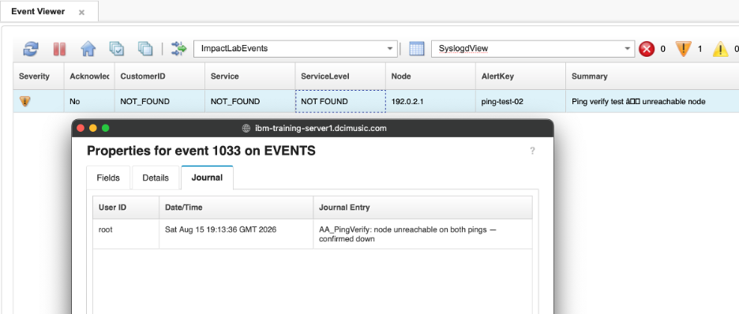
- Event list showing 192.0.2.1 alert with severity raised after both pings failed

Validation
The exercise is successful when all of the following are true:
- 127.0.0.1 was enriched, then resolved on the first ping and the event was cleared immediately (no hibernation).
- 192.0.2.1 was enriched, failed both pings, and the policy log shows the 60-second gap between ping attempts.
- After the second failed ping, the event severity was raised by one and the correct journal entry was set.
- A second 192.0.2.1 event triggered the full pipeline again.
- You can explain why EventId = 'PingFailure' must be set in the insert for the mapping filter to match.
- You can explain why Get Updated Events is required for AA_PingVerify to fire.
- You can explain why ImpactFlag = 88 is set and ReturnEvent is called before Hibernate.
- You can explain what would happen if RemoveHibernation were not called.
- You can explain why the HibernatingPolicyActivator service must be running.

Expected result
You have built a verification loop that uses hibernation to add a deliberate delay between two checks. Events for genuinely reachable nodes are cleared on the first pass with no hibernation at all. Events for truly unreachable nodes go through the full 60-second wait, re-check, and are confirmed as down. The same guard-hibernate-resume-cleanup pattern applies to any scenario where a policy needs to wait before acting — retry logic, deferred notifications, or staged remediation workflows.

8. Making a Java call
IPL gives you direct access to the Java runtime through the JavaCall function. This means any Java class available on the Impact server’s classpath — whether from the standard library or a custom JAR — can be invoked from policy code. The result can be used immediately in IPL, giving you access to the full breadth of Java functionality without leaving the policy editor.
This section demonstrates the pattern using java.util.Arrays.sort(), a straightforward example that is easy to verify and clearly illustrates the calling convention. The same pattern applies to any static method or instance method on any Java class.

8.1 Write a policy that sorts an array using a Java call

Objective
In this exercise, you will write a policy that builds an IPL array of strings, calls the static Java method java.util.Arrays.sort() to sort it in place, and logs the result. By the end of the exercise, you will understand the four-argument JavaCall signature and how IPL arrays map to Java arrays.

Prerequisites
- Completion of sections 4 through 6, or familiarity with IPL policy creation.
- You are logged in to the Impact GUI.

Background

The JavaCall function
JavaCall has the following signature:
JavaCall(ClassName, ObjectInstance, MethodName, { arg1, arg2, ... });
Argument | Purpose
ClassName | Fully qualified Java class name (e.g. "java.util.Arrays")
ObjectInstance | The Java object to invoke the method on. Use null for static methods
MethodName | The method name as a string (e.g. "sort")
{ arg1, ... } | An IPL array of arguments to pass to the method
For static methods — methods that belong to the class rather than a particular instance — pass null as ObjectInstance. java.util.Arrays.sort() is a static method, so the call looks like:
JavaCall("java.util.Arrays", null, "sort", { words });
IPL arrays passed to JavaCall are automatically bridged to Java arrays and back. When sort is called, it sorts the array in place, meaning the original words variable in IPL reflects the sorted order immediately after the call returns — no return value needs to be captured.

Tasks
- Select the Policies tab from the top navigation bar. In the toolbar, click the dropdown arrow next to the New Policy icon and select IPL Policy.
- Click the Save icon, enter AA_JavaSortDemo in the Policy Name field, and click Save.
- Enter the following policy code in the editor:
- /*
* Policy: AA_JavaSortDemo
* Purpose: Demonstrate JavaCall by sorting an array of strings using
* the static method java.util.Arrays.sort().
* Trigger: PolicyActivator (run manually via a one-time activation).
*/
/* Build an unsorted array of strings. */
words = {"zipper", "apple", "carrot"};
Log("AA_JavaSortDemo: before sort: " + words);
/* Call the static Java method java.util.Arrays.sort().
* null = no object instance (static call).
* The array is sorted in place — words is updated directly. */
JavaCall("java.util.Arrays", null, "sort", { words });
Log("AA_JavaSortDemo: after sort: " + words);
- Click the Syntax Check icon. Confirm the Syntax check successful dialog appears, then click Close.
- Click the Save icon to save the policy.
- Open a terminal on the Impact server. The policy log file is not created until the policy runs for the first time, so create it now so that tail has a file to follow:
- touch $IMPACT_HOME/logs/NCI_policylogger_AA_JavaSortDemo.log
- Then start a live tail:
- tail -f $IMPACT_HOME/logs/NCI_policylogger_AA_JavaSortDemo.log
- Leave this terminal open — output will appear here as soon as the policy runs.
- Back in the Impact GUI, with AA_JavaSortDemo open in the policy editor, click the green Run icon in the toolbar to execute the policy immediately.
- Note — the Run icon is a useful testing tool. Any policy can be run on demand this way, without attaching it to a service. The Run dialog also lets you supply parameter values before execution, which is convenient for testing policies that read named parameters. If you are developing a policy that will eventually be driven by an OMNIbusEventReader, you can stub out the event at the top of the policy code — create an EventContainer object explicitly and populate its fields — then use Run to test the logic before the event reader is wired up.
- Confirm the Policy executed successfully dialog appears, then click Close.
- Switch back to the terminal. You should see two log entries appear:
- AA_JavaSortDemo: before sort: [zipper, apple, carrot]
AA_JavaSortDemo: after sort: [apple, carrot, zipper]
- Confirm that the array is in alphabetical order after the JavaCall.

Validation
The exercise is successful when all of the following are true:
- The AA_JavaSortDemo policy is saved and the syntax check passes.
- The policy log shows both the before and after arrays, with the after array in alphabetical order.
- You can describe the four arguments of JavaCall and explain when to pass null as the second argument.
- You can explain the difference between a static method call and an instance method call in this context.

Expected result
You have demonstrated that IPL can bridge directly into the Java runtime. The JavaCall pattern — class name, instance (or null), method name, argument array — works for any accessible Java method. In production, this is used to invoke custom utility classes (string parsers, encryption helpers, web service clients) from within Impact policy code without requiring a separate integration layer.

9. Using the Eval function
The Eval function evaluates an IPL filter expression against an event or object at runtime, returning true if the object matches the expression and false if it does not. This inverts the normal query direction: instead of querying a data source for records that match a known filter, you query for filter expressions and test the current event against each one.
The practical effect is powerful: you can drive policy behavior entirely from a database table. Adding a new row to the table adds a new action rule — no policy edits required. This makes Eval-based policies suitable for environments where the rules change frequently or need to be managed by operators rather than developers.
This section builds a data-driven event action policy. A TAKEACTION table in the existing DB2 CMDB database holds filter expressions and associated action types. For each incoming event, the policy loops through the table, evaluates the event against each filter, and takes the corresponding action if a match is found.

9.1 Prepare the data source

Objective
In this exercise, you will create the TAKEACTION table in the existing DB2 CMDB database, create a matching Impact data type, and populate the table with two test rules. By the end of the exercise, you will have a data-driven rule store that the escalation policy can query.

Prerequisites
- Completion of sections 4 through 6.
- The CMDB DB2 DSA is configured and connected.
- You are logged in to the Impact GUI and have SSH access to the lab server.

Background
The TAKEACTION table stores one row per action rule. Each row contains:
Column | Type | Purpose
ACTID | INTEGER | Primary key — uniquely identifies the rule
FILTERSTAT | VARCHAR(255) | An IPL filter expression evaluated against each event
ACTION | VARCHAR(32) | What to do when the filter matches (email or suppress)
PARAMS | VARCHAR(255) | Action-specific parameters (see below)
For the email action, PARAMS contains the recipient address and email subject separated by a | character:
oncall@example.com|Alert on @Node: @Summary
For the suppress action, PARAMS contains the integer value to write to the SuppressEscl field (e.g. 4 for suppressed).

Tasks
- SSH into the lab server and switch to the DB2 instance user:
- su - db2inst1
- Create the TAKEACTION table in the CMDB database:
- db2 connect to CMDB
db2 "CREATE TABLE TAKEACTION (
ACTID INTEGER NOT NULL PRIMARY KEY,
FILTERSTAT VARCHAR(255),
ACTION VARCHAR(32),
PARAMS VARCHAR(255)
)"
db2 connect reset
- You should see DB20000I The SQL command completed successfully. after the CREATE TABLE statement.
- Insert two test rules:
- db2 connect to CMDB
db2 "INSERT INTO TAKEACTION VALUES (1,
'(Node=\"router-lon-01\") AND (Severity=5)',
'email',
'oncall@example.com|Critical alert on router-lon-01')"
db2 "INSERT INTO TAKEACTION VALUES (2,
'(Node=\"switch-nyc-01\") AND (Severity=3)',
'suppress',
'4')"
db2 connect reset
exit
- Rule 1 sends an email when router-lon-01 reaches severity 5. Rule 2 suppresses events from switch-nyc-01 at severity 3 by setting SuppressEscl = 4.
- In the Impact GUI, create a data type for the new table:
  - Select the Data Model tab.
  - Locate the CMDB DSA in the left-hand tree, right-click it, and select New Data Type.
  - Set Data Type Name to TAKEACTION.
  - Set Table to TAKEACTION.
  - Click on the Refresh Fields button
  - Mark ACTID as the Key field.
  - Click Save.
- 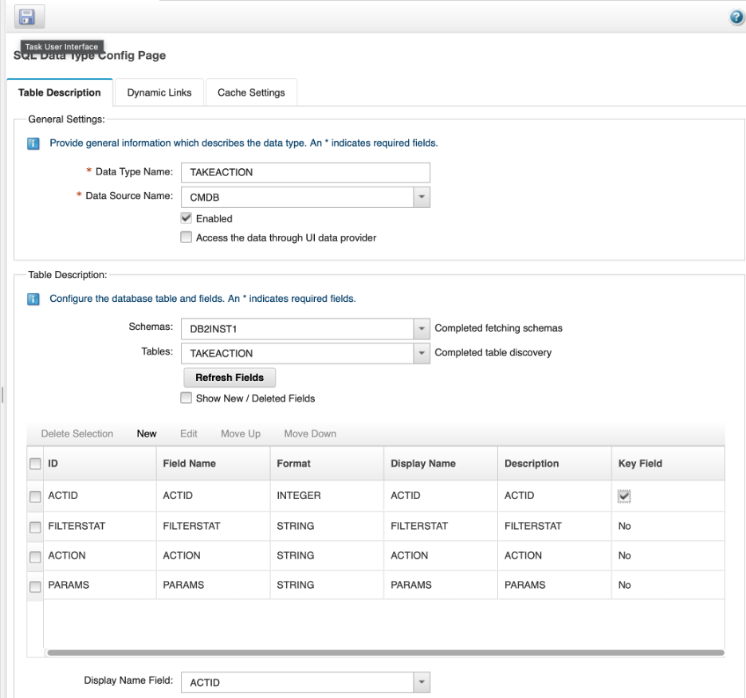
- The completed TAKEACTION data type configuration in the Impact Data Model tab, showing the four discovered fields with ACTID marked as the key field.

Validation
The exercise is successful when all of the following are true:
- The TAKEACTION table exists in the CMDB database with four columns.
- Both rows are present in the table.
- The TAKEACTION data type is visible in the Impact Data Model under the CMDB DSA.
- You can explain why the filter expressions in FILTERSTAT use escaped double quotes (\") when inserted from the DB2 command line.

Expected result
The TAKEACTION table is ready to use as a rule store. The next exercise writes the policy that queries this table and uses Eval to match each rule against the incoming event.

9.2 Write the Eval-based action policy

Objective
In this exercise, you will write a policy that queries the TAKEACTION table, loops through every row, and evaluates the FILTERSTAT expression against the current event using Eval. When a match is found, the policy executes the corresponding action — either sending an email or suppressing the event. By the end of the exercise, you will understand how Eval inverts the normal query direction and why this pattern is useful for data-driven automation.

Prerequisites
- Completion of section 9.1.
- The TAKEACTION data type is configured in the Impact Data Model.
- The NotifyFlag integer field has been added to alerts.status and the EVENTS data type has been refreshed in Impact. Complete both steps now:
- 1. Add the column to the ObjectServer:
- $OMNIHOME/bin/nco_sql -server EVENTS -user root -password netcool << 'EOF'
ALTER TABLE alerts.status ADD COLUMN NotifyFlag INTEGER;
go
EOF
- You should see 0 rows affected. confirming the column was added.
- 2. Refresh the EVENTS data type in Impact:
  - In the Impact GUI, select the Data Model tab.
  - Locate the EVENTS data type in the left-hand tree under the defaultobjectserver data source and double-click on it to bring up its configuration
  - In the Table Description section of the data type configuration page, click Refresh Fields.
  - Confirm that NotifyFlag now appears in the field list.
  - Click Save and close the EVENTS configuration tab.

Background

EmailSender configuration
In a production environment, the email action path would call SendEmail via a configured EmailSender service in Impact. To set one up, you would go to Services → New Service → EmailSender and supply the SMTP host, port, sender address, and credentials. In this lab the SMTP infrastructure is not available, so SendEmail is commented out in the policy below and replaced with a Log statement that records what the call would have done. The functional behavior of the Eval loop, the Split, and the action dispatch is identical — only the final delivery step is simulated.

How Eval works
Eval(filterExpression, objectToEvaluate)
Eval takes a string containing an IPL filter expression and an object (typically EventContainer or a row returned by GetByFilter) and returns true if the object satisfies the expression, false otherwise.
The filter expressions stored in TAKEACTION.FILTERSTAT use the same syntax as OMNIbusEventReader event mappings — field names, comparison operators, AND, OR, LIKE, etc. This means the same filter language you use when configuring services can be driven from a database row.

Why this pattern scales
Without Eval, adding a new action rule means editing a policy — checking the code into source control, testing, deploying. With Eval, adding a rule means inserting a row into a table. The policy itself never changes. This separation of logic (the policy) from configuration (the table) is one of the most powerful patterns in Impact automation.

Tasks
- Select the Policies tab from the top navigation bar. In the toolbar, click the dropdown arrow next to the New Policy icon and select IPL Policy.
- Click the Save icon, enter AA_EvalActionPolicy in the Policy Name field, and click Save.
- Enter the following policy code in the editor:
- /*
* Policy: AA_EvalActionPolicy
* Purpose: Query the TAKEACTION rule table and evaluate the current event
* against each filter expression using Eval(). When a match is found,
* execute the corresponding action (email or suppress).
* Trigger: OMNIbusEventReader (event-driven).
*/
/* Query all rows from the TAKEACTION table. */
Actions = GetByFilter("TAKEACTION", "ACTID > 0", False);
numActions = Length(Actions);
Log("AA_EvalActionPolicy: " + numActions + " rule(s) loaded from TAKEACTION");
i = 0;
while (i < numActions) {
/* Evaluate the current event against this row's filter expression. */
if (Eval(Actions[i].FILTERSTAT, EventContainer)) {
Log("AA_EvalActionPolicy: rule " + Actions[i].ACTID
+ " matched (action=" + Actions[i].ACTION + ") for Node=" + EventContainer.Node);
if (Actions[i].ACTION == "email") {
/* PARAMS format: "recipient|subject"
* Split on | to get the two parts. */
spParams = Split(Actions[i].PARAMS, "|");
Contact = spParams[0];
Subject = spParams[1];
Message = EventContainer.Summary;
EventContainer.NotifyFlag = 1;
EventContainer.JournalEntry = "Emailed per rule " + Actions[i].ACTID
+ " (" + Contact + ")";
/* SendEmail is commented out — SMTP not available in this lab.
* In production: SendEmail(null, Contact, Subject, Message, null, false); */
Log("AA_EvalActionPolicy: [SIMULATED] email to " + Contact
+ " | subject: " + Subject + " | body: " + Message);
} elseif (Actions[i].ACTION == "suppress") {
/* PARAMS contains the integer value for SuppressEscl. */
EventContainer.SuppressEscl = Int(Actions[i].PARAMS);
EventContainer.NotifyFlag = 1;
EventContainer.JournalEntry = "Suppressed per rule " + Actions[i].ACTID
+ " (SuppressEscl=" + Actions[i].PARAMS + ")";
Log("AA_EvalActionPolicy: SuppressEscl set to " + Actions[i].PARAMS
+ " for Node=" + EventContainer.Node);
}
}
i = i + 1;
}
/* Commit any field changes back to the ObjectServer. */
ReturnEvent(EventContainer);
- Click the Syntax Check icon. Confirm the check passes.
- Click the Save icon to save your policy.

Validation
The exercise is successful when all of the following are true:
- The AA_EvalActionPolicy policy is saved and the syntax check passes.
- You can trace through the policy and explain what happens for each of the two rows in the TAKEACTION table.
- You can explain what Eval returns for an event that does not match any row.
- You can explain why ReturnEvent is placed at the very end of the policy rather than inside each action branch.
- You can describe how to add a new action rule without touching the policy code.

Expected result
You have a fully data-driven action policy. Rules live in the database, not in the policy. Adding, changing, or removing rules is as simple as modifying rows in the TAKEACTION table.

9.3 Create the service and validate

Objective
In this exercise, you will create an OMNIbusEventReader service that triggers AA_EvalActionPolicy on incoming events, insert test alerts that match each rule, and confirm that the email and suppress actions fire correctly.

Prerequisites
- Completion of section 9.2.
- The AA_EvalActionPolicy policy is saved.
- You have viewed the default EmailSender service in Impact. Take a moment to do this now:
  - Select the Services tab and locate the EmailSender service in the service list.
  - Double-click it to open its configuration. You will see fields for SMTP host, port, sender address, and SSL configuration — the setup is straightforward.
  - Note that the service is stopped and leave it that way. In a production environment you would fill in the SMTP details and start it, and the SendEmail call in AA_EvalActionPolicy would deliver real email. In this lab, SMTP is not available, so the call remains commented out — but the policy code shows exactly what a live implementation would look like.
  - Close the EmailSender configuration without making any changes.

Tasks
- Select the Services tab. Click the dropdown arrow next to the New Service icon and select OMNIbusEventReader.
- Configure the service:
  - Service Name: EvalActionEventReader
  - ObjectServer DSA: defaultobjectserver
  - Event Mapping filter: NotifyFlag = 0
  - Policy: AA_EvalActionPolicy
  - Active: checked
- Click Save, then right-click the service and select Start. Confirm the state changes to Running.
- Switch to the OMNIbus Web GUI in your private/incognito browser. Select the ImpactLab Events filter and the SyslogdView view. Select all existing events and delete them so the list is clear before inserting the test alerts.
- Insert a severity 5 test alert for router-lon-01 — this should match rule 1 and trigger the email action:
- $OMNIHOME/bin/nco_sql -server EVENTS -user root -password netcool << 'EOF'
INSERT INTO alerts.status (Node, Summary, AlertKey, AlertGroup, Severity, Type, Identifier, Manager, OwnerUID)
VALUES ('router-lon-01', 'Critical interface failure', 'eval-test-01', 'TrainingAlerts', 5, 1, 'router-lon-01:eval-test-01:TrainingAlerts', 'ImpactLab', 65534);
go
EOF
- Insert a severity 3 test alert for switch-nyc-01 — this should match rule 2 and set SuppressEscl = 4:
- $OMNIHOME/bin/nco_sql -server EVENTS -user root -password netcool << 'EOF'
INSERT INTO alerts.status (Node, Summary, AlertKey, AlertGroup, Severity, Type, Identifier, Manager, OwnerUID)
VALUES ('switch-nyc-01', 'Minor link degradation', 'eval-test-02', 'TrainingAlerts', 3, 1, 'switch-nyc-01:eval-test-02:TrainingAlerts', 'ImpactLab', 65534);
go
EOF
- Insert a severity 3 test alert for server-fra-01 — this should not match any rule and no action should be taken:
- $OMNIHOME/bin/nco_sql -server EVENTS -user root -password netcool << 'EOF'
INSERT INTO alerts.status (Node, Summary, AlertKey, AlertGroup, Severity, Type, Identifier, Manager, OwnerUID)
VALUES ('server-fra-01', 'Disk usage warning', 'eval-test-03', 'TrainingAlerts', 3, 1, 'server-fra-01:eval-test-03:TrainingAlerts', 'ImpactLab', 65534);
go
EOF
- Check the policy log to confirm the rules fired as expected:
- tail -30 $IMPACT_HOME/logs/NCI_policylogger_AA_EvalActionPolicy.log
- You should see:
  - A log entry for router-lon-01 showing action=email matched and the email was sent.
  - A log entry for switch-nyc-01 showing action=suppress matched and SuppressEscl was set.
  - A log entry for each alert showing 2 rule(s) loaded from TAKEACTION.
  - No match log entries for server-fra-01.
- In the OMNIbus Web GUI, locate the switch-nyc-01 test alert. Double-click it and confirm SuppressEscl = Suppressed in the event details.
- Add a new rule to the TAKEACTION table — no policy changes needed. First, switch to the DB2 instance user:
- su - db2inst1
- Insert the new rule and exit:
- db2 connect to CMDB
db2 "INSERT INTO TAKEACTION VALUES (3,
'(Severity >= 4) AND (Node LIKE \"server-fra.*\")',
'email',
'dba@example.com|High severity alert on Frankfurt server')"
db2 connect reset
exit
- Insert a fresh severity 4 test alert for server-fra-01 — this should now match rule 3 and trigger the email action. Note the distinct AlertKey and Identifier (eval-test-04) to ensure this arrives as a new event rather than deduplicating against the earlier severity 3 insert:
- $OMNIHOME/bin/nco_sql -server EVENTS -user root -password netcool << 'EOF'
INSERT INTO alerts.status (Node, Summary, AlertKey, AlertGroup, Severity, Type, Identifier, Manager, OwnerUID)
VALUES ('server-fra-01', 'High disk utilisation', 'eval-test-04', 'TrainingAlerts', 4, 1, 'server-fra-01:eval-test-04:TrainingAlerts', 'ImpactLab', 65534);
go
EOF
- Check the policy log and confirm the email action for rule 3 appears — with no policy edits made:
- tail -20 $IMPACT_HOME/logs/NCI_policylogger_AA_EvalActionPolicy.log
- In the OMNIbus Web GUI, check the journal entries on the actioned alerts to confirm the policy wrote them correctly:
  - Double-click the router-lon-01 alert and open the Journal tab. You should see an entry reading Emailed per rule 1 (oncall@example.com).
  - Double-click the switch-nyc-01 alert and open the Journal tab. You should see an entry reading Suppressed per rule 2 (SuppressEscl=4).
  - Double-click the server-fra-01 (severity 4) alert and open the Journal tab. You should see an entry reading Emailed per rule 3 (dba@example.com).
- 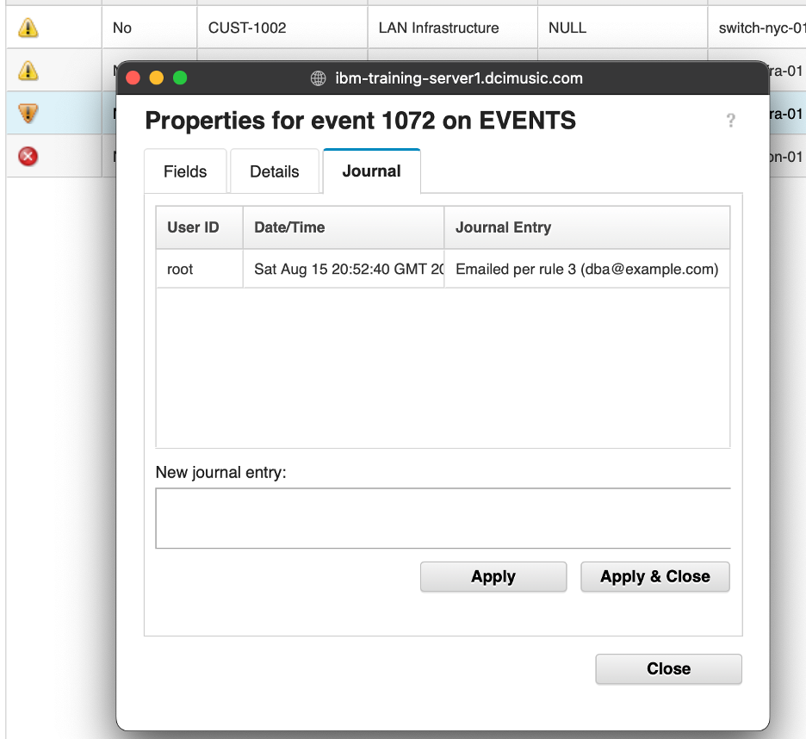
- Journal tab of the router-lon-01 alert showing the ‘Emailed per rule 1’ journal entry written by AA_EvalActionPolicy.

Validation
The exercise is successful when all of the following are true:
- router-lon-01 (sev 5) triggered the email action.
- switch-nyc-01 (sev 3) had SuppressEscl set to 4.
- server-fra-01 (sev 3) produced no action entries in the policy log.
- After adding rule 3, a severity 4 alert from server-fra-01 triggered the email action without any policy edits.
- Journal entries are visible on all three actioned alerts, correctly identifying the rule and action taken.
- You can explain how Eval enables this data-driven approach.

Expected result
You have built a data-driven action policy where all rules live in a database table. The policy code handles the loop, the Eval call, and the action dispatch — but the rules themselves are data. This is one of the most flexible patterns in Impact: it lets operators or administrators add, modify, or retire automation rules without involving a policy developer or a deployment cycle.

Lab completion summary
Congratulations on completing the Netcool Impact lab guide. Across eleven sections you have built a fully working Impact automation environment from scratch — from configuring data source adapters on day one to managing user access on the last. This page summarises what you covered in each section and the skills you have developed along the way.

Section 1 — Impact fundamentals and UI navigation
You learned what IBM Netcool Impact is and how it fits into the OMNIbus architecture. You explored the Impact GUI, navigated the main tabs — Policies, Services, Data Model, Operator View, and Maintenance Window — and established the lab environment conventions that carried through the rest of the guide.

Section 2 — Data source adapters
You configured the two data sources used throughout the lab: the ObjectServer DSA (defaultobjectserver) connecting Impact to the OMNIbus EVENTS ObjectServer, and the DB2 CMDB DSA (CMDB) connecting Impact to the device inventory database. You created the DEVICE_INVENTORY data type and validated both connections.

Section 3 — Impact policy language
You learned the IPL syntax fundamentals: variables, conditionals, loops, GetByFilter, Log, direct field assignment, ReturnEvent, and DirectSQL. You worked through the key patterns that appear in every policy in the lab — reading event fields from EventContainer, querying external data, writing results back to the ObjectServer, and understanding when to use ReturnEvent versus DirectSQL.

Section 4 — Event enrichment
You wrote your first production-style policy, AA_EnrichAlert, which queries the DEVICE_INVENTORY CMDB table and writes customer, service, and location data back to incoming alerts. You configured the EnrichmentEventReader OMNIbusEventReader service to trigger the policy on new events, and validated the full enrichment pipeline — both the found path (ImpactFlag = 1) and the not-found path (ImpactFlag = 2).

Section 5 — Scheduled automation
You extended the enrichment pipeline to handle events that could not be enriched on first attempt — nodes not yet in the CMDB. The AA_DeferredEnrichment policy and its DeferredEnrichmentActivator PolicyActivator service poll every 60 seconds, retry enrichment for ImpactFlag = 2 events, and enforce a retry limit using the Poll counter field. You validated the retry loop and confirmed that alerts exceeding the retry limit are silently dropped from further processing.

Section 6 — Event escalation
You added a SERVICE_LEVEL dimension to the enrichment pipeline and wrote AA_EscalatePlatinum, a time-based escalation policy that progressively raises the severity of unacknowledged Platinum-tier alerts. You learned why age-based escalation requires a PolicyActivator rather than an event reader, how to write back to the ObjectServer using DirectSQL from a scheduled policy, and how to use the Flash field to drive visual notifications in the Web GUI.

Section 7 — Automation and hibernation
You wrote AA_PingVerify, a policy that uses JRExecAction to ping a node and confirm whether a failure is real before raising severity. You used the Hibernate function to pause policy execution and re-evaluate after a delay, and extended the EnrichmentEventReader service with a second mapping row to trigger the ping policy selectively. You validated both the reachable-node path (event clears) and the unreachable-node path (severity is raised after hibernation).

Section 8 — Making a Java call
You learned how to call Java methods directly from IPL using JavaCall. The exercise demonstrated the four-argument calling convention — class name, object instance, method name, argument array — using java.util.Arrays.sort() as a clear, verifiable example. You also used the policy editor’s Run icon to execute a policy on demand without attaching it to a service, establishing a useful testing pattern.

Section 9 — Using the Eval function
You built a fully data-driven action policy using Eval. The AA_EvalActionPolicy queries a TAKEACTION rule table in the CMDB, evaluates the current event against each stored filter expression at runtime, and dispatches the corresponding action — email or suppression — without any hardcoded conditions in the policy code itself. You demonstrated that adding a new automation rule requires only a database insert, with no policy changes or redeployment.

Section 10 — Organizing artifacts using projects
You used the Impact project selector to create ImpactLabProject and populate it with all of the lab’s data sources, data types, policies, and services. You learned how projects scope the Policies and Services views to show only the relevant artifacts. You then used nci_export to export the project from the command line, deliberately deleted two artifacts to simulate a configuration loss, and used nci_import to restore them — directly demonstrating the rollback use case.

Section 11 — Granting users access to Impact
You learned how Impact’s role-based access control model works. You observed the blank workspace presented to an authenticated but unmapped user, granted the ncoadmin account the Maintenance Window Manager roles to give it scoped access, and then granted it the impactAdminUser role to give it full administrative access. You understand the distinction between authentication (handled by the ObjectServer in this lab) and authorization (controlled by role mappings applied with mapRoles.sh).

What you built
Over the course of the lab you assembled a complete, layered Impact automation environment:
Component | Purpose
AA_EnrichAlert + EnrichmentEventReader | Real-time enrichment of incoming alerts from the CMDB
AA_DeferredEnrichment + DeferredEnrichmentActivator | Scheduled retry enrichment with a poll-count limit
AA_EscalatePlatinum + EscalationActivator | Time-based severity escalation for Platinum-tier alerts
AA_PingVerify + HibernatingPolicyActivator | Ping-based verification with hibernation before severity raise
AA_JavaSortDemo | Demonstration of Java runtime integration via JavaCall
AA_EvalActionPolicy + EvalActionEventReader | Data-driven action dispatch using Eval and a CMDB rule table
ImpactLabProject | Project packaging all artifacts for export, import, and recovery
Each layer built on the one before it. Real-time enrichment feeds deferred enrichment. Enrichment populates the ServiceLevel field that escalation depends on. The hibernation policy reuses the same event pipeline. The Eval policy generalizes the dispatch pattern used throughout.

Where to go next
The patterns you practised here — enrichment, deferred retry, time-based escalation, Java integration, data-driven dispatch, and project-based packaging — are the same patterns used in production Impact deployments. From here you can:
- Explore the Operator View tab to build custom event dashboards.
- Configure a real EmailSender service and remove the SendEmail comment from AA_EvalActionPolicy.
- Extend the escalation policy to notify an on-call engineer when an alert reaches severity 5.
- Use nci_export on a schedule to maintain regular configuration backups.
- Apply role mappings to additional users or explore LDAP and Keycloak/OIDC authentication for production deployments.

