**Lab to explore the IBM Watson Studio, Machine learning and Auto AI with Sample data**

In this lab, we will understand the concepts of Watson studio, machine learning and Auto AI services on the IBM Cloud platform. Please follow the below mentioned steps to see how quickly we can enable/Create the projects on Watson studio and Apply Auto AI service on top of it.

**Create an IBM Cloud account**

Create the IBM Cloud account using the link - <https://ibm.biz/Bdqy3t> and login to the IBM Cloud.

Sign up/Login to IBM Cloud Platform with your credentials and click on continue.

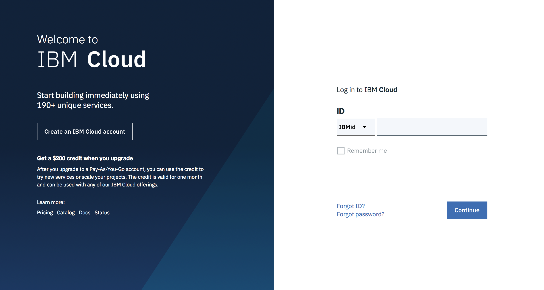

From the landing page/Dashboard Select “Catalog”

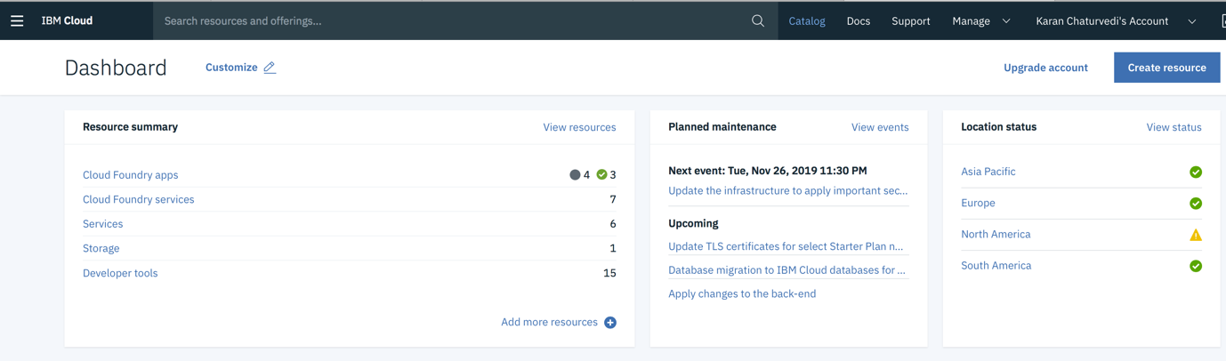

In the Catalog , Search for “Watson Studio” service and Select:

Choose the Lite plan and click on Create:

Allow few minutes for the Watson Studio development environment to be provisioned.

Go back to Catalog, Search for Machine learning service and Select

Choose the Lite plan, and click on create

Click on “Access in Watson Studio” to create a machine learning service through Watson studio

Download the training Dataset:

<https://github.com/IBMDevConnect/DBS2020/AI4Enterprise>

File Name - Homeloan_autoAI.csv

Download the validation dataset:

File Name - validate_data.json

Read about the following Algorithmn and Terminologies:

1. Logistic Regression
2. Decision Tree
3. Random Forest
4. Gradient Boosting
5. LogLoss
6. F1
7. Precision / Recall
8. AUC ROC
9. Confusion matrix