1. IBM Cloud account
2. Signup for a free GitHub account, if not already - <https://github.com/>
3. Windows 7 is NOT supported. Minimum supported OS version is Windows 10.
4. Ensure your OS – Windows / Linux / Mac has been run with all the latest updates
5. Make sure you have Administrative Privileges on your machines to download, install & run software
6. Nearly “Open” Network where Open Source software can be downloaded, installed and configured on developers’ machines
7. On a Windows machine, use Power Shell only (in Administrative mode) to run commands. Do NOT use the Command Prompt – *cmd*.
8. Browsers - Firefox, Chrome, Edge & Safari to be on the latest version
9. If *curl* is not installed on your machine, download it from <https://curl.haxx.se/download.html>
   1. Add the *curl* folder path to your machine’s PATH environment variable so it is available from any location from command line
   2. Check if *curl* is configured properly by running *curl --help* from command line
   3. It should show the help menu
10. IBM Cloud CLI bundle - <https://cloud.ibm.com/docs/cli?topic=cloud-cli-ibmcloud-cli>

This will install stand-alone IBM Cloud CLI plus the following tools:

* Homebrew (Mac only)
* Git
* Docker
* Helm
* kubectl
* curl (Linux only)
* IBM Cloud Functions plug-in
* IBM Cloud Object Storage plug-in
* IBM Cloud Container Registry plug-in
* IBM Cloud Kubernetes Service plug-in

1. Apply the promo-code / feature-code assigned to you to create a Free Kubernetes cluster on IBM Kubernetes Service. You can create a Free cluster on IBM Kubernetes Service only, not on Red Hat OpenShift.
2. Login to your IBM Cloud
3. Click on Manage -> Account

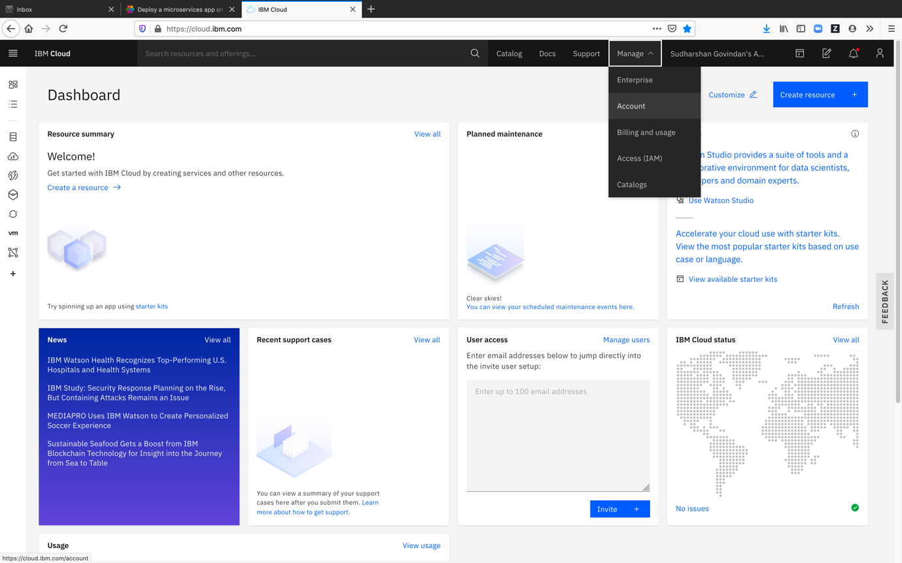

1. Click on Account Settings

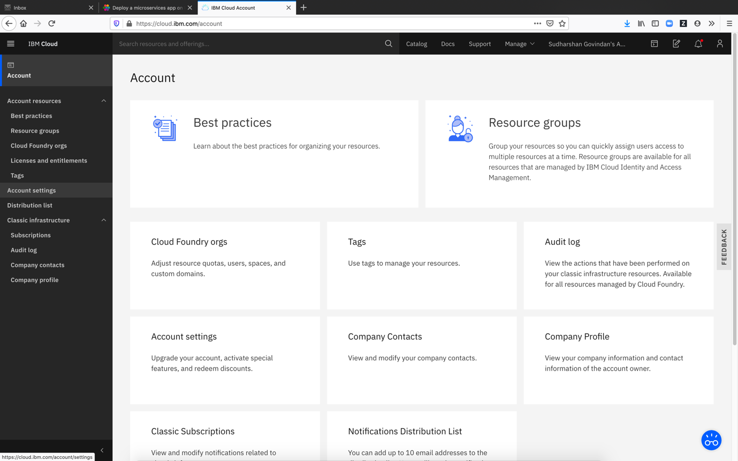

1. Scroll down to “Subscription and feature codes” section and click on Apply code

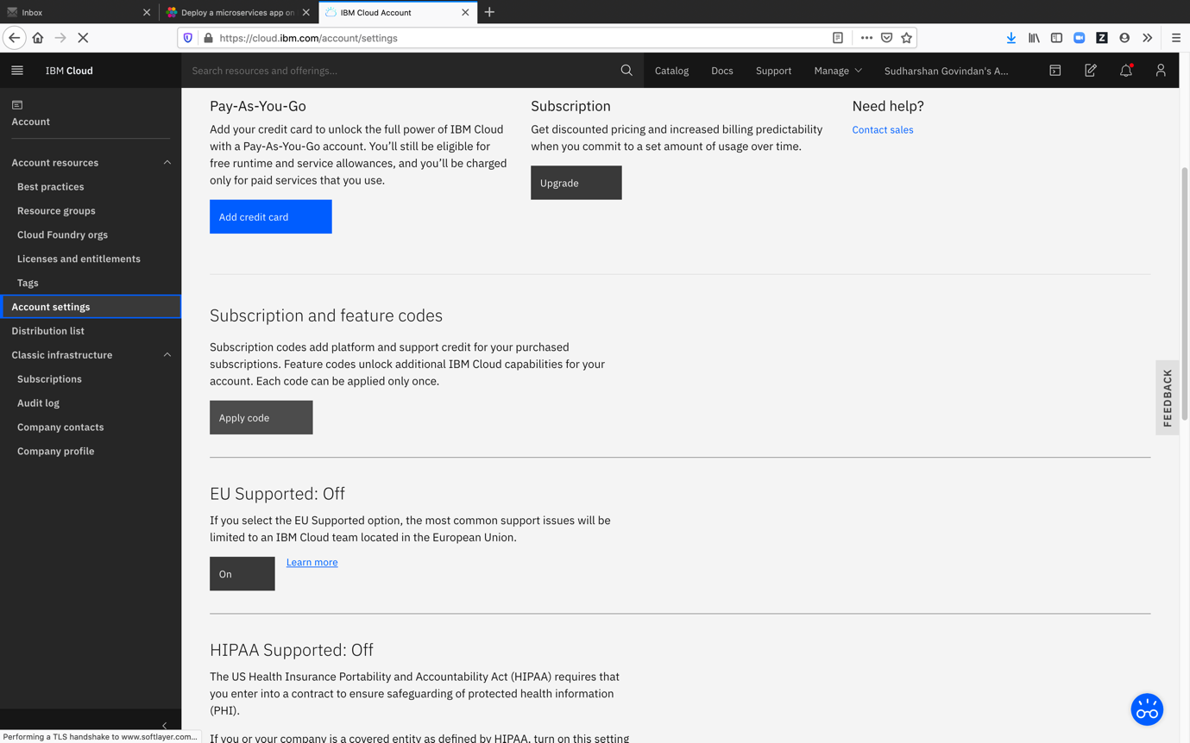

1. Enter the promo code and click on Apply. Make sure there are no whitespaces in the text field.

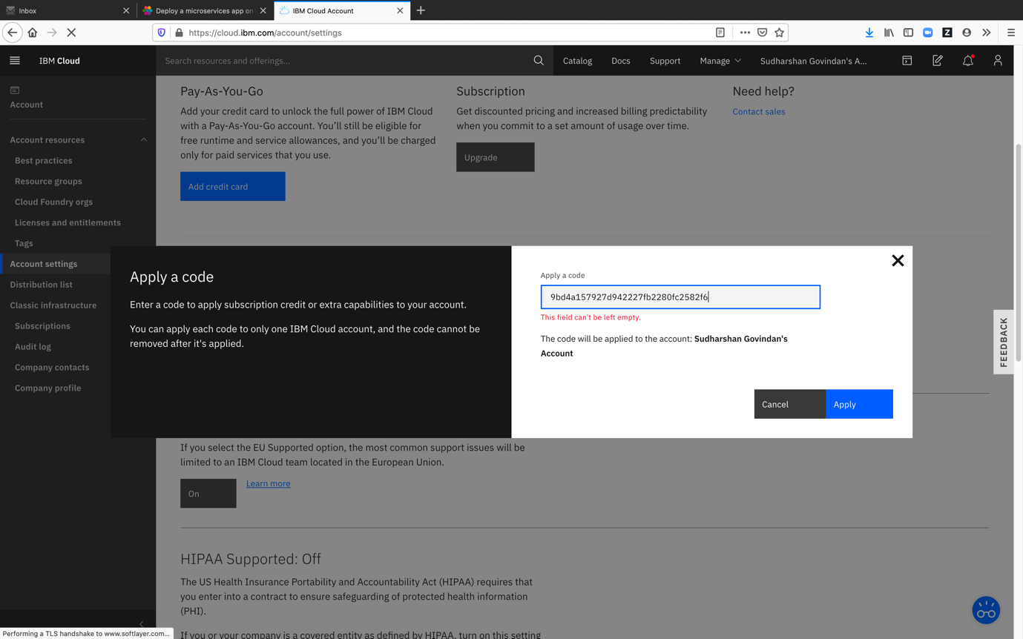

1. Click on Close

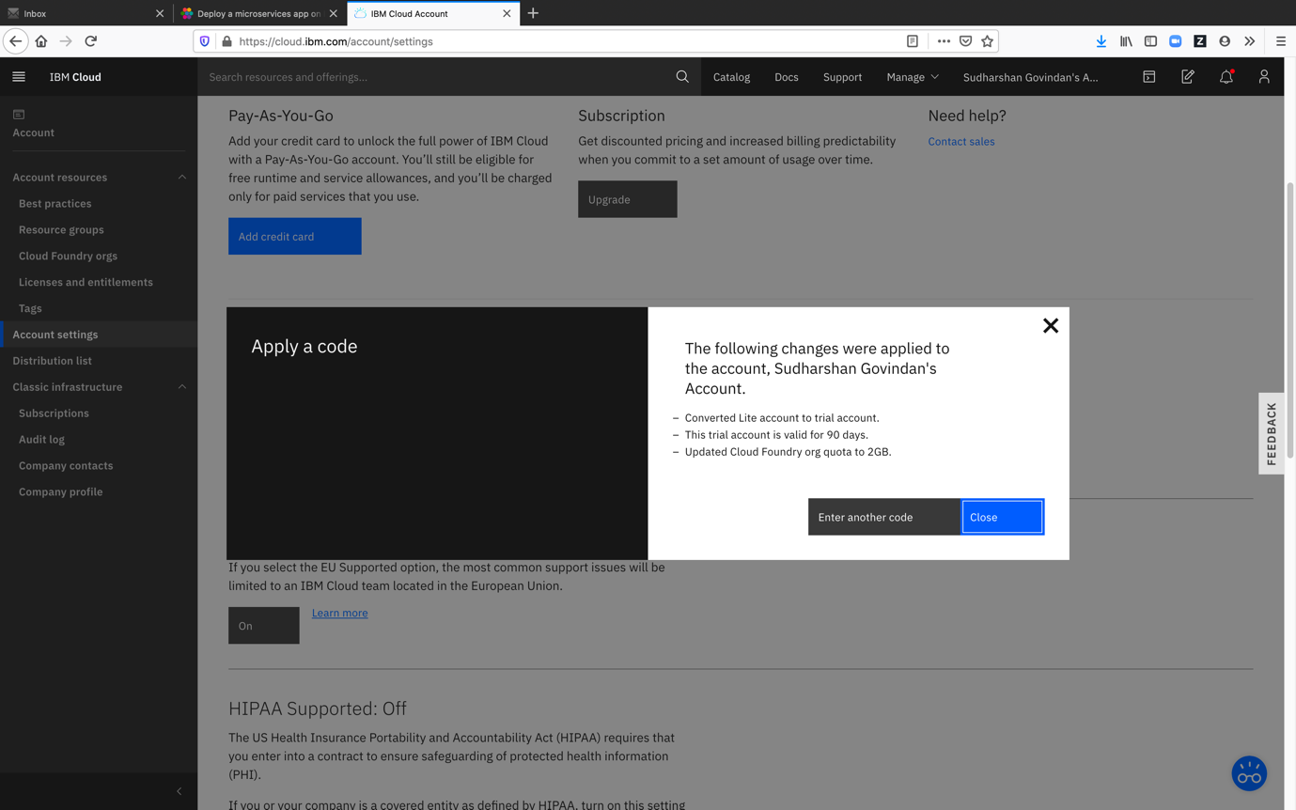

1. You can see that your Lite account is converted a Trial account, valid for 90 or 120 days

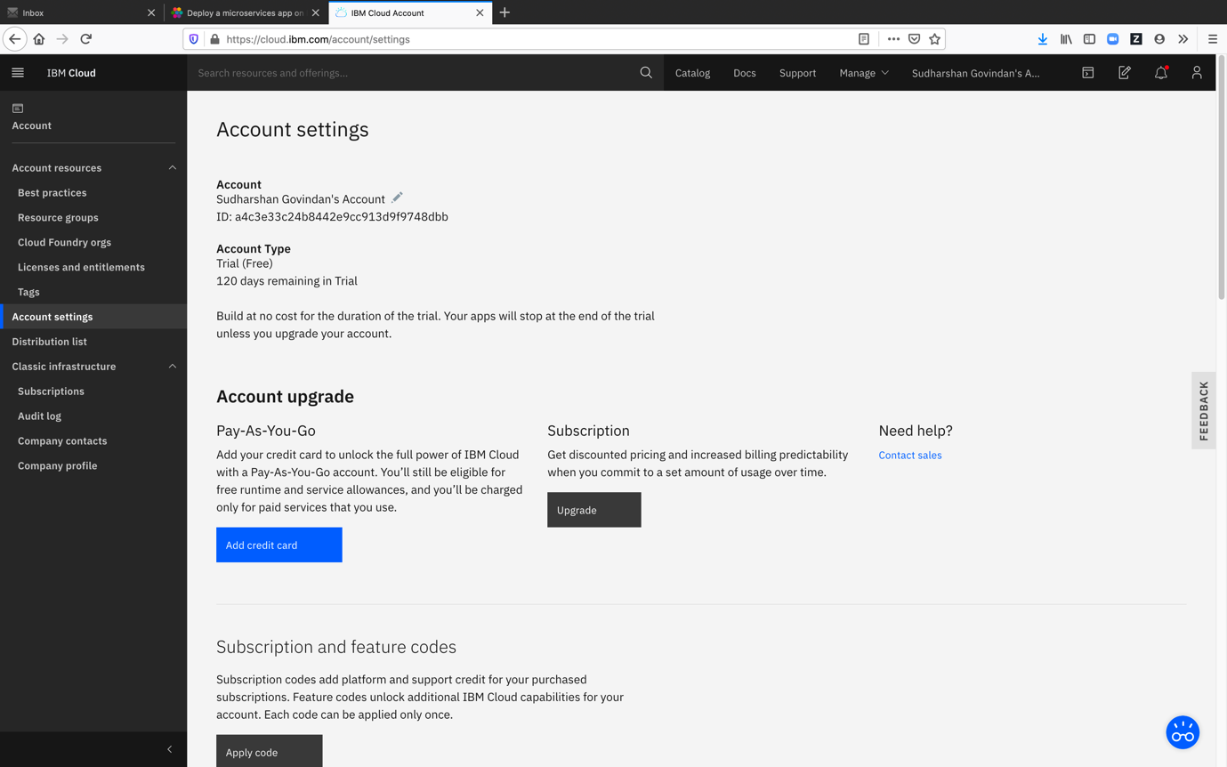

1. Log off from your account

Create a Free Kubernetes Cluster

1. Log in to IBM Cloud
2. Click on Create Resource at the top right corner

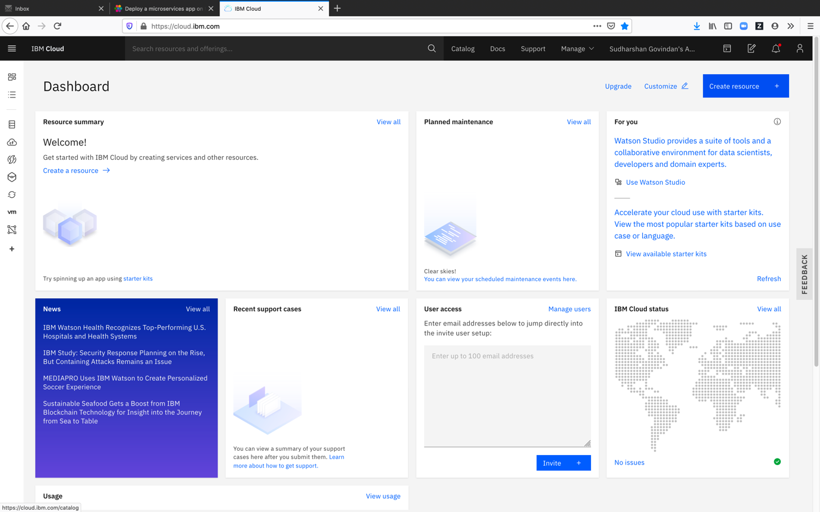

1. Click on Services -> Containers from left side menu

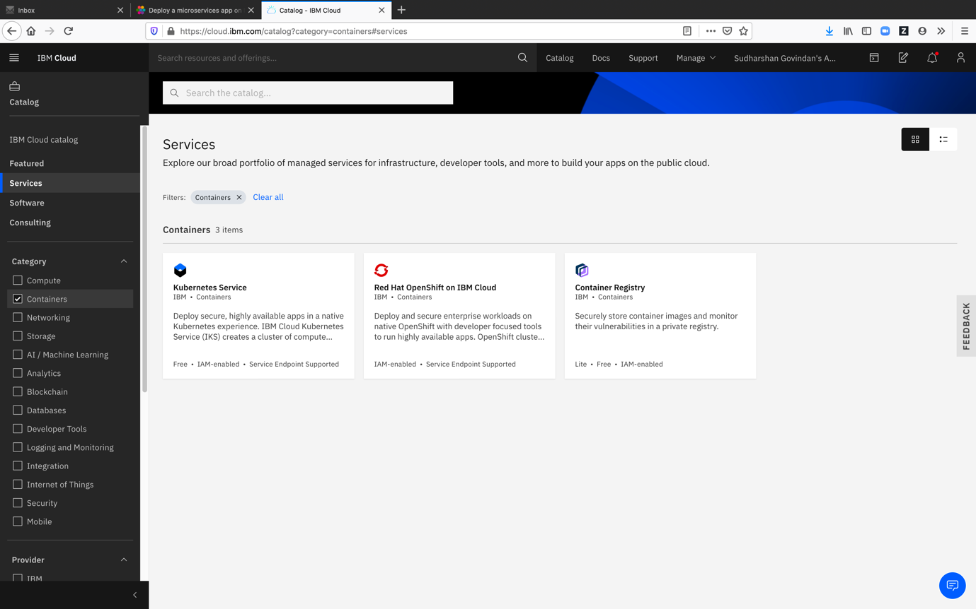

1. Click on Kubernetes Service and select Free cluster from plan. Leave the default values as they are and click on Create from bottom right corner.

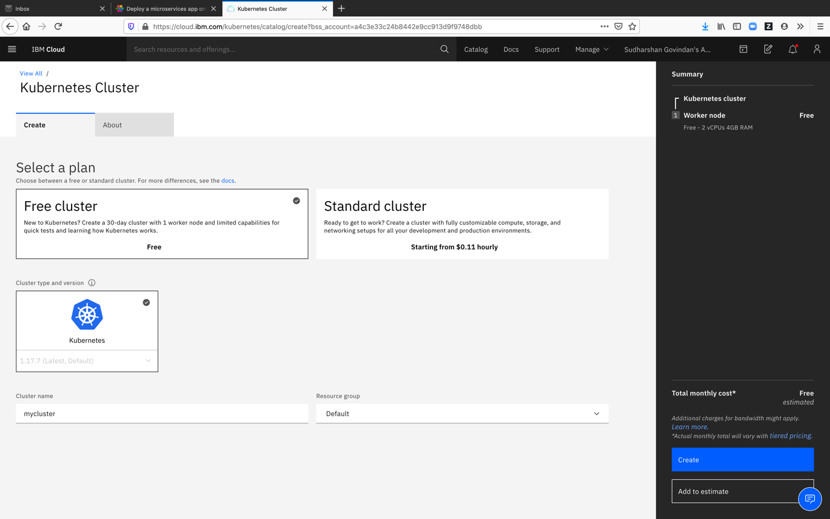

1. It will take 15 to 20 minutes to create the cluster

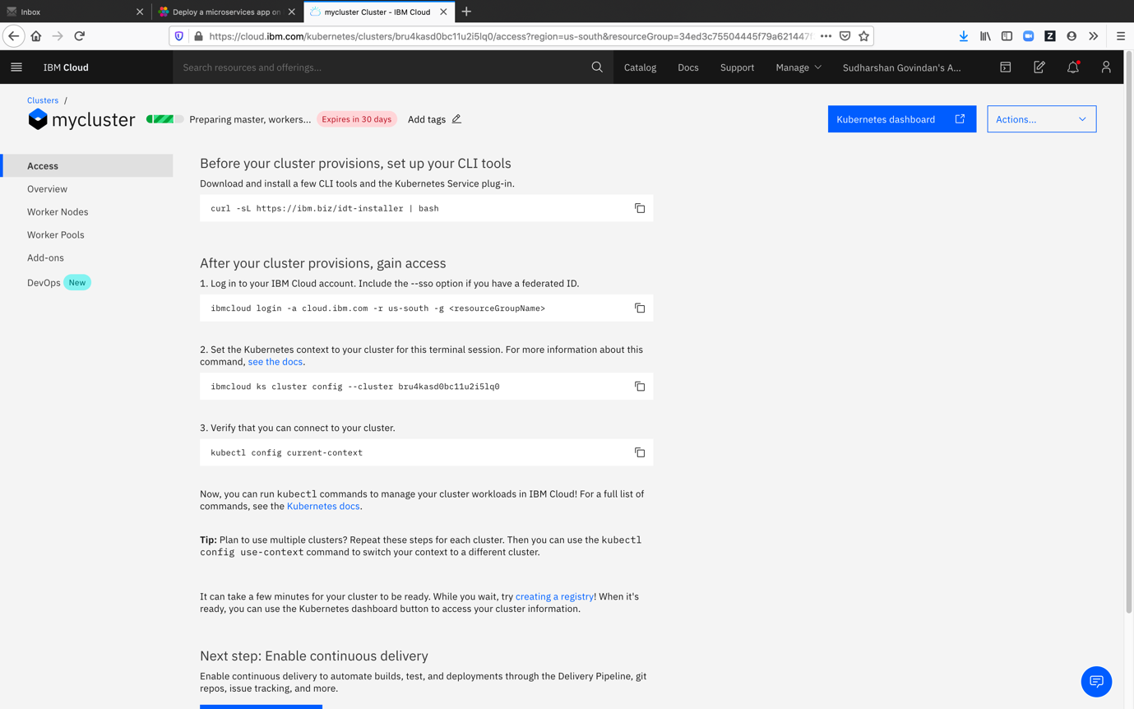

1. Click on Overview from left side menu. You should see 1 Worker Node successfully created with 100% Normal status.

