**Create an IBM Cloud account**

Create the IBM Cloud account using the link - <https://ibm.biz/Bdqy3t> and login to the IBM Cloud.

**Creation of Watson Assistant**

1. In the IBM Cloud catalog, navigate to the Services and provision an instance of Watson Assistant

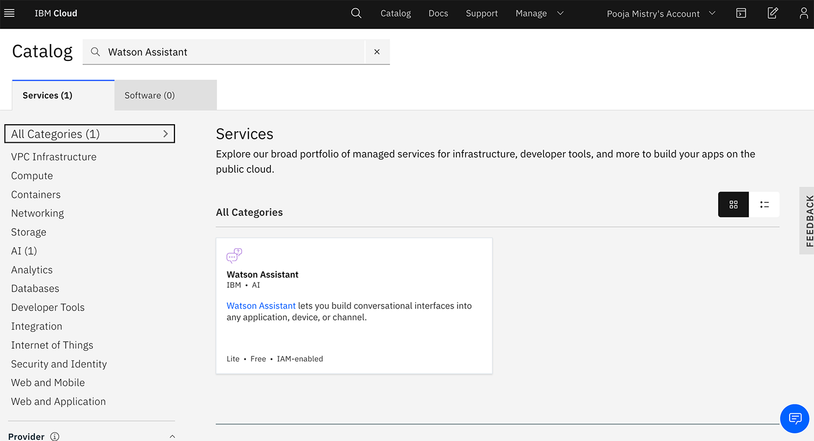

2. Launch the Watson Assistant service.

3. Click Create assistant

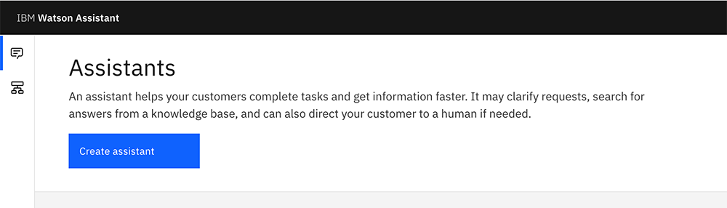

4. Name the Watson Assistance instance **COVID Crisis Communication**

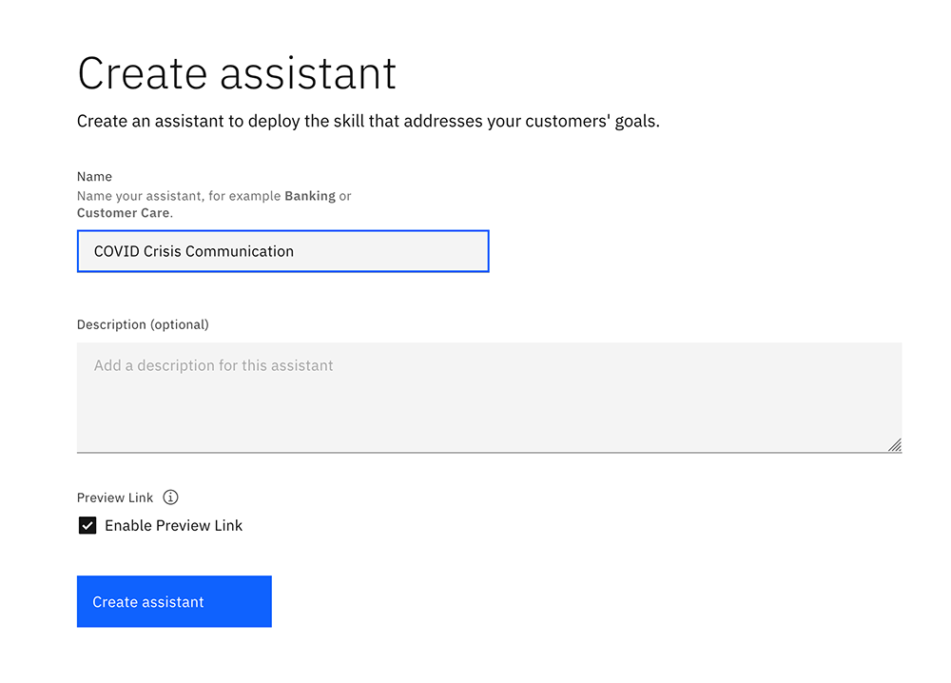

**Create Watson Discovery**

1. From your IBM Cloud account, go to Watson Discovery

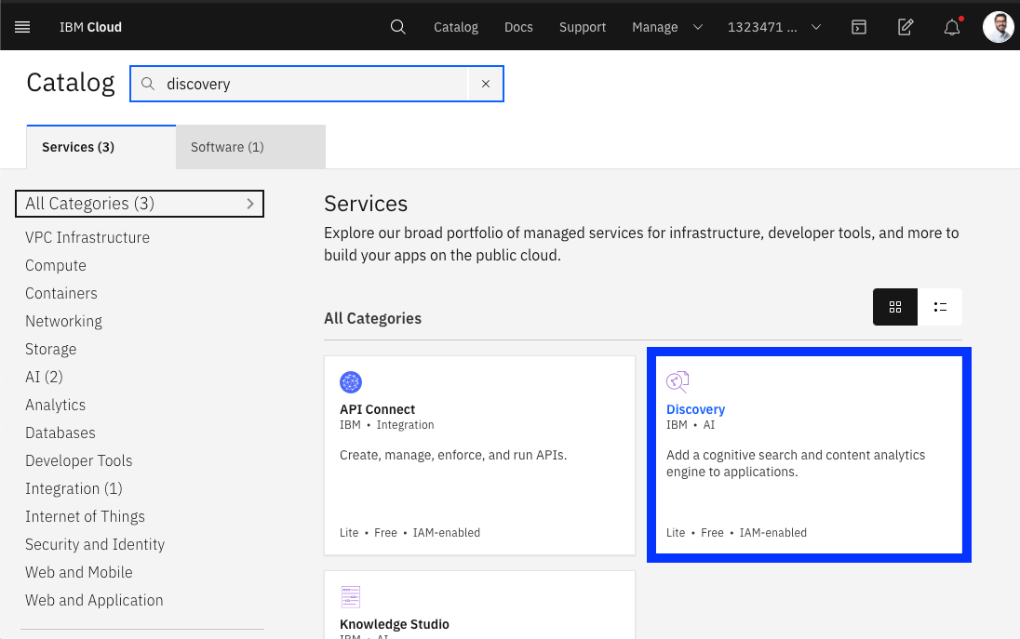

1. Create a new lite service by clicking Create.

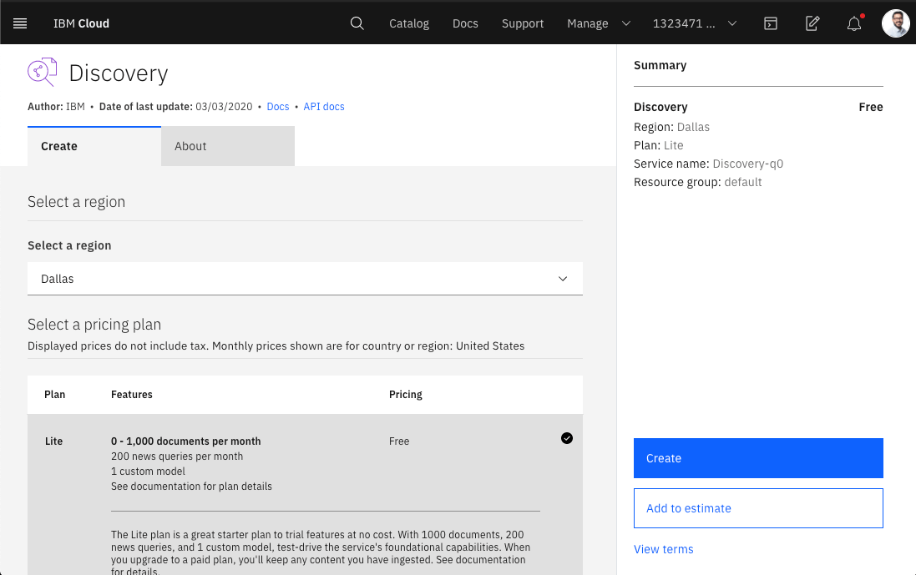

**Create Cloud Functions**

1. In the IBM Cloud catalog, go to [IBM Cloud Functions](https://cloud.ibm.com/functions/).
2. Click **Start Creating**.

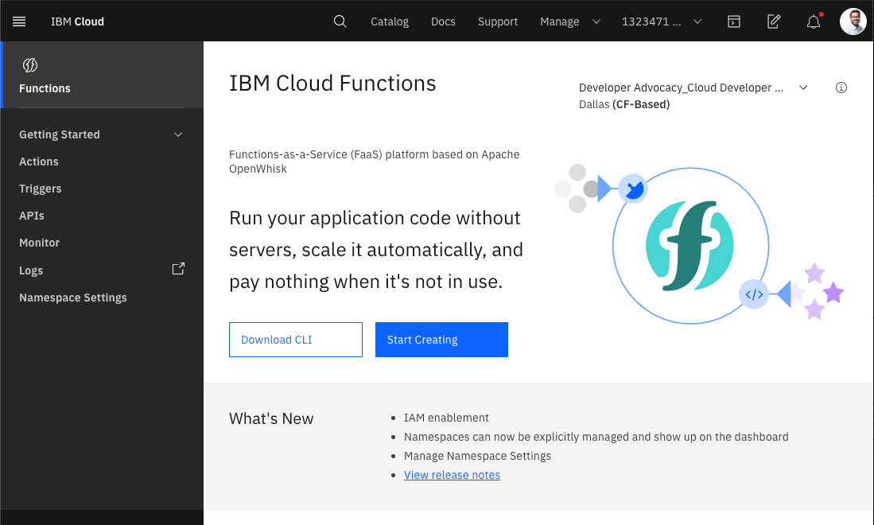

1. Select **Create Action**

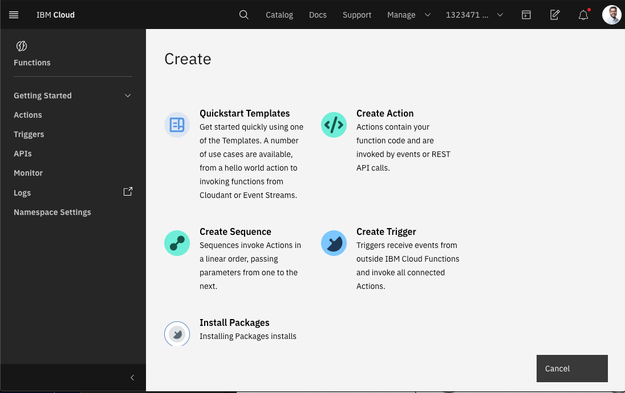

1. Name your action. For the Runtime dropdown, select Node.js 10 and provide an Action Name

