Step 1 – Click on the link - <http://bit.ly/skill-app>

which should take you to the below screen

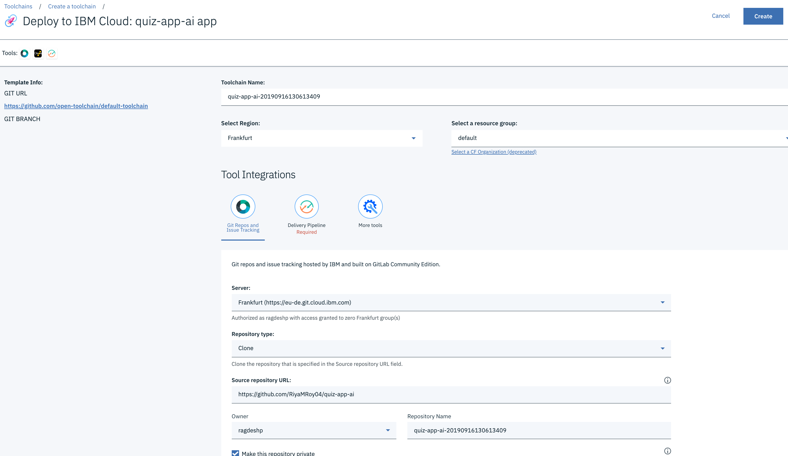

Step 2 – Select Dallas Region, then Click on Create, you should see the below screen –

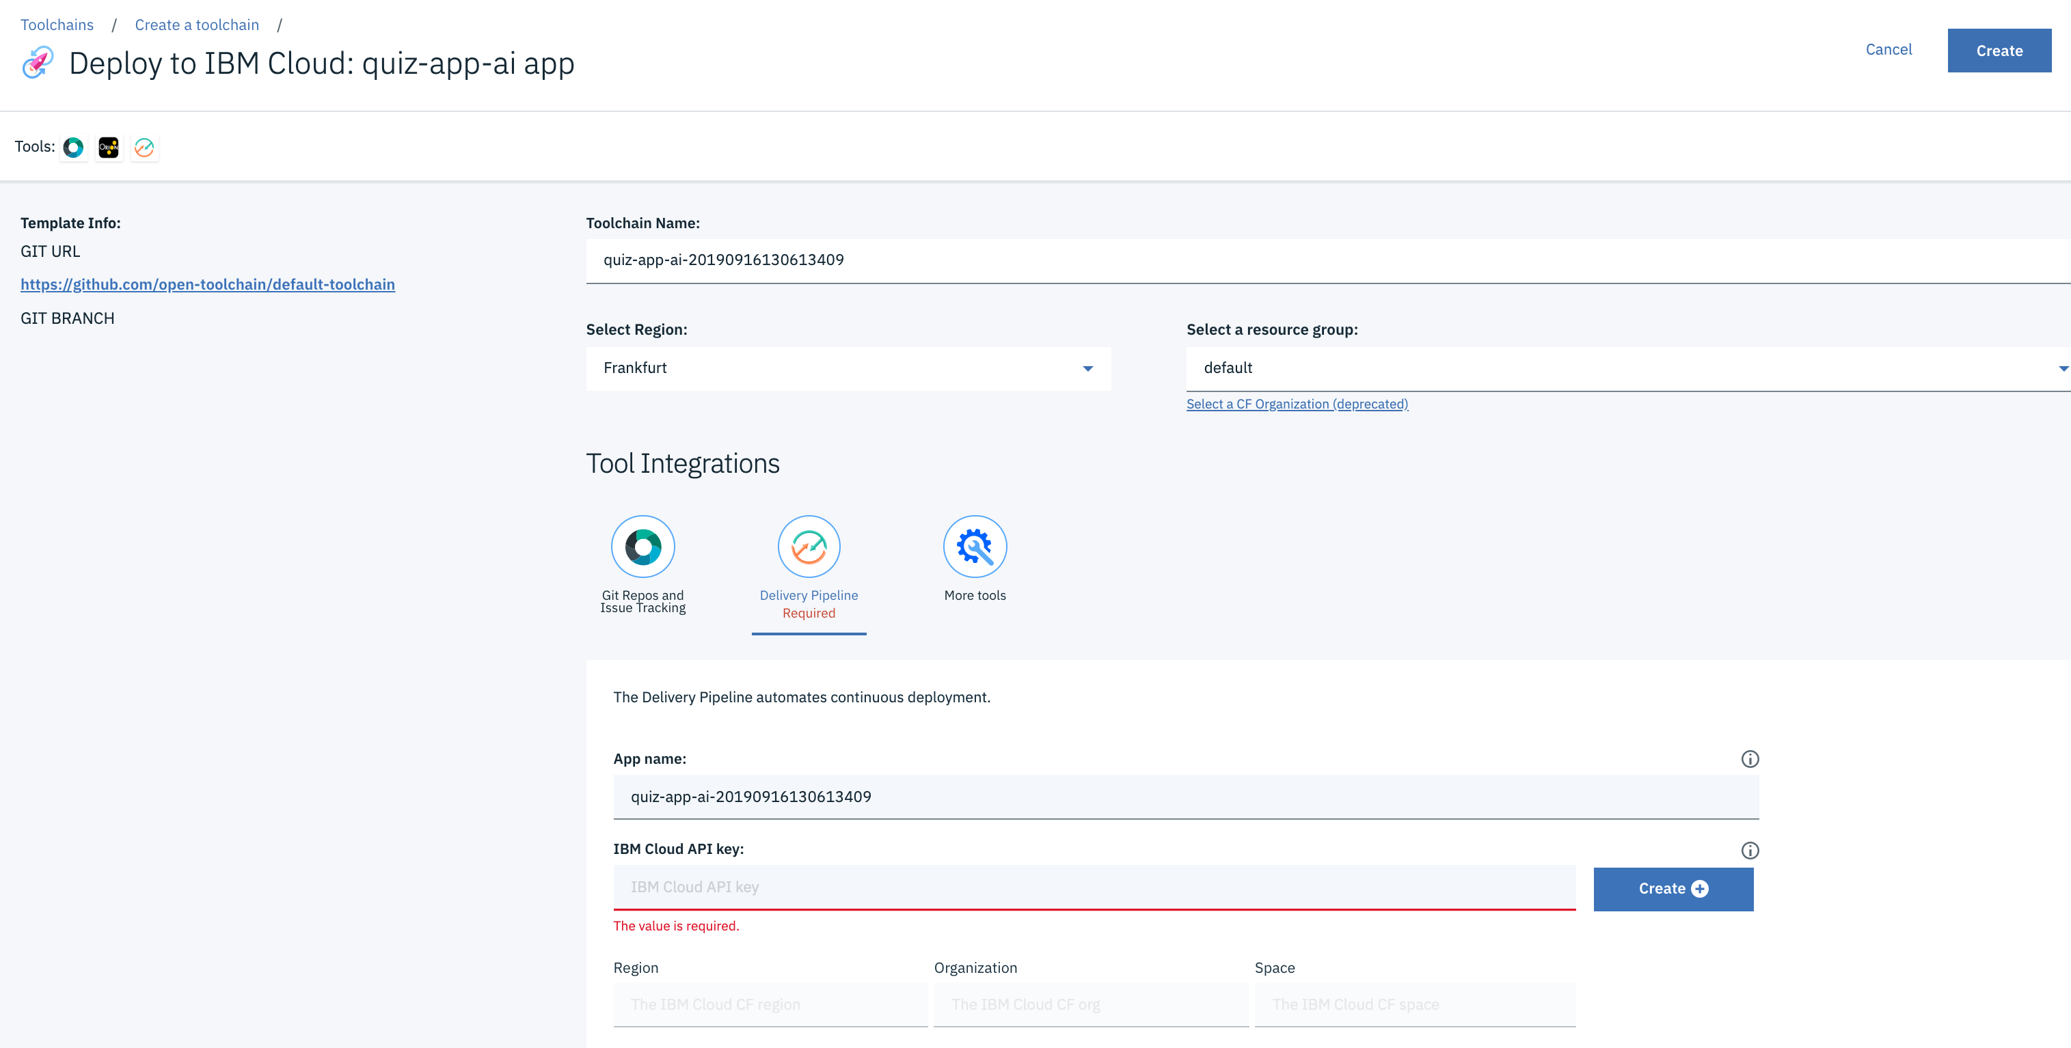

Step 3 – We need **IBM Cloud API key,** click on ‘Create’ link against the IBM Cloud API key field to generate the API Key.

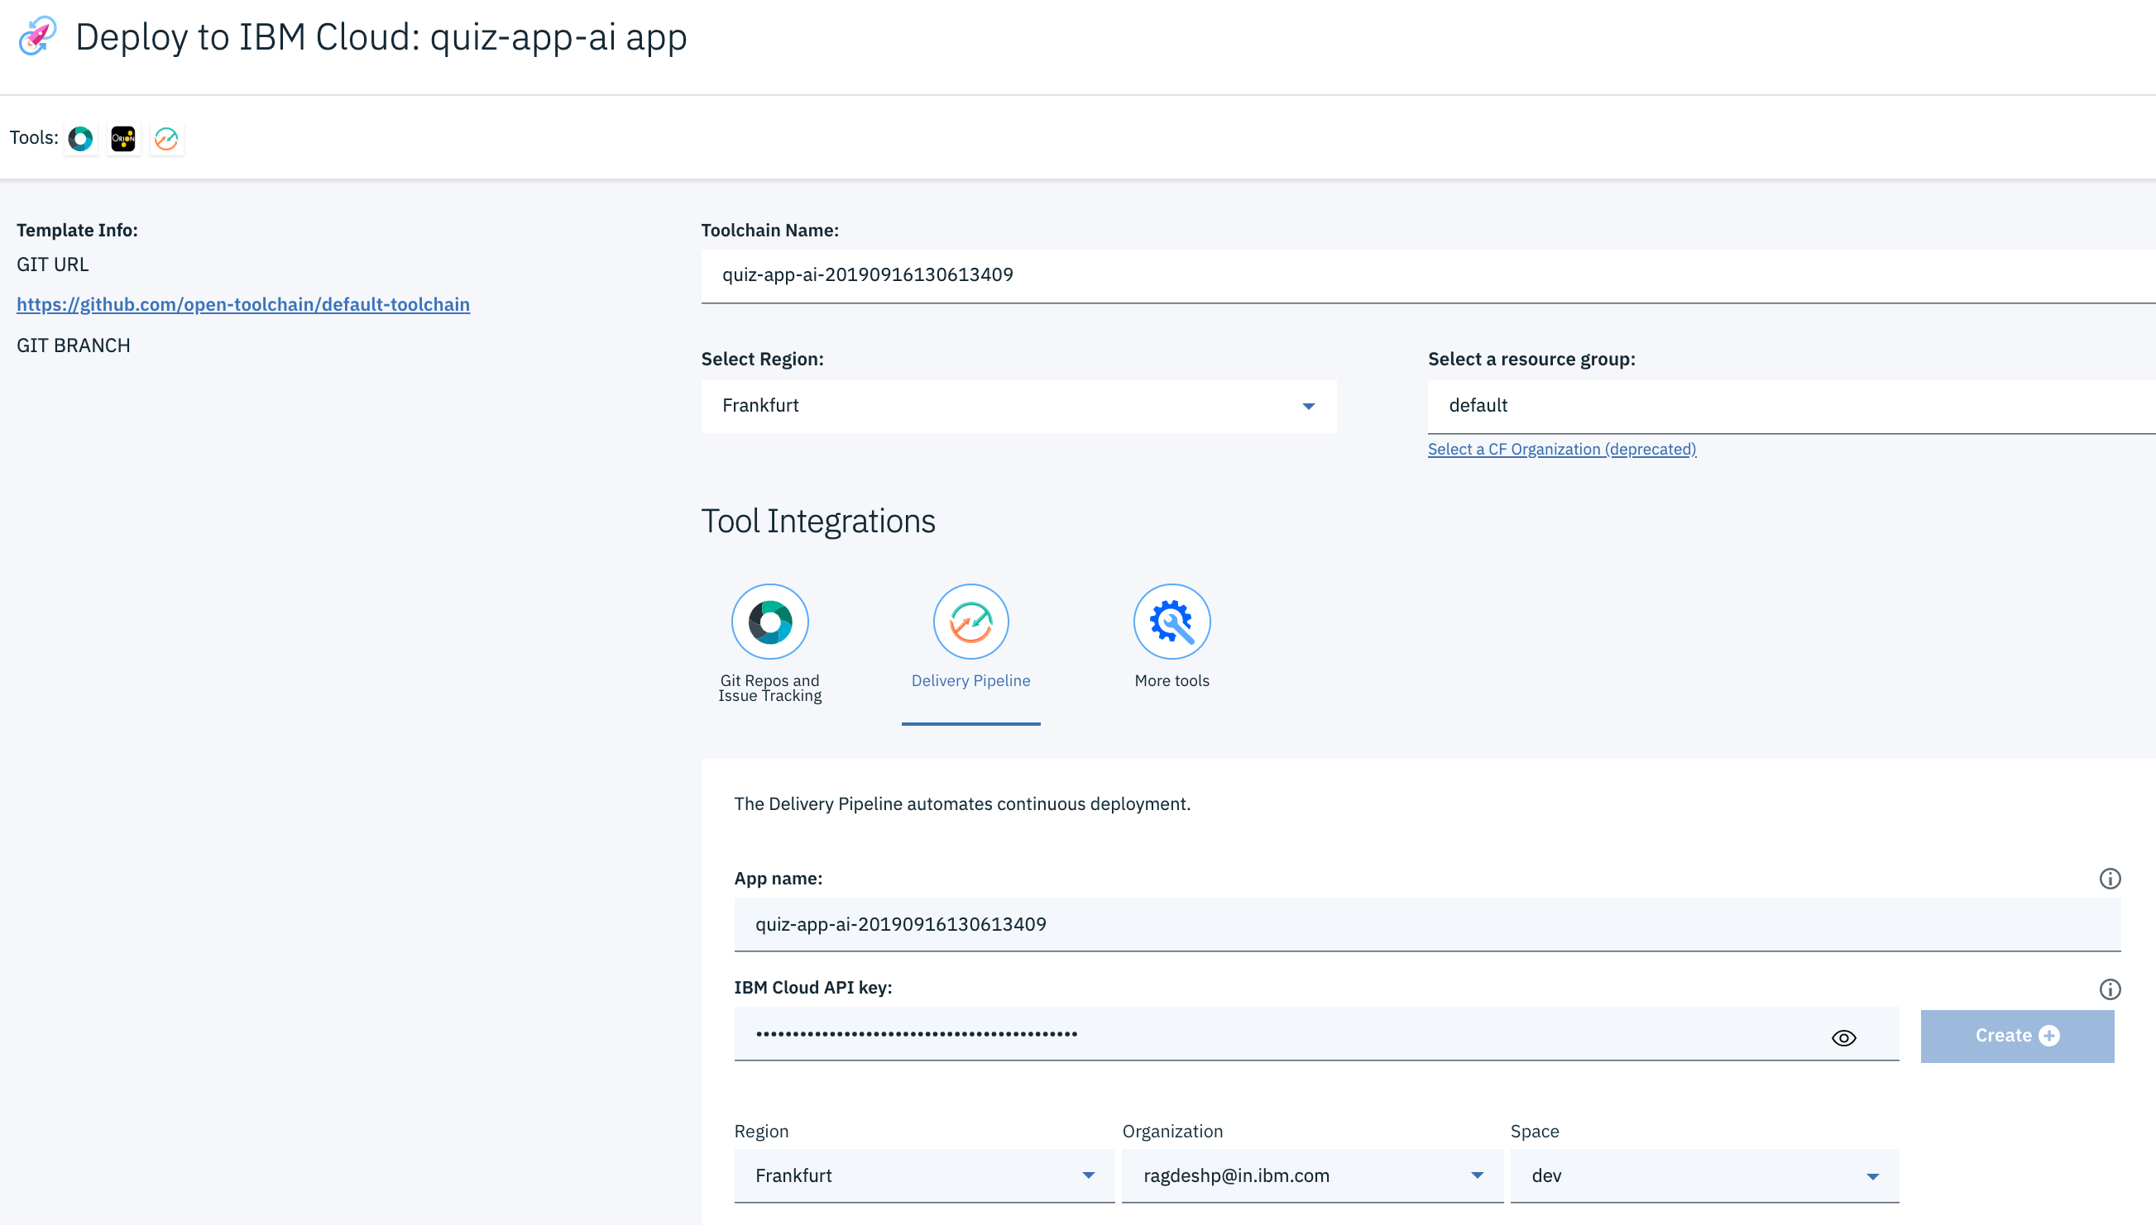

Step4 – Now click on ‘Create’ link on top right corner of the screen and should see the below screen.

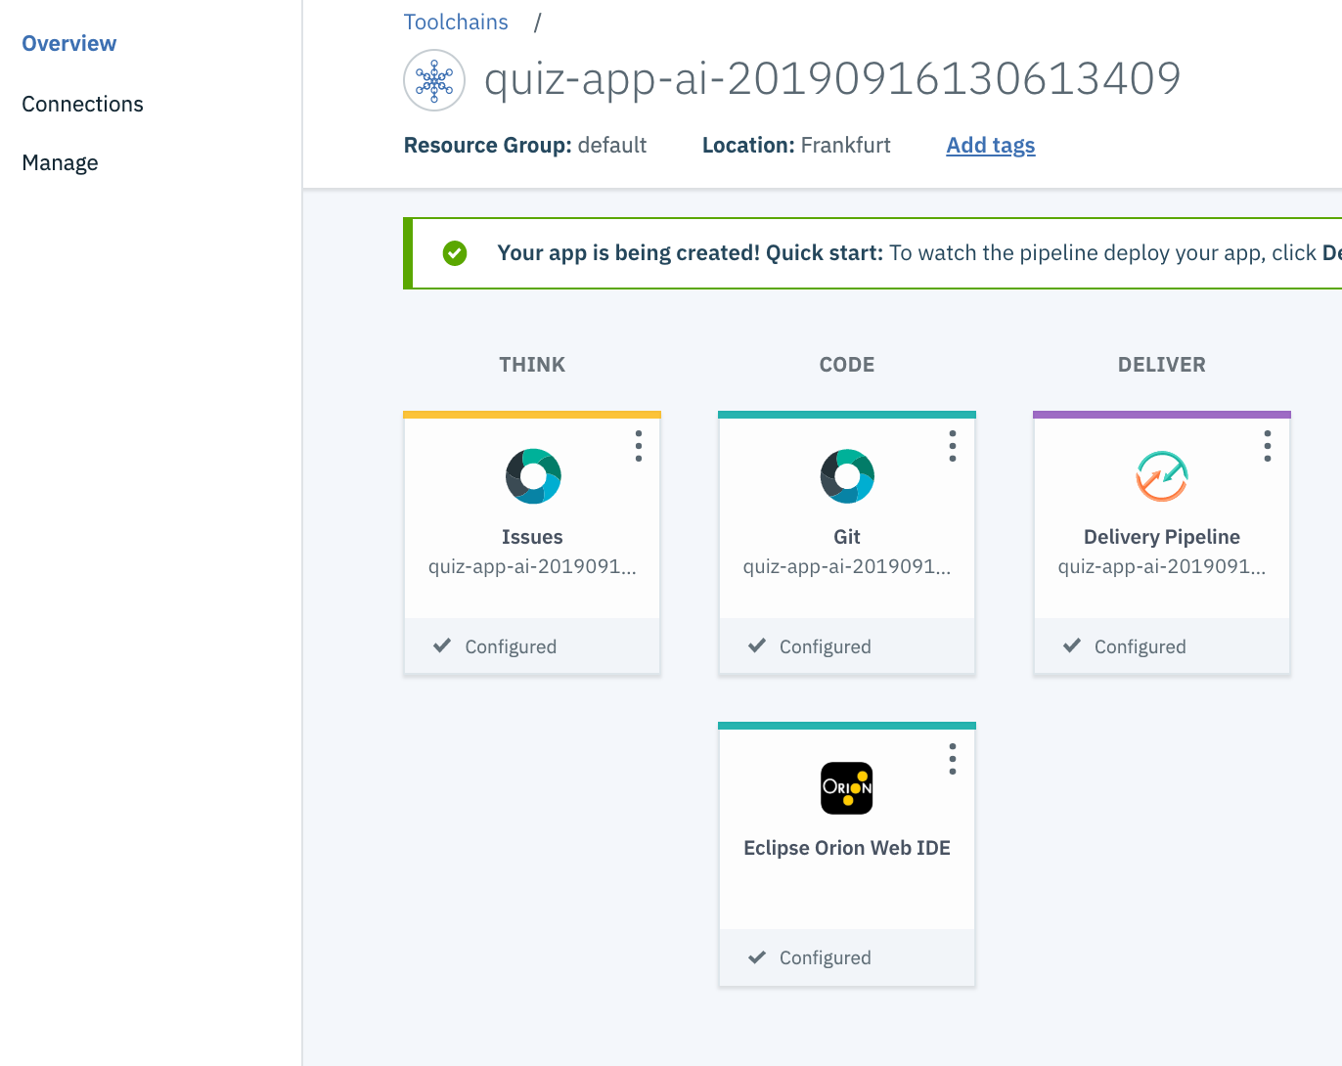

Step5 – Click on Delivery Pipeline tab and should see the Build and Deploy stage as below

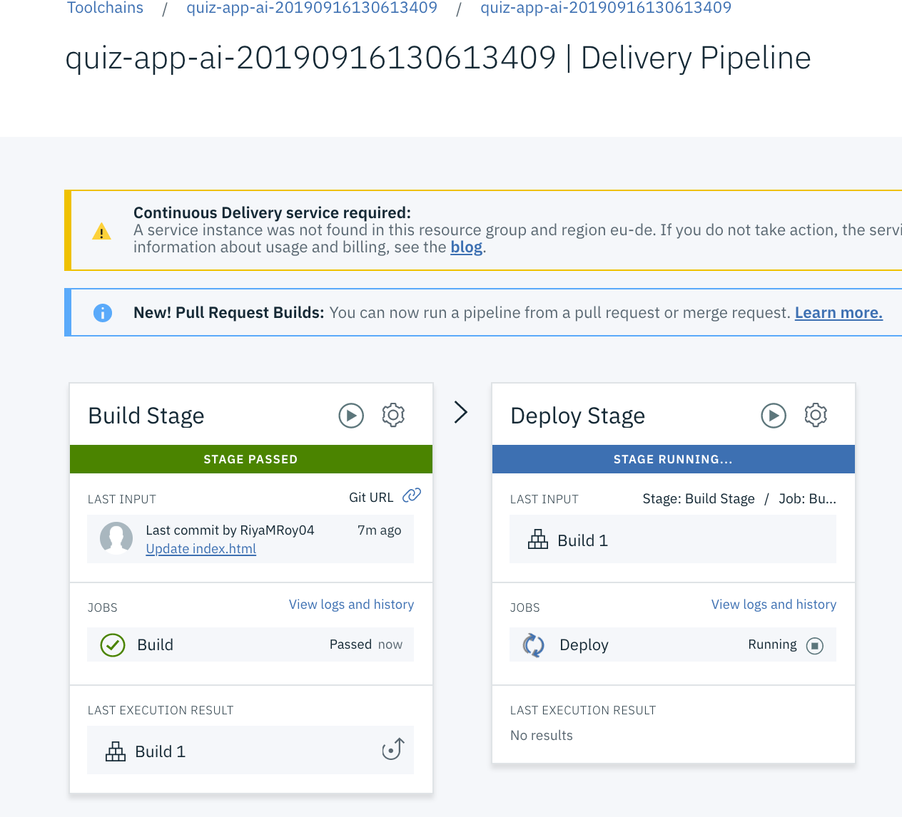

Step 6 – After the Deploy Stage is Passed – Click on the url to view the deployed app.

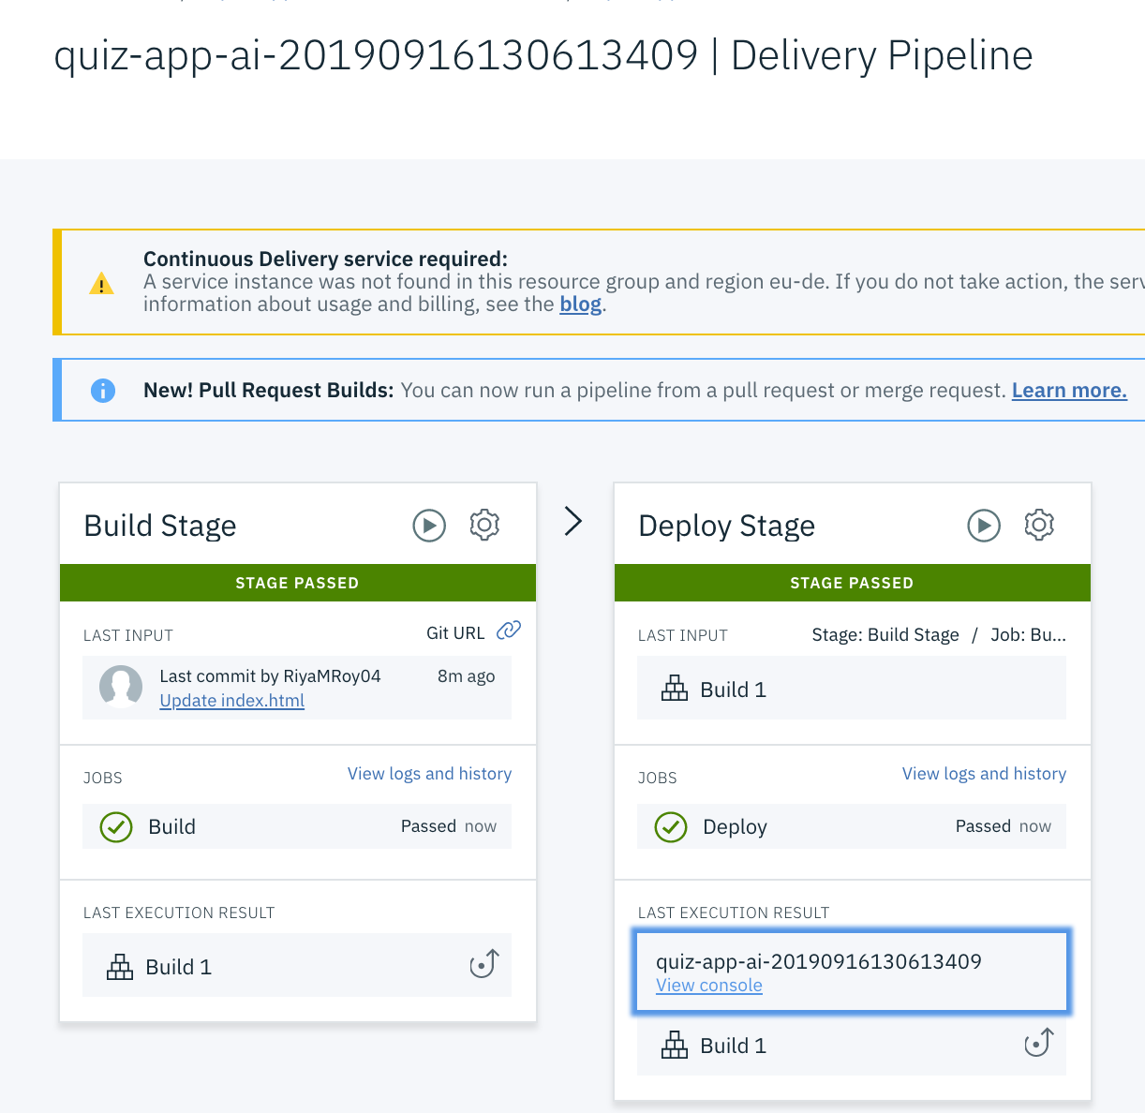

Step 6 – Click on ‘View console’ link to view the Quiz app.

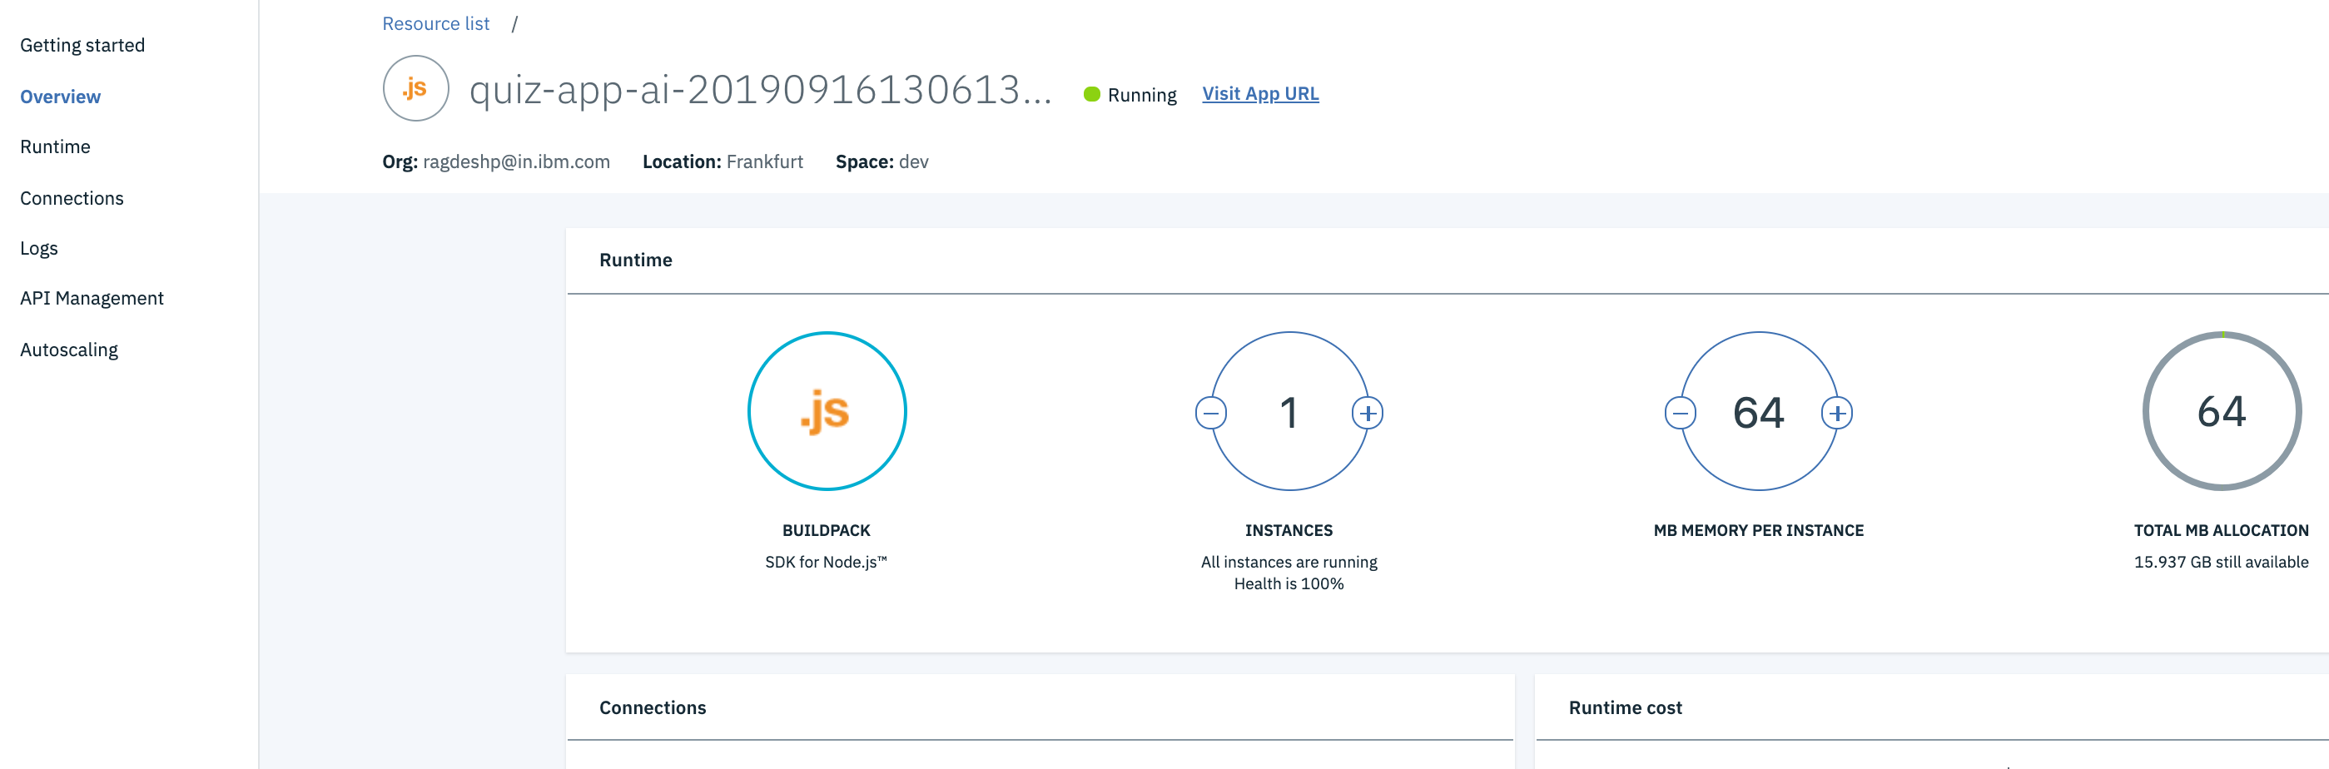

Step 7- Click on ‘Visit App URL’ link to access the quiz questions and **submit the quiz**.