Lab: Deploy a scalable WordPress Implementation on a Kubernetes Cluster

# Overview

In this lab, you will deploy a WordPress implementation on a IBM cloud Kubernetes Cluster.

WordPress is the world’s most popular website management and blogging system, supporting more than 60 million websites. At its core, WordPress is built on one of the most common web programming languages, PHP, and uses MySQL as its back-end database. Kubernetes, the open-source container management system, is one of the top 10 GitHub projects based on number of unique developers contributing code. The challenge for developers is how to bring these two giant open source projects together to provide maximum benefits

## Prerequisites

Following are the prerequisites software for this lab:

* IBM Cloud CLI
* Kubernetes CLI
* Container Service Plugin
* A Pay-As-You-Go or Subscription [IBM Cloud account](https://console.bluemix.net/registration/)

**Objectives**

This scenario provides instructions for the following tasks:

* Create local persistent volumes to define persistent disks.
* Create a secret to protect sensitive data.
* Create and deploy the WordPress frontend with one or more pods.
* Create and deploy the MySQL database.

# Architecture

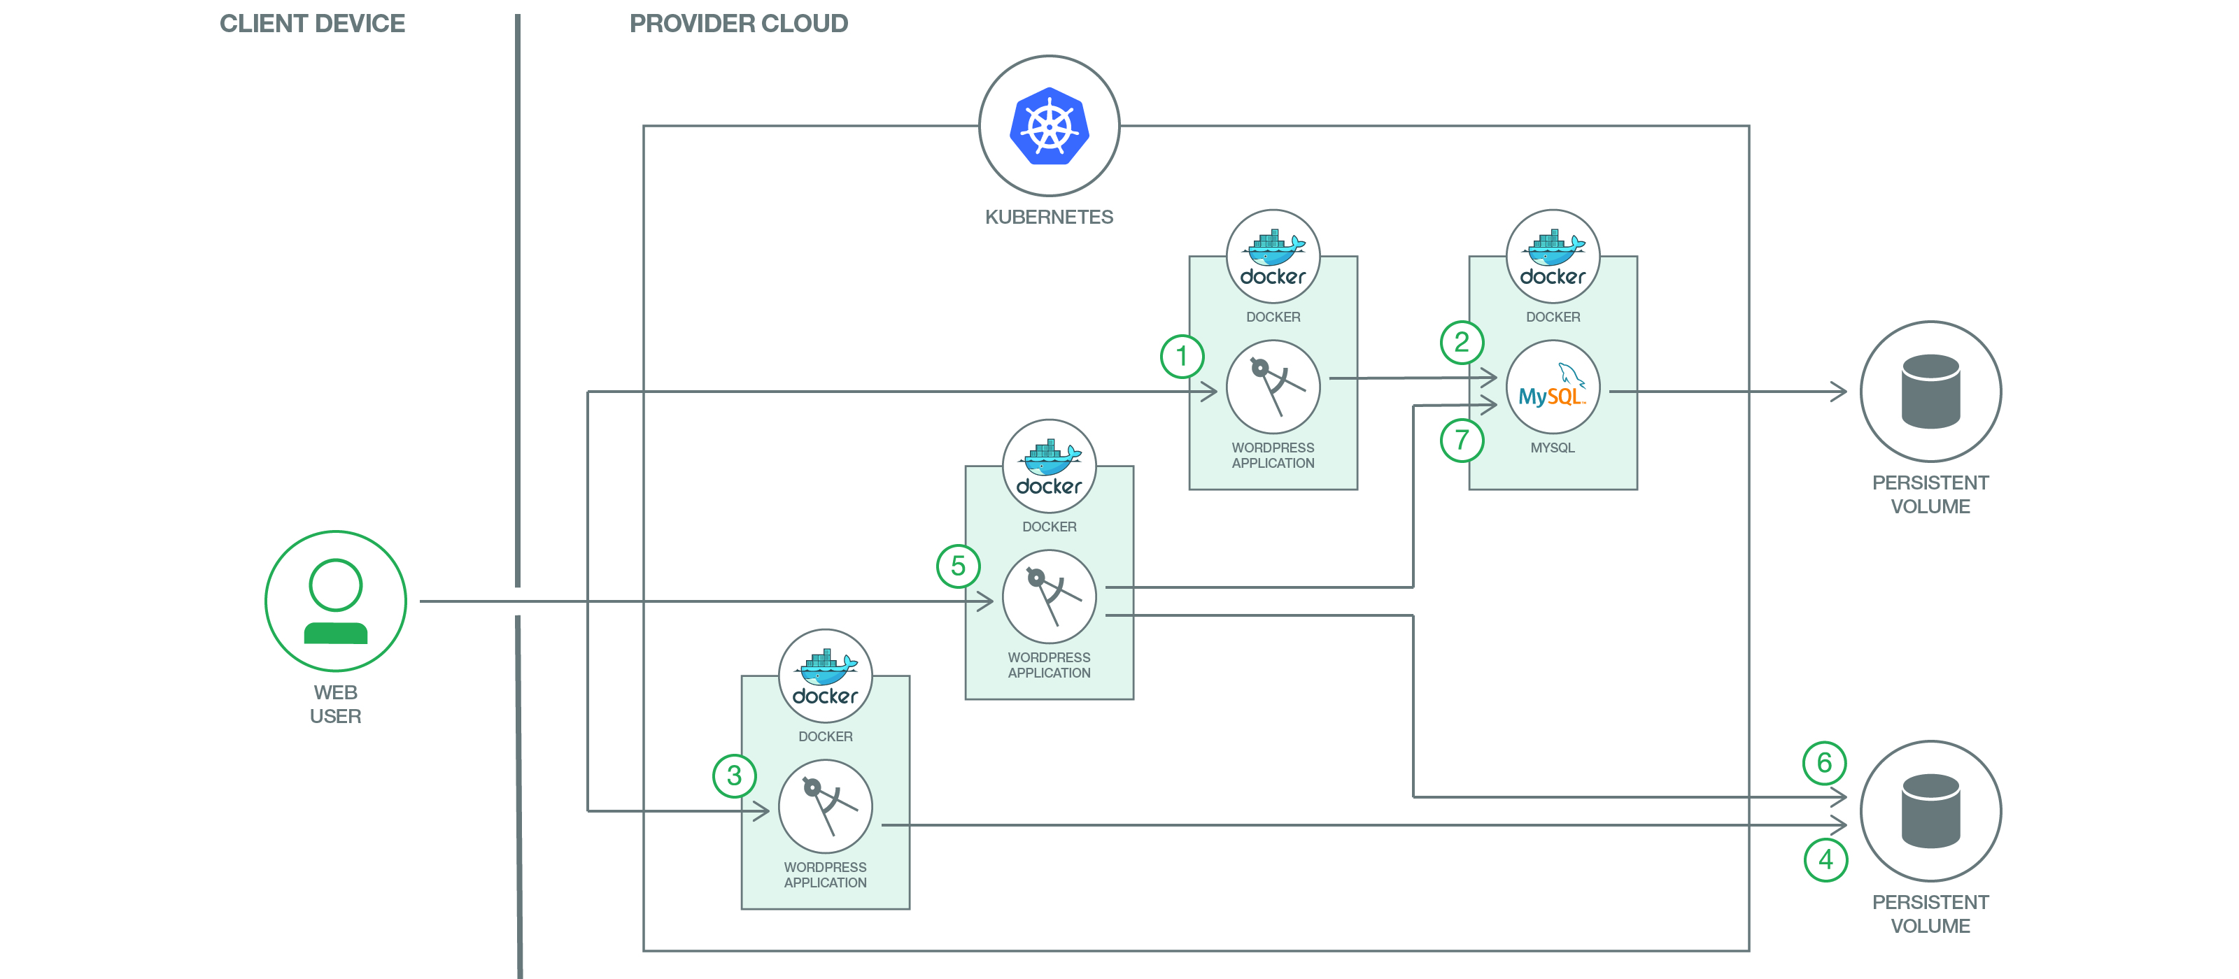

1. The user interacts with WordPress via the web interface. Each WordPress container will respond to its users via HTTP/HTTPS.
2. When a user posts to any WordPress container, WordPress will typically post the changes to the MySQL database. The MySQL database stores the post data into persistent disks to maintain security. In addition to a MySQL container, you can also use the Compose MySQL service from Bluemix. After authentication and authorization are complete, WordPress user information such as password (encrypted with MD5) and email address are created and stored in MySQL. Website, blogs, tags, categories, and other data are also stored in MySQL.
3. The user can also upload themes, plugins, images, and documents. Non-textual data such as PDFs, videos, and MP3s, can also be uploaded.
4. Themes, plugins, PDFs, videos, MP3s, etc. are stored in a persistent volume attached to the WordPress pods.
5. The user accesses the WordPress website or blog. The WordPress core (that is, the WordPress “brain”) calls the required PHP scripts, starting with index.php.
6. WordPress reaches out to the MySQL database to retrieve the website, blogs, tags, categories, and so on.
7. The WordPress core then retrieves the themes, documents, images, etc. from the persistent volume, combines it with data retrieved from the database, and presents the page to the user.

*Step 1: Login to IBM Cloud*

Open the Command Terminal and execute the following command to login to IBM Cloud. When it prompts for Email, provide your IBM Cloud email id and enter your password.

**bx login -a** [**https://api.ng.bluemix.net**](https://api.ng.bluemix.net)

API endpoint: https://api.ng.bluemix.net

Email> <Enter valid Email>

Password><Enter valid Password>

Select an account (or press enter to skip):

1. Demo Account

Enter a number>1

Execute “bx target -–cf” to set the Organization and Space

**bx target –-cf**

*Step 2: Initialize Container Service Plugin*

**bx cs init**

Using default API endpoint: https://containers.bluemix.net

OK

*Step 3: Create Kubernetes cluster [Not required if cluster is already created]*

**bx cs cluster-create --name <Cluster Name>**

Creating cluster...

The machine-type flag was not specified. So, a lite cluster with default parameters will be created. To customize the parameters, create a standard cluster and include all required flags.

OK

*Step 4: Initialize Kubernetes client configuration*

Check the Cluster status before proceeding further. Cluster should in “normal” state.

**bx cs clusters**

*OK*

*Name    ID       State    Created  Workers   Datacenter   Version*

*cluster   695bfab1a* ***normal*** *27 minutes ago   1         hou02     1.8.6_1504*

Initialize the Kubernetes Client configuration

**bx cs cluster-config <Cluster Name>**

OK

The configuration for cluster was downloaded successfully. Export environment variables to start using Kubernetes.

export KUBECONFIG=/Users/rameshpoomalai/.bluemix/plugins/container-service/clusters/mydemocluster/kube-config-hou02-mydemocluster.yml

Set the KUBECONFIG environment variable by executing the above export statement. For Windows, use the following command:

set KUBECONFIG=/Users/rameshpoomalai/.bluemix/plugins/container-service/clusters/mydemocluster/kube-config-hou02-mydemocluster.yml

Check if kubectl is installed properly

**kubectl version**

Client Version: version.Info{Major:"1", Minor:"7", GitVersion:"v1.7.3", GitCommit:"2c2fe6e8278a5db2d15a013987b53968c743f2a1", GitTreeState:"clean", BuildDate:"2017-08-03T07:00:21Z", GoVersion:"go1.8.3", Compiler:"gc", Platform:"darwin/amd64"}

**Server Version:** version.Info{Major:"1", Minor:"8+", GitVersion:"v1.8.6-4+e5b2250ba66db9", GitCommit:"e5b2250ba66db94bf5c6b60196aec6e577a005b1", GitTreeState:"clean", BuildDate:"2018-01-08T08:11:01Z", GoVersion:"go1.8.3", Compiler:"gc", Platform:"linux/amd64"}

*Step 5: Setup Mysql Secrets*

Create a password file

**echo "changeme" > password.txt**

**kubectl create secret generic mysql-pass --from-file=password.txt**

*Step 6: Create Local Persistent Volumes*

Change your working directory to the git repo on your machine. The deployment descriptor files can be downloaded from git repo.

**kubectl create -f local-volumes.yaml**

*Step 7: Create Services and Deployments for WordPress and MySQL*

**kubectl create -f mysql-deployment.yaml**

**kubectl create -f wordpress-deployment.yaml**

Run the following command to verify the node’s status. Proceed further after its status is changed to Ready.

**kubectl get nodes**

NAME STATUS ROLES AGE VERSION

10.77.155.90 Ready <none> 12d v1.8.6-4+9c2a4c1ed1ee7e

Run the following command to verify the pods’ status. Proceed further after their status is changed to Running.

**kubectl get pods**

NAME                               READY     STATUS    RESTARTS   AGE

wordpress-76b66d5644-qzc7t         1/1       Running   0          2m

wordpress-mysql-5cdbc78858-qvt5h   1/1       Running   0          2m

*Step 8: Check the Deployment status*

**kubectl get deployments**

NAME DESIRED CURRENT UP-TO-DATE AVAILABLE AGE

wordpress 1 1 1 1 23h

wordpress-mysql 1 1 1 1 23h

*Step 9: Access the Application*

Get the Public IP address

**bx cs workers <your_cluster_name>**

OK

ID Public IP   Private IP   Machine Type   State    Status

Kube-w1   **169.47.220.142**   10.10.10.57    free   normal   Ready

Get the port details

**kubectl get svc wordpress**

NAME        CLUSTER-IP    EXTERNAL-IP   PORT(S)        AGE

wordpress   10.10.10.57   <nodes>       80:30180/TCP   2m

Congratulations ! You have successfully deployed the WordPress application on Kubernetes cluster. Now you can access your WordPress site at http://[Public IP]:[port number]

*Step 10: Now that WordPress is running, you can register as a new user and install WordPress*

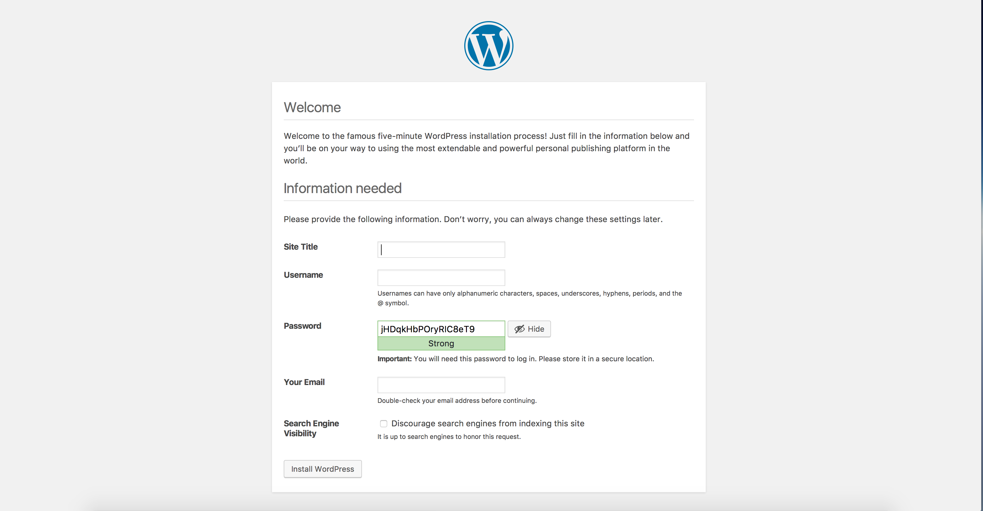

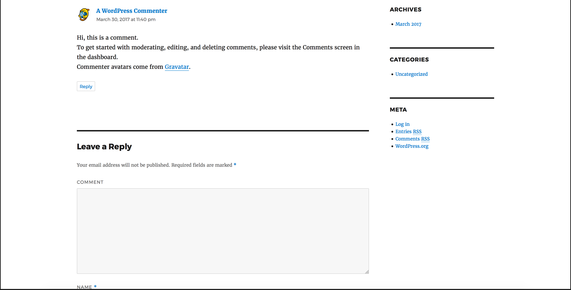

# Scaling the application

Run the following commands to scale your WordPress front-end

**kubectl scale deployments/wordpress --replicas=2**

*deployment "wordpress" scaled*

**kubectl get deployments**

*NAME DESIRED CURRENT UP-TO-DATE AVAILABLE AGE*

*wordpress 2 2 2 2 23h*

*wordpress-mysql 1 1 1 1 23h*

# Resources

* Code Pattern: <https://developer.ibm.com/code/patterns/scalable-wordpress-on-kubernetes/>
* Github: <https://github.com/IBM/scalable-wordpress-deployment-on-kubernetes?cm_sp=IBMCode-_-scalable-wordpress-on-kubernetes-_-Get-the-Code>
* Docs: <https://console.bluemix.net/docs/containers/container_index.html#container_index>