**Creating a Pizza ordering Chatbot using Watson Conversation Slots feature**

When the reader has completed this Code Pattern, they will understand how to:

* Create a chatbot dialog with Watson Conversation
* Use the power of Conversation Slots to more efficiently populate data fields
* Use Conversation Slots to handle various inputs within one Node

## The Flow:

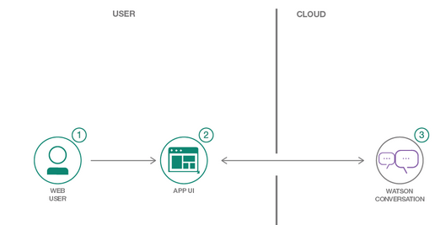

1. User sends messages to the Watson Conversation Service.
2. Watson Conversation uses the Slots feature to fill out the required fields for a pizza order, and sends requests for additional information back to the user.

**Task1:** Analyse the existing Conversation workspace (without slots).

Analyse the existing dialog flow to make use of slots to reduce the number of nodes required to implement logic in your Watson Conversation Dialog and should look as below 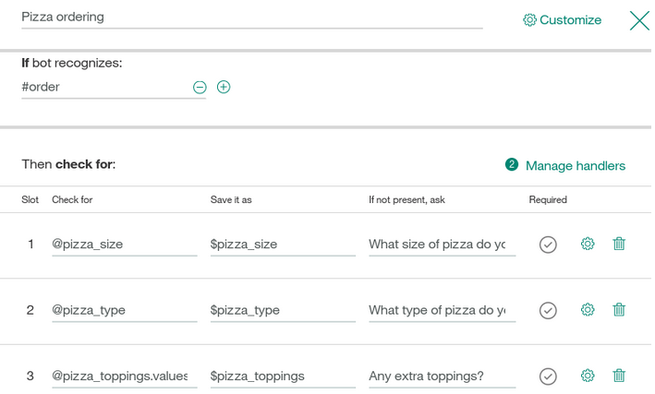

**Task2: More exploration and learning visit**-

<https://github.com/IBM/watson-conversation-slots-intro>

Instructions for creating the chatbot:

1. Login to IBM Cloud using the following link:

<http://console.bluemix.net/>

After you login you will reach a dashboard

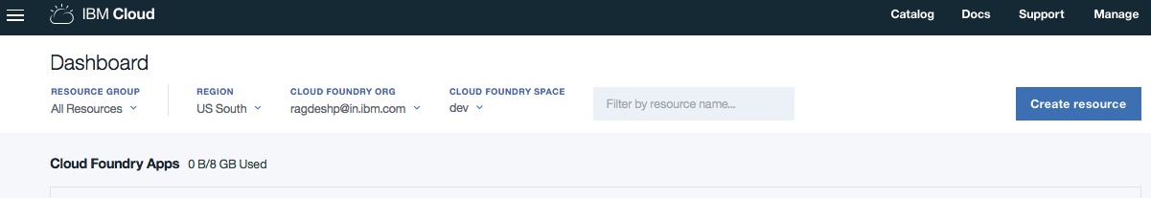

You will observe the Cloud Foundry Apps and Cloud Foundry Services

1. Click on the ‘Catalog’ from top right hand corner

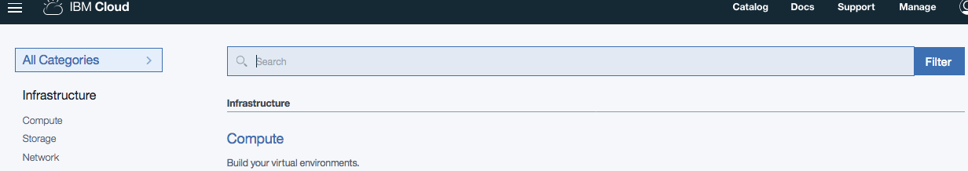

1. Search ‘Conversation’ in the search catalog

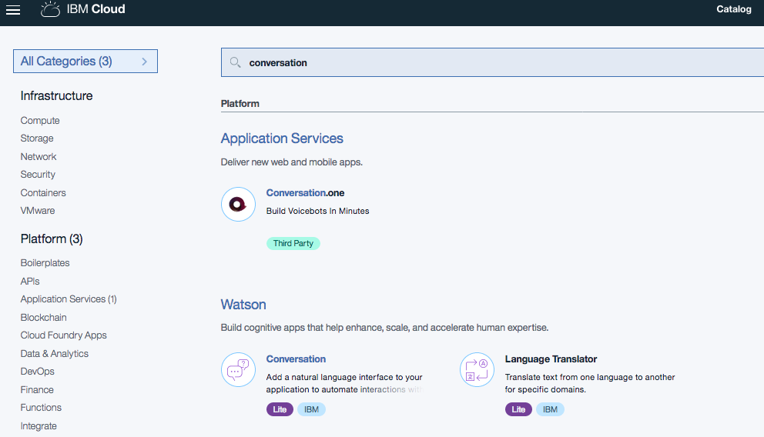

1. Click on the ‘Conversation’ service from Watson catalog.

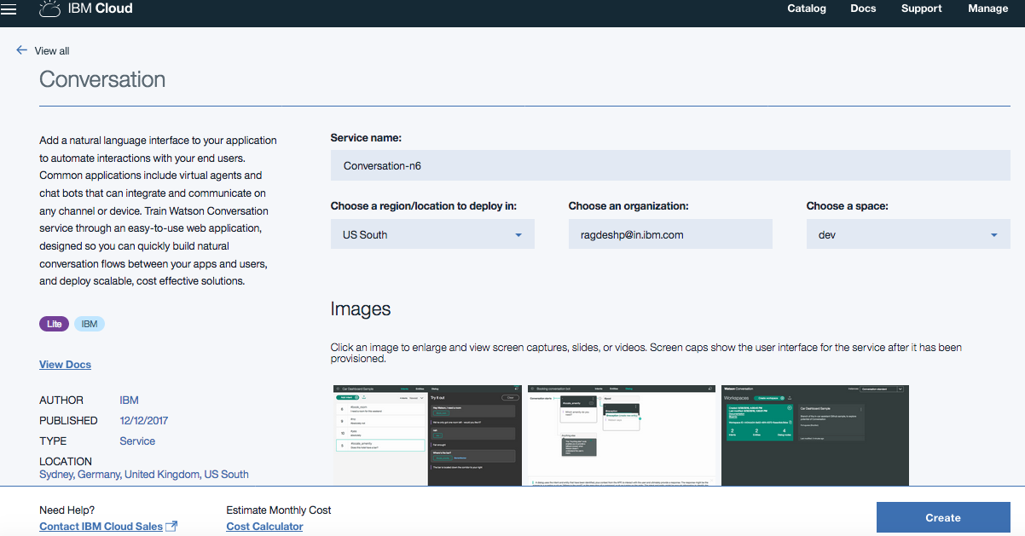

Now enter the Service name appropriately.

1. You reach the Conversation service dashboard

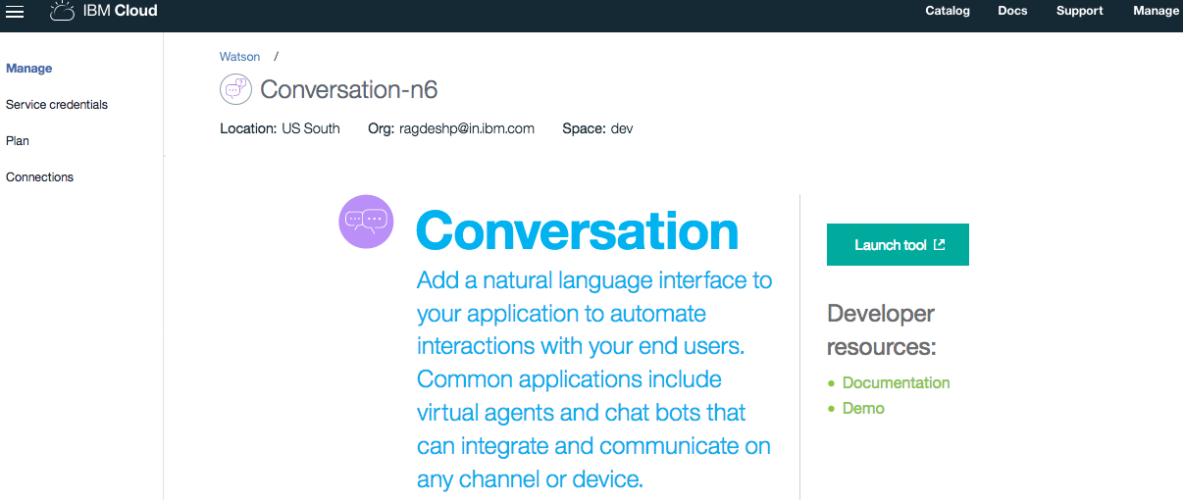

1. Click on the ‘Launch tool’ link and you would see the below page

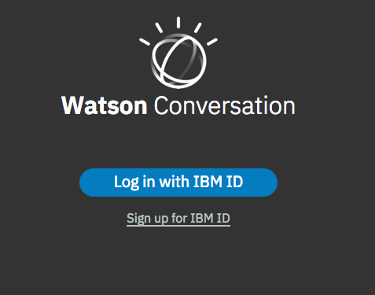

1. Now sign in with IBM ID and you would see the workspace dashboard

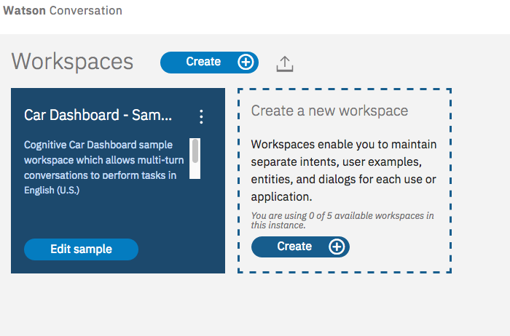

1. Import the workspace by click the below icon:



Pizza ordering chatbot without using the slots

1. Import a workspace PizzaBotWithoutSlotFinal.json by choosing the file from the repository <https://github.com/IBMDevConnect/IBMCodeDay-2018/tree/master/SlotChatBot_MiniLab>

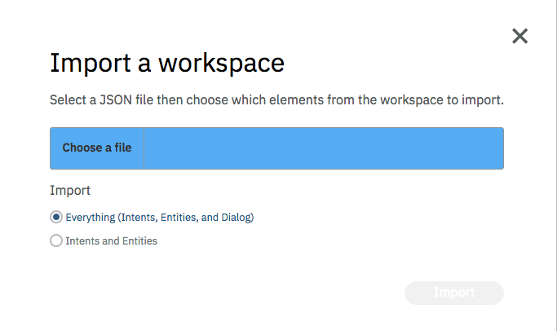

1. You would see the following ‘Build’ area to view the ‘Intents’, ‘Entities’ and ‘Dialog’ and perform the following the steps below

The dialog is as follows:

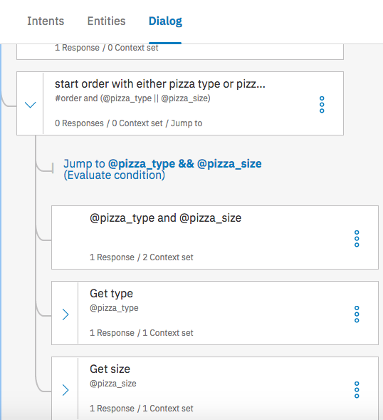

1. Enter ‘Order a pizza’
2. Enter the size of the pizza
3. Enter the type of the pizza
4. For question – Do you require the extra toppings? Enter ‘Yes’. Enter the toppings as ‘onions’
5. Last you would see the total order being placed.

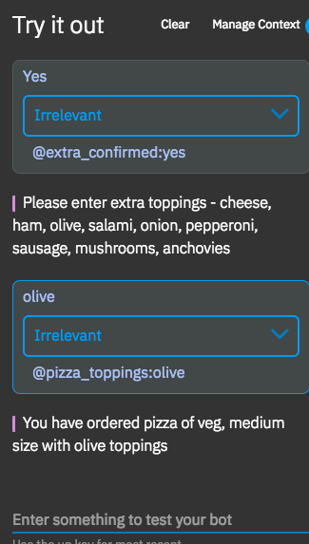

Pizza ordering chatbot with using the slots

1. Then import the workspace - watson-pizzeria_final.json into the workspace. You would see the following ‘Build’ area to view the ‘Intents’, ‘Entities’ and ‘Dialog’
2. Click on the ‘Dialog’ tab and you would see the below:

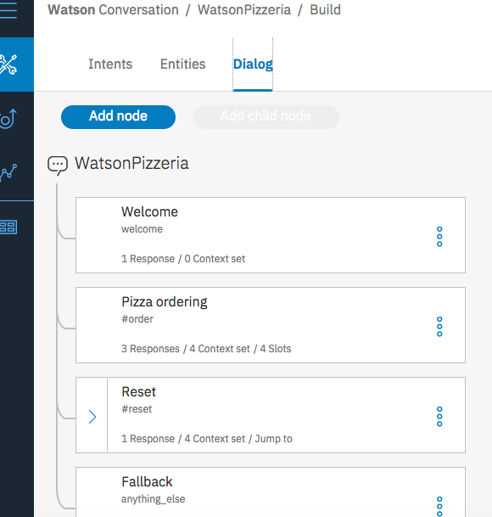

1. Click on the right top corner icon  to open the ‘Try it Out’ Pane as below:

Enter ‘I want to order a medium vegetarian pizza with onion toppings’ as input

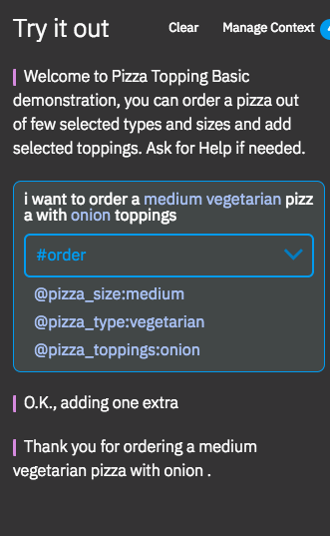

During the above execution – please observe the nodes which are getting executed, all the executing stands at a single node which is the slot node.