There are 2 ways to launch Grafana dashboard

A. By creating service in IBM cloud

1. Login to IBM cloud
   1. <https://cloud.ibm.com/login>
2. Click **Catalog**. The list of the services that are available on IBM Cloud opens.
3. Go to Developer tool and click on Monitoring

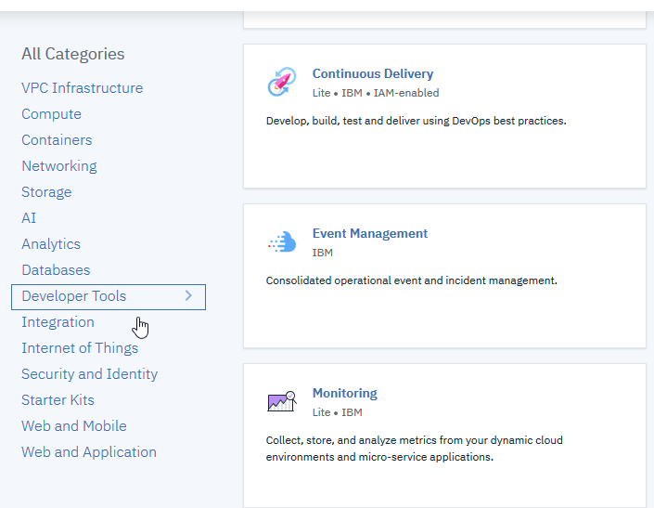

1. Take a note of location of your Kubernetes cluster and use the same location while deploying Grafana
2. Click on launch dashboard to launch Grafana dashboard

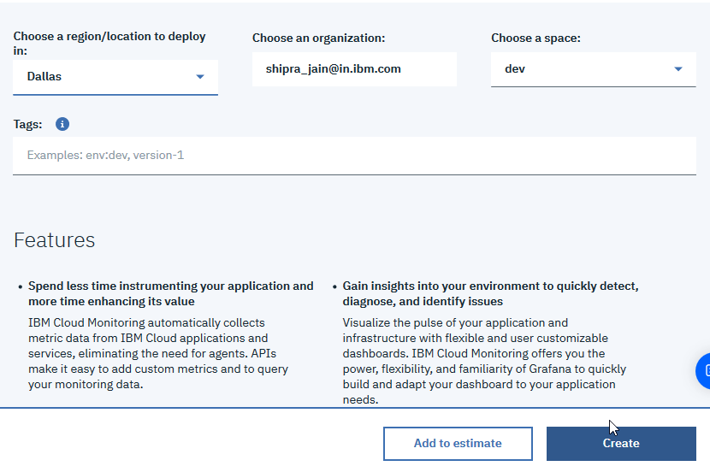

1. Select **Grafana**.

B. You can also login to Grafana dashboard directly via web bowser

1. Enter the URL for the region where you want to monitor metrics.
2. The following table lists the URLs per region:

|  |  |
| --- | --- |
| Region | Endpoint |
| Germany | <https://metrics.eu-de.bluemix.net> |
| United Kingdom | <https://metrics.eu-gb.bluemix.net> |
| US South | <https://metrics.ng.bluemix.net> |
| United Kingdom | <https://metrics.au-syd.bluemix.net> |
| URLs to launch Grafana in different regions | |

To access kubernates cluster data in Grafana dashboard, follow the steps to provide access to user

1. Login to IBMcloud
2. From the topbar menu on righthand side , select Manage->Access(IAM)
3. From left hand side menu , select user and select your user name
4. Go to access policy tab and click on assign access
5. Select kubernates-Cluster as service name ,All Region as Region and All instance as cluster as shown below

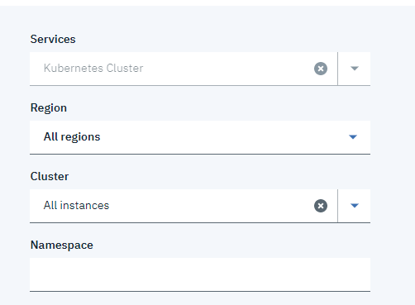

1. Select Admin and Viewer permission and click on save
2. Create another access by clicking on assign access
3. Write service name as Monitoring, AllRegion as Region and All Instance in service instance as shown below

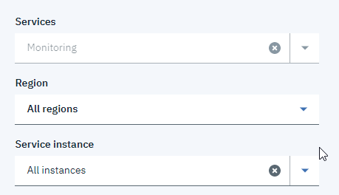

1. Provide editor and viewer roles and save

You have provided the required access to the user