* Open the URL <http://www.hackathon.io/events/4685>
* Enter the password shared by IBM Team.

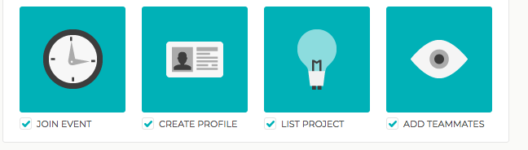

**Step 1: Join the event**

**Step 2: Create your profile (Sign in & update your profile & role)**

**Step 3: List Project**

Enter your project details

Mandatory fields: Name, Pitch, Description, GitHub link, Project Stack & APIs used

**Step 4: Add Teammates**

Add team members name & email id.

