Introduction
This procedure estimates classification and regression trees. In contrast to the CHAID, CART, and QUEST algorithms available in the SPSS TREES procedure, conditional inference trees use statistical significance test levels on means or categorical data with multiple testing corrections to find splits. These trees are less likely to overfit and are, therefore, more stable. That is, they generalize better to new data and will have fewer false branches.
Trees can grow very large, making them difficult to display and understand. This procedure can display separate subtree outlines and plots as well as the full tree and suppresses interior node details in the plots, so they are easier to understand. and will fit better on the display.
See the vignettes written by the authors of the R modules used by this procedure and accessible from the Vignettes tab in the dialog box for details on the statistical algorithms. The R module authors are Torsten Hothorn. Kurt Hornik, and Achim Zeileis. Those papers also have usage details of the R code to run those modules, but the SPSS user does not need that information as this procedure works the same as the ordinary built-in SPSS procedures. No R knowledge is required.
There are two types of trees provided by this procedure: conditional inference trees (CIT) and model based trees (MOB). The descriptions here and below are adapted from the documentation for the underlying procedures.

Conditional Inference Trees
The procedure utilizes a unified framework for conditional inference or permutation tests developed by Strasser and Weber. The stopping criterion in step 1 is either based on multiplicity adjusted p-values (testtype = Bonferroni) or on the univariate p-values (testtype = univariate). In both cases, the criterion is maximized, i.e., 1 - p-value is used. A split is implemented when the criterion exceeds the value given by the mincriterion parameter. For example, when mincriterion = 0.95, the p-value must be smaller than 0.05 in order to split the node.
This statistical approach ensures that the right-sized tree is grown without additional post-pruning or cross-validation. The level of mincriterion can either be specified to be appropriate for the size of the data set (and 0.95 is typically appropriate for small to moderately sized data sets) or can potentially be treated like a hyperparameter . The selection of the input variable to split in is based on the univariate p-values thereby avoiding a variable selection bias towards input variables with many possible cutpoints. The test statistics in each of the nodes can be shown by selecting the sctest table.
In cases where splitting stops due to the sample size, e.g., minsplit or minbucket, the test results may be empty.
What makes conditional inference trees different from decision trees as produced by the TREES procedure is the use of the significance test to select input variables rather than maximizing the information measure. The Gini coefficient or another impurity measure is used in traditional decision trees to select the variable that maximizes the information measure.

Model-Based Trees
Two types of model-based trees are provided: moblinear for regression and moblogit for logistic regression. Model-based partitioning fits a model tree using two groups of variables: (1) The model variables, which can be just a set of responses, y, or additionally include regressors x1, ..., xk. These are used for estimating the model parameters. (2) Partitioning variables z1, ..., zl, which are used for recursively partitioning the data. In the tree outline output, the second set of variables appear after a “|” in the model statement. The y variables appear first followed by a tilde. The x and z sets of variables may overlap. That is, a variable may generate a split at one or more points, but if the split includes multiple values of that variable, it could also be a regressor.
The moblinear and moblogit models do not support categorical dependent variables. The dependent variables must have a scale measurement level.
To fit a MOB model the following algorithm is used.
- Fit a model to the y or y and x variables using the observations in the current node
- Assess the stability of the model parameters with respect to each of the partitioning variables z1, ..., zl. If there is some overall instability, choose the variable z associated with the smallest p value for partitioning; otherwise stop.
- Search for the locally optimal split in z by minimizing the objective function of the model. Typically, this will be something like deviance or the negative log likelihood.
- Refit the model in both child subsamples and repeat from step 2.

Using the Procedure
The procedure provides the ability to estimate ctree or mob models and display the trees in outline form and as a plot. The dependent variables may be scale (continuous) or categorical (nominal or ordinal). As with the TREES procedure but not most other SPSS procedures, the measurement levels declared for the variables are used in determining the tree structure. Besides the categorical and continuous distinction, nominal versus ordinal matters when creating splits. Dichotomous variables should generally be declared as nominal or ordinal as this affects the output statistics even though they have only two values.
Trees can become very large and be difficult to display and comprehend, especially for the plots. To address this issue, the procedure can produce subtree outlines and plots. These are selected according to the node numbers to be used as roots, so it may be good to first display the full tree and then select subtrees based on the node numbers. There are also controls for plot size and font. An estimated model can be saved and reloaded for display or prediction, and the estimated model remains in the workspace until replaced or the session ends or the workspace is cleared.
The user interface has seven tabs, but only the first one has to be completed for basic usage.

Estimation
Check the Calculate Tree box and enter one or more target variables. Specify the variables that will be used to partition the tree, which can be categorical or scale. Note that the partition variables go in the second box for ctree models but the third box for mob models.
SPSS date variable values, which are represented in the standard SPSS definition as the number of seconds since October 14, 1582, are treated as plain numbers here (assuming that they have a scale measurement level).
Choose the model type – conditional inference tree (ctree), model-based linear regression (moblinear), or logistic regression (moblogistic). For the latter two, you can specify regressors. The mob model estimation finds the subgroups where the regression results are statistically different and, therefore, need to be treated differently. That is, it tests for instability in the regression coefficients across the potential subgroups. The significantly different equations are shown for each subpopulation in the tree. This can be very helpful in deciding on what control variables are ultimately needed in the equation. In mob models, the dependent variables must be scale level.
Categorical variable (factors) can be either based on value labels or actual values. The labels or values appear in the tree and plot, so using the labels makes those easier to read. Values are used where there is no label. However, for prediction purposes, values should generally be used. Labels do not have to be unique, and, since they are not data, predictions using them are not operational. It may be useful to start with labels but then rerun with values when predictions are wanted. Another possibility would be to create the categorical splitting variables as strings with values that would be labels.
User missing values by default cause cases to be excluded, but they can be included as valid, in which case, they can be the basis for splits. This would only make sense for categorical variables.
The estimated model can be saved in a file and/or retained in memory for use in prediction.

Prediction
Check the Calculate Predictions box to make predictions. The results will appear in a new dataset, whose name must be entered in the Prediction Dataset box. An ID variable must be supplied. This will be needed if merging the predicted values back to the input dataset. Its values must all be distinct.
The data to be used can be the same as the estimation data and, therefore, are not entered on the Estimation tab if not estimating. Do not check the Estimate box if using an already estimated model unless it is to be replaced. Data for prediction will either be the data that was just used for estimation or will be automatically loaded from the prediction dataset based on the estimated model except that the ID variable can be supplied at either stage. It is better in general if the estimated model is based on variable values, not their labels.
The model to be used for prediction can be one retained in the workspace or loaded from a specified file. You can save the estimated model on the Save tab.
There are four choices for the prediction result type. Only one type can be used at a time. The most common is the response value for each case. The prediction would be the mean or most probable category. Note that if the dependent variable is categorical and the Labels option was used when the model was estimated, the predicted values will be labels, and the input variable labels will be used rather than their values.
Class probabilities only apply to a categorical dependent variable. The output dataset will have a variable for each class showing the probability of that class. The variable names will be the category values adjusted to be valid as variable names.
Quantiles can be specified for a single scale dependent variable. For each case, the specified quantile values for its calculated subpopulation (node) will be returned. Quantile values must be specified as decimal fractions in [0,1], not percentages. Enter a blank-separated list of values.
Node number creates a variable containing the most likely node from among the terminal nodes. These can be created for either scale or categorical variables.
The output dataset variable types will be based on the statistic chosen and the dependent variable type, but for merging back to the input dataset, adjustments may be required to the variable type, including string variable widths.

Display
The estimation and prediction output will include a summary of the estimation model parameters and, if saved, the file name of the model used. Running the command without either estimating or predicting will still display the model properties for the model file or model in memory, so you can check the prediction requirements and model properties before using the model for prediction.
By default, the estimated model outline and plot for the entire tree are displayed. The root of the tree is mode 1. You can specify node numbers of the tree for displaying the model outlines and the plot subtrees.. You can see those numbers from the estimation results, and you can specify any number of trees and/or plots to display as a blank-separated list. Numbers greater than the maximum node number are ignored with a warning, and entering a zero in the list causes any following node numbers to be ignored.
Plots may need to be large to display the entire tree or even some subtrees. While the procedure tries to choose a reasonable default size, the necessary size cannot be calculated automatically, so you may want to redisplay the plots with a different size in order to avoid overwriting. You can specify a size in inches for the main plot, i.e., tree number 1 and a different and presumably smaller size for the subplots desired. You can also adjust the font size for the plot to help manage the necessary plot size.
If the dependent variable is categorical, a confusion table can be displayed showing the distribution of predicted categories against actuals. All labelled categories for the dependent variable will appear in the table whether or not they actually occur in the data.
Summary statistics for the terminal nodes can be displayed as a table by checking the Terminal node statistics table box. For scale-level dependent variables, the mean is shown; for categorical variables, the mode is shown. There can be ties in the mode statistic, but only one value per node is shown in the table.
A Structural Change Tests table can be displayed showing the significance level for all possible nodes even if they do not appear in the generated tree, because they were not significant. The values are labelled by node number and variable name.

Save
The estimated model can be saved for later viewing and use in prediction. Once the saved model has been reloaded using the Model File specification on the Prediction tab, the properties of the model and tree outlines and plots are displayed. The model file itself is an R data file and requires R code to view outside of SPSS.
The prediction dataset can be saved in SPSS in the standard way. The STATS CITREE procedure generates a dataset, not a sav file.

Options – Ctree Models
These settings control the statistical rules for building the tree. The parenthesized text below shows the syntax keyword for the setting.
Variable Selection Test and Selection Significance (teststat and alpha): the type of the test statistic to be applied for variable selection and the significance threshold
Splitpoint Selection Test (splitstat): the type of test statistic to be applied for splitpoint selection
Test Distribution Calculation (testtype): how to compute the distribution of the test statistic. The first three options refer to p-values as the criterion, Teststatistic uses the raw statistic as criterion. Bonferroni and Univariate relate to p-values from the asymptotic distribution (adjusted or unadjusted). Bonferroni-adjusted Monte-Carlo p-values are computed when both Bonferroni and MonteCarlo are given.
Cutpoint for Split (mincriterion): the value of the test statistic or 1 - p-value that must be exceeded in order to implement a split.
Minimum Cases in a Split (minsplitsum): the minimum sum of weights in a node in order to be considered for splitting.
Minimum Cases in a Terminal Node (minterminal): the maximum depth of the tree. The default is that no restrictions are applied to tree sizes.
Minimum Data Proportion for a Terminal Node (minprob): proportion of observations needed to establish a terminal node.
Maximum Number of Surrogate Splits to Evaluate (maxsurrogates): number of surrogate splits to evaluate
Maximum Depth of Tree (maxdepth): maximum number of nodes the tree is allowed to split into

Options – MOB Models
Significance Level for Splits and Whether to Use Bonferroni Correction: alpha and whether to use the Bonferroni multiple testing correction
Minimum Node Size for Split: Minimum number of observations in a node
Maximum Tree Depth: Maximum depth of a tree
Trimming: the trimming in the parameter instability test for the numerical variables. If smaller than 1, it is interpreted as the fraction relative to the current node size.
Post Pruning: post-pruning rule. For likelihood-based mob trees, prune can be "AIC" or "BIC" for post-pruning based on the corresponding information criteria. By default, there is no post pruning.
Parameter Instability Test: the type of parameter instability test that should be employed for ordinal partitioning variables. If chisq then the variable is treated as unordered and a chi-squared test is performed. If L2, then a maxLM-type test as for numeric variables is carried out but correcting for ties. This requires simulation of p-values and requires some computation time. For max a weighted double maximum test is used.

Vignettes
Using this tab, you can display the selected documents in a browser tab. If you select more than one document, you might see only the last one depending on the browser used and your settings. If you use this tab, the procedure will exit after displaying the document(s) without doing anything else. This requires an internet connection.

Output Explanation
This ctree model output comes from the data on passengers on the Titanic, which sank in 1912 in the north Atlantic ocean after colliding with an iceberg. The dataset has only 24 records, but the case weights bring the passenger count up to 2201.
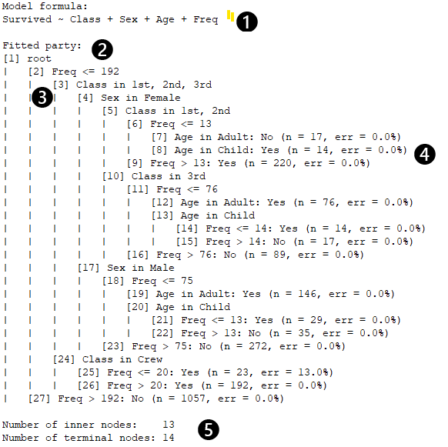
Figure 1: Tree of Survival Probability
❶ The tree display shows the breakdown of passengers by booking class, sex, and adult/child (Age). The formula shows the dependent and independent variables. Variables to the left of the ~ are dependent, and those to the right are independent.
❷ The tree is shown in an outline format.
❸ The number in [ ] identifies the node and the subtree starting at that position. These numbers will appear in the tree plot and can be used for specifying subtree outlines and plot to display.
❹ The statistics for a categorical dependent variable in the err field show the percentage of cases classified incorrectly. For a continuous node, the sum of squared errors would be shown.
❺ Terminal nodes are at the lowest level of the tree. Inner nodes show the branches as the tree is traversed.
Here is the plot corresponding to the tree above.
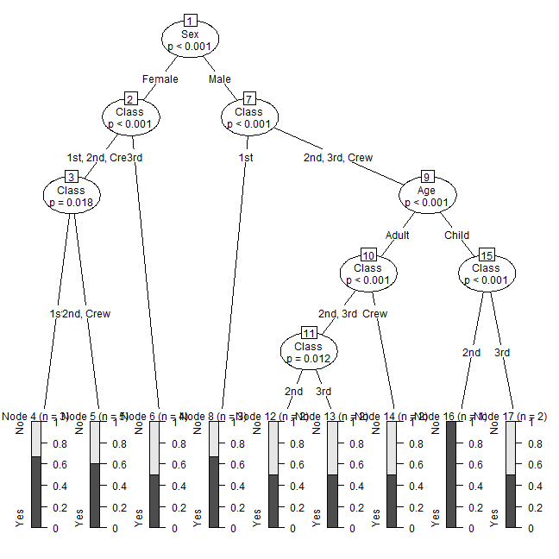
Figure 2 Plot of survival probability
It may be useful to plot subtrees 2 (third class) and 7 (class one) to accommodate the large plot. Alternatively, the plot can be specified to be larger. The small plots in the terminal nodes show the proportion of the dependent variable, i.e., the survivor proportion. The chart type in the terminal nodes depends on the properties of the dependent variable.
Here are the results for a moblinear model. Using the employee data.sav file shipped with SPSS Statistics, it estimates the effect of education, treated as a scale variable, on salary taking account of job category, gender, and birth date (bdate),
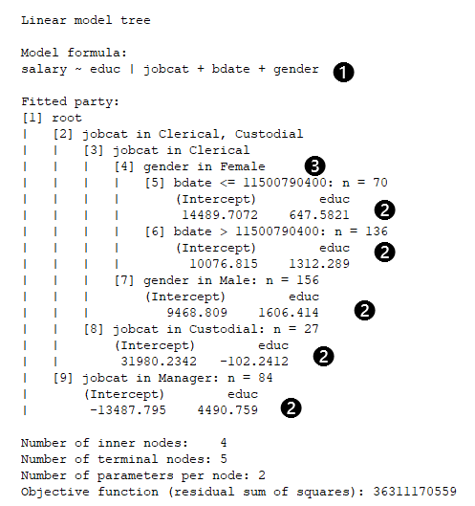
Figure 3 Tree of MOB estimates of education effect on salary

❶ The equation shows that the dependent variable, salary, is regressed on educ and partitioned on jobcat, bdate, and gender. The variables to the right of the vertical bar define the partition while the variable to the left defines the regression equation.
❷ The equation variable coefficients are shown for each partition where they differ. For managers, the educ coefficient is not significantly different for any subgroup; custodial has a negative coefficient different from the other groups, and for clerical, males have a bigger educ effect than females.
❸ The birth date variable value is shown as the SPSS numerical value of the date. While it would not affect the tree calculation, transforming birth date into age in years before running the procedure would make the results more readable.
The plot of the tree also shows the date as its numerical value. It includes small scatterplots of each subgroup with points, and a fit line. The font size and plot size were increased to show everything without overlap. The x axis covers the range of the educ variable for the entire sample.
In summary, the story in this tree is that education has a large positive effect for managers as seen in the slope of the fit line, a small but negative effect for custodial staff, and, for clerical staff, an in-between effect on salary. For females, the effect is larger for younger females.
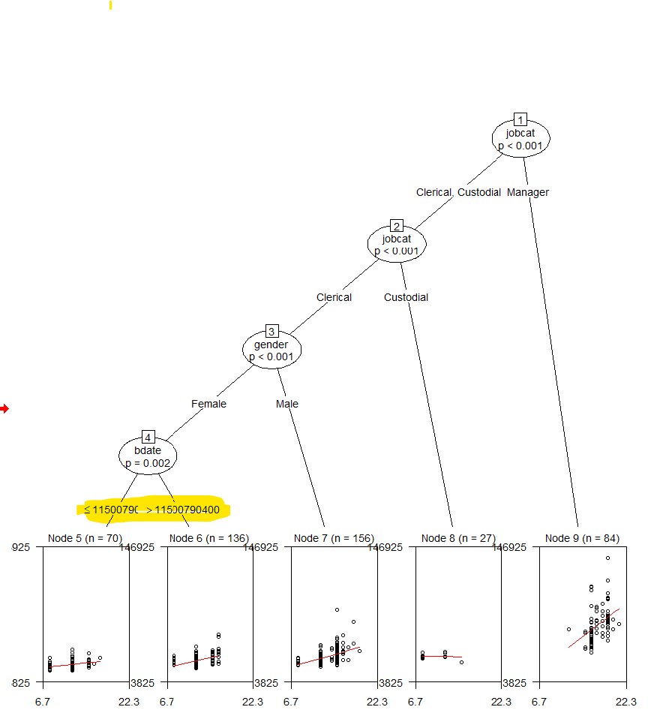
Figure 4 Plot of education effect on salary
Here is an example with two categorical dependent variables, minority and gender with educ as a factor for partitioning
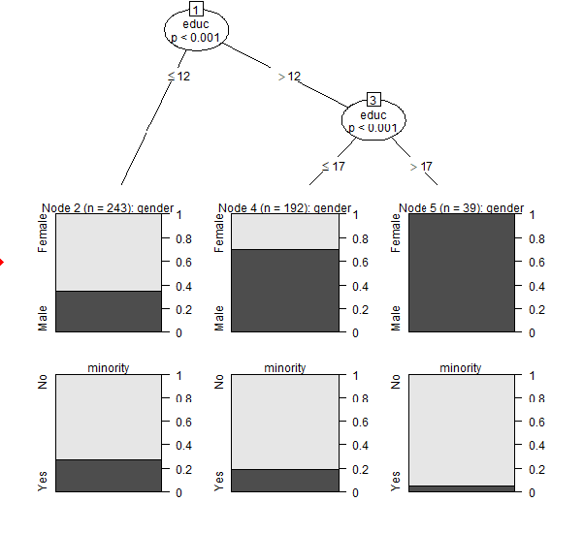
Figure 5 gender and jobcat with educ for splits
The first row of plots shows how the gender proportions vary with the educ breakdown, which is less than or equal to 12 versus greater than 12, which is further broken down. The second row shows how the proportions vary for gender.
This display shows boxplots for the terminal nodes using a tree estimating sepal length, which is a scale variable, using the iris dataset. The maximum tree depth was set to two.
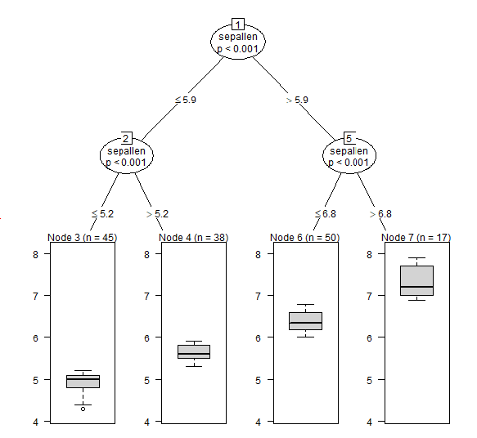
Figure 6 Boxplots in the terminal nodes

