Jeremiah Crossett
NRGSIM LLC
7255 SW 31st
Portland, OR 97219
jeremiah@nrgsim.com

06/06/2013

Dear, Erik

Thank you for your interest in forming a chapter of the USA affiliate of the International Building Performance Simulation Association (IBPSA-USA). The Board of Directors (BoD) of IBPSA-USA is very excited about the prospect of chapters and is in the process of amending its By-laws and developing chapter guidelines to make this possible. Creation of these documents may be a lengthy process and the BoD does not wish to unduly delay you in beginning your activities as an IBPSA-USA chapter.

The BoD has expedited the creation of the first steps in becoming a chapter. These are the steps that will designate your organization as a Provisional Chapter of IBPSA-USA. Being a Provisional Chapter allows you to start having meetings and other activities identified as an IBPSA association while completing the remaining steps for becoming a full chapter.

To apply to become a Provisional Chapter, the following information needs to be provided to the IBPSA –USA Secretary:

- A list of the members of the organizing committee that identifies the primary contact
- A schedule of planned meetings (include any meetings that you have already conducted)
- A timeline for completion of the steps for becoming a full chapter (this requirement is waived until the BoD has approved the steps for becoming a full chapter)

Once the BoD has received the information, it will vote on whether to approve the application. In cases that multiple applications from a similar geographic region have been received, the BoD may suggest that the groups combine to form a single chapter. Upon approval by the BoD the Provisional Chapter will receive from the BoD the following:

- An official letter from the BoD formally announcing the approval as a Provisional Chapter of IBPSA-USA
- An electronic version of the IBPSA-USA logo to use in correspondence and announcements
- A primary contact at IBPSA-USA that can help the chapter with questions on the process of becoming a full chapter
- Guideline and By-laws for becoming a full IBPSA-USA chapter (once these are completed and approved by the BoD)

Provisional Chapters should refrain from raising and accumulating funds until they have become incorporated in their State of operation and recognized as a full chapter.

Sincerely,
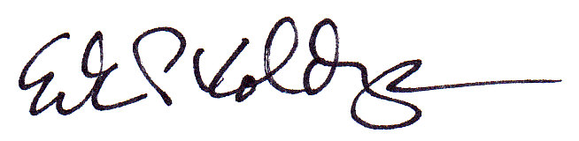

Erik Kolderup
IBPSA-USA Secretary

cc. Shanta Tucker, President IBPSA-USA, shanta.tucker@atelierten.com
Joe Deringer, Vice President IBPSA-USA, jderinger@su-per-b.org
Drury Crawley, Treasurer IBPSA-USA, cbarnaby@wrightsoft.com
Organizing Committee:

- Jeremiah Crossett - Primary Contact jeremiah@nrgsim.com
- Arunabha Sau - Outreach runabha@gmail.com
- Eric Youngson - Secretary eric@successionecological.com

Meetings
- May, 22 2013 – Identify chapter goals,
- June 6, 2013 – Determine, timeline and outreach strategy
- July, 2013 – Plan steps to launch
- October, 2013 – Launch regular, open meetings

Steps for launching the chapter
- Launch interactive website
- Establish regular meeting logistics
- Engage academic students & faculty at:
  - Portland State University
  - University of Oregon
  - Portland Community College
  - Concordia University
  - Oregon Institute of Technology
- Engage NGOs
- New Buildings Institute
- NEEA
- Energy Trust of Oregon
- PNNL
- Engage Professional community after steps 1 & 2 are accomplished
  - Presentation at Building Simulation Energy Forum

