IBP2012-IVIS-002. Making Germplasm Lists

Introduction:

In order to start using the Genealogy Management System (GMS) to enforce unique identification of germplasm and track pedigrees you need to import lists of germplasm from your breeding program. These can be imported with complete pedigrees, but we will consider simply importing existing lists without pedigrees.

Once germplasm are imported into the GMS it is often necessary to make lists of germplasm for different purposes by selecting entries from previous lists and adding imported lines.

Objectives:
At the end of this chapter, the user should be able to:
- Complete an excel template with germplasm names for import to GMS;
- Import germplasm to GMS from an excel template (without pedigrees);

A. Importing a list of germplasm from an excel template file.

Tutorial Steps:
A1. Creating a basic germplasm list in Excel

- You can use Excel to create a file with the following format and minimum content:

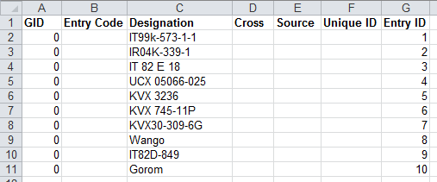

This format is required if the file is to be entered directly into the IB Fieldbook and the columns Designation and Entry ID are the minimum that must be completed. Other details are optional. With a file in this format it is possible to directly to create a fieldbook, but in order to have the data from the fieldbook linked unambiguously to pedigree and genotyping data it is desirable to obtain Germplasm Identifiers (GIDs) and Unique IDs for the entries. To do this you must import the list into the GMS of the breeding database using the Germplasm List Creation feature as explained in the next section.

Using the template \ICIS5\Document\GermplasmLists\GermplasmList-template.xls, two basic lists have been prepared and stored in Directory \ICIS5\Documents\Training\IVIS\. These contain a set of female parents in UCR2010F_GermplasmList.xls and a set of matched male parents in UCR2010M_GermplasmList.xls

Open these file in excel and check the use of the template format.

A2. Importing a Nursery List from an Excel Spreadsheet

- Launch the Breeding manager application from the IB Workbench. Select Germplasm from the Database menu to see the existing Germplasm Lists

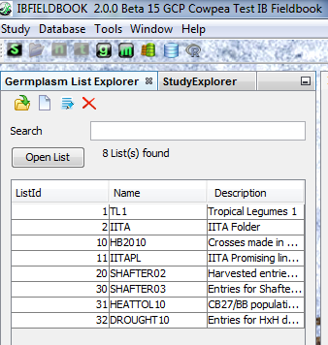

3. Click the (g) icon to open the Germplasm List Creation page:

4. Click on the Excel File Tab below the heading Germplasm Sources. Browse to the directory \ICIS5\Document\Training\IVIS containing the import file UCR2010F.xls and open it.

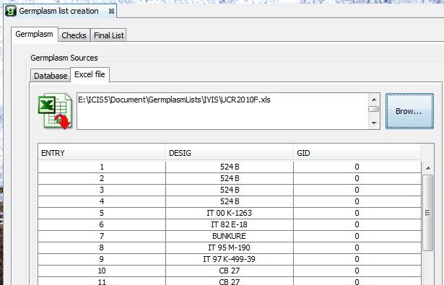

5. Highlight the first entry and then type Ctrl-a to select all entries. Drag the selected entries to the Germplasm List panel on the right of the screen:

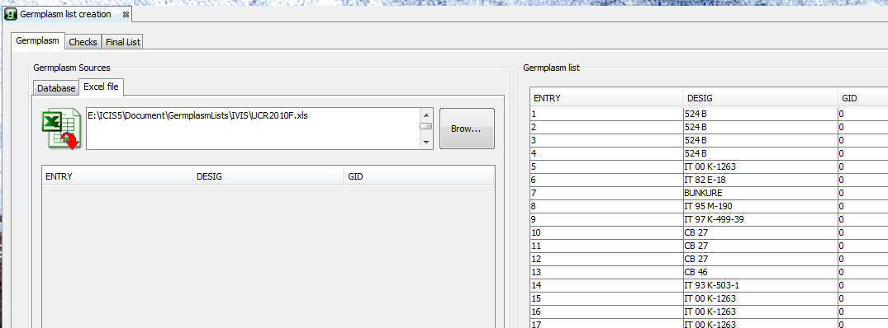

6. Click on the Final List tab in the Germplasm list creation panel. Enter the list name UCR2010F and the list description. “UCR 2011 Female parents” in the boxes. Click the Without Checks radio button, then click on the save icon.

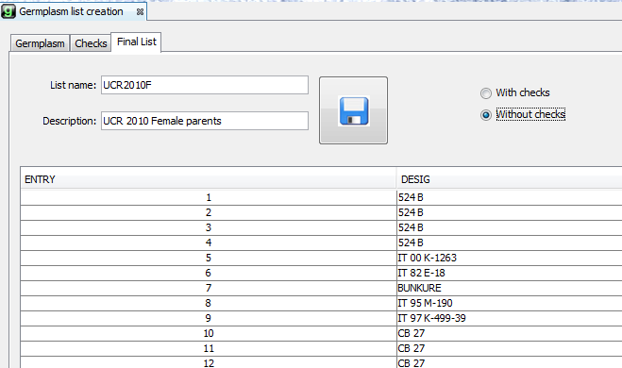
SAVE

7. When the message “Your Germplasm List Has been Saved” is cleared, select Germplasm from the Database menu again and you will see the new list as the last item in the Germplasm Explorer Window.

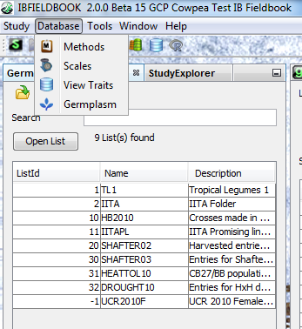

8. Highlight the new list (click on the LisdID) and then click Open List. A Germplasm List Tab opens showing the list entries. Since all of the entry Designations in this list match germplasm in the database they have all been stored with their positive GIDs from the central database. If names did not match new entries with negative GIDs would have been added to the local database. Only persons with access to this local database would be able to see them..

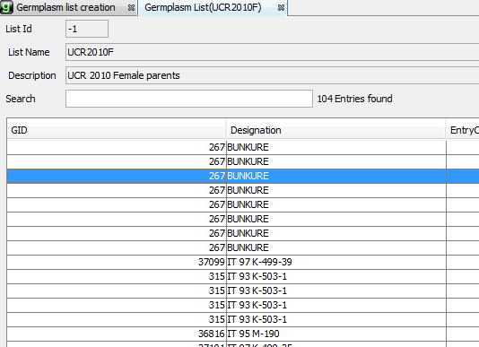
9. Repeat steps 3 to 6 for the list of male parents UCR2010M.xls. And the ens of this process the directory of lists looks as follows:

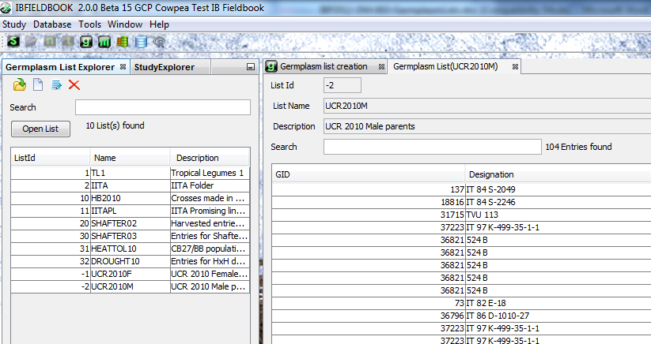

10. Close the application as the lists are now saved and can be used by other applications such as making the F1 nursery.

