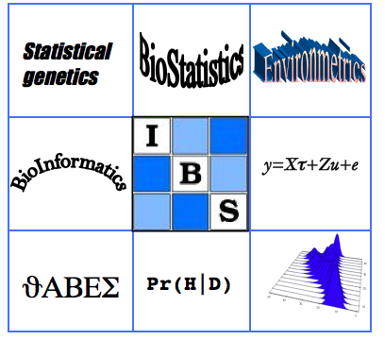 | Biometrics by the Canals  IBS-AR conference  December 1-5, 2013  The Sebel Mandurah, WA  Australia | 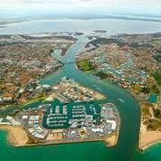

(All rates are in Australian dollars)

ATRIUM RESORT Mandurah
65 Ormsby Terrace, Mandurah WA 6210
Tel: +61 8 9535 6633 Fax: +61 8 9581 4151
mailto:reservations@atriumhotel.com.au
You must email or phone/fax your details and quote the group code ‘DEPTAG’ to obtain the special rates below. We have asked the resort to hold these with a checkin date of 30/11/2013 and a checkout date of 5/12/2013. Please try to book a room by the early bird registration date in mid-October, 2013. Thank you.
Standard Studio Room: 1 x Queen Bed on 1st & 2nd Floors with Tea & Coffee facilities | (Holding 10 of these)  $120 per night
Deluxe Studio Room: 1 x Queen Bed on 3rd & 4th Floors with Tea & Coffee facilities | (Holding 10 of these)  $135 per night
Standard twin room or Queen/Single room: 1 x Queen Bed & 1 Single Bed with self-contained kitchen (no oven) | (Holding 10 of these)  $140 per night
Deluxe 2 Bedroom Apartment: 1 x Queen Bed, 2 x Single Beds on 3rd - 5th Floors with self-contained kitchen (no oven) | (Holding 5 of these)  $187 per night
Last updated May 30, 2013. MD

