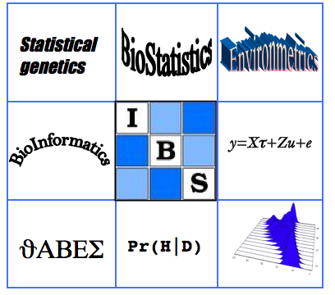 | Biometrics by the Canals  IBS-AR conference  December 1-5, 2013  The Sebel Mandurah, WA  Australia | 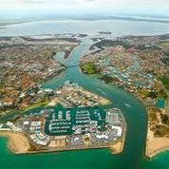

Satellite course 1:
Statistics for Spatio-Temporal Data - Noel Cressie
Co-sponsored by the National Institute for Applied Statistics Research Australia (NIASRA)

Presenter: Noel Cressie
Date: Sunday, December 1, 2013 (9:00am-4:30pm).
Registration from 8:15am
Place: Sebel Mandurah Hotel as for main conference
Note: Maximum number of participants, thirty (30).

Attendee background: Should be at least that of Bachelor's level probability and statistical inference, and they should have a good understanding of matrix algebra.

Course Abstract: The course will follow the recently published book by Noel Cressie and Chris Wikle, "Statistics for Spatial Data" (2011, John Wiley and Sons, Hoboken, NJ). It is a state-of-the-art presentation of spatio-temporal processes, bridging classic techniques with modern hierarchical statistical modeling concepts. From understanding environmental processes and climate trends to developing new technologies for mapping public-health data and the spread of invasive species, there is a high demand for statistical analyses of data that take spatial, temporal, and spatio-temporal information into account.

The course will consider a systematic approach to key quantitative techniques for the analysis of such data, particularly hierarchical (empirical and Bayesian) statistical modeling with an emphasis on dynamical spatio-temporal models. Illustrative real-world examples will be presented throughout the course.

Course Outline: The course is split into four subsections.
1. Overview of Statistical Modeling of Complex Data and Processes (key concepts of hierarchical modeling and overview of requisite background in spatial statistics and time series).
2. Descriptive Analysis of Spatio-Temporal Data (exploratory techniques for spatio-temporal data including visualization and empirical dimension reduction).
3. Fundamentals of Spatio-Temporal Modeling (spatio-temporal covariance functions, spatio-temporal kriging, relationship between process and covariance, and random-effects perspectives).
4. Spatio-Temporal Dynamical Models (hierarchical perspective of data, process, and parameter models for spatio-temporal dynamical systems; parameterization approaches for dealing with the curse of dimensionality; computation).
Last updated May 30, 2013. MD

