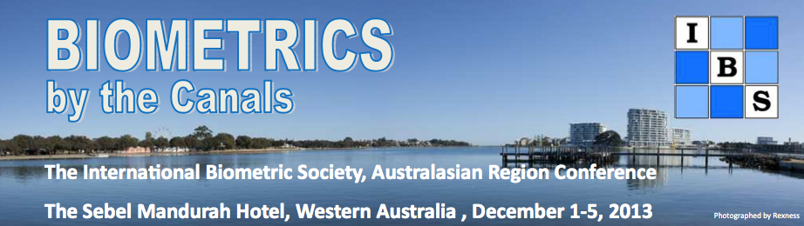

Social Programme (All rates are in Australian dollars)
Conferences can be intense and lead to "brain strain" for some, so relief from the scientific programme is often welcome and necessary for recharging your batteries. With this in mind, the Local Organising Committee (LOC) have organised some great social events that will hopefully afford you the opportunity to meet new faces and catch up with your biometrical colleagues.

The costs of the welcome reception and the conference dinner are included in the registration fee for a conference delegate (IBS member, non-member or student) attending the whole week. Additional tickets may be purchased for day registrants and partners who are interested in attending either of these events. Please indicate the number of extra tickets required on the registration form.

1. Welcome reception: Sunday 1 December 2013 – 6:30pm to 9:30pm
A welcome reception / cocktail party will be held from 6:30pm onwards in the Acacia room at The Sebel Mandurah Hotel (TSMH) which is the venue for the conference. Registration will be open from 4pm-7pm. For the cocktail party, drinks will be available from 6:30pm. The cocktail food/canapés will be served at 7pm for 2 hours.
Cost: Included for registered conference delegates (attending the whole week), and registered delegates for the short courses only, but $65 each for any accompanying guest or any day-conference delegate.

2. Students/young statisticans’ evening: Monday 2 December 2013 – to be organised
This will depend on how many students register. Traditionally, this is an evening when the President and/or regional council members meet with students (or newly graduated statisticians) at the conference. We usually meet at the conference venue at 7pm and then go together at a local restaurant. It is a good way for people to get to know each other and of course the new blood of the Society.

Please let the Chair of the LOC (LOC@biometricsociety.org.au) know if you are interested in attending this event.

3. Social activities: Afternoon of Tuesday 3 December 2013
This is a long-standing part of the conference programme and so keeping with tradition we have arranged two options for the afternoon of Tuesday 3 December 2013 after lunch. We want you to relax, get a breath of fresh air, have fun and see some of what this part of Australia has to offer, especially for first-time visitors.

3a. Tour 1. Thrombolites and Winery tour
We first visit the thrombolites, which are odd, rock-like structures formed by photosynthetic microbes that precipitate calcium carbonate (limestone). This is located at Lake Clifton in the Yalgorup Lakes National Park, about 30 minute’s drive south of Mandurah along Old Coast Road. For more details click on the website: http://www.westaustralianvista.com/thrombolites.html

Then we visit two wineries located in the Peel region, including a tour of each winery and the opportunity to sample and purchase local wines. Lake Clifton has unique reds, whites and fruit wines for tasting, grown in the limestone soil of the estate. Vineyard 28 (http://www.vineyard28.com.au/) also has red and white wine tastings and a winery tour. Lake Clifton Vineyard & Winery is located south of Mandurah along the Old Coast Road, and Vineyard 28 is on the edge of the Myalup State Forest. The tour includes a stop for afternoon tea at Decadent C's (http://decadentchocolate.com.au/).
Time: 1.15pm – 5pm
Place to meet for bus: Outside Sebel Mandurah Hotel
Take: Hat, camera, comfortable clothes
Number of people: 10-33
Cost: $40
Further information: www.mandurahwinetours.com.au

3b. Tour 2. Mandurah canal & dolphin cruise
Mandurah Dolphin Tours offer a relaxing one and a half hour scenic canal cruise. The boat departs from Dolphin Quay taking in the Ocean Marina and Venetian Canals before cruising inland towards the Peel Estuary through the Creery Wetlands and Port Mandurah Canal. The trip passes the mansions of the wealthy in Mandurah and we also hope to see wild bottle-nose dolphins playing in their natural habitat. The unique Quay to Quay cruise will make a brief stop at the Waterside Restaurant in Mandurah Quay, before the return trip to Dolphin Quay.

The endangered Osprey Eagles have built nests on either side of the Mandurah Quay harbour with walking trails leading right to them. Kangaroos and dolphins also show up here, often quite unexpectedly. If you enjoy photography, bird watching, playful dolphins, nature, wildlife or excursions on the water, then you will love this cruise. The best way to see Mandurah is from the water and Mandurah Dolphin Tours certainly hold the key to a unique experience. On-board afternoon tea included.

Time: 2pm – 3:30pm
Place to meet for boat: Dolphin Quay, Mandurah Ocean Marina
Take: Hat, camera, comfortable clothing
Maximum numbers: 26
Cost: $40
Further information: http://www.mandurahdolphintours.com.au

4. Other self-organised activities

4a. Mandurah Boat & Bike Hire:
http://www.mandurahboatandbikehire.com.au/

4b. Mandurah Community Museum: http://www.mandurahcommunitymuseum.org/

4c. Kings Park in Perth is the most visited tourist destination in WA. It covers 400.6 hectares, comprising bushland, tranquil parklands and the botanic gardens, and offers spectacular views overlooking the Swan River and the city of Perth. To reach Fraser Ave, take the train to Perth from Mandurah Station alighting at the Esplanade Station, and then catch buses 24 or 37 from St Georges Tce. Purchase a day-pass on the bus stopping outside the Tourist Bureau, in Mandurah (a short distance on the boardwalk from the Sebel Hotel). The website for Kings Park is http://bgpa.wa.gov.au/kings-park.

4d. Fremantle is a vibrant city located at the mouth of the Swan River and is recognised as one of the best preserved 19th Century seaports with over 150 buildings classified by the National Trust. It offers a fishing boat harbour, and shops and cafes, along with examples of colonial, convict and maritime buildings. http://www.fremantlewesternaustralia.com/ Also visit the Fremantle Maritime Museum (the home the America’s cup boat (Australia II) that Alan Bond won in 1983). See more details at http://museum.wa.gov.au/museums/maritime

4e. Cruise the Swan River from Perth to Fremantle with tours departing from the Barrack St Jetty. http://www.captaincookcruises.com.au/half-day-cruises

4f. Visit the nature reserve Penguin Island, home to a colony of fairy penguins, and located a 5-minute ferry ride across the Shoalwater Islands Marine Park. http://www.penguinisland.com.au/

4g. You can also contact the Mandurah Visitors Centre at (www.visitmandurah.com.au) for information about many other activities available in the area.

5. Conference dinner Wednesday 4 December 2013 from 6:30pm to 10:30pm
The conference dinner will be on Wednesday 4 December at the Mandurah Offshore Fishing and Sailing Club Inc. (http://www.mofsc.com.au), from 6:30pm to 10:30pm. Drinks (beer, wine and non-alcoholic) will be provided from 6:30pm. Dinner will commence 7pm, and all dietary requirements can be catered for (please indicate on your registration form if you have a special dietary requirement). It will be a special evening with Society presentations.

Cost: conference dinner included for registered delegates (attending the whole conference) and $95 for each accompanying guest.

To get to the conference dinner, people can either
· Walk [see the Google map on the Social Programme link] - the blue line is the way the bus will go, the short-cut is to walk via the bridge near the Keith Holmes Reserve] which should take less than 20 minutes (easy-pace). There are no hills.
· Transport will also be arranged from The Sebel Mandurah Hotel to the MOFSC, and return. (More details to come in mid-November 2013).
Last updated 6 July 2013 (ro+md)

