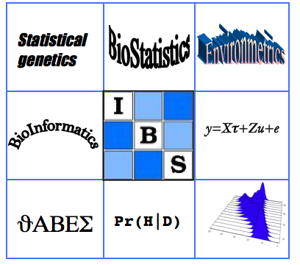 | Biometrics by the Canals  IBS-AR conference  December 1-5, 2013  The Sebel Mandurah, WA  Australia | 

Satellite course 2:
Vector Generalized Linear and Additive Models

Presenter: Thomas Yee
Date: Sunday, December 1, 2013 (9:00am-4:30pm).
Registration from 8:15am
Place: Acacia rooms, Sebel Mandurah Hotel, as for main conference.
Note: Maximum number of participants, thirty (30).
Attendee background: Should have a good working knowledge of R including experience in fitting linear models. At least a second year level of undergraduate statistical theory and mathematics (linear algebra and calculus) is assumed.
Course Abstract: The course will involve a mixture of basic theory and hands-on data analysis using R. Real data sets will be used throughout. Delegates should bring their own laptop with the latest version of VGAM installed on the latest version of R. Any additional files will be made available later.
Course Outline: The course is split into four chapters.
1. Vector generalized linear and additive models (VGLMs and VGAMs) Overall framework, constraint matrices, using the VGAM package.
2. Analysis of counts Negative binomial regression (NB-1, NB-2, NB-P, NB-H, NB-C, etc) versus quasi-Poisson models, zero-inflated distributions, zero-altered (hurdle) distributions, positive distributions.
3. Quantile and expectile regression LMS-Box-Cox-normal quantile regression, what are expectiles?
4. Models based on latent variables Reduced-rank VGLMs, row-column interaction models, some categorical data analysis models, ordination methods [constrained quadratic ordination, constrained additive ordination].
Last updated May 30, 2013. MD

