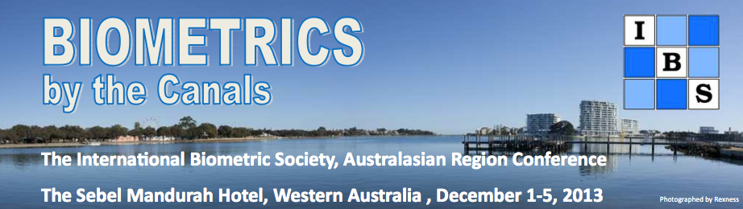

Travel options (All rates are in Australian dollars)

These notes will be updated in mid-November 2013. Please check the website for latest news before you leave home to come to the conference. Please email the LOC@biometricsociety.org.au or contact one of the LOC members on the website home page if you have any queries.

We expect most delegates from outside Western Australia to arrive at the domestic airport (terminals T3 or T4) or from direct international flights form New Zealand and beyond (terminal T1). There is a FREE transfer bus from international to domestic airport. See the link:
http://www.perthairport.com.au/ToTheAirport/GettingAroundtheAirport.aspx

- Conference organised buses
  - Perth Domestic Airport to Mandurah: There will be one organised shuttle bus. $20 per passenger. The bus takes approximately 1 hour.
    - 4:30pm Sunday (1 December, 2013)
    - If there are delegates arriving on Saturday for the short courses on Sunday, we may consider a bus on the Saturday afternoon (4:30pm 30 November, 2013). More details after early bird registration (14 October 2013).
  - Mandurah to Perth Domestic Airport: Thursday afternoon, 5 December 2013. There will be one organised shuttle bus leaving from The Sebel Mandurah Hotel. $20 per passenger. The bus takes approximately 1 hour.
    - 1:15pm (NOTE: first preference will be given to the people travelling on flights that leave before 4pm). Please indicate your flight departure time on the registration form. If there is sufficient demand, we may organise another bus later than 1:15pm.

- Other options – do it yourself
  - Rental car http://www.perthairport.com.au/ToTheAirport/CarRental.aspx
This is a good option if 2 to 4 people can use it for other trips (eg going to Fremantle or Perth on the days outside the conference or on Tuesday afternoon December 3, 2013).
  - An exercise in connecting various means (shuttle bus, then train, then bus; $26pp approximately)
    - Perth airport shuttle bus (http://www.perthairportconnect.com.au/) to Esplanade Train station (due to road works for Elizabeth Quay, shuttle will drop you near Train station and only short walk). From $15pp.
    - From Esplanade Station to Mandurah Station (http://www.transperth.wa.gov.au/) by train. Buy a ticket for the last stop which is Mandurah Train Station for $9.40 (as of this date). Best to have exact change, as you need to buy ticket from machine.
    - Mandurah train station to Sebel Hotel (or any other hotel) approximately 3.5km
    - Either catch Bus 588 or 589. Use the same ticket to show the bus driver. There is no extra charge.
(http://www.transperth.wa.gov.au/). Take the bus to the Mandurah Visitor Centre, then walk along board walk to the Sebel Hotel Mandurah (~400m) [588 is the better bus to catch since you do not have to cross the road. Note that these two buses do not travel later than 7pm on weekends or 9pm on weekdays.]
    - Or catch a Taxi about $15. So if you share with someone it will be cheaper.
- Door to door shuttle bus ($75 pp) , if outside the above conference organised buses.
  - Peel Bus Hire & Charters. $75.00 per passenger (minimum 2 passenger charge). Bus will pick up from Perth airport and drop off at Sebel Hotel, or any other hotel. http://www.peelbuscharters.com.au/bookings/
  - Standard taxi from Perth airport to Mandurah total cost approximately $170. This is plausible if say 4 people can share the taxi one way. Please tell the taxi driver your destination before you all jump in!
- Exploring Perth with public transport. You can also purchase a DayRider pass (after 9am) for use on all public Perth transport (bus/train/ferry) for a whole day. Cost is $11 for a DayRider pass. This may be useful if you want to explore Perth and Fremantle or the zoo (in South Perth via Ferry from Perth Bell Tower). You can buy this from the bus driver. PLEASE CARRY CASH (various denominations eg coins and $10 notes but not $50 or $100 notes. The driver may not be able to change that denomination.
- How to get to Perth Airport after the conference if not departing Perth airport on Thursday 5 December 2013?
  - Some delegates may wish to stay on in Western Australia and tour the state after the conference. We recommend you hire a car to explore Western Australia. See more at http://www.westernaustralia.com/au/Pages/Welcome_to_Western_Australia.aspx
  - If you want to get back to Perth city on Thursday December 5, 2013 in your time, then as per the leg from Perth to Mandurah, the cheapest way is public transport (www.transperth.wa.gov.au). You can catch the bus outside the Mandurah Tourist Visitor Centre back to the Train Station. Pay the bus driver (try to have loos change). Then get of at the train station and buy a ticket to the Perth Underground Station or the Perth Esplanade Train Station. To get to the airport there are special shuttle bus from your Perth accommodation via http://www.perthairportconnect.com.au/ or by taxi.

Last updated 6 July 2013 (ro+km+md)

