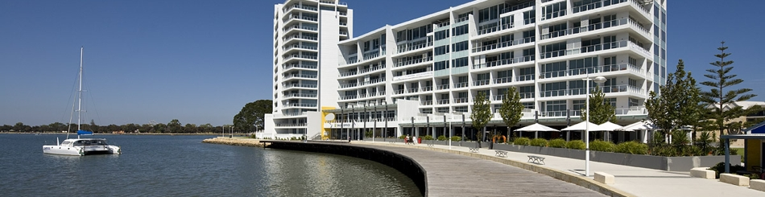

***Biometrics***

***by the Canals***

The International Biometric Society

Australasian Regional Conference, Dec 1-5, 2013