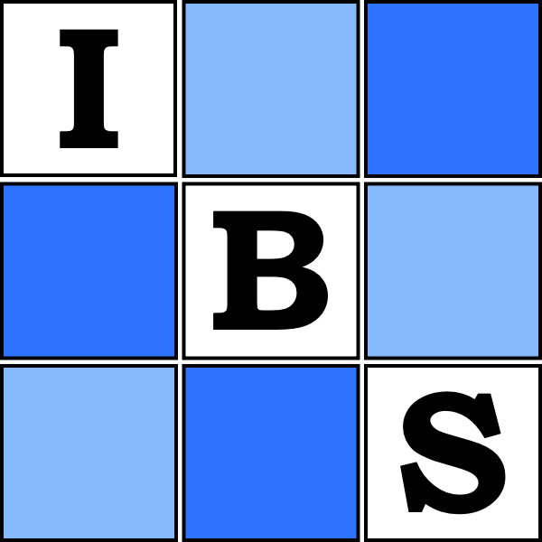
Biometrics in the Bush Capital
WiFi

Username: biometrics
Password: biometrics

