Setup guide for using IBS components

General information and overview:
1. General information and prerequisites
2. IBS Pack contents
3. Main WCM components and short explanation for their purpose
4. Setup
4.1. Importing „IBS Pack“ library
4.2. Additional configuration depending on the components used
5. Usage
5.1. Usage of Single Gallery
5.2. Usage of Gallery List
5.3. Usage of Gallery to content
5.4. Usage of File Manager.

1. General Information and prerequisites

The components included in this package have been used and tested on Websphere Portal version 8.5 and 9.0. In order to be able to setup and use them, an administrator will need to have access to the following systems: Portal administration, Web Content Authoring and Integrated Solutions Console.

2. IBS Pack contents

The IBS package zip file contains three files
- IBS pack – this is the WCM library
- WCMCustomRenderingPluginEAR application
- IBS_package.doc which is the current document explaining setup procedure and usage.

3. Main functional components

- Single Gallery -> this allows for quick creation of image gallery by creating content items representing each image. The gallery displays one main image with arrow controls and multiple smaller thumbnails showing the rest of the gallery below it. They can be edited, moved, resized or deleted in edit mode.
- Gallery List -> this one is a list of single galleries displaying their title and head image
- Gallery to content -> this component allows a gallery to be added to any user content in the form of image thumbnails and when a given user clicks on any of them, fancybox is used for visualization.
- File Manager -> all portal-allowed types of files can be added and shown as a list to any user content by a simple click.

4. Setup

4.1. Import “IBS Pack” library

1. First, log in to the WebSphere Integrated Solutions console, which is located by default at this address:
https://<YOUR PORTAL SERVER IP>:10041/ibm/console

2. Find on the left Resource > Resource Environment > Resource Environment Providers > WP ConfigService and open it:

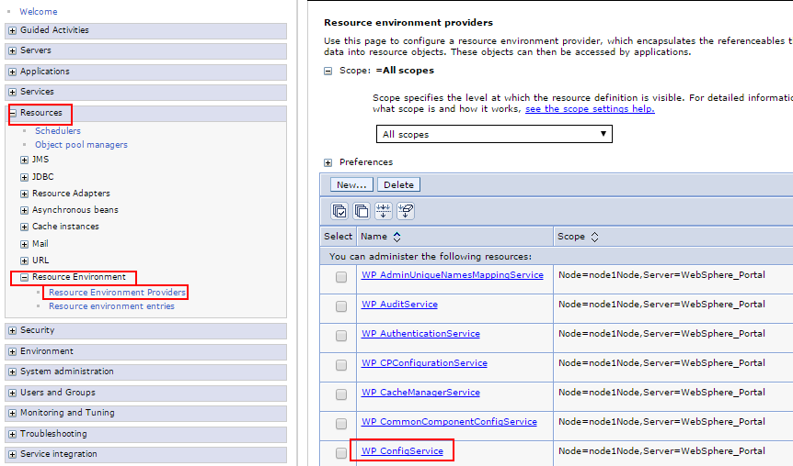
3. Click Custom properties and then create the following properties (or update them if existing)

Create or update import.directory property. This directory is the folder that will be read from when importing the IBS Pack library. You can use the one where you have placed or downloaded the library from the IBS package.
Example: c:\Downloads\IBS Pack

4. Go to wp_profile_root/ConfigEngine
The wp_profile is the default profile name but it depends on your installation.
- Under Linux it could be:
/opt/IBM/WebSphere/wp_profile/ConfigEngine
- under Windows it could be:
C:/IBM/WebSphere/wp_profile/ConfigEngine

5. Open command prompt and execute this task:
(for linux)
./ConfigEngine.sh import-wcm-data -Dimport.directory=yourpackagedirectory/ibs\ pack -DWasPassword=youradminpassword -DPortalAdminPwd=youradminpassword
(for windows)
ConfigEngine.bat import-wcm-data -DwasPassword=youradminpassword -DPortalAdminPwd=youradminpassword
Important: In case you are importing on a virtual portal, you have to include this parameter:
-DVirtualPortalContext=yourVirtualPortalContext
It could take several minutes. At the end you should see in the terminal a “BUILD SUCCESSFUL” message.
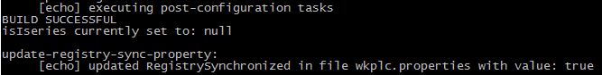

4.2. Additional setup regarding Gallery List and/or Single Gallery

Important: These steps are necessary when you intend to use Gallery List or Single Gallery. To setup File Manager or Gallery for content you do not need to execute these steps. Check step 4.3. for information regarding their setup.

1. Clone Web Content Viewer portlet

Both solutions are using cloned Web Content Viewer. In order to use both, you need to create two different portlets.
- Log in to the base portal with your administrator account

- Create the Image Gallery (Single) portlet
> Portal administration > Portlet management > Portlets > find Web Content Viewer > Copy portlet > name the new portlet Image Gallery (Single))

(Optional: you need to do this only in case you will be using Gallery List portlet)
- Create the Image Gallery (List) portlet.
The steps are the same as above (name the new portlet Image Gallery (List))

2. Configure portlet and page

Attention: In case you are importing to virtual portal, next two steps are carried out on the virtual portal, where the new library is located. Both Gallery and Gallery List need the page to be with Single Column Layout.

- Choose a page where you can temporarily add the new portlets, so that you can configure them. It may be the actual page you want to include gallery to. It may or it may not contain other portlets, this is entirely up to you. This is just a configuration step, so it doesn’t really matter.

- Enter EDIT MODE → click Add page components and applications → click Applications → search for “gallery” → you will see the portlets listed. Select Image Gallery Single portlet, then click “Add to page” or drag & drop. Then click Configure
and change the property “When this Portlet is added to the page...” to “Create content(based on selection)”

- Set the content to be mapped to IBS Pack/Enter the title for the Image Gallery

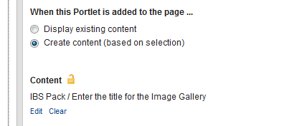
3. Remove the portlet from this page!
Important: You need to remove the portlet before using it – the configuration you set in step 2. will take effect when adding it again – this means new gallery content will appear in your library/sitearea. If you start using the gallery right away, you will be doing it in IBS Pack, not your own library!

(Optional: you need to do this only in case you will be using Gallery List portlet)
Now you need to repeat the last three steps when creating the Image Gallery (List) portlet with one key difference:
Add the new portlet to the page, but when configuring the portlet, set the content to be mapped to IBS Pack/Gallery
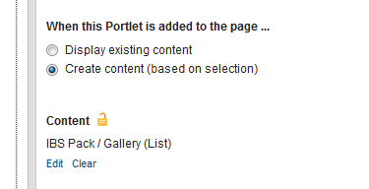
After deleting the portlet, you will be ready to use both of them on your production portal, virtual or base.

4.3. Additional setup regarding Gallery to Content and File Manager

Important: These steps are necessary when you intend to use File Manager or Gallery for content. To setup Gallery List ot Single Gallery you do not need to execute these steps. Check step 4.2. for information regarding their setup.

To be able to use these solutions you simply have to include one component in your Presentation Template. All the necessary components are inside it and use the IBS Pack library. There are a certain limits to what can be done and how many files or images can be added.

1. Install WCMCustomRenderingPluginEAR file

- Log in to the WebSphere Integrated Solutions console
- Choose Applications > Application Types > WebSphere enterprise applications and then choose “Install” from the top right screen:

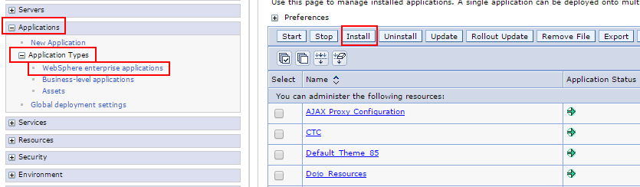
- Follow these steps in order to install the enterprise archive:
- choose file and select the .ear application
- click “next”, on the next screen leave the default settings, click “next”
- again “next”
- on screen “Map modules to servers” select the module, then the servers and clusters you will be installing on, then click “apply”
- on screen “Map context roots for Web modules” leave the default settings and click “Next”
- on screen “Summary” again, leave the default settings and click “finish”
If everything is successfully installed, you will see this message:
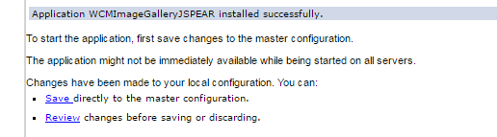

- finally, click “Save”.

- Start WCMCustomRenderingPluginEAR
- Choose Applications > Application Types > WebSphere enterprise applications
On the top of the right screen you will find the start button. You should receive message for successful initialization.

- Restart Portal server (necessary for custom plugins)

FYI: There are a number of custom plugins packed in this file which may aid you in different tasks. You will find them when you add Component > tag type Plugin > plugin type Content:

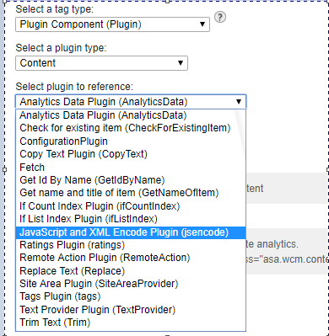
Some of them are used by this package, the rest could be useful to you so we have included them. However, at this point we cannot guarantee the behaviour of them all.

2. Adding File Manager

To be able to add gallery or file list to your content, it needs to have a presentation template. They will be stored inside a new site area as separate content items whose authoring templates you can find in IBS Pack. To be able to use these solutions you simply have to include one component in your Presentation Template.

- Import main component:
There is a HTML component called FileManagerWrapper. It contains all the other necessary components used by the file manager. To include it, enter Web Content Authoring, locate your Presentation Template and click Edit > Insert Tag > select tag type: Component. The component is located in library IBS Pack > FileManager > FileManagerWrapper. It is up to you where you need the file manager control and file list in the layout of your html. The control will be visible only in EDIT MODE.

3. Adding Gallery To Content

- Import main component:
There is a HTML component called Gallery Wrapper for Content. It contains all the other necessary components. It needs to be added to the html of your presentation template. To include it, enter Web Content Authoring, locate your Presentation Template and click Edit > Insert Tag > select tag type:Component. It is up to you where you will place the list of images in your design. The component is located in IBS Pack > Gallery > Gallery Wrapper for Content.

5. Usage

Prerequisitives: Your page must have a web content association at this point.

5.1. Usage of single gallery

Single gallery is an isolated case of gallery list, as the list contains multiple galleries of the same kind as the single one.

1. Choose a page with “single layout” where you will want to display the single Gallery

2. Add Image Gallery (Single) portlet. This will create a site area “imageGallery” inside your current WCM sitearea, associated with this page. It will store all images you create in the future.

3. You can now add a title and upload images to the gallery. They can be downloaded, moved, edited or deleted in edit mode.

5.2. Usage of Gallery List

1. Choose a page with “single layout” where you will want to display the list of
galleries (parent page)

2. Add Image Gallery (List) portlet. Adding this portlet will result in creating site area “imageGalleryList” inside your current WCM sitearea, associated with this page. It will contain all the galleries. Below is an image with example gallery list with one gallery inside:

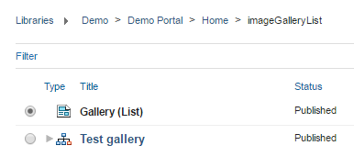
3. You are ready to create galleries through the link „+ Add gallery“
4. Galleries can also be deleted when in edit mode

5.3. Usage of file manager

- Enter Edit Mode
- At first you will see a simple link “Create new file list”. This link will trigger the creation of new site area. Its name will be derived from the name of the current rendered content to which the string “_filelist” is concatenated so that we have consistent names. Each file list corresponds to only one content.
- After the file list is created this link will not be visible anymore. Two new links will appear. The first is “+Create new file” meaning that portal already knows the file list exists and where to put the new content. When clicking it a familiar window will appear just like any other portal content creation. The second link allows deletion of the whole file list - “-Delete file list”.
- All new files should be listed below this control. Each of them has a button for editing and deletion.
- The list of files supports by default up to 20 results but that can be changed in the corresponding menu.

5.4. Usage of Gallery to Content

- Enter Edit Mode
- At first you will see a simple link “Add gallery”. This link will trigger the creation of new site area. Its name will be derived from the name of the current rendered content to which the string “_gallery” is concatenated so that we have consistent names and know how to locate the gallery. Each file list corresponds to only one content.
- After the gallery is created this link will not be visible anymore. Two new links will appear. The first is “+Add image” meaning that portal already knows the gallery exists and where to put the new content. The second link allows deletion of the whole gallery - “-Delete gallery”. When clicking it a familiar window will appear just like any other portal content creation.
- All new images should be listed below this control. Each of them has a button for editing, deletion and moving.
- The list of images supports by default up to 20 results but that can be changed in the corresponding menu.
- The main displayed image has editable width and height (up to 1900px in width and 1200px in height). The thumbnails below will be 10% of the size the user has chosen for the main image. In the imageGallery.css component this ratio can be changed

