My KPI

- Overview:
MyKPI is a solution to manage KPI and compare with other peoples in company. The user can input sale amount, order, cv sent, interview, placement every day, the notification will be sent at 5 PM every day to remind user input KPI. User can compare my value with top, average sale's value in last month by Gauge chart, or review last 6 months's values by Line chart. Ranking list will arrange sale value's from highest to lowest, so user can see sale arrange list in their company.

- System Enviroment:

Categories | Technologies
Operation System | IOS 7, 8...
Languages | Objective C, Swift
Devices support | Iphone 4, 4s, 5, 5s, 6, 6 plus
Tool | Xcode

- User Case Diagram:
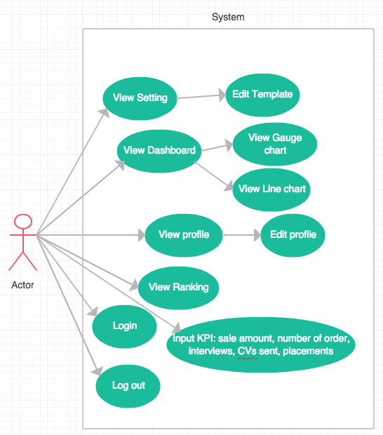
- Sequence Diagram:

4.1. Login:
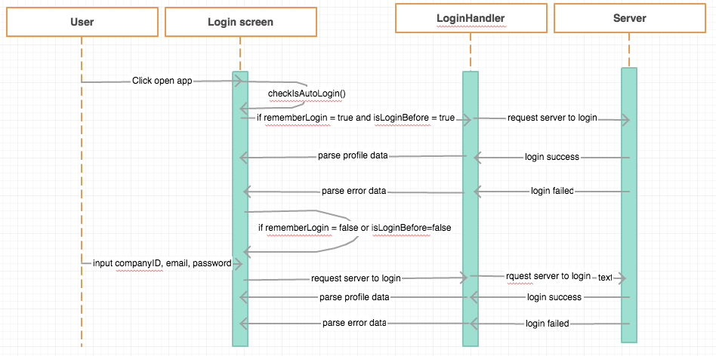

4.2. Dashboard:

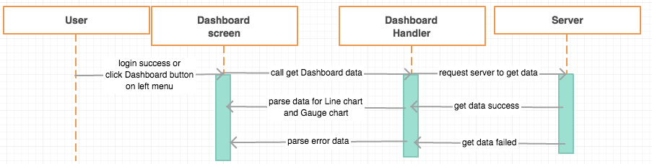
  - Setting:
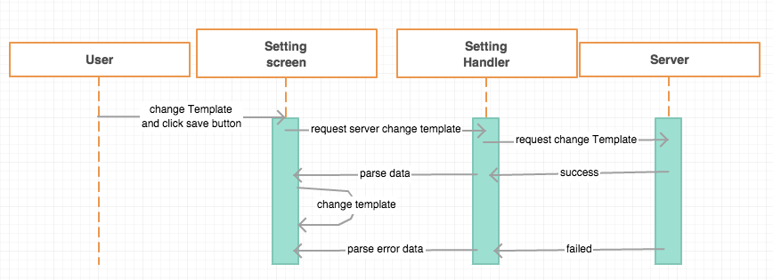

  - Input KPI:

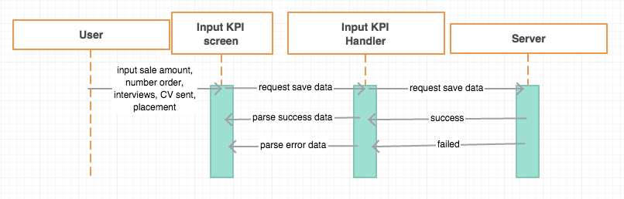
  - Profile:
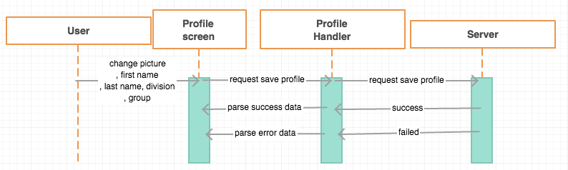
  - Ranking:
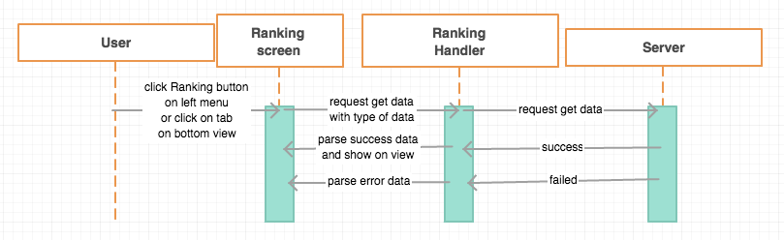
- User Inteface Design:
5.1. Login:
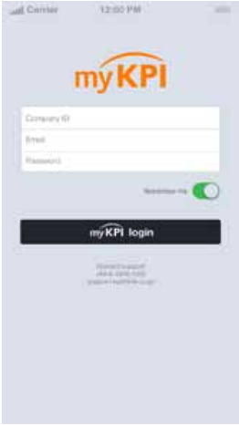
5.2. Dashboard:

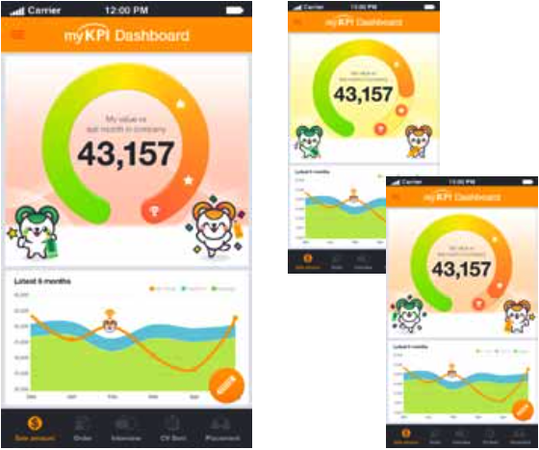

5.3. Ranking:
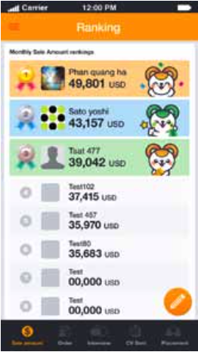
5.4. Setting:

  - Input KPI:

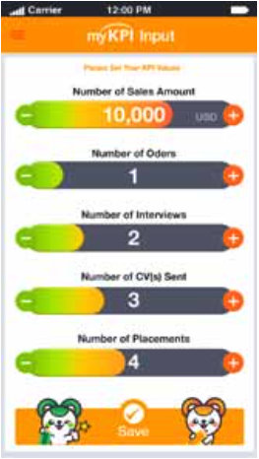
5.6. Profile:
