# Backend – Tom

### Each file has

* Error messages for:
  + Wrong get/post
  + Called from the correct location
  + User not being logged in
  + Sql query issues
  + Empty inputs that are essential
* SQL injection protection when $_POST is used for sql querys
* Use commonly repeated code, connect.php

### Examples of these

* All files where user information is used have SQL injection checking, this is done using prepare.

code- 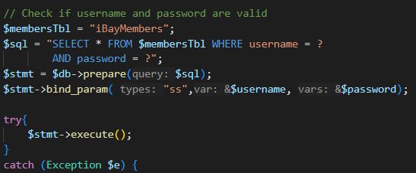

* All pages that should check that the user is logged in before allowing any code to run

* Error checking if the result of an SQL query is null/blank.

* Errors from user input pass a popup back.

* Check location that the file is called from to ensure it is being used as designed (kradle)

* Php files restricted to post & get methods separately dependent on the files function.

* ../../connect.php used code- 

## Connect.php

Sets up Access to the db, used across multiple files.

## Login

Nothing fancy to note

starts session adding userId & passes onto buyer’s page

incorrect username or password checker is implemented

## Register

Nothing fancy to note

Adds user to db.

## Sellers Create Item

Takes inputs from the form in the form of $_POST variable for everything but the image, finds a new item id by iterating through adding 1 each time and finding the smallest possible unique value. Then using prepare() adds the item to the db.

For adding the image to the image db we do the same thing to find the id, then we add the needed elements into the db.

## Sellers View items

Loops through each item with the userID equal to that found in the $_SESSION variable. Then loops through each items image encoding the stored binary data using 

Base64_encode. This allows us to use json_encode($items) later. One by one we add all of the images to $images for a given item and then add a new entry to items containing the image.

## Sellers Update/ Deleteitem

Updates the item in the db as expected using the sql injection protection techniques stated previously.

Red image (new)

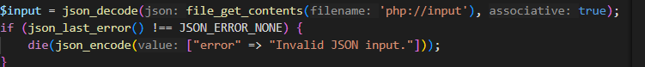

Red image(new)

both use json_decode to hndle the input from js. This is then used to find item id/ new item information.

## Buyers View Items

Verry similar to seller’s view items. However instead of sorting items by userId we sort them by a given category. This allows us to load the page one category at a time. With the use of AJAX…..not my bit…