Omar Rahman

Professor Hunchuck

COP2800C

11/26/2017

**Part 1:**

In part 1 as I was not there when it was written (In traffic court). I was able to view what my class wrote and understand it. The doThis method was a bit messy and some of the other code needed to be organized. But overall it was something to go off of. Although it did not actually run due to some null references those can be fixed.

**Part 2**:

In part 2 I got to work fixing and formatting the code so it can compile. I then added a menu system to control everything. In the menu system I added everything the rubric / directions told me to. I then added another player. I then used enhanced for loops to loop through objects using instanceof to meet the assignment requirements. Everything was displayed with joptionpane. I then went through the assignment directions to make sure everything in part1 is written correctly. After that I have fixed the toString methods. I then made an interface containing the string doThis. I then made the person class abstract to implement that method. Now when Athelete extends Person all doThis becomes abstract without making every class abstract. It was a bit funky but it ended up working. Other than that I just formatted the loop output and made sure everything looks pretty!

TestClass.java

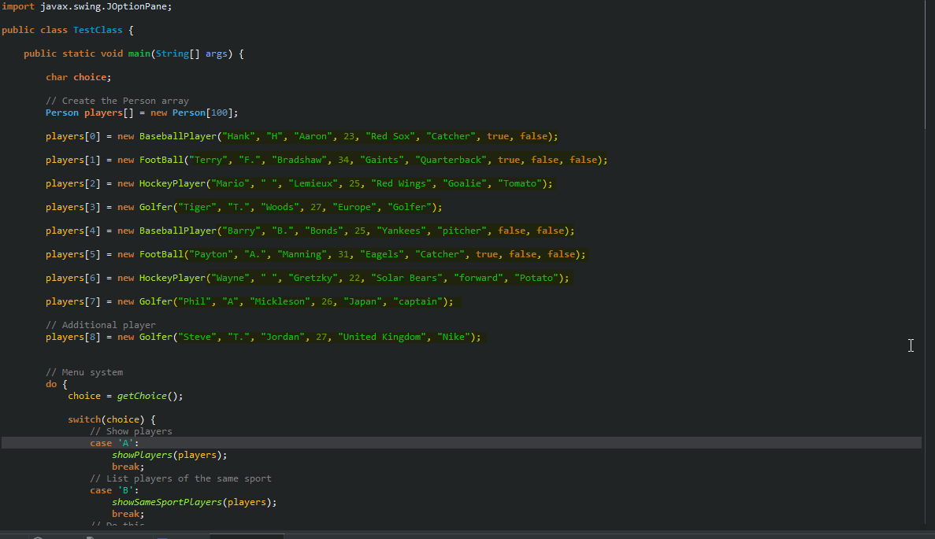  
<https://i.imgur.com/jhkWIvI.png>  
  
Person.java  
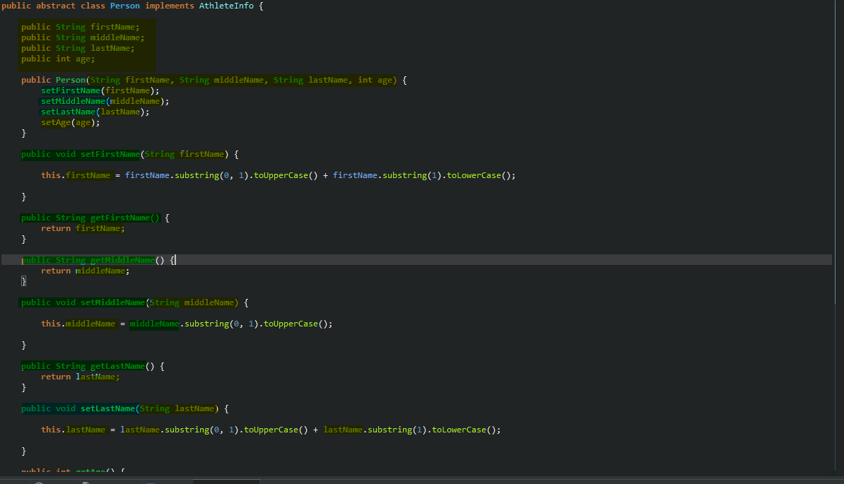  
<https://i.imgur.com/rdJWQ87.png>

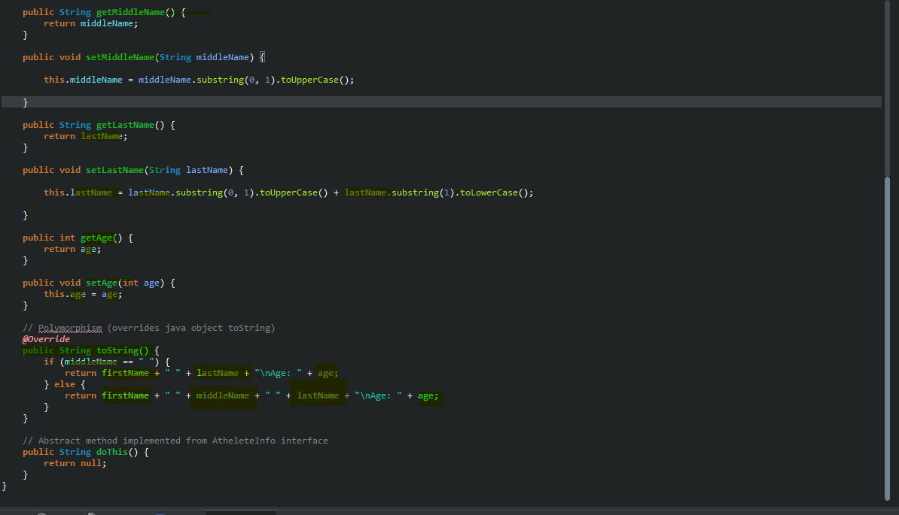  
https://i.imgur.com/69uxl9b.png

Athelete.java

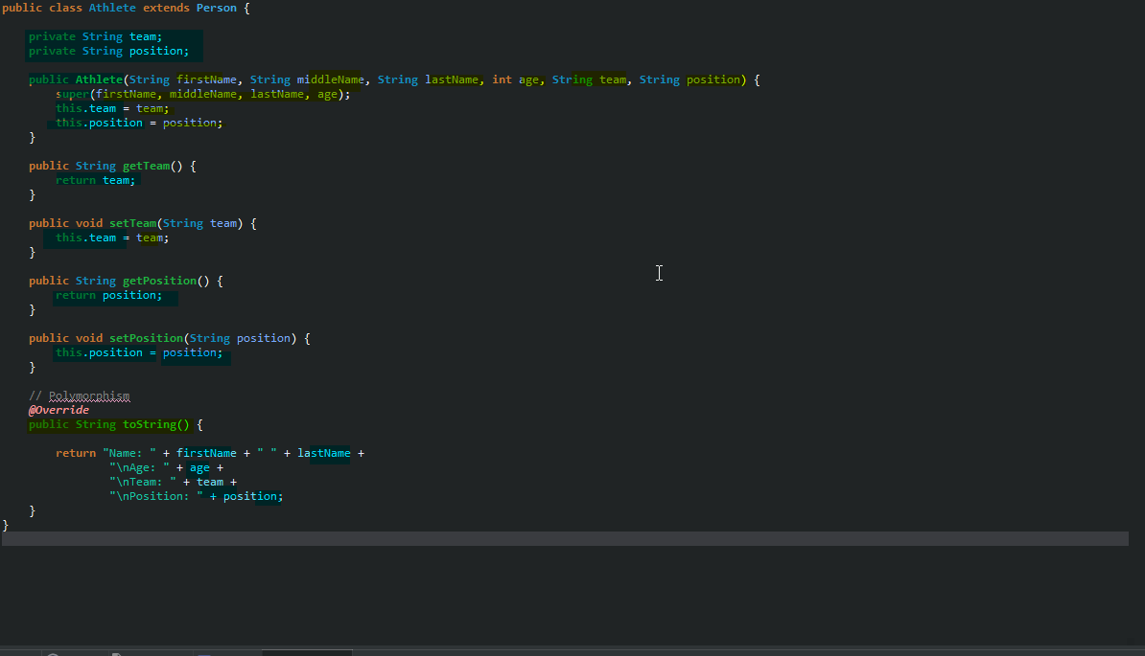

<https://i.imgur.com/GHN0feh.png>  
  
BaseballPlayer.java

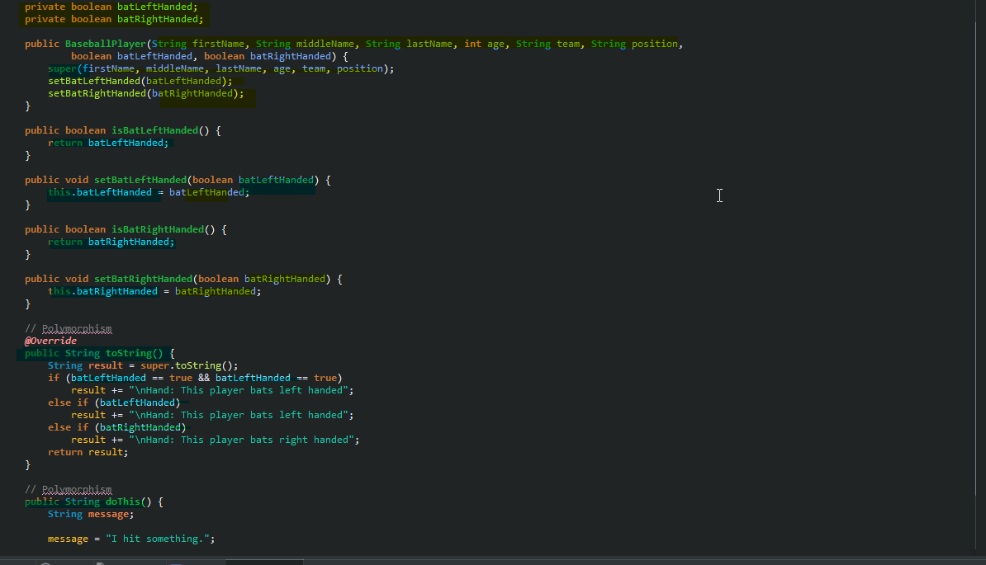

<https://i.imgur.com/Q0B1WXo.png>

Golfer.java

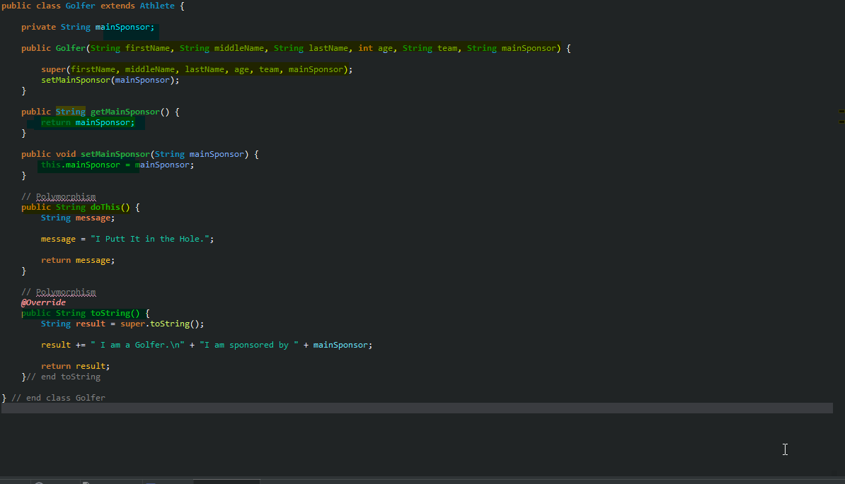

<https://i.imgur.com/qFWnRhp.png>

HokeyPlayer.java

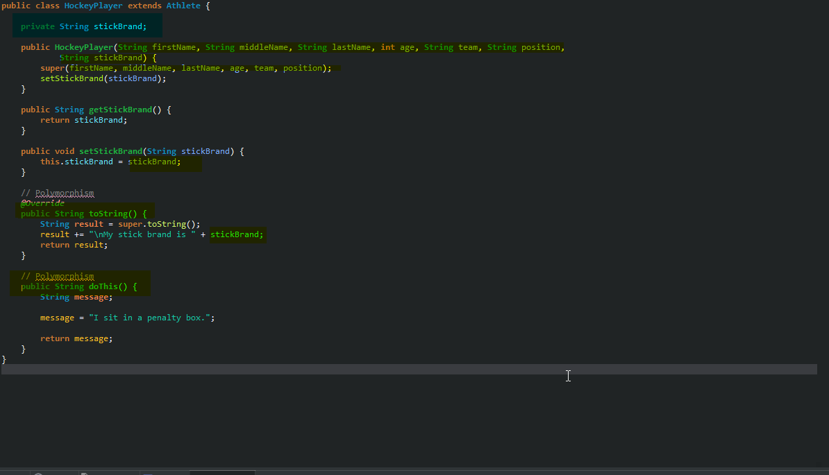

https://i.imgur.com/jS5l39N.png