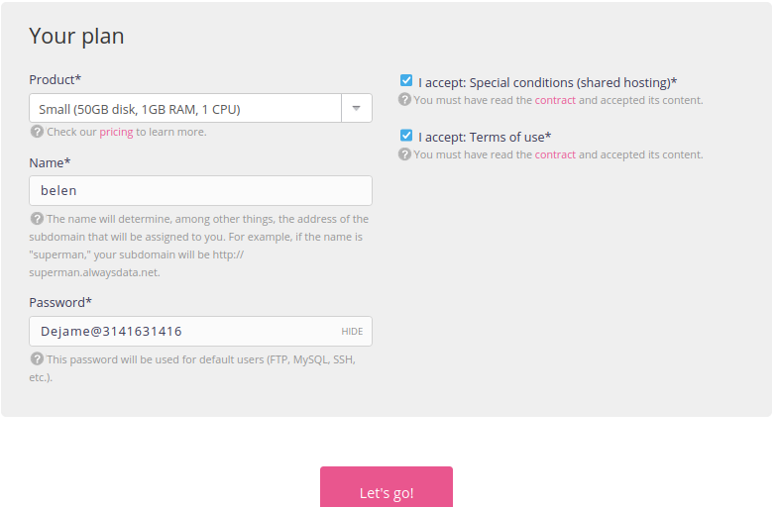

postgresql-belen.alwaysdata.net
Datos de la base de datos.
psql -h postgresql-belen.alwaysdata.net -p 5432 -U belen -d belen_catalogo

DB_HOST=postgresql-belen.alwaysdata.net
POSTGRES_DB=belen_catalogo
POSTGRES_USER=belen
POSTGRES_PASSWORD=Dejame@3141631416
BOT_TOKEN=8201020051:AAGZbW-_cEk_utKS4vfsCRjsDsXEA1dUYCI
CHAT_ID=1582052556

FTP host: ftp-belen.alwaysdata.net
Ftpdejame@pi

BASE DE DATOS MYSQL
mysql -h mysql-belen.alwaysdata.net -P 3306 -u belen -pMydejame@31416 belen_mycatalog
mysql-belen.alwaysdata.net

DB_ROOT_PASSWORD=raiz_segura_123
DB_NAME=belen_mycatalog
DB_USER=belen
DB_PASSWORD=Mydejame@31416
DB_HOST=mysql-belen.alwaysdata.net
BOT_TOKEN=8201020051:AAGZbW-_cEk_utKS4vfsCRjsDsXEA1dUYCI
CHAT_ID=1582052556

mysql -h mysql-belen.alwaysdata.net -P 3306 -u belen -pMydejame@31416 belen_mycatalog< ult_backup.sql

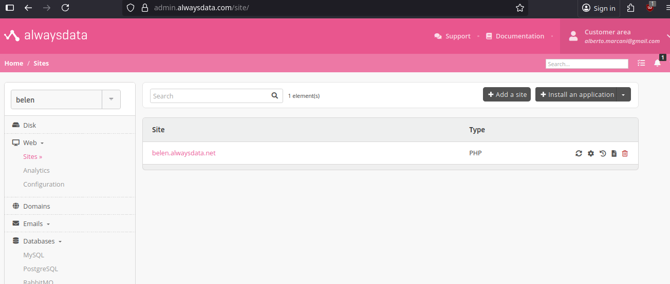

CREANDO RREPOSITORIO REMOTO.
https://github.com/IBertoo/remote_repo.git

git@github.com:IBertoo/remote_repo.git

…or create a new repository on the command line
echo "# remote_repo" >> README.md
git init
git add README.md
git commit -m "first commit"
git branch -M main
git remote add origin git@github.com:IBertoo/remote_repo.git
git push -u origin main

…or push an existing repository from the command line
git remote add origin git@github.com:IBertoo/remote_repo.git
git branch -M main
git push -u origin main

