;>>>>>>>>>>>>>>>>>>>>>>>>>>>>>>>>>>>>>>>>>>>>>>>>>>>>>>>>>>>>>>>>>>>>>>>>>>>>>>>>>>

; ED2022, Computer Technology I

; Lab 2, task 1

; Hardware: STK600, CPU ATmega2560

; Date: 2015-11-26

; Authors: Ivan Hussein

; Function:

; --------

; The program switch between Ring counter and Johnson counter. When the pushbutton, SW0 is

; pressed it switches between Ring counter and Johnson counter.

; Used subroutine: Delay as subroutine.

; Global subroutines (that can be used from other programs):

; Other information: Stock Pointer

;<<<<<<<<<<<<<<<<<<<<<<<<<<<<<<<<<<<<<<<<<<<<<<<<<<<<<<<<<<<<<<<<<<<<<<<<<<<<<<<<<<

.INCLUDE "m2560def.inc"

RingCounter: ; RINGCOUNTER

ldi r16, 0x00 ; PORTA IS OUTPUT

ldi r17, 0xff

out DDRA, R17;

ldi r20, HIGH(0x45F) ; R20 = high part of RAMEND address ; ST-POINTER

out 0x3E,R20 ; SPH = high part of RAMEND address

ldi R20, low(0x45F) ; R20 = low part of RAMEND address

out 0x3D,R20 ; SPL = low part of RAMEND address

loop: ; RINGCOUNTER EXCUTE WHOLE THE TIME

dec r17

call Delay_Tva

out PORTA, r17

inc r17

lsl r17

cpi r17, 0

brne loop

jmp RingCounter

Delay_Tva: ; DELAY

ldi r18, 255

ldi r19, 0

ldi r23, 255

ldi r24, 0

del_0:

del_3:

in r16, PINB

cpi r16, 0b11111110 ; INPUT OCCUR JUMP TO JOHNSSONCOUNTER

breq testTva

inc r24

cp r24, r23

brne del_3

ldi r24, 0

dec r18

cp r19, r18

brne del_0

ret

;;;;;;;;;;;;;;;;;;;;;;;;;;;;;;;;;;;;;;;;;;;;;;;;;;;;;;;;;;;;;;;;;;;;;;;;;;;;;;;;;;;;;;;;;;;;;;;;;;;;;;;;;;;;;;;;;;;;;;

JohnssonCounter: ; JOHNSSONCOUNTER

ldi r16, 0x00 ; JOHNSSONCOUNTER EXCUTES HOLE THE TIME

ldi r17, 0xff

out DDRA, r17

jmp loop_mot_v

ldi r16, 0xff

ldi r17, 0xff

out DDRA, r17

jmp loop_mot_h

ldi r20, HIGH(0x45F) ; R20 = high part of RAMEND address ; ST-POINTER

out 0x3E,R20 ; SPH = high part of RAMEND address

ldi R20, low(0x45F) ; R20 = low part of RAMEND address

out 0x3D,R20 ; SPL = low part of RAMEND address

loop_mot_v: ; RINGS COMES FROM RIGHT

call Delay_Ett ;DELAY WITH THE SAME TIME

lsl r17

out PORTA, r17

cpi r17, 0

brne loop_mot_v

jmp loop_mot_h

loop_mot_h: ; RINGS COMES FROM LEFT

cpi r17, 0b11111111

breq loop_mot_v

call Delay_Ett

com r17

lsr r17

com r17

out PORTA, r17

cp r17, r16

brne loop_mot_h

test:

jmp RingCounter

testTva:

jmp JohnssonCounter

Delay_Ett:

ldi r18, 255

ldi r19, 0

ldi r23, 255

ldi r24, 0

del_1:

del_2:

in r16, PINB

cpi r16, 0b11111110 ; IINPUT OCCUR JUMP TO RINGCOUNTER

breq test

inc r24

cp r24, r23

brne del_2

ldi r24, 0

dec r18

cp r19, r18

brne del_1

ret

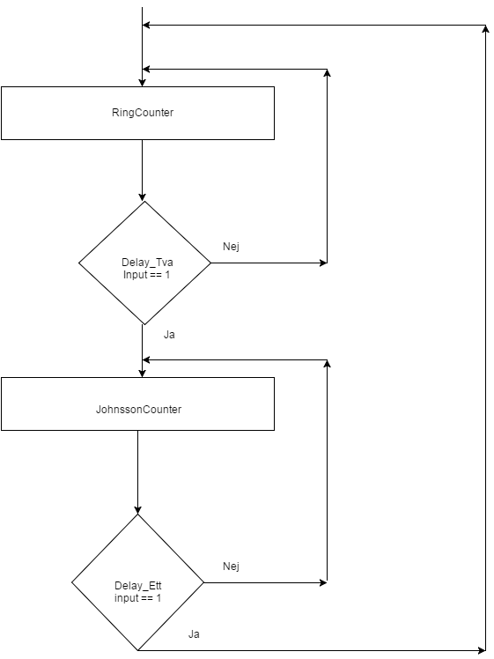

;>>>>>>>>>>>>>>>>>>>>>>>>>>>>>>>>>>>>>>>>>>>>>>>>>>>>>>>>>>>>>>>>>>>>>>>>>>>>>>>>>>

; ED2022, Computer Technology I

; Lab 2, task 2

; Hardware: STK600, CPU ATmega2560

; Date: 2015-11-26

; Authors: Ivan Hussein

; Function:

; --------

; An electronic dice: while the pushbutton is pressed a register increment from 1 to 6. It clears it and

; starts again. When the pushbutton is releasd then that value is compared and sended to OUtPUT.

; Used subroutine:

; Global subroutines (that can be used from other programs):

; Other information: Stock Pointer

;<<<<<<<<<<<<<<<<<<<<<<<<<<<<<<<<<<<<<<<<<<<<<<<<<<<<<<<<<<<<<<<<<<<<<<<<<<<<<<<<<<

.INCLUDE"m2560def.inc"

; Inintialize SP, Stack Pointer

ldi r20, HIGH(RAMEND) ; R20 = high part of RAMEND address

out SPH,R20 ; SPH = high part of RAMEND address

ldi R20, low(RAMEND) ; R20 = low part of RAMEND address

out SPL,R20 ; SPL = low part of RAMEND address

ldi r16, 0xff ;INPUT/OUTPUT DECLARATION

out DDRA, r16

ldi r16, 0x00

out DDRB, r16

ldi r17, 0

start_loop: ; MAIN LOOP

counter: ; INC R17(1-6)

in r16, PINB

cpi r16, 0b11111110

breq surhDice

inc r17

cpi r17,7

brne counter

ldi r17,1

rjmp start_loop

surhDice: ; STORED VALUE IN R17 COMPARES WITH SIX CONSTANTS

Dice1:

cpi r17,1

brne Dice2

out PORTA, r17

jmp start_loop

Dice2:

cpi r17,2

brne Dice3

out PORTA, r17

jmp start_loop

Dice3:

cpi r17, 3

brne Dice4

out PORTA, r17

jmp start_loop

Dice4:

cpi r17, 4

brne Dice5

out PORTA,r17

jmp start_loop

Dice5:

cpi r17,5

brne Dice6

out PORTA, r17

jmp start_loop

Dice6:

cpi r17, 6

breq Dice

Dice:

out PORTA, r17

jmp start_loop

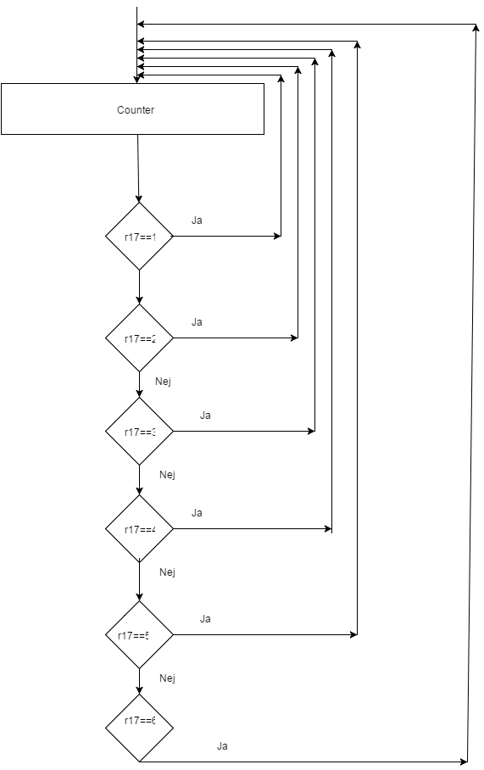

;>>>>>>>>>>>>>>>>>>>>>>>>>>>>>>>>>>>>>>>>>>>>>>>>>>>>>>>>>>>>>>>>>>>>>>>>>>>>>>>>>>

; ED2022, Computer Technology I

; Lab 2, task 3

; Hardware: STK600, CPU ATmega2560

; Date: 2015-11-26

; Authors: Ivan Hussein

; Function:

; --------

; This program counts the number of changes on a switch. As a change we count

; when the switch SW0 goes from 0 to 1 and from 1 to 0, we expect therefore positive and negative

; edges.

; Used subroutine:

; Global subroutines (that can be used from other programs):

; Other information: Stock Pointer

;<<<<<<<<<<<<<<<<<<<<<<<<<<<<<<<<<<<<<<<<<<<<<<<<<<<<<<<<<<<<<<<<<<<<<<<<<<<<<<<<<<

.INCLUDE"m2560def.inc"

; Inintialize SP, Stack Pointer

ldi r20, HIGH(RAMEND) ; R20 = high part of RAMEND address

out SPH,R20 ; SPH = high part of RAMEND address

ldi R20, low(RAMEND) ; R20 = low part of RAMEND address

out SPL,R20 ; SPL = low part of RAMEND address

ldi r16, 0xff ; OUPUT/INPUT PORTs

out DDRA, r16

ldi r16, 0x00

out DDRB, r16

ldi r17, 0

;ldi r18, 0

start_loop:

dec r17

start1:

inc r17 ; INC R17 HOLE THE TIUME

counter:

in r16, PINB

out PORTA, R17

cpi r16, 0b11111110 ; INPUT OCCURE NAD JUMPS

breq start2

jmp counter

start2:

inc r17

switch1:

in r16, PINB

out PORTA, r17 ; R17 TO OUTPUT PORT

cpi r16,0b11111111

breq start1 ; STARTS AGAIN

jmp switch1

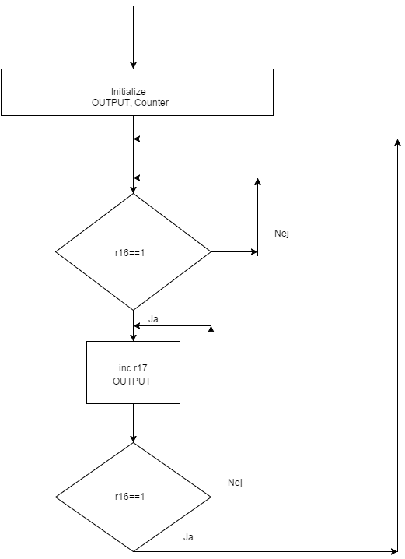

;>>>>>>>>>>>>>>>>>>>>>>>>>>>>>>>>>>>>>>>>>>>>>>>>>>>>>>>>>>>>>>>>>>>>>>>>>>>>>>>>>>

; ED2022, Computer Technology I

; Lab 2, task 4

; Hardware: STK600, CPU ATmega2560

; Date: 2015-11-26

; Authors: Ivan Hussein

; Function:

; --------

; This program runs Ring Counter with a longer delay. Register pair is used here in order to store the

; larger number, which will delay longer between each step.

; Used subroutine: wait_milliseconds as a subroutine

; Global subroutines (that can be used from other programs):

; Other information: Stock Pointer

;<<<<<<<<<<<<<<<<<<<<<<<<<<<<<<<<<<<<<<<<<<<<<<<<<<<<<<<<<<<<<<<<<<<<<<<<<<<<<<<<<<

.include "m2560def.inc"

ldi r20, HIGH(0x45F) ; R20 = high part of RAMEND address ; ST-POINTER

out 0x3E,R20 ; SPH = high part of RAMEND address

ldi R20, low(0x45F) ; R20 = low part of RAMEND address

out 0x3D,R20 ; SPL = low part of RAMEND address

start: ;OUTPUT DECLARATION

ldi r16, 0x00

ldi r17, 0xff

out DDRA, R17

loop:

dec r17 ; WORK AS RINGCOUNTER

ldi r24, LOW(5000) ; LOADING HIGH-LOW REGISTER

ldi r25, HIGH(5000)

call wait_milliseconds ;Delay

out PORTA, r17

inc r17

lsl r17

cp r17, r16

brne loop

jmp start

wait_milliseconds: ; THIS DELAY CONTAIN A REGISTER PAIR

; TAKES LONGER "TIME"

again:

ldi r23, 255

ldi r22, 0

del_2:

inc r22

cp r22, r23

brne del_2

/***************************************************************************/

sbiw r25:r24,1

brne again

ldi r24, LOW(5000)

ldi r25, HIGH(5000)

ret

