Learning Objectives
By the end of this guide, learners will be able to:
- Explain how Git communicates with remote repositories.
- Differentiate between cloning, forking, and creating a repository.
- Describe the purpose of the `origin` and `upstream` remotes.
- Explain the relationship between local and remote-tracking branches.
- Explain why pulling before pushing helps prevent conflicts.
- Explain the purpose of the fetch, pull, and push commands.
- Describe how `git pull` combines fetching and merging.
- Explain how to review changes before committing or pushing.
- Explain good commit etiquette when collaborating with others.
- Explain the mental model of how local repositories synchronize with remote repositories.

Introduction
In the beginner section, we learned that local repositories exist on your own computer and that remote repositories are stored on another system. If we want to keep the local and remote repositories synchronized for a project, we must be able to exchange repository history and information between them. Furthermore, if we have teammates that are also working on the same repository, they need to be able to access the changes that we make, just as we need to be able to access theirs.

How Git Knows Where to Synchronize
In the introduction, we discussed that we need to be able to synchronize a local and remote repository. But how does Git actually know where this remote repository is located so that it can synchronize with it?
The answer is through remotes. A remote is almost like a bookmark that stores the location of another Git repository. Instead of you having to type out the URL to the location of your remote repository every time you push changes, Git stores this information under a human-readable name.
For example, when you clone a repository from GitHub (create a local repository containing the history of a remote repository), Git automatically creates a remote named origin. This remote points to the repository’s URL that you cloned and stores this information within the `.git/config` file in your repository.
Below is a picture of the `.git/config` file for this repository, showing the URL for the remote repository saved as “origin”.
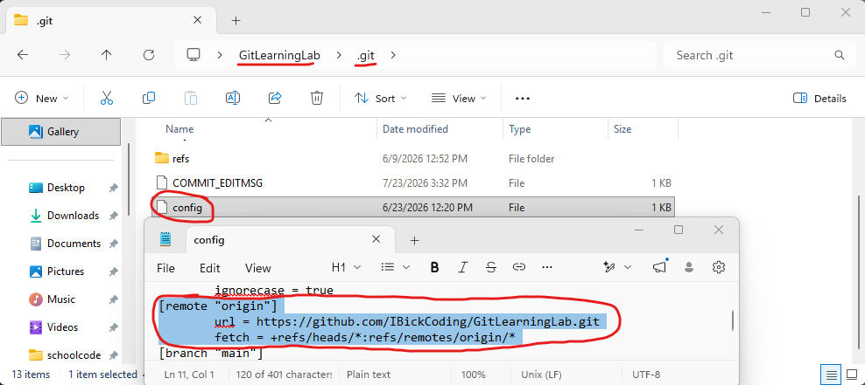
You can also see all remotes that exist for a repository by using the command `git remote -v`. The -v flag in this command allows us to see the URLs associated with each remote. The reason this is important is because repositories can have multiple remotes. For example, when you are contributing to an open-source project, it is common to have an `origin` remote pointing to your own fork of a repository and an `upstream` remote pointing to the original project repository. We will go into more detail on this later.

Clone, Fork, or Creating a Repository
When using Git, there are several ways to obtain or create a repository. You may clone an existing repository, fork an existing repository, or create a new repository from scratch depending on your goal.

Clone
Cloning a repository creates a local copy of an existing Git repository, including its files, commit history, branches, and remote configuration. If you own this repository or have permission to write to the remote repository, you can push your changes to the remote repository. However, if you do not have permission to write to the remote repository, cloning a repository will not allow you to make changes to the remote repository. Instead, this cloned repository becomes its own separate repository. It shares the repository history of the remote repository up to this point in time, but you cannot push changes to the remote repository.
You can clone a repository by opening a Git Bash terminal and using the command `git clone {insert clone URL}`. You can get this clone URL by going to a repository that you want to clone from on GitHub, clicking on the green “code” button on the main page of the repository, and selecting the HTTPS option.
You can also clone a repository using SSH. This requires that you have an SSH key configured on your computer and that the corresponding public key has been added to your GitHub account.
Below is an example of me cloning this repository from GitHub to my computer, using the URL method.
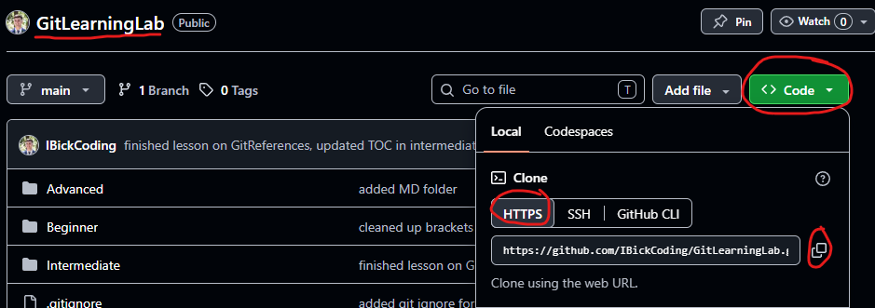
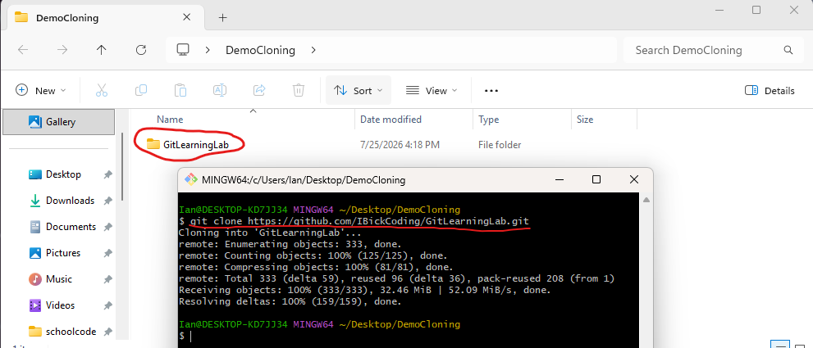

Fork
Forking creates a copy of a repository on a Git hosting platform such as GitHub under your own account. Forking occurs on GitHub and cloning occurs on your computer. Since forking is done on GitHub, there are no commands required for forking a repository. Instead, we will use the GitHub interface from the browser.
Forking is typically used when you do not own a repository and do not have permission to push changes, but you want to contribute to the project. You would fork the repository, clone that forked repository to your computer, and then make your contributions to the project. But how do we keep up to date with the original repository’s changes on this forked repository?
This is where adding an additional remote to your repository comes in handy. You can add an `upstream` remote by using the command `git remote add upstream {insert URL of the original repository}`. This would leave us with two remotes:
origin Your forked repository.
upstream Original project repository.
After adding an upstream remote, you can fetch changes to your local repository from the upstream repository by using the command `git fetch upstream {branch name}`. This downloads the latest commits from the upstream remote on the branch name you provided and updates your local remote-tracking branch. Fetching does not automatically merge these changes into the current branch. It only updates your local copy of the upstream branch, allowing you to review and integrate changes made to the original repository when you are ready. But how do we submit our changes to the original project’s repository?
This is also done on GitHub. Once your forked repository has all the contributions pushed to it from your local clone of the repository, you would then open a pull request on the original project repository’s page. You will write a description of the changes or contributions that you made, and then the owner of the original repository will review your pull request. If they approve of your contributions, they will merge your pull request into the original repository, or they could decline the pull request if they do not approve of your contributions.
Below is a series of images that show the process of forking a repository, making contributions, making a pull request, and merging a pull request.
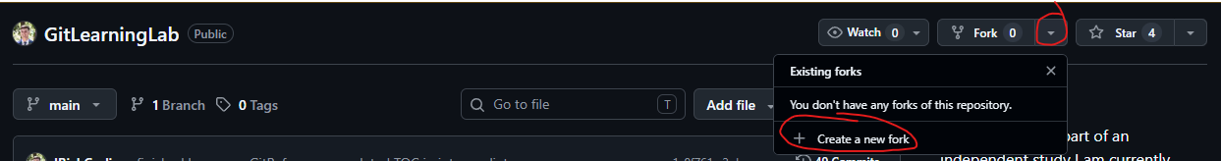
First, we will click on the dropdown menu for “Fork” and then the “Create a new fork” option.
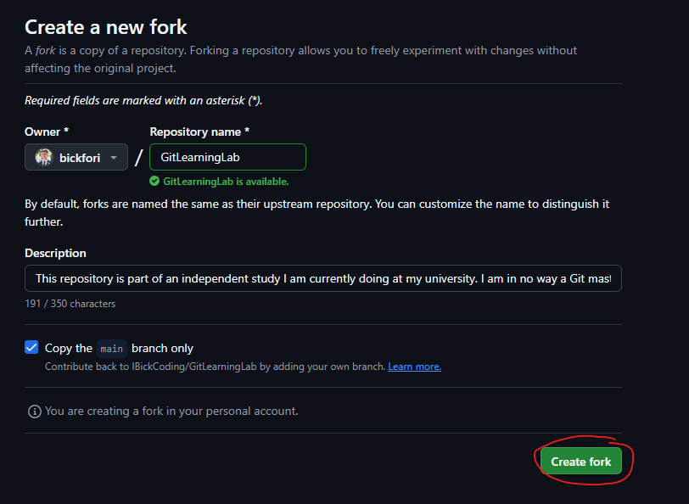
Next, we will keep all the settings default and press the “Create fork” button. After a few seconds, we will be redirected to the forked repository.
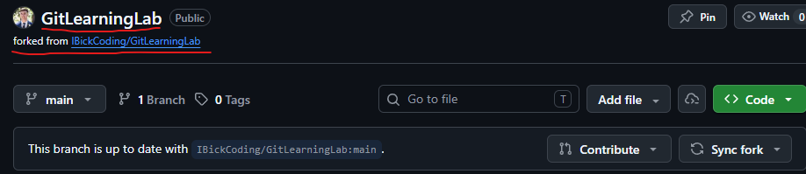
We can confirm this is a forked repository by looking at the name of this repository and see that it is a forked repository from the original project.
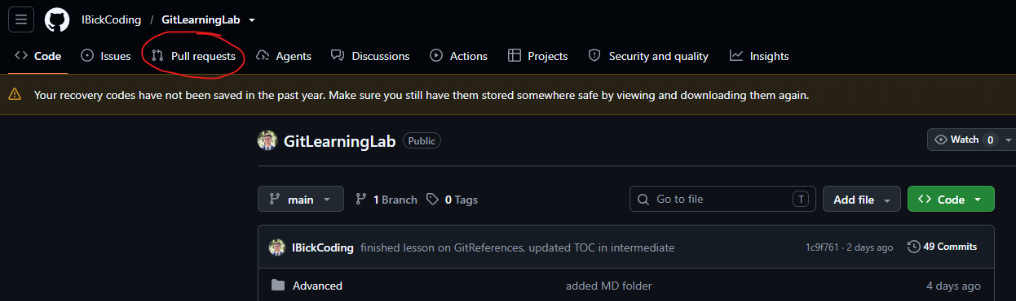
We will now go to the original project repository and click on the “pull requests” option on the top of the page after making our contributions. For this example, I created a new file called TempForkExample.txt with one line of text that I will be making a pull request for. I made this file within the GitHub page for the forked repository, otherwise we would need to clone the repository to this computer and push our changes up to the forked repository.
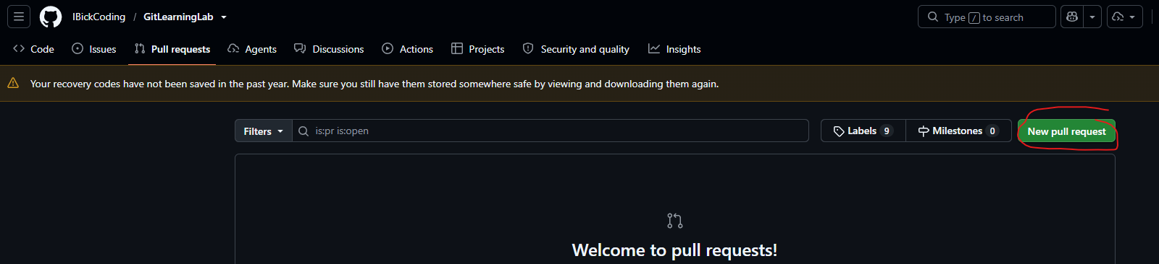
We will then click on “New pull request”.
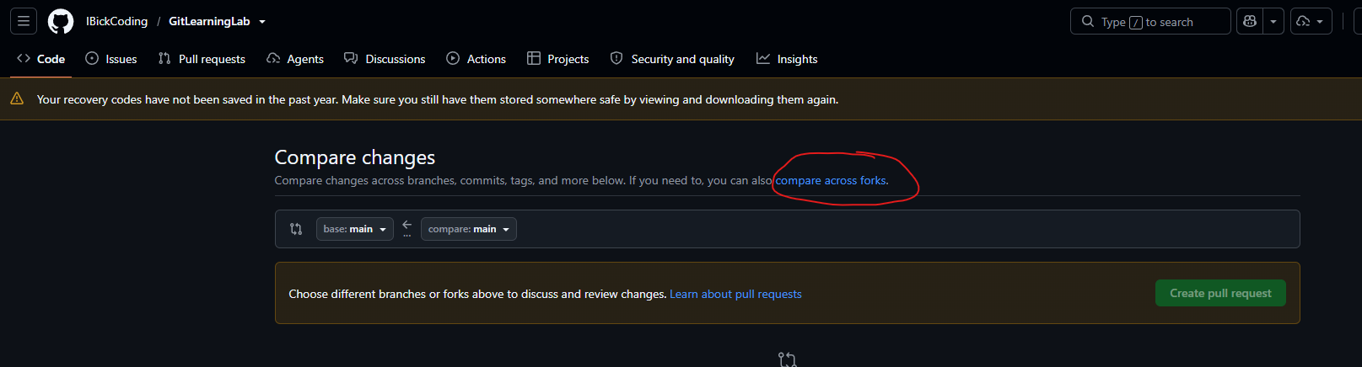
Click on the compare across forks option as GitHub currently does not know that you want to compare a fork to the original repository and instead is trying to compare branches within the same repository.
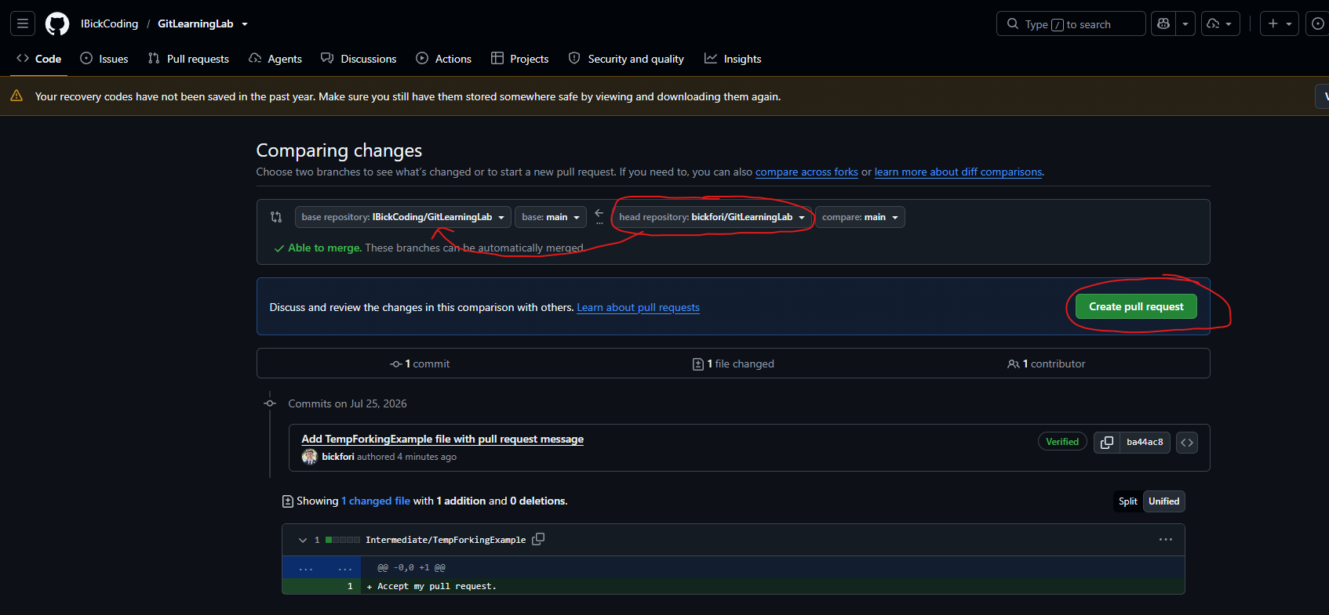
We then will change the head repository to the forked repository, make sure we are comparing the correct branch in each repository to each other (in this case we just have one branch “main” to compare to one another). We can then see the summary of the commits, files changes, and the contributor to those changes below. If we are satisfied with the pull request, we will click the “Create pull request” button.
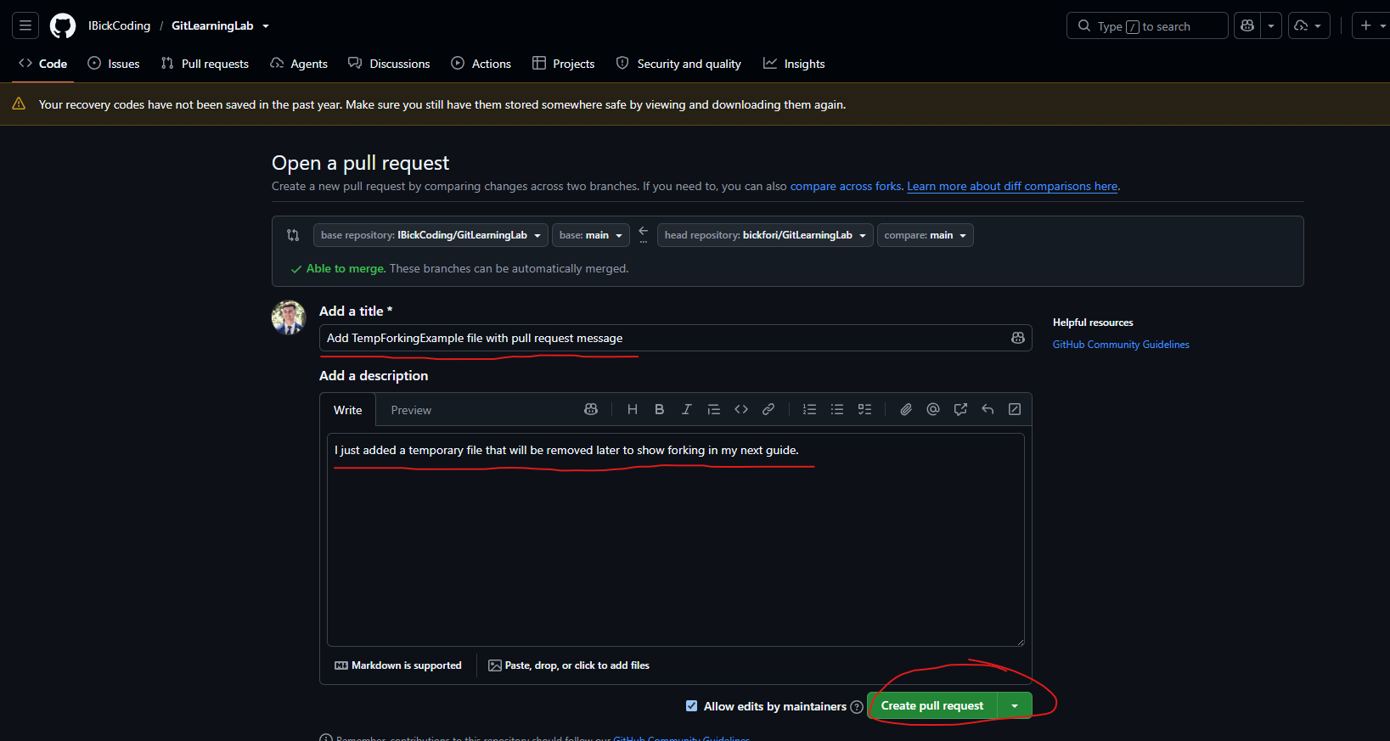
We will then add an appropriate title, an appropriate description of all changes made, and then click the “Create pull request” button.
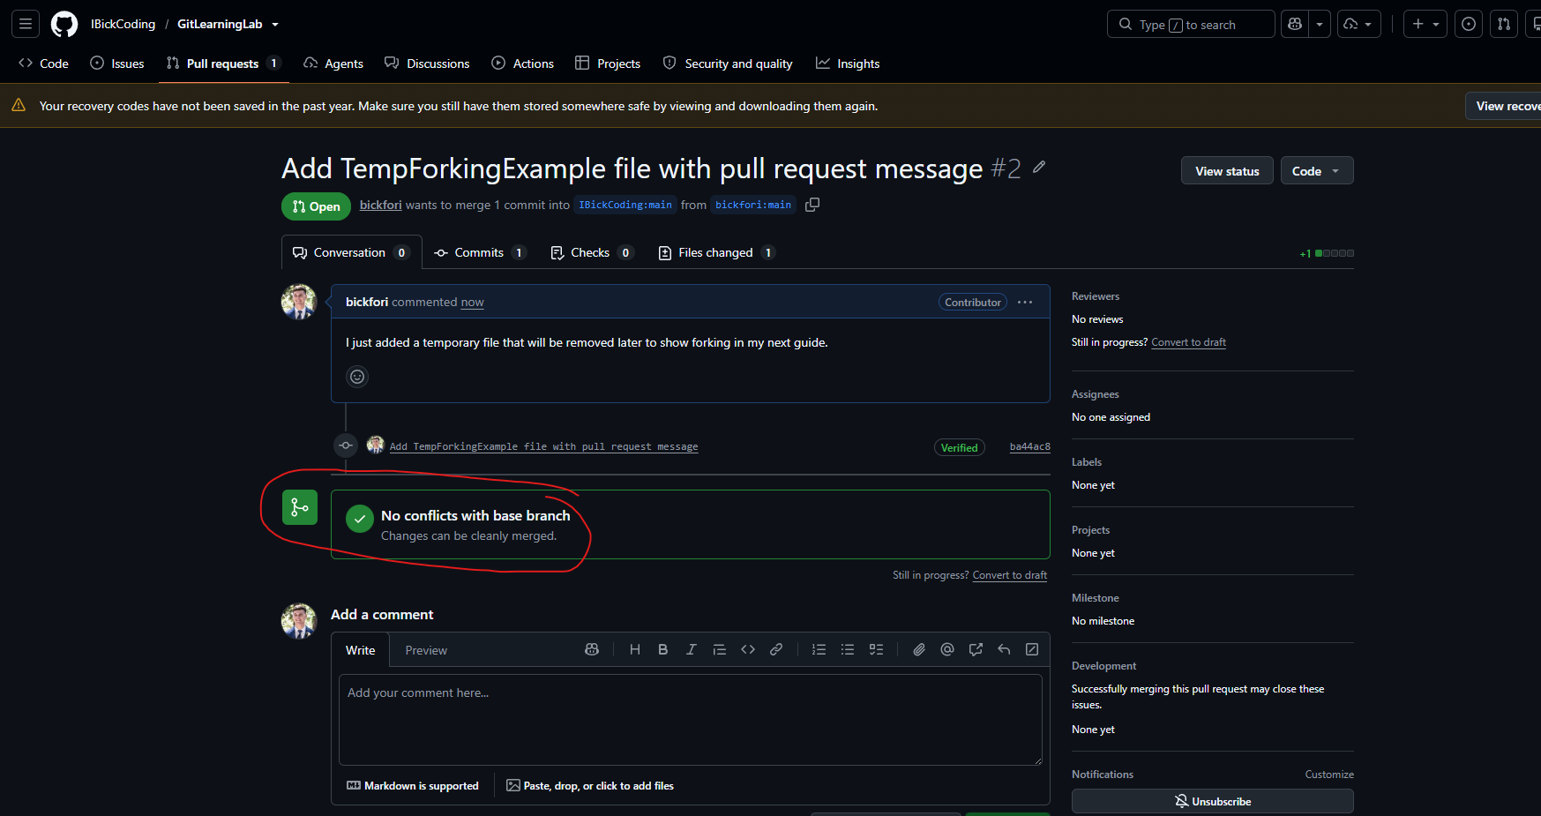
Once we create the pull request, we can see that there are no conflicts with the changes that we have made. Now it is up to the owner to either merge the pull request or close it if they do not want to merge the contributions that you have made.
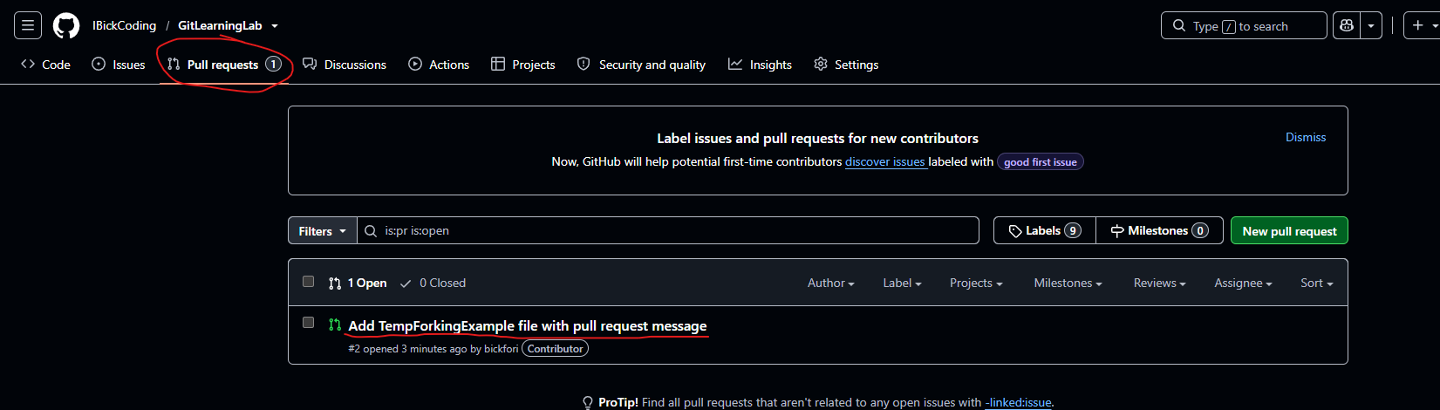
Now that I am signed back into the account that owns this repository, I can see the pull request that we made. Note: We would not be able to select the pull request and merge it if we were not the owners of this repository. We could still view open pull requests, but we could not merge them.
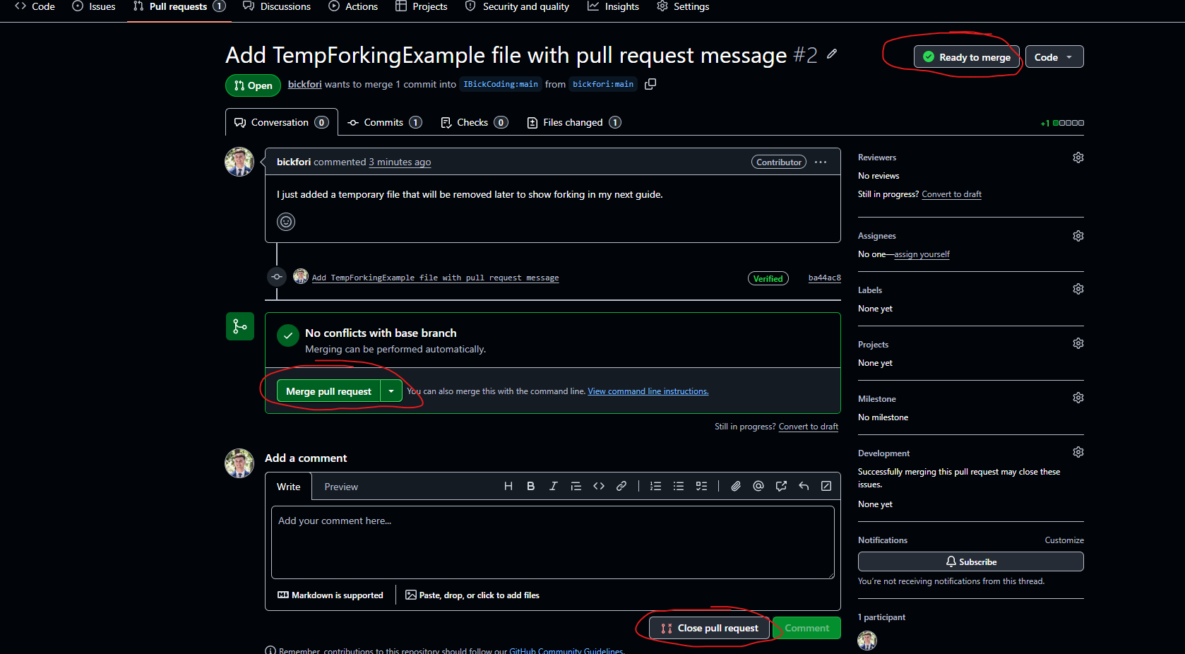
Once we click on the pull request, we can see that the pull request is ready to be merged as there are no merge conflicts. If there were merge conflicts, we would see in the top right that the pull request was not ready to merge, the conflicts section would tell us where there are conflicts, we would have to manually resolve the conflicts, and only then could we merge the pull request. Alternatively, we can also select the “close pull request” option at the bottom if we do not approve of the contribution. We will select this as I have no need for this contribution.

